d9 River Discharge and runoff
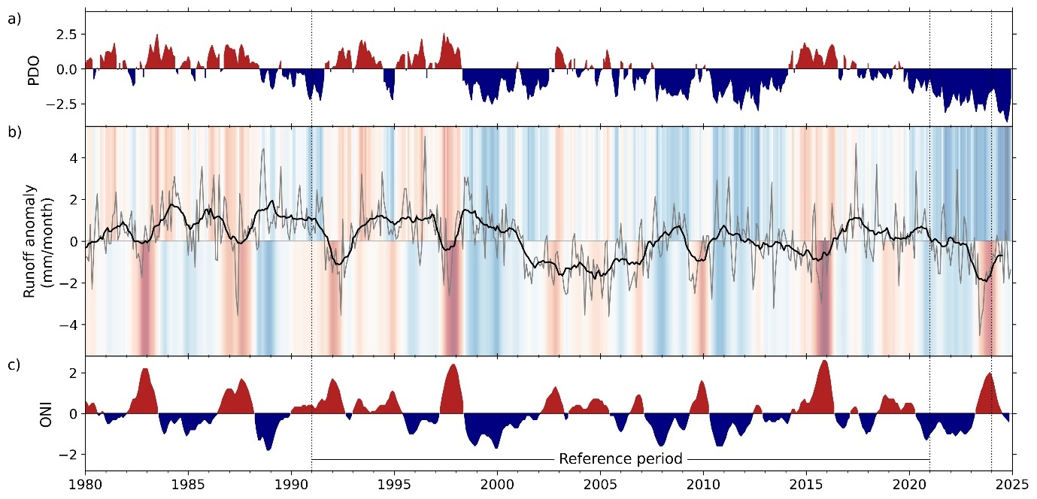
Fig. 2.d.9.1. Interannual variability of global runoff (b) and its connections with the (a) Pacific Decadal Oscillation (PDO) and (c) Oceanic Niño Index (ONI; c). In panel (a), the gray line represents the monthly time series of anomalies compared with the base period 1991–2020, the black line the 12-month moving average, and the shading indicates the phase of the two indices (PDO in the upper part and ONI in the lower).

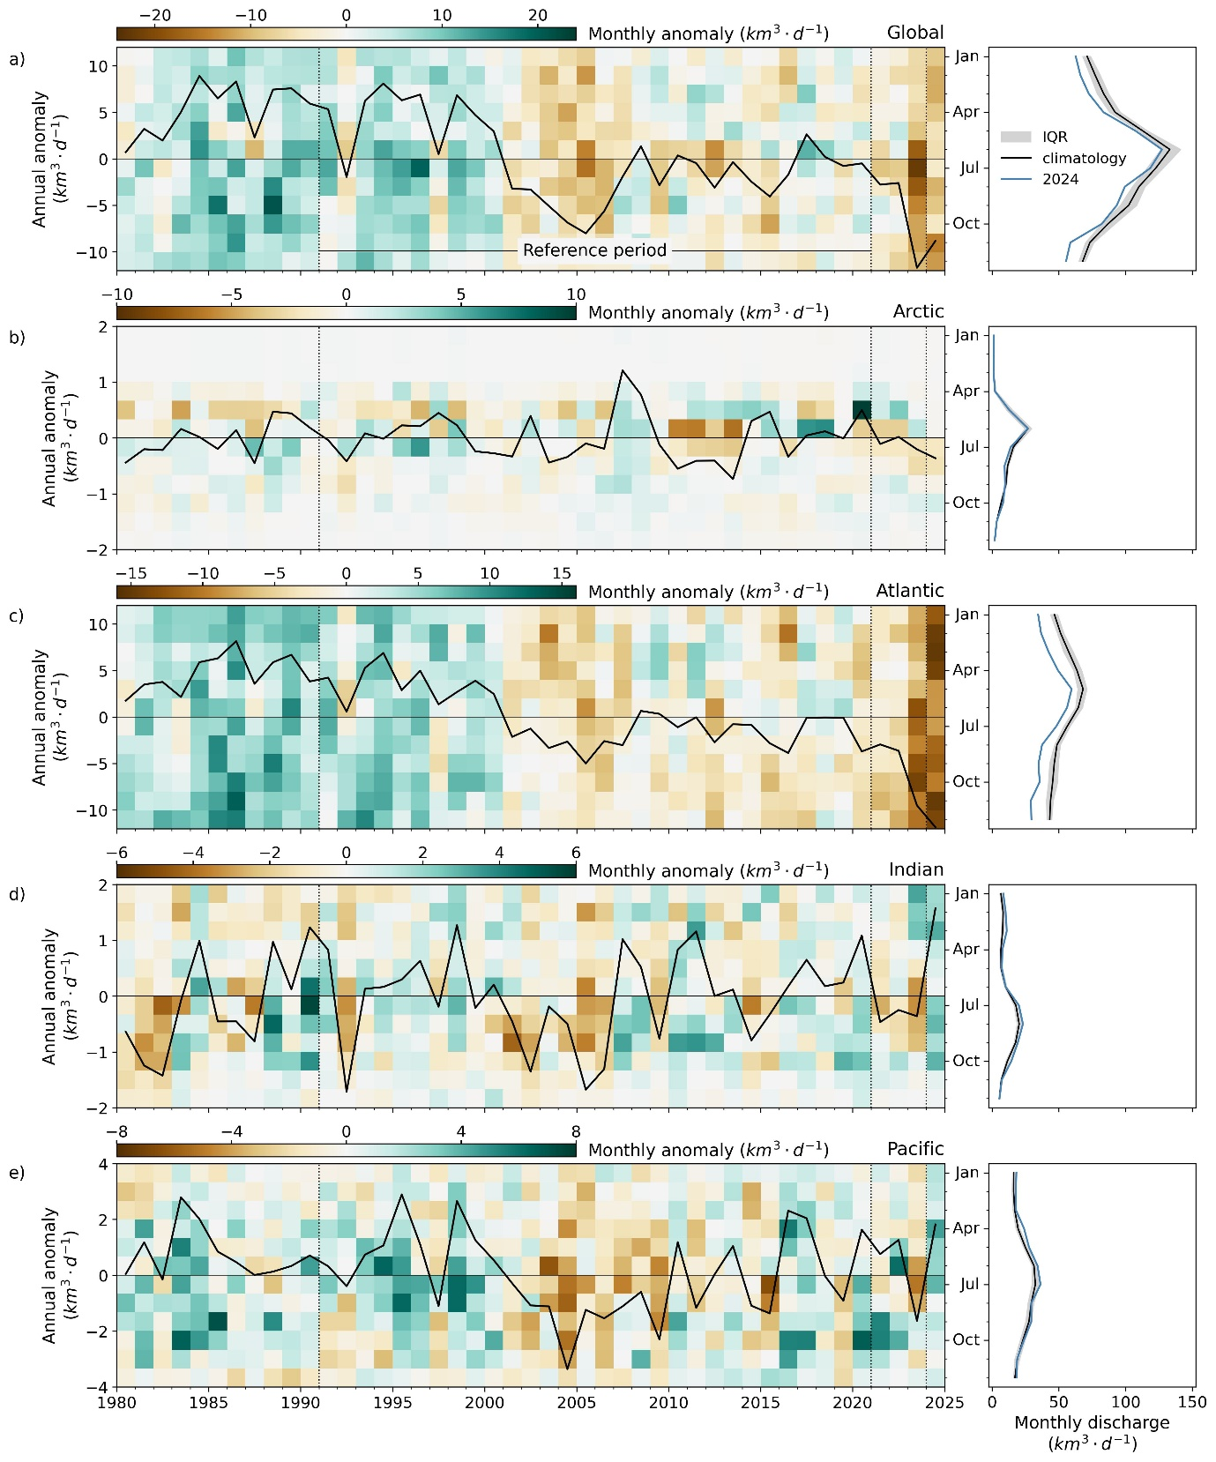
Fig. 2.d.9.2. Interannual variability and seasonality of freshwater discharge to global ocean basins. In the left panels, the black line represents the annual discharge anomaly, and the background heat map shows the monthly anomalies with respect to the reference seasonality in the base period 1991–2020. The right panels exhibit the seasonality, where the black line represents the climatological mean, the gray shading indicates the interquartile range in the climatology, and the blue line shows the seasonal variation in 2024.

