Plate 2.1
Note to reviewer: There is a standard way the captions for all plates presented here will be written in final publication form. The captions presented here are for reviewer knowledge but do not need to be reviewed or commented on.

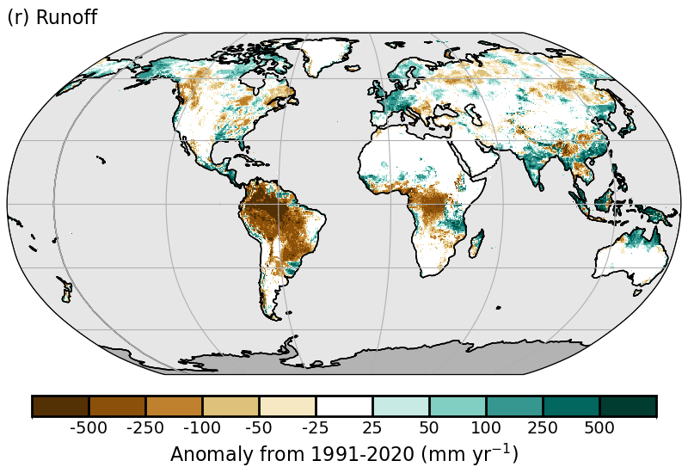Plate 2.1r. GloFASv4 (Global Flood Awareness System) distribution of runoff anomalies (mm yr⁻¹).

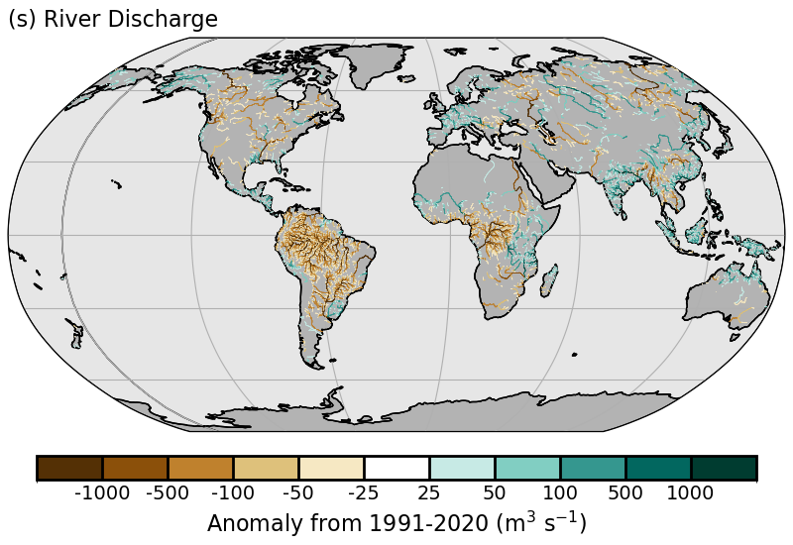
Plate 2.1s. GloFASv4 distribution of discharge anomalies (m³ s⁻¹).

