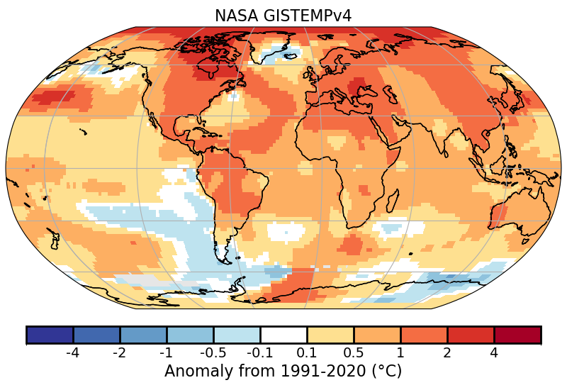
Appendix

Appendix Fig. A2.b.1.1. Global surface temperature anomalies (°C). (Source: NASA-GISTEMPv4.)
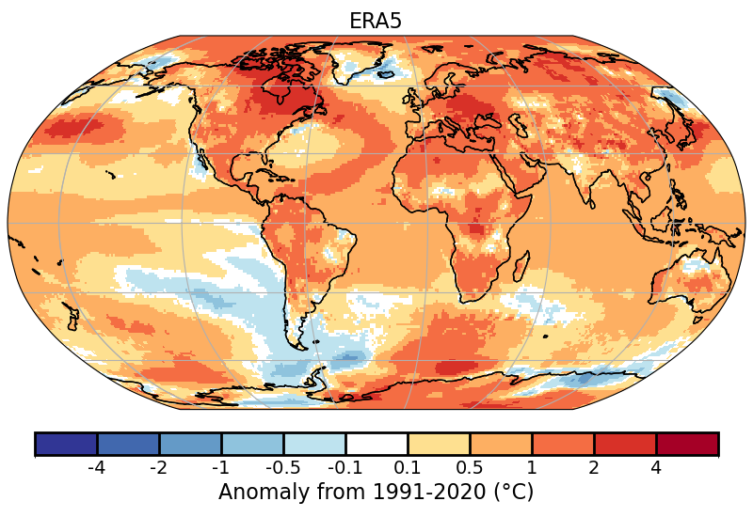
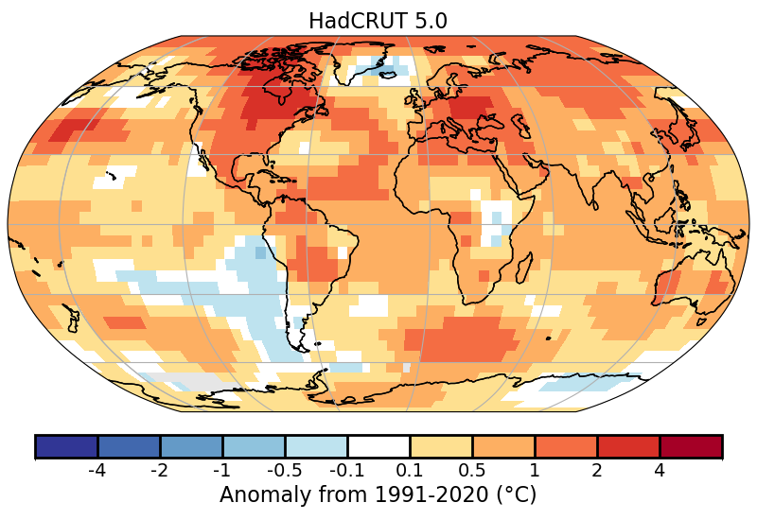
Appendix Fig. A2.b.1.2. Global surface temperature anomalies (°C). (Source: HadCRUT5.)
Appendix Fig. A2.b.1.3. Global surface temperature anomalies (°C). (Source: ERA5.)
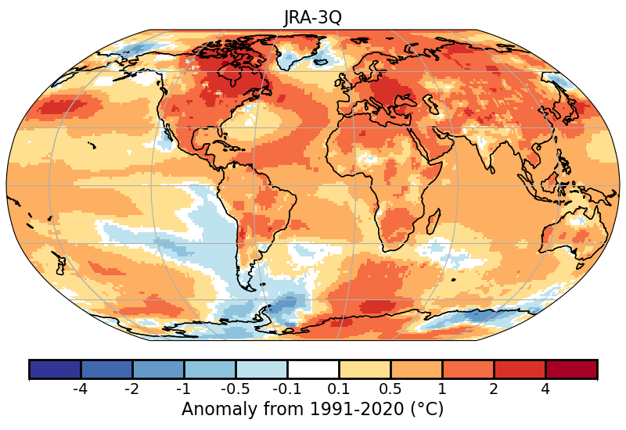
Appendix Fig. A2.b.1.4. Global surface temperature anomalies (°C). (Source: JRA-3Q.)

Appendix Table A2.b.7.1. Ten highest annual global equivalent temperature anomalies (Teq) and their constituent parts (air temperature [Ta]; latent temperature [Tq]) in °C (1991–2020 base period) since 1979 for ERA5.

Rank | Ta Year | Ta (°C) | Tq Year | Tq (°C) | Teq (Year) | Teq (°C)
1 | 2024 | 0.72 | 2024 | 0.85 | 2024 | 1.57
2 | 2023 | 0.60 | 2023 | 0.59 | 2023 | 1.19
3 | 2016 | 0.44 | 2016 | 0.50 | 2016 | 0.94
4 | 2020 | 0.43 | 2019 | 0.44 | 2019 | 0.84
5 | 2019 | 0.40 | 2020 | 0.38 | 2020 | 0.82
6 | 2017 | 0.34 | 2017 | 0.33 | 2017 | 0.68
7 | 2022 | 0.30 | 1998 | 0.27 | 2015 | 0.53
8 | 2021 | 0.27 | 2015 | 0.27 | 2018 | 0.52
9 | 2018 | 0.26 | 2018 | 0.25 | 2021 | 0.41
10 | 2015 | 0.26 | 2010 | 0.15 | 2022 | 0.40

Appendix Table A2.b.7.2. Ten highest annual global equivalent temperature anomalies (Teq) and their constituent parts (air temperature [Ta]; latent temperature [Tq]) in °C (1991–2020 base period) since 1979 for JRA-3Q.

Rank | Ta Year | Ta (°C) | Tq Year | Tq (°C) | Teq (Year) | Teq (°C)
1 | 2024 | 0.67 | 2024 | 0.98 | 2024 | 1.65
2 | 2023 | 0.57 | 2023 | 0.74 | 2023 | 1.30
3 | 2016 | 0.42 | 2016 | 0.45 | 2016 | 0.86
4 | 2020 | 0.38 | 2020 | 0.41 | 2020 | 0.79
5 | 2019 | 0.36 | 1998 | 0.33 | 2019 | 0.68
6 | 2017 | 0.30 | 2019 | 0.32 | 2017 | 0.52
7 | 2015 | 0.25 | 2015 | 0.24 | 2015 | 0.49
8 | 2022 | 0.24 | 2017 | 0.23 | 2022 | 0.44
9 | 2018 | 0.22 | 2022 | 0.21 | 2021 | 0.38
10 | 2021 | 0.19 | 2021 | 0.19 | 1998 | 0.36

Appendix Table A2.b.7.3. Top ten ranked global equivalent temperature anomalies (Teq) and their constituent parts (air temperature [Ta]; latent temperature [Tq]) in °C (1991–2020 base period) since 1979 for HadISDH (Land-Only).

Rank | Ta Year | Ta (°C) | Tq Year | Tq (°C) | Teq (Year) | Teq (°C)
1 | 2024 | 0.96 | 2024 | 1.13 | 2024 | 2.04
2 | 2023 | 0.74 | 2023 | 0.74 | 2023 | 1.49
3 | 2020 | 0.58 | 2016 | 0.61 | 2016 | 1.14
4 | 2016 | 0.55 | 1998 | 0.58 | 2020 | 1.03
5 | 2019 | 0.44 | 2020 | 0.46 | 1998 | 0.72
6 | 2015 | 0.42 | 2010 | 0.35 | 2017 | 0.67
7 | 2017 | 0.39 | 2022 | 0.31 | 2019 | 0.64
8 | 2021 | 0.37 | 2017 | 0.29 | 2021 | 0.63
9 | 2022 | 0.33 | 2021 | 0.27 | 2022 | 0.62
10 | 2018 | 0.24 | 2019 | 0.21 | 2015 | 0.60

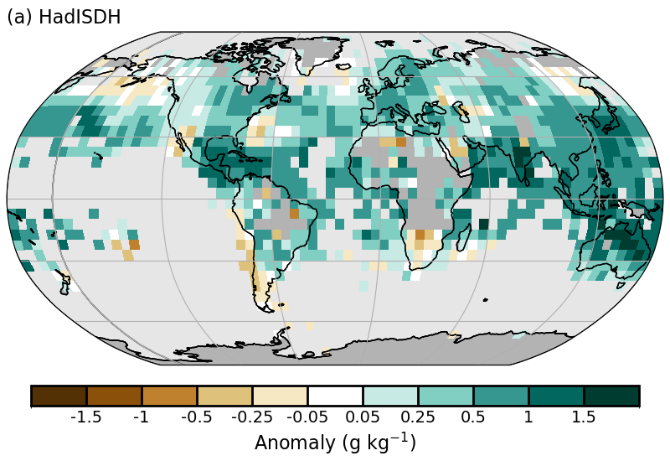
Appendix Fig. A2.d.1.1. Surface specific humidity anomaly relative to 1991–2020 from HadISDH.blend.1.5.1.2024f.

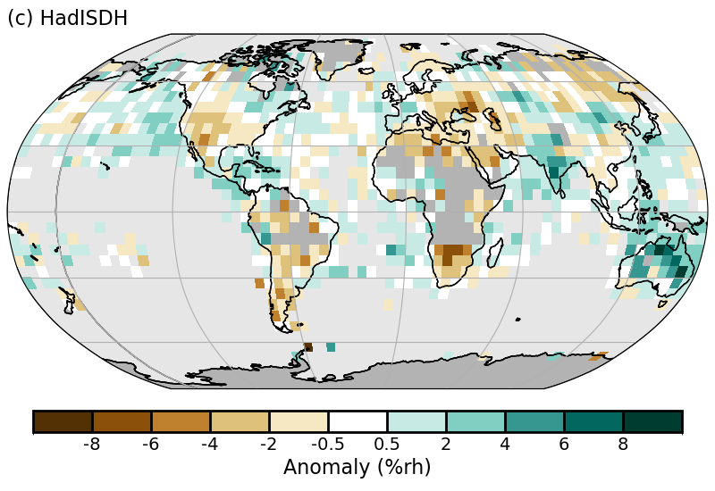
Appendix Fig. A2.d.1.2. Surface relative humidity anomaly relative to 1991–2020 from HadISDH.blend.1.5.1.2024f.

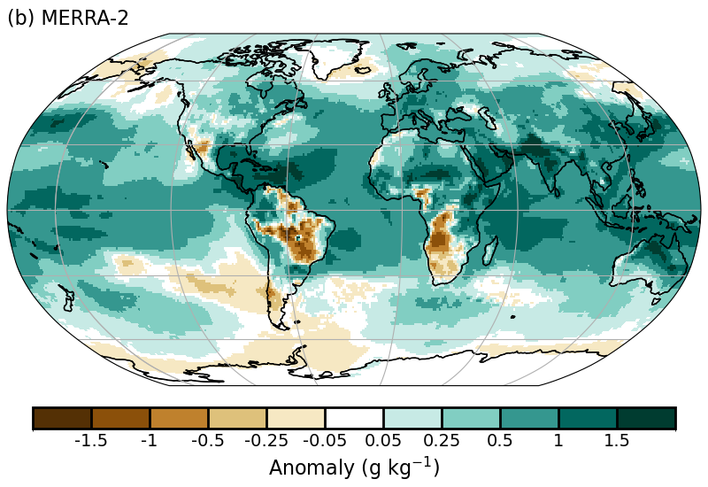
Appendix Fig. A2.d.1.3. Surface specific humidity anomaly relative to 1991–2020 from MERRA-2.

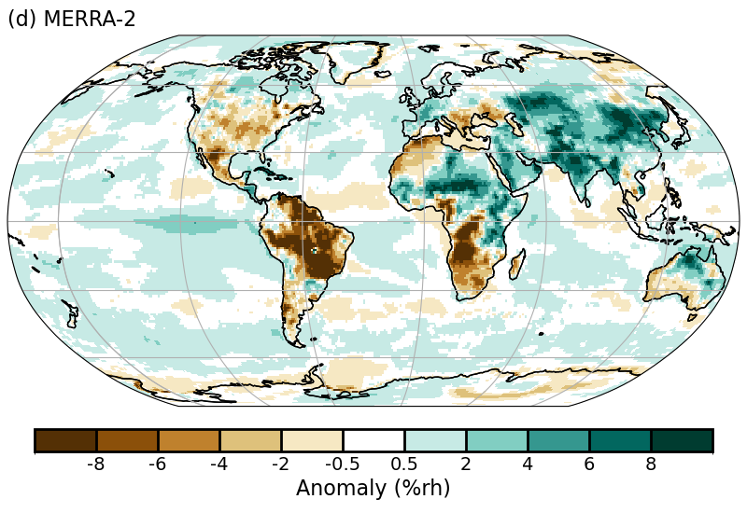
Appendix Fig. A2.d.1.4. Surface relative humidity anomaly relative to 1991–2020 from MERRA-2.

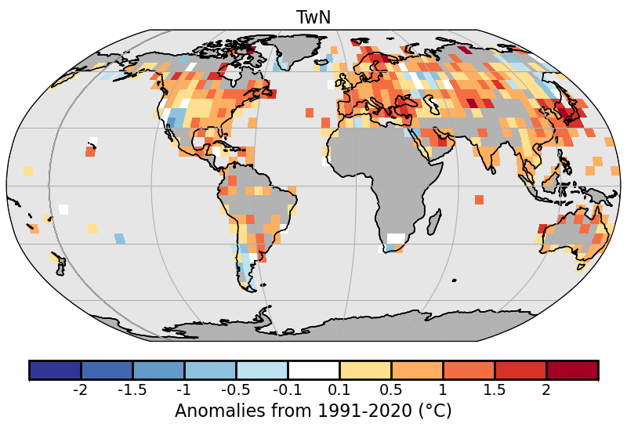
Appendix Fig. A2.d.2.1. 2024 intensity of daily minimum humid heat aomalies (T_{w}N) as measured by the annual median anomaly of daily minimum wet-bulb temperature from HadISDH.extremes. White gridboxes (over land) represent regions with insufficient data.

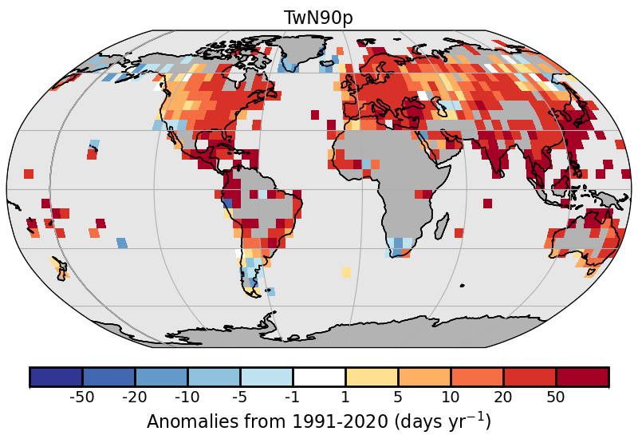
Appendix Fig. A2.d.2.2. 2024 frequency of high daily minimum humid-heat days (anomalies) as measured by the number of days where the daily minimum wet-bulb temperature exceeds the local daily 90th percentile (calculated over the 1991–2020 period) from HadISDH.extremes. White gridboxes (over land) represent regions with insufficient data.

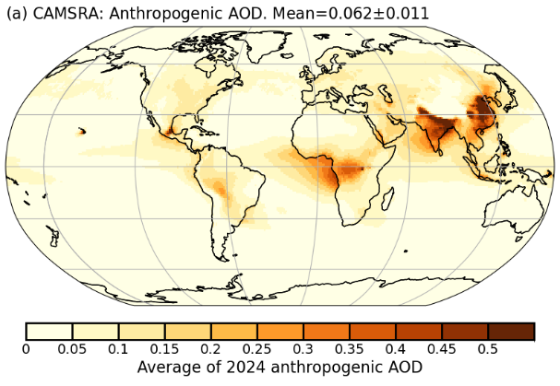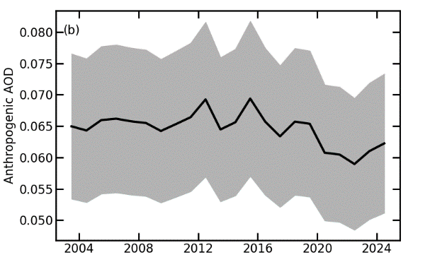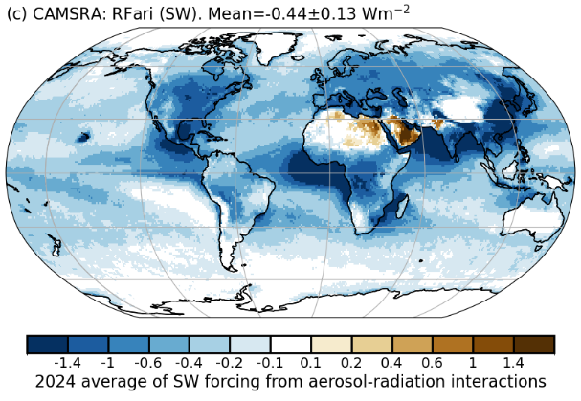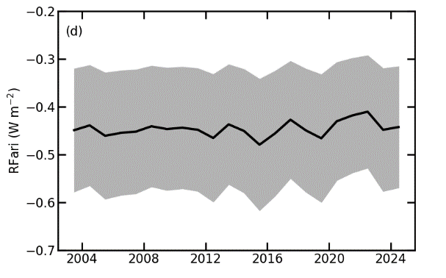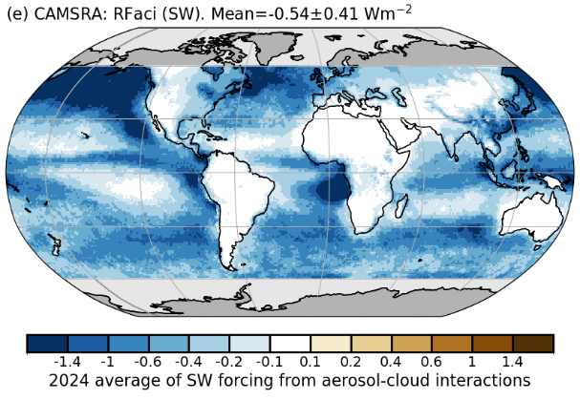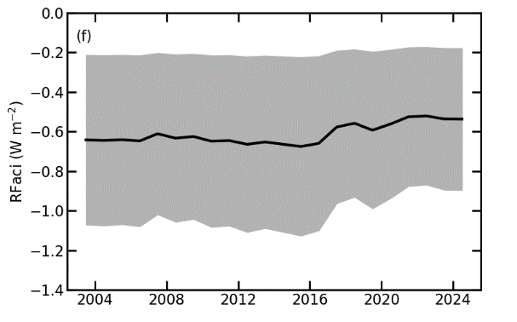
Appendix Fig. A2.e.3.1. CAMSRA (a) 2024 average of anthropogenic aerosol optical depth (AOD); (b) global annual average of anthropogenic AOD from 2003 to 2024. Radiative forcing in the shortwave (SW) spectrum due to (c),(d) aerosol-radiation (RFari) and (e),(f) aerosol-cloud interactions (RFaci). The left column shows the distributions for the year 2024. The right column shows the time series of global averages for the period 2003–24, with the mean +/− 1-σ uncertainties of these estimates shown in beige.

