a Introduction
b Temperature
b1 Surface Temperature
b2 Lake Surface Temperatures
b3 Night Marine Air Temperatures
b4 Surface Temperature Extremes
b5 Tropospheric Temperature
b6 Stratospheric Temperature
b7 Equivalent Temperature
c Cryosphere
c1 Permafrost Temperatures and Active Layer Thickness
c2 Rock Glacier Velocity
c3 Alpine Glaciers
c4 Lake Ice Cover
c5 Northern Hemisphere Continental Snow Cover Extent
d Hydrological Cycle - Atmosphere
d1 Surface Humidity
d2 Humid Heat extremes
d3 Total Column Water Vapor
d4 Upper Tropospheric Humidity
d5 Precipitation
d6 Land surface Precipitation Extremes
d7 Cloudiness
d Hydrological Cycle - Land
d8 Lake Water Level
d9 River Discharge
d10 Groundwater and Terrestrial Water Storage
d11 Soil Moisture
d12 Monitoring Drought using the Self Calibrating Palmer Drought Severity Index
d13 Global Land Evaporation
e Atmospheric Circulation
e1 Mean Sea Level Pressure and Related Modes of Variability
e2 Surface Winds
e3 Upper air winds
e4 Lightning
f Earth Radiation Budget
f1 Earth Radiation Budget at Top-of-Atmosphere
f2 Mauna Loa Clear-Sky Atmospheric Solar Transmission
g Atmospheric Composition
g1 Long-lived Greenhouse Gases
g2 Ozone-Depleting Gases
g3 Tropospheric Aerosols
g4 Tropospheric Ozone
g5 Stratospheric Aerosols
g6 Stratospheric Ozone
g7 Stratospheric Water Vapor
g8 Carbon Monoxide
h Land Surface Properties
h1 Land Surface Albedo Dynamics
h2 Terrestrial Vegetation Dynamics
h3 Biomass Burning
h4 Phenology of Primary Producers
h5 Vegetation Optical Depth
Sidebar – Short-lived GHGs [to occur just before 2g?]
a Introduction
b Temperature
b1 Surface Temperature
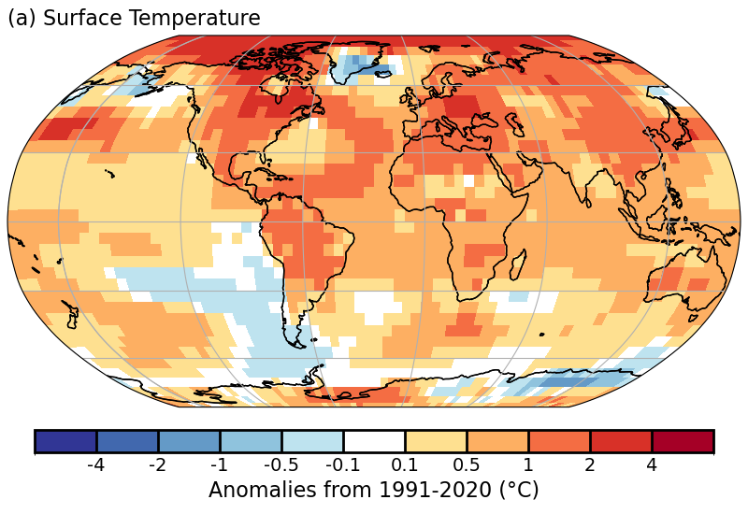
Plate 2.1a: NOAA NCEI Global land and ocean surface annual temperature anomalies (°C)

b2 Lake Surface Temperatures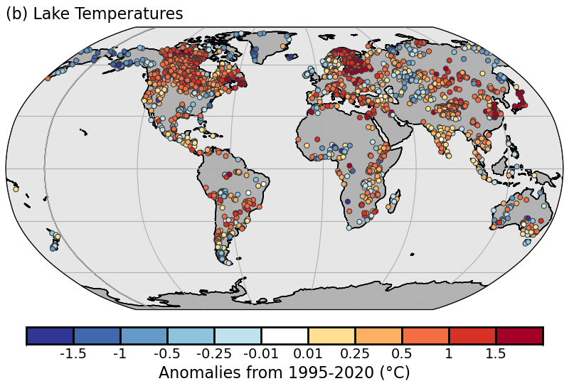
Plate 2.1b: Satellite-derived lake surface water temperature anomalies, from ESA CCI LAKES/Copernicus C3S/EOCIS (°C)
b3 Night Marine Air Temperatures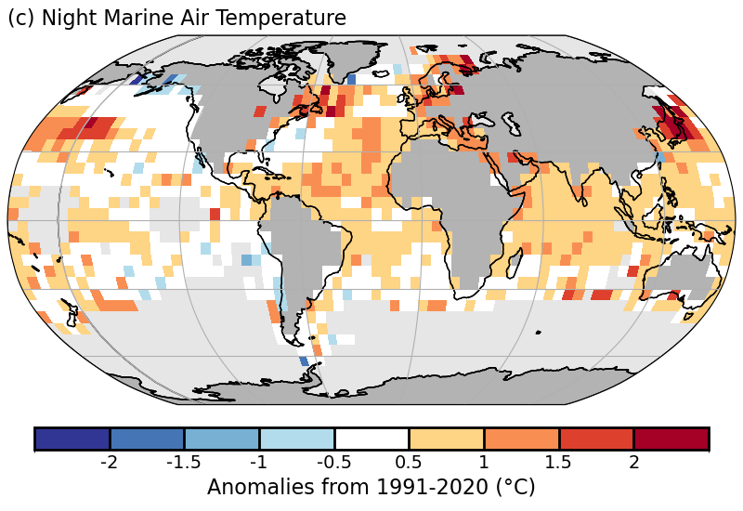
Plate 2.1c: CLASSnmat night marine air temperature annual average anomalies (°C)

b4 Surface Temperature Extremes
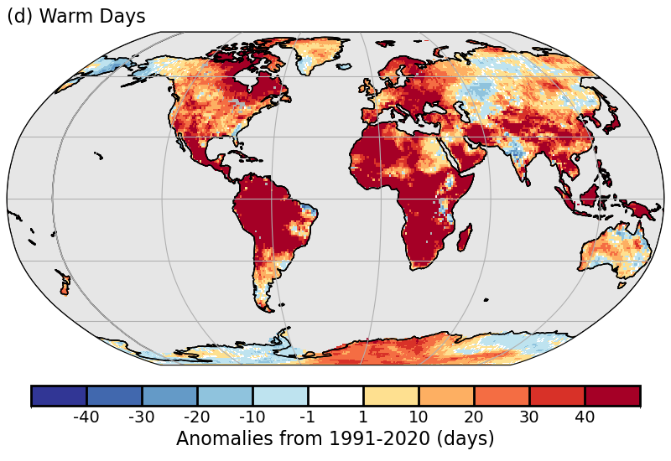
Plate 2.1d: ERA5 warm day threshold exceedance (TX90p)

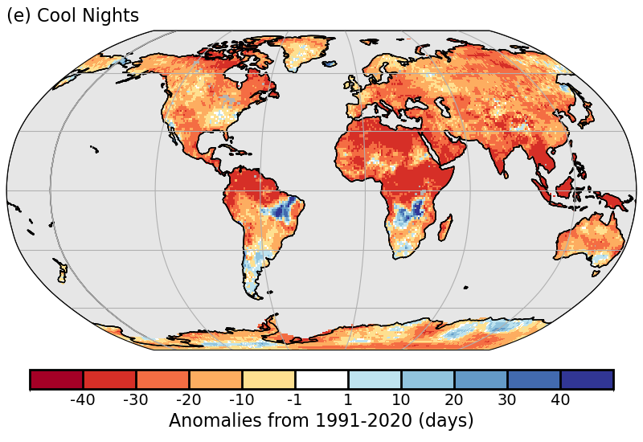
Plate 2.1e: ERA5 cool night threshold exceedance (TN10p)

b5 Tropospheric Temperature
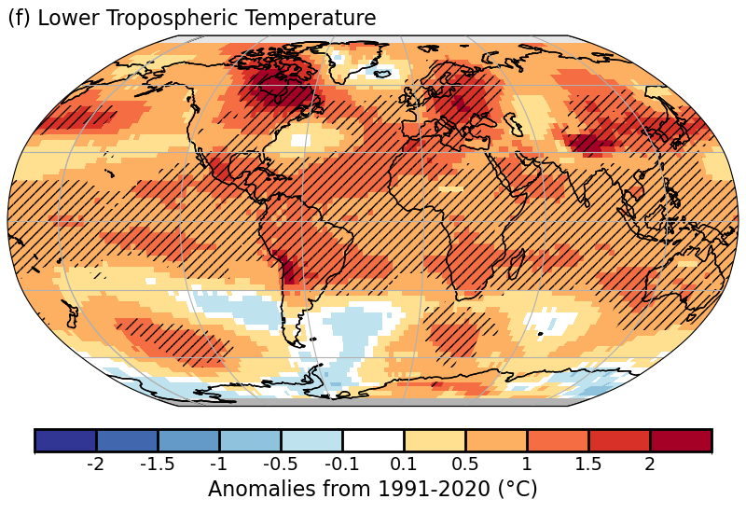

Plate 2.1f: Annual average of Remote Sensing Systems (RSS) and UAH lower-tropospheric temperature anomalies. Hatching denotes regions in which 2024 was the warmest year on record in the averaged product.

b6 Stratospheric Temperature

b7 Equivalent Temperature
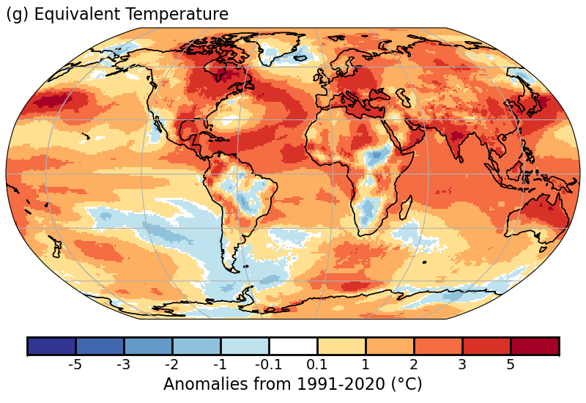

Plate 2.1g Global annual mean anomalies of Equivalent Temperature from ERA5 relative to the 1991-2020 baseline.

c Cryosphere
c1 Permafrost Temperatures and Active Layer Thickness
c2 Rock Glacier Velocity
c3 Alpine Glaciers
c4 Lake Ice Cover
c5 Northern Hemisphere Continental Snow Cover Extent

d Hydrological Cycle - Atmosphere
d1 Surface Humidity
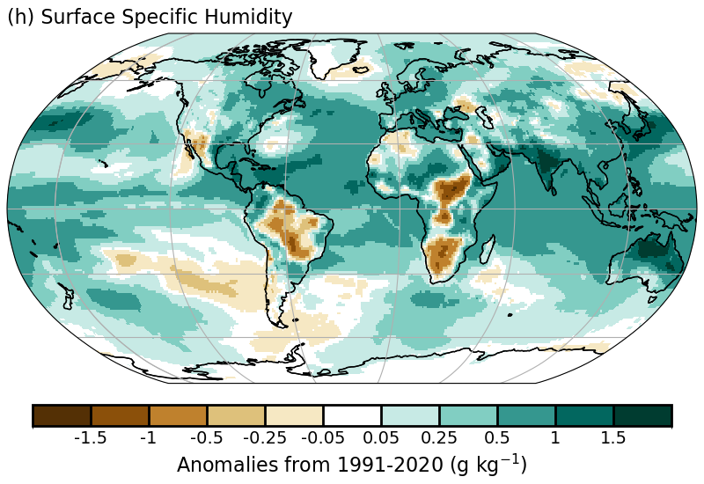
Plate 2.1h Surface specific humidity anomaly relative to 1991-2020 from ERA5.
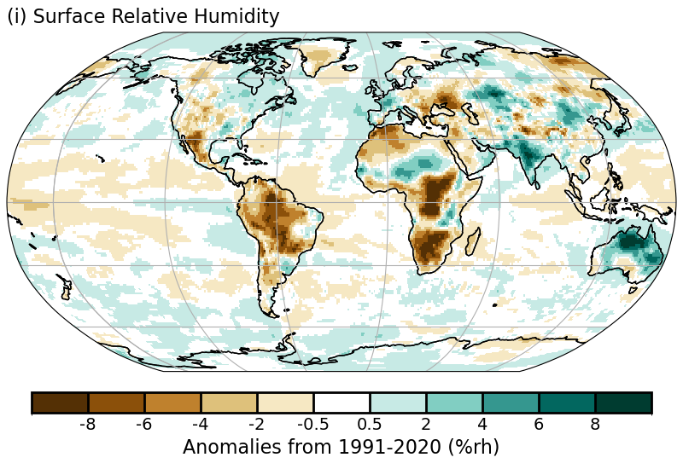
Plate 2.1i Surface relative humidity anomaly relative to 1991-2020 from ERA5.

d2 Humid Heat extremes
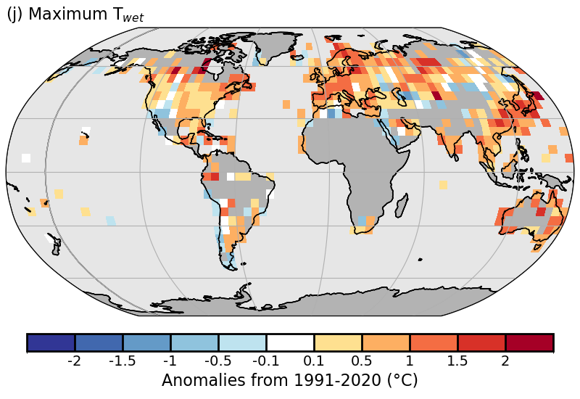
Plate 2.1j: 2024 humid-heat intensity as measured by the annual median anomaly of daily maximum wet-bulb temperature (T_{w}X) from HadISDH.extremes. White gridboxes (over land) represent regions with insufficient data.

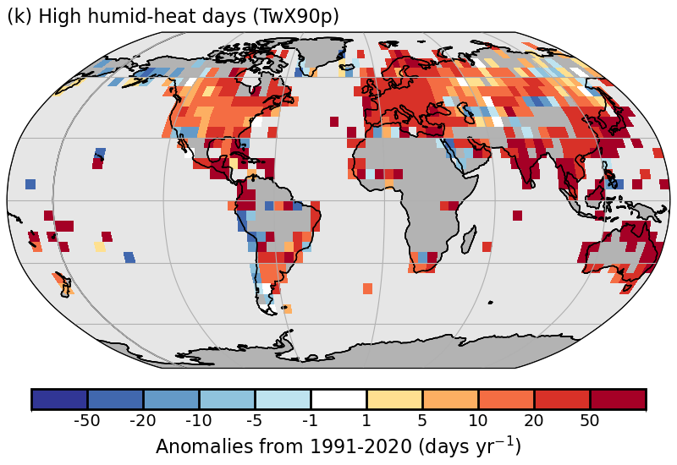
Plate 2.1k 2024 humid-heat frequency anomalies as measured by the number of days where the daily maximum wet-bulb temperature exceeds the local daily 90th percentile (T_{w}X90p, calculated over the 1991-2020 period) from HadISDH.extremes. White gridboxes (over land) represent regions with insufficient data.

d3 Total Column Water Vapor
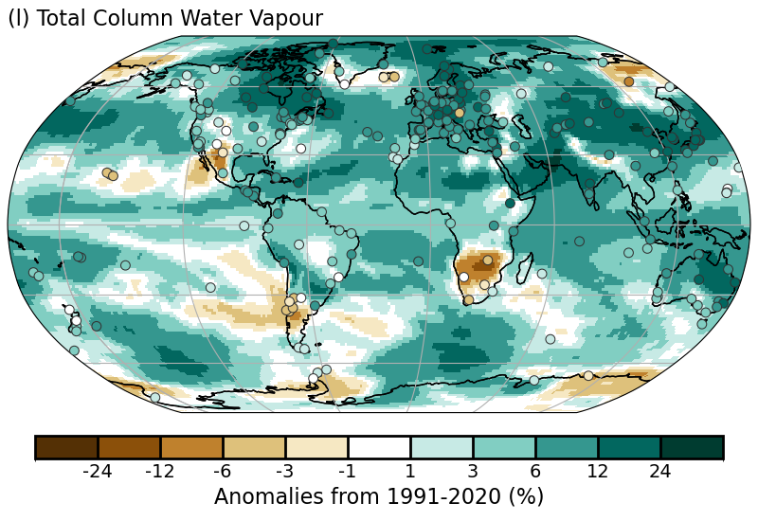
Plate 2.1l: TCWV anomalies (unit %) from JRA-3Q reanalysis (shading) and 236 ground-based GNSS stations (filled circles).

d4 Upper Tropospheric Humidity
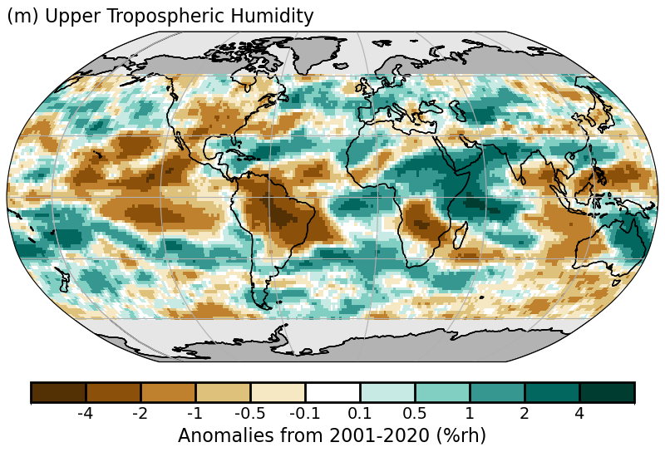
Plate 2.1m: UTH anomaly map (in % relative humidity) for 2024 for the Microwave data record using the 2001-2020 base period.

d5 Precipitation
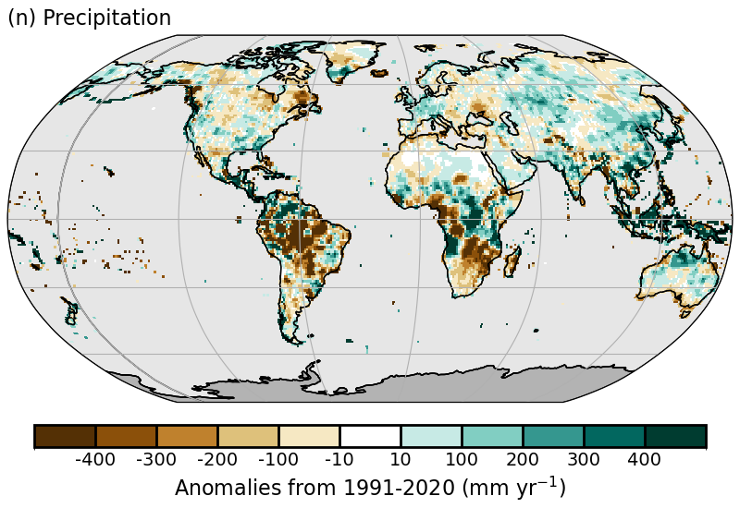
Plate 2.1n: Deviation from the long-term mean 1991-2020 for the annual total in 2024, brown indicates drier, blue-green wetter than normal conditions. Data source: GPCC.

d6 Land surface Precipitation Extremes
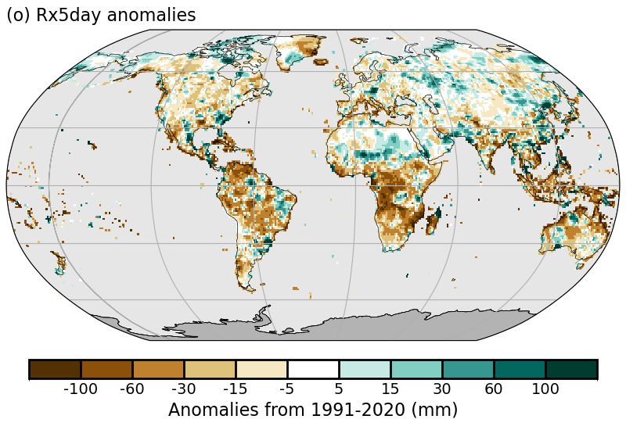
Plate 2.1o: Accumulated 5-day maxima (Rx5day) anomalies from 1991-2020, from GPCC (Ziese et al. 2022).

d7 Cloudiness
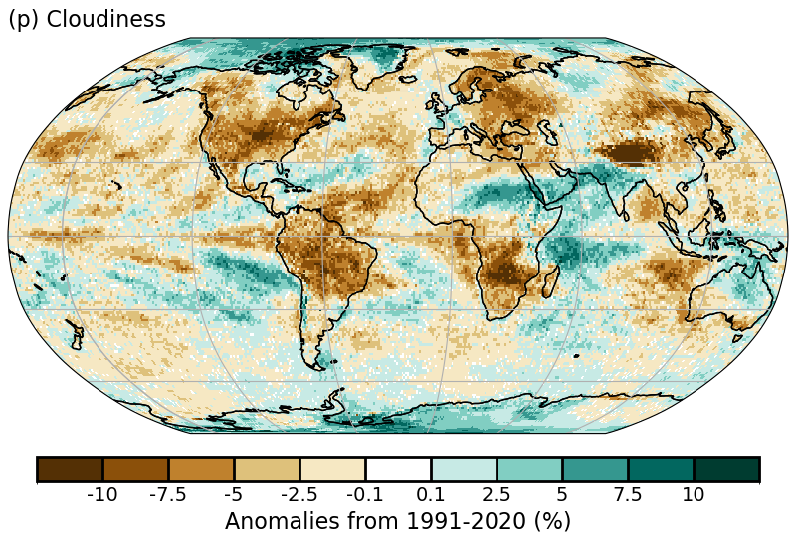
Plate 2.1p Global annual mean cloudiness (cloud fraction) anomalies for 2024 from PATMOS-x 6.0.

d Hydrological Cycle - Land
d8 Lake Water Level
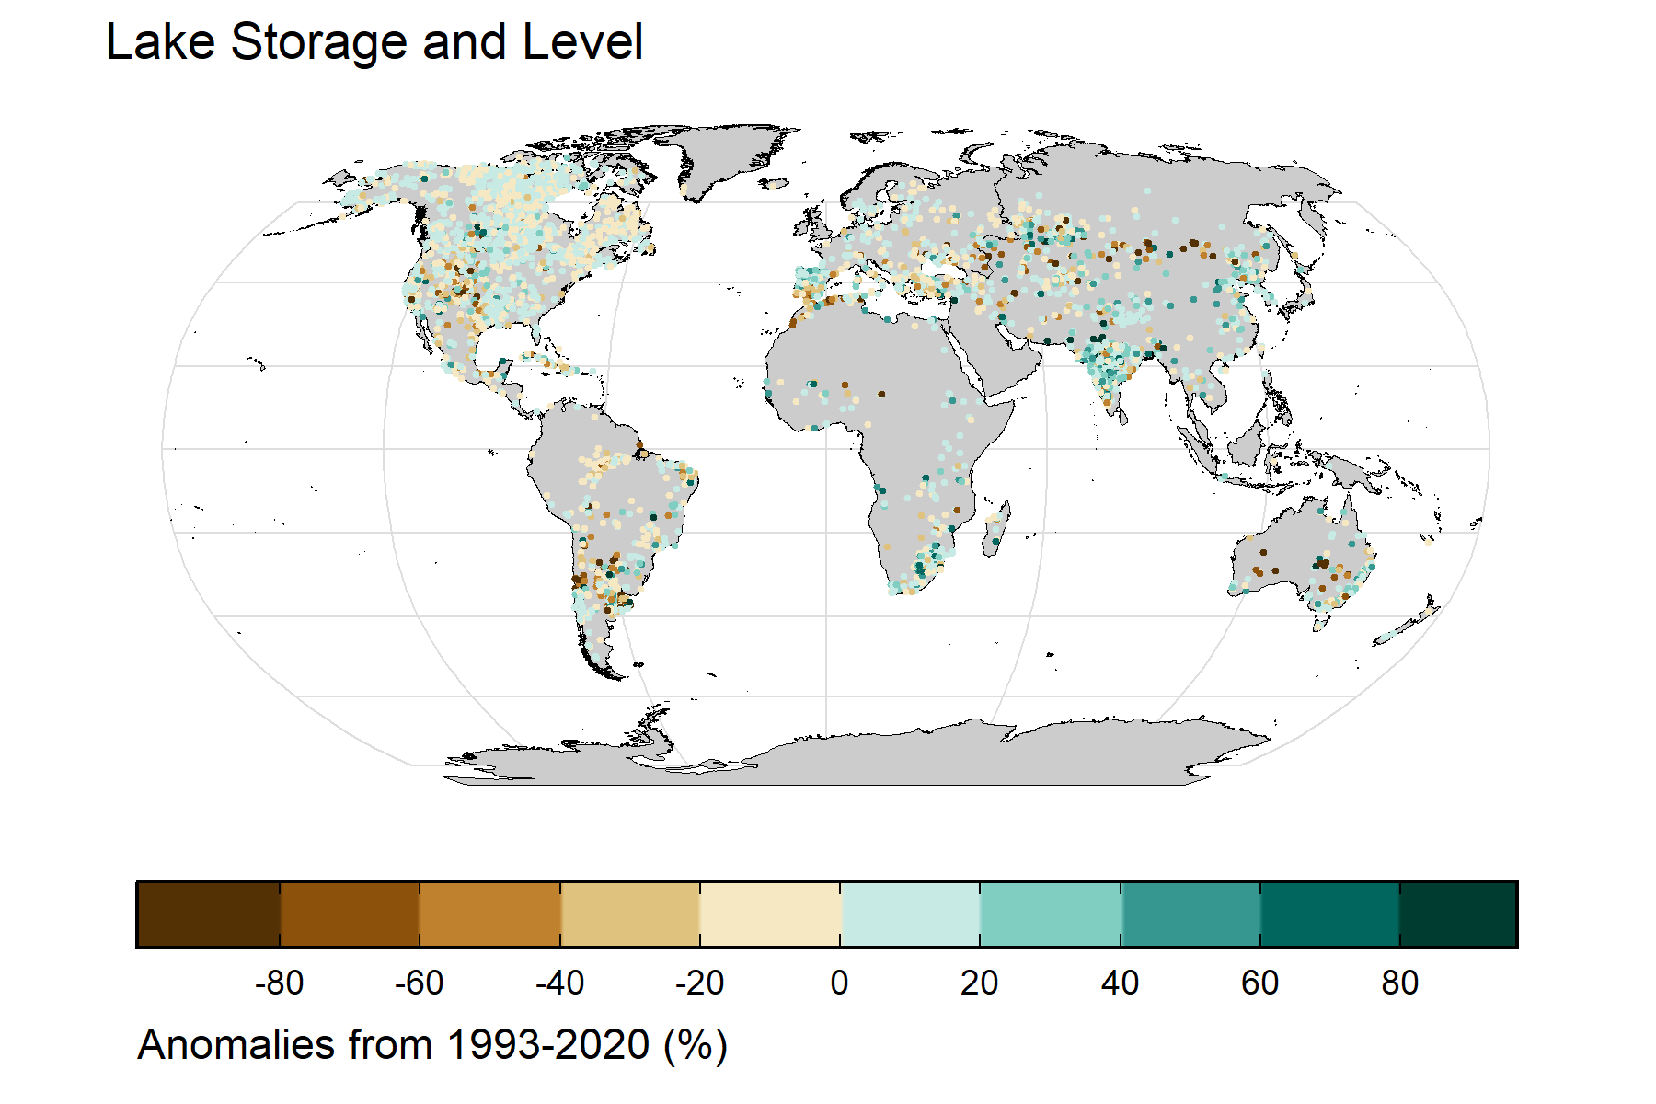
Plate 2.1q Lake Water Level

d9 River Discharge
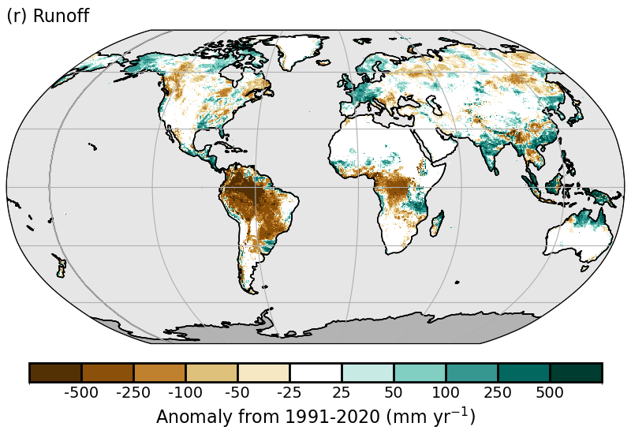Plate 2.1r: GloFASv4 (Global Flood Awareness System) distribution of runoff anomalies (mm·yr⁻¹).

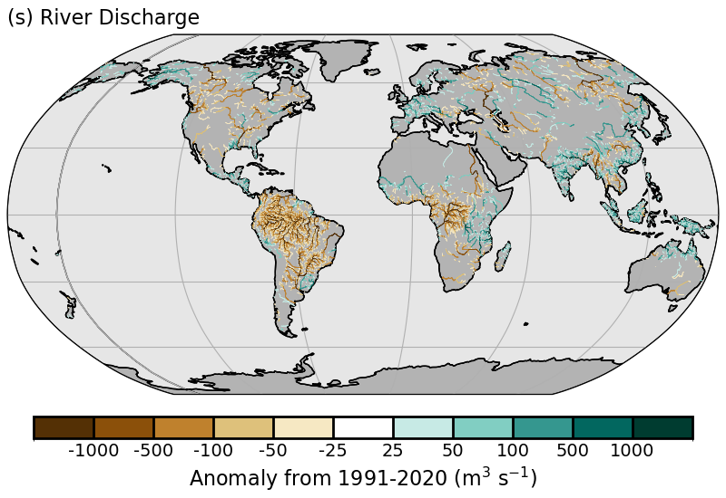
Plate 2.1s: GloFASv4 distribution of discharge anomalies (m3·s⁻¹).

d10 Groundwater and Terrestrial Water Storage
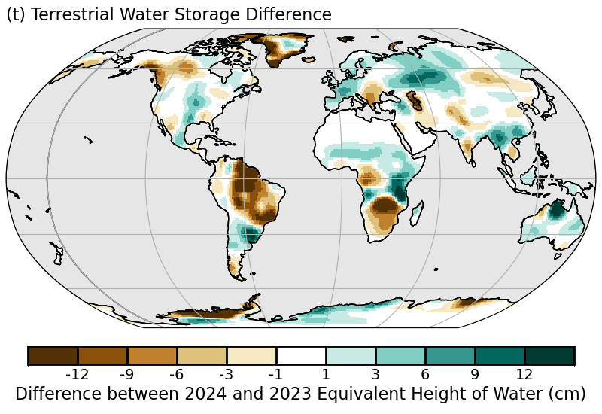
Plate 2.1t. Changes in annual-mean terrestrial water storage (the sum of groundwater, soil water, surface water, snow, and ice, as an equivalent height of water in cm) between 2024 and 2023, based on gravity observations from the GRACE-FO satellite mission.

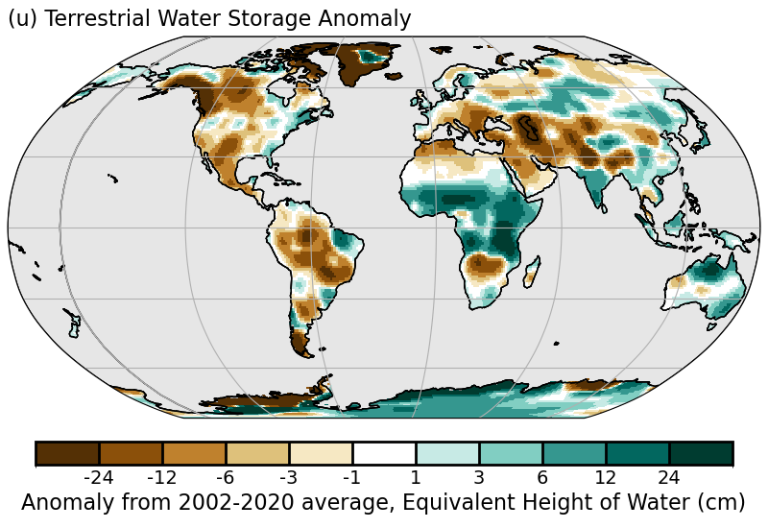
Plate 2.1u. Anomalies in annual-mean terrestrial water storage in 2024 relative to the 2002-20 average, based on gravity observations from the GRACE-FO satellite mission.

2.d.11 Soil Moisture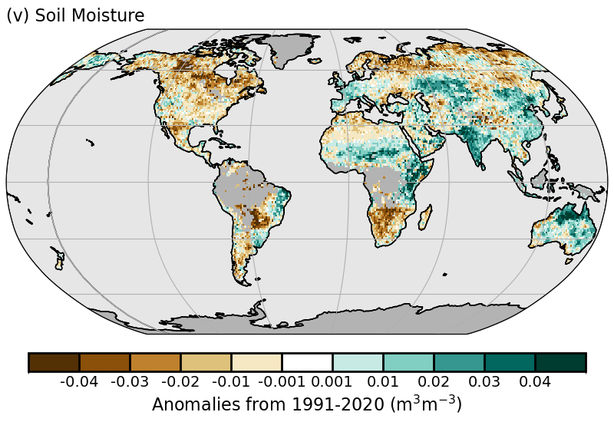
Plate 2.1v: C3S average surface soil moisture anomalies (m3 m−3). Data are masked where no retrieval is possible or where the quality is not assured and flagged, for example due to dense vegetation, frozen soil, or radio frequency interference;

d12 Monitoring Drought using the Self Calibrating Palmer Drought Severity Index
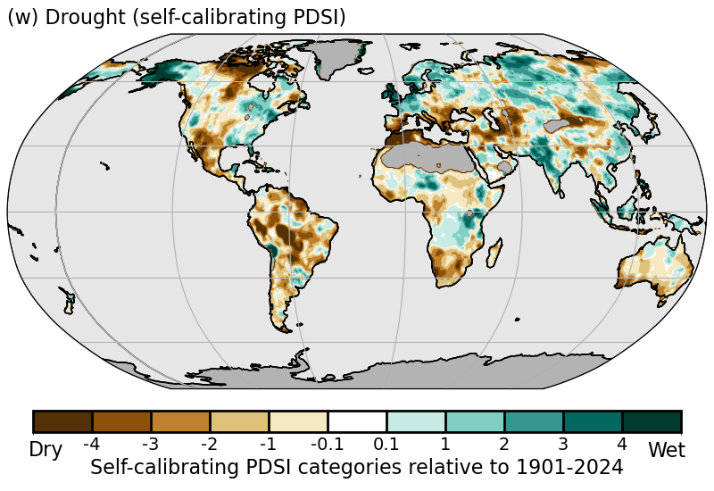
Plate 2.1w: Mean scPDSI for 2024. Droughts are indicated by negative values (brown), wet episodes by positive values (blue). No calculation is made where a drought index is meaningless (grey areas: ice sheets or deserts with near-zero mean precipitation).

2.d.13 Global Land Evaporation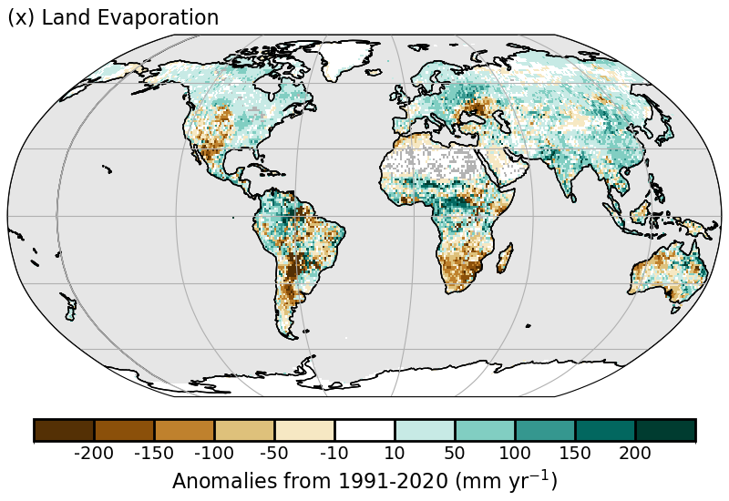
Plate 2.1x: GLEAM4 land evaporation anomalies (mm yr⁻¹; relative to 1991–2020).

e Atmospheric Circulation
e.1 Mean Sea Level Pressure and Related Modes of Variability
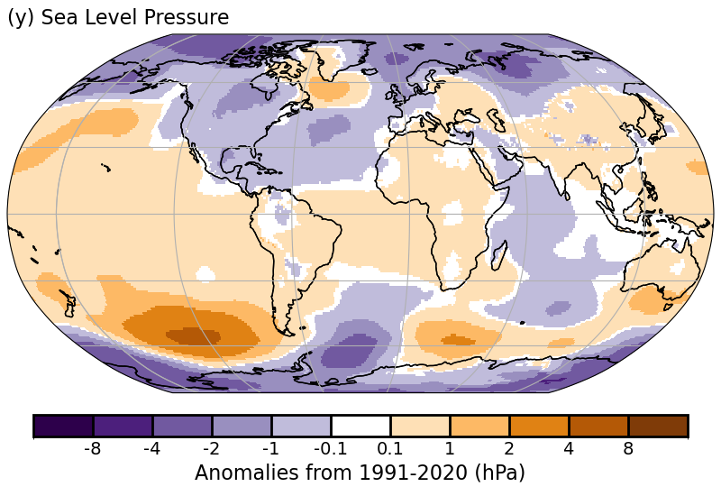
Plate 2.1y: SLP anomalies from ERA5

e.2 Surface Winds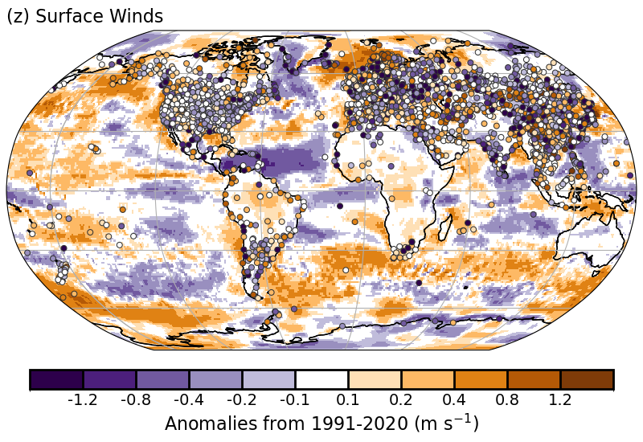
Plate 2.1z: Surface Wind Speed anomalies (m s⁻¹) from the observational HadISD3 dataset (land, circles), the ERA5 reanalysis (land, shaded areas), and RSS merged satellite radiometer observations (ocean, shaded areas) for 2024 with respect to 1991-2020.

e.3 Upper air winds
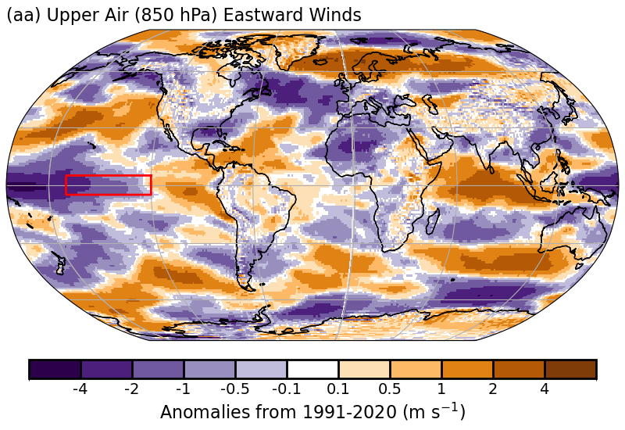
Plate 2.1aa: 850hPa eastward wind speed anomaly (from ERA5, with respect to 1991-2020 climatology) averaged over October-December 2024. Red box shows the Niño 3.4 region.

e4 Lightning

f Earth Radiation Budget
f1 Earth Radiation Budget at Top-of-Atmosphere
f2 Mauna Loa Clear-Sky Atmospheric Solar Transmission

g Atmospheric Composition
g1 Long-lived Greenhouse Gases
g2 Ozone-Depleting Gases
g3 Tropospheric Aerosols

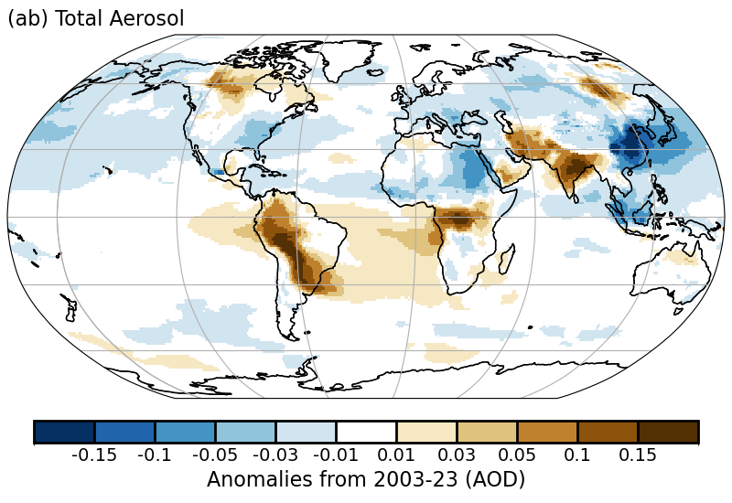
Plate 2.1ab: Anomalies of total aerosol optical depth (AOD) at 550 nm in 2024 relative to the period 2003-23
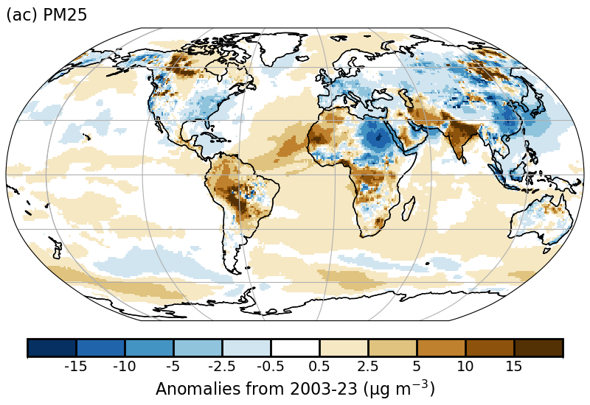
Plate 2.1ac: Anomalies of PM2.5 in 2024 relative to the period 2003-23.
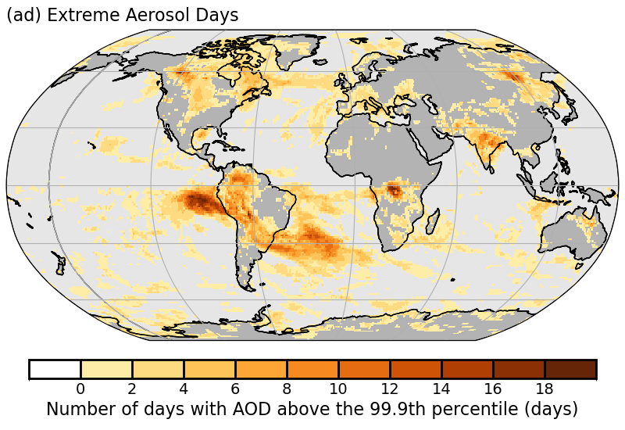
Plate 2.1 ad (c) Number of days in 2024 with extremely high AOD (extreme being defined as above the local 2003–2023 99.9th percentile). The fire events over Canada, S. America and Siberia are the most prominent features, with the associated transport over the Pacific and the Atlantic.

g4 Tropospheric Ozone
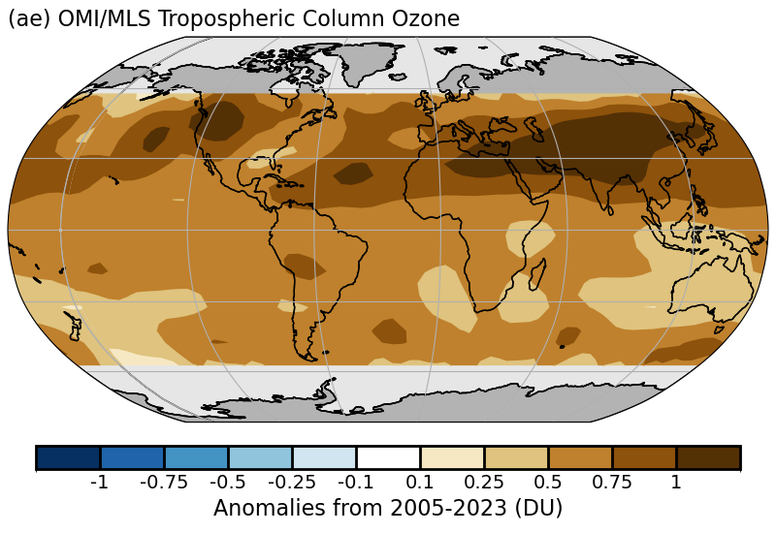
Plate 2.1ae: OMI/MLS tropospheric column ozone anomalies (Dobson Units) for 2024 relative to the 2005-2023 mean field.

g5 Stratospheric Aerosols

g6 Stratospheric Ozone
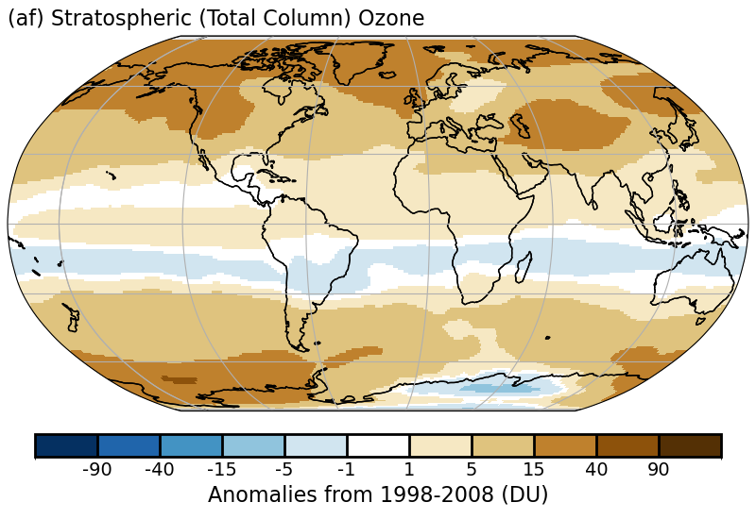
Plate 2.1af: 2024 total column ozone anomalies from TROPOMI aboard Sentinel-5 Precursor (S5P).

g7 Stratospheric Water Vapor

g8 Carbon Monoxide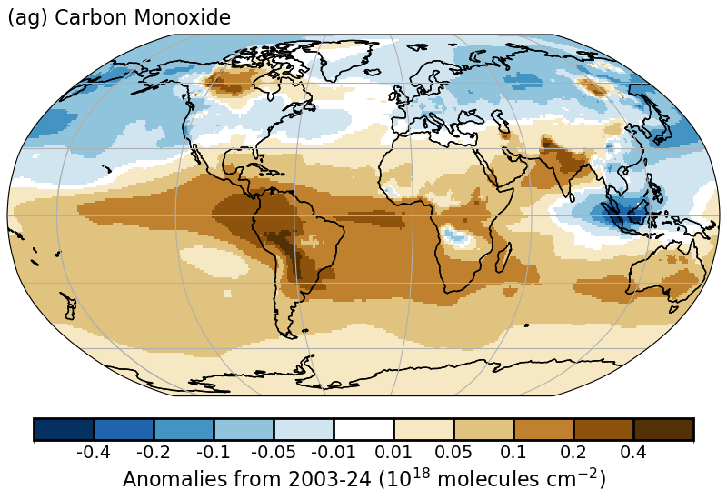
Plate 2.1ag: Anomalies of the total column of Carbon Monoxide in 2024 (in 1.0e18 molec/cm²) compared to the reference period 2003-2024 derived from the CAMS re-analysis.

h Land Surface Properties
h1 Land Surface Albedo Dynamics
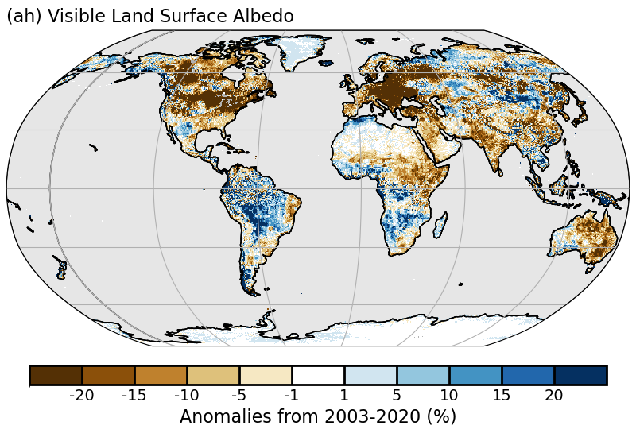Plate 2.1ah: Land surface visible broadband albedo anomalies (%) in 2024 using a 2003-2020 reference period.
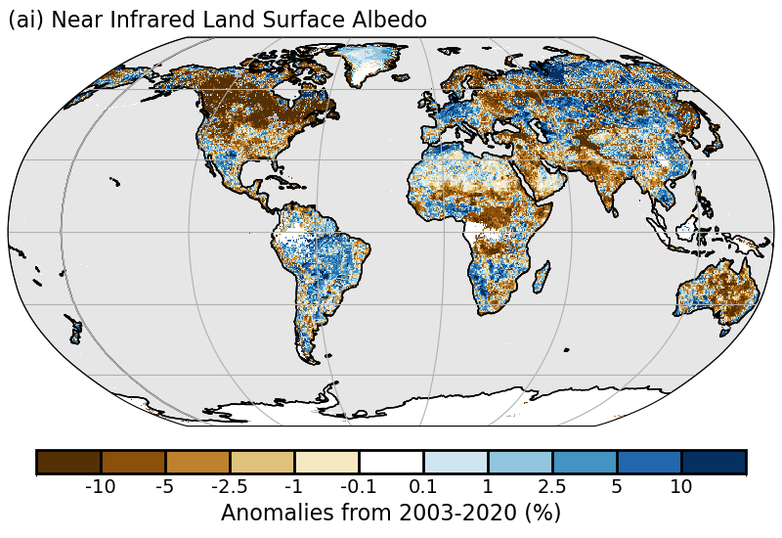
Plate 2.1ai: Land surface near-infrared broadband albedo anomalies (%) in 2024 using a 2003-2020 reference period.

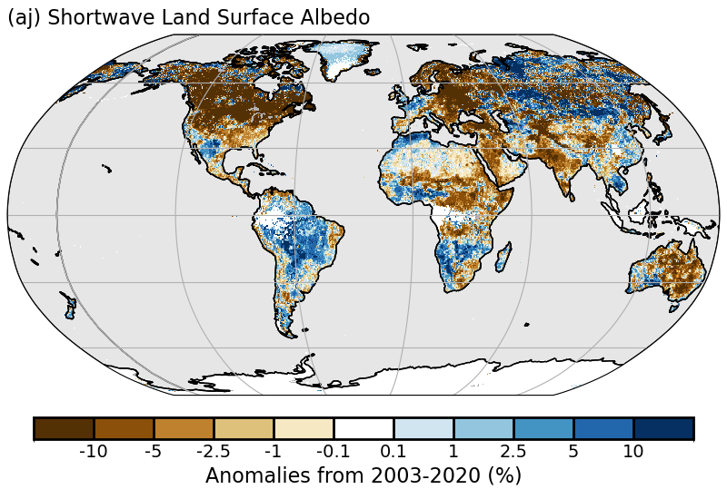Plate 2.1aj: Land surface shortwave broadband albedo anomalies (%) in 2024 using a 2003-2020 reference period.

h2 Terrestrial Vegetation Dynamics
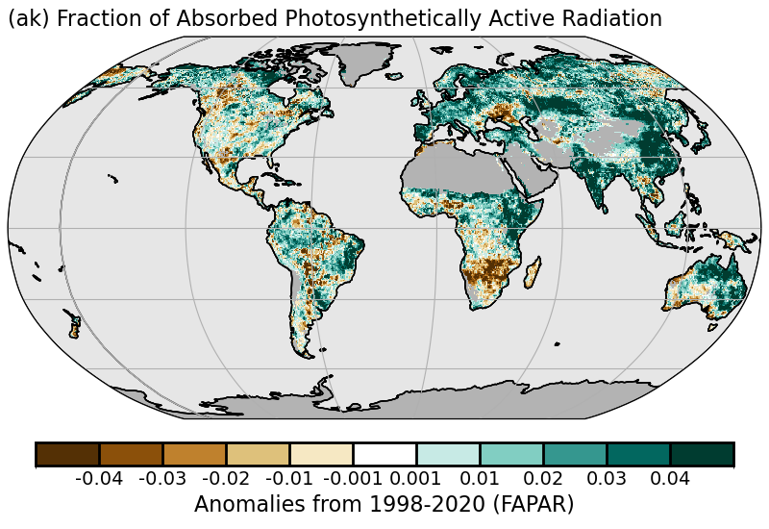
Plate 2.1ak: FAPAR anomalies

h3 Biomass Burning
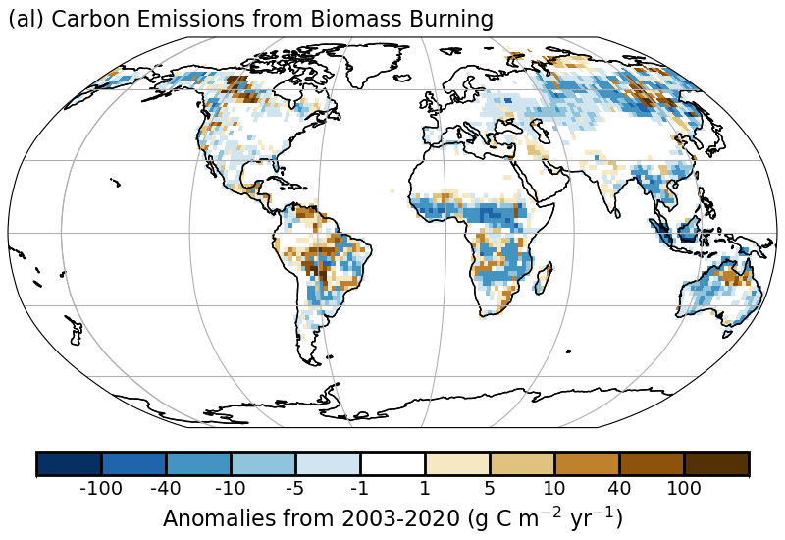
Plate 2.1al: Anomaly map of biomass burning in terms of carbon consumption.

h4 Phenology

h5 Vegetation Optical Depth
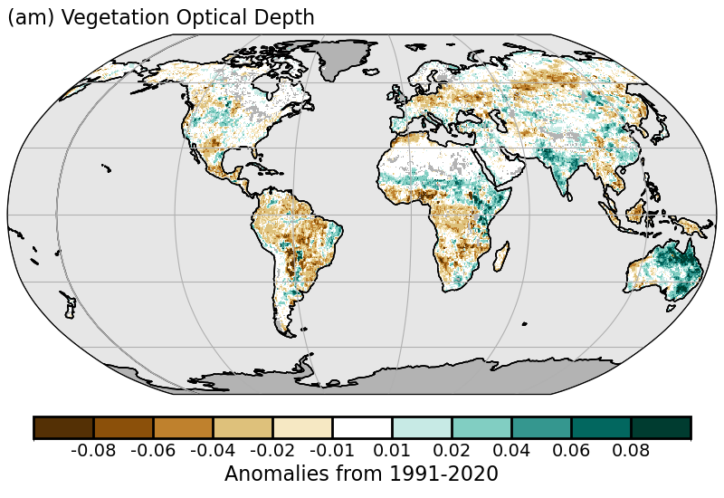
Plate 2.1am. VODCA CXKu-band VOD Annual anomalies.

Sidebar – Super Extreme Land Surface Temperature Hotspots
Sidebar – Short-lived GHGs

