a Introduction
b Temperature
b1 Surface Temperature
b2 Lake Surface Temperatures
b3 Night Marine Air Temperatures
b4 Surface Temperature Extremes
b5 Tropospheric Temperature
b6 Stratospheric Temperature
b7 Equivalent Temperature
c Cryosphere
c1 Permafrost Temperatures and Active Layer Thickness
c2 Rock Glacier Velocity
c3 Alpine Glaciers
c4 Lake Ice Cover
c5 Northern Hemisphere Continental Snow Cover Extent
d Hydrological Cycle - Atmosphere
d1 Surface Humidity
d2 Humid Heat extremes
d3 Total Column Water Vapor
d4 Upper Tropospheric Humidity
d5 Precipitation
d6 Land surface Precipitation Extremes
d7 Cloudiness
d Hydrological Cycle - Land
d8 Lake Water Level
d9 River Discharge
d10 Groundwater and Terrestrial Water Storage
d11 Soil Moisture
d12 Monitoring Drought using the Self Calibrating Palmer Drought Severity Index
d13 Global Land Evaporation
e Atmospheric Circulation
e1 Mean Sea Level Pressure and Related Modes of Variability
e2 Surface Winds
e3 Upper air winds
e4 Lightning
f Earth Radiation Budget
f1 Earth Radiation Budget at Top-of-Atmosphere
f2 Mauna Loa Clear-Sky Atmospheric Solar Transmission
g Atmospheric Composition
g1 Long-lived Greenhouse Gases
g2 Ozone-Depleting Gases
g3 Tropospheric Aerosols
g4 Tropospheric Ozone
g5 Stratospheric Aerosols
g6 Stratospheric Ozone
g7 Stratospheric Water Vapor
g8 Carbon Monoxide
h Land Surface Properties
h1 Land Surface Albedo Dynamics
h2 Terrestrial Vegetation Dynamics
h3 Biomass Burning
h4 Phenology of Primary Producers
h5 Vegetation Optical Depth
Sidebar – Short-lived GHGs [to occur just before 2g?]
a Introduction
b Temperature
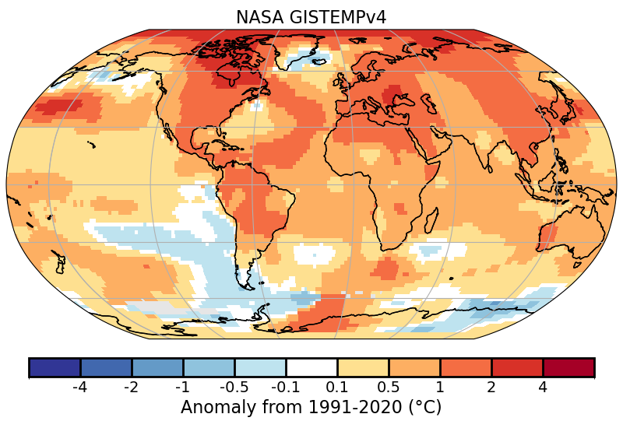
b1 Surface Temperature
Fig. A2.b.1.1: Global surface temperature anomalies (°C; Source: NASA-GISTEMPv4).
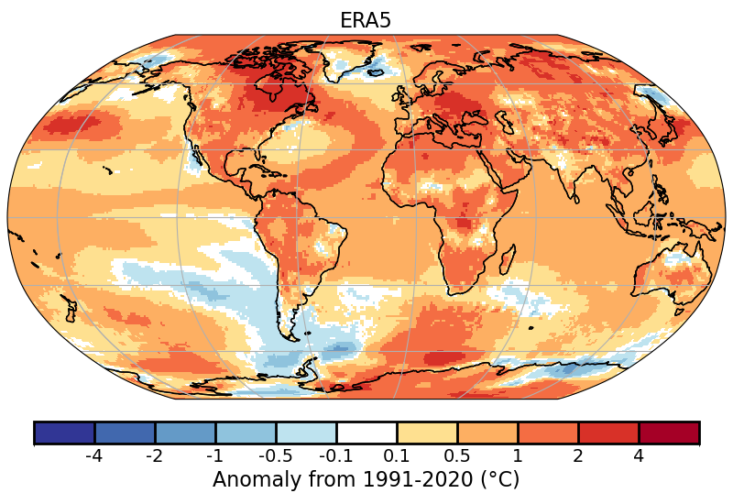
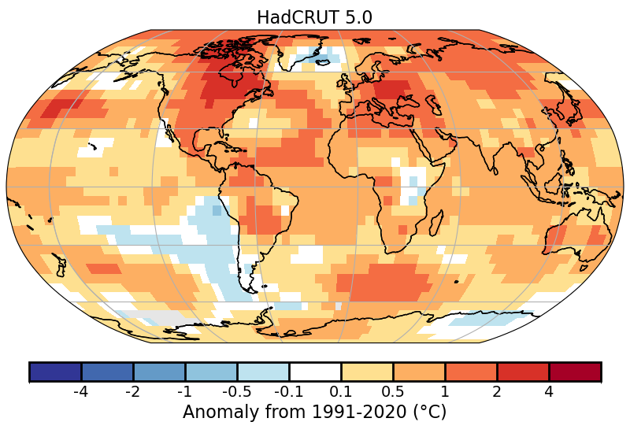
Fig. A2.b.1.2: Global surface temperature anomalies (°C; Source: HadCRUT5).
Fig. A2.b.1.3: Global surface temperature anomalies (°C; Source: ERA5).

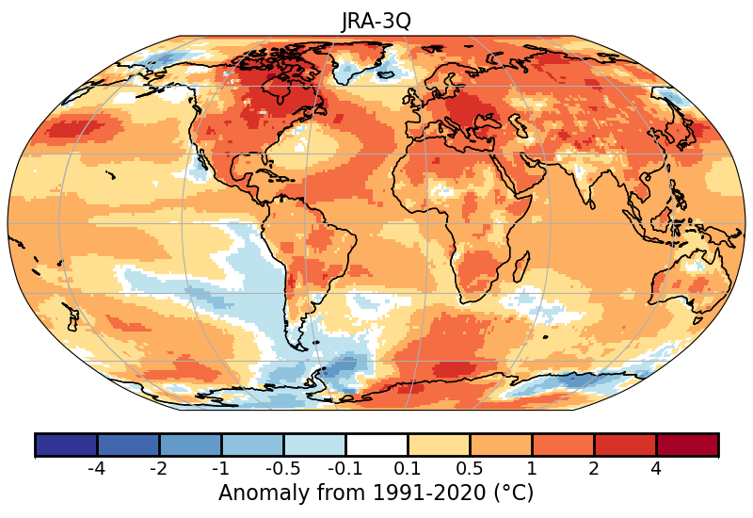
Fig. A2.b.1.4: Global surface temperature anomalies (°C; Source: JRA-3Q).

b2 Lake Surface Temperatures
None
b3 Night Marine Air Temperatures
None
b4 Surface Temperature Extremes
None
b5 Tropospheric Temperature
None
b6 Stratospheric Temperature
None
b7 Equivalent Temperature
Table S2.b.7.1 . Top ten ranked global equivalent temperature anomalies (Teq) and their constituent parts (T, Tq) in °C (1991–2020 base period) since 1979 for ERA5.

Rank | Ta Year | Ta (°C) | Tq Year | Tq (°C) | Teq (Year) | Teq (°C)
1 | 2024 | 0.72 | 2024 | 0.85 | 2024 | 1.57
2 | 2023 | 0.60 | 2023 | 0.59 | 2023 | 1.19
3 | 2016 | 0.44 | 2016 | 0.50 | 2016 | 0.94
4 | 2020 | 0.43 | 2019 | 0.44 | 2019 | 0.84
5 | 2019 | 0.40 | 2020 | 0.38 | 2020 | 0.82
6 | 2017 | 0.34 | 2017 | 0.33 | 2017 | 0.68
7 | 2022 | 0.30 | 1998 | 0.27 | 2015 | 0.53
8 | 2021 | 0.27 | 2015 | 0.27 | 2018 | 0.52
9 | 2018 | 0.26 | 2018 | 0.25 | 2021 | 0.41
10 | 2015 | 0.26 | 2010 | 0.15 | 2022 | 0.40

Table S2.b.7.2. Top ten ranked global equivalent temperature anomalies (Teq) and their constituent parts (T, Tq) in °C (1991–2020 base period) since 1979 for JRA3Q.

Rank | Ta Year | Ta (°C) | Tq Year | Tq (°C) | Teq (Year) | Teq (°C)
1 | 2024 | 0.67 | 2024 | 0.98 | 2024 | 1.65
2 | 2023 | 0.57 | 2023 | 0.74 | 2023 | 1.30
3 | 2016 | 0.42 | 2016 | 0.45 | 2016 | 0.86
4 | 2020 | 0.38 | 2020 | 0.41 | 2020 | 0.79
5 | 2019 | 0.36 | 1998 | 0.33 | 2019 | 0.68
6 | 2017 | 0.30 | 2019 | 0.32 | 2017 | 0.52
7 | 2015 | 0.25 | 2015 | 0.24 | 2015 | 0.49
8 | 2022 | 0.24 | 2017 | 0.23 | 2022 | 0.44
9 | 2018 | 0.22 | 2022 | 0.21 | 2021 | 0.38
10 | 2021 | 0.19 | 2021 | 0.19 | 1998 | 0.36

Table S2.b.7.3 . Top ten ranked global equivalent temperature anomalies (Teq) and their constituent parts (T, Tq) in °C (1991–2020 base period) since 1979 for HadISDH (Land-Only).

Rank | Ta Year | Ta (°C) | Tq Year | Tq (°C) | Teq (Year) | Teq (°C)
1 | 2024 | 0.96 | 2024 | 1.13 | 2024 | 2.04
2 | 2023 | 0.74 | 2023 | 0.74 | 2023 | 1.49
3 | 2020 | 0.58 | 2016 | 0.61 | 2016 | 1.14
4 | 2016 | 0.55 | 1998 | 0.58 | 2020 | 1.03
5 | 2019 | 0.44 | 2020 | 0.46 | 1998 | 0.72
6 | 2015 | 0.42 | 2010 | 0.35 | 2017 | 0.67
7 | 2017 | 0.39 | 2022 | 0.31 | 2019 | 0.64
8 | 2021 | 0.37 | 2017 | 0.29 | 2021 | 0.63
9 | 2022 | 0.33 | 2021 | 0.27 | 2022 | 0.62
10 | 2018 | 0.24 | 2019 | 0.21 | 2015 | 0.60

c Cryosphere
c1 Permafrost Temperatures and Active Layer Thickness
c2 Rock Glacier Velocity
c3 Alpine Glaciers
c4 Lake Ice Cover
c5 Northern Hemisphere Continental Snow Cover Extent

d Hydrological Cycle - Atmosphere
d1 Surface Humidity
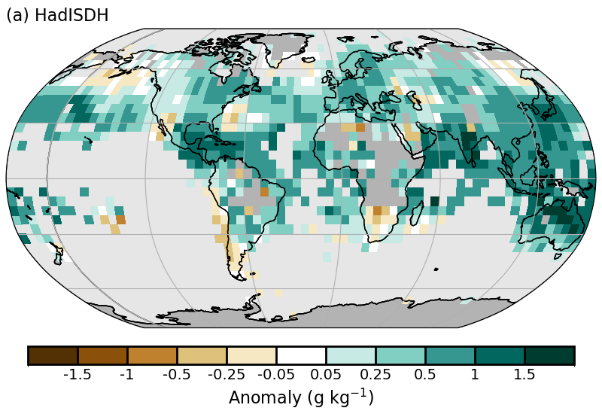
Figure S2.d.1.1 Surface specific humidity anomaly relative to 1991-2020 from HadISDH.blend.1.5.1.2024f.
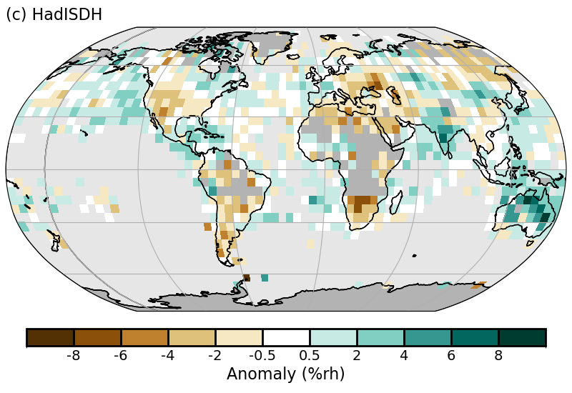
Figure S2.d.1.2 Surface relative humidity anomaly relative to 1991-2020 from HadISDH.blend.1.5.1.2024f.
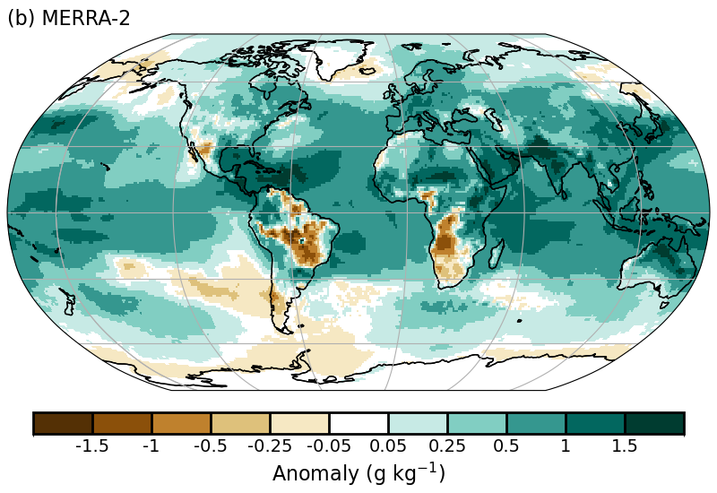
Figure S2.d.1.3 Surface specific humidity anomaly relative to 1991-2020 from MERRA-2.
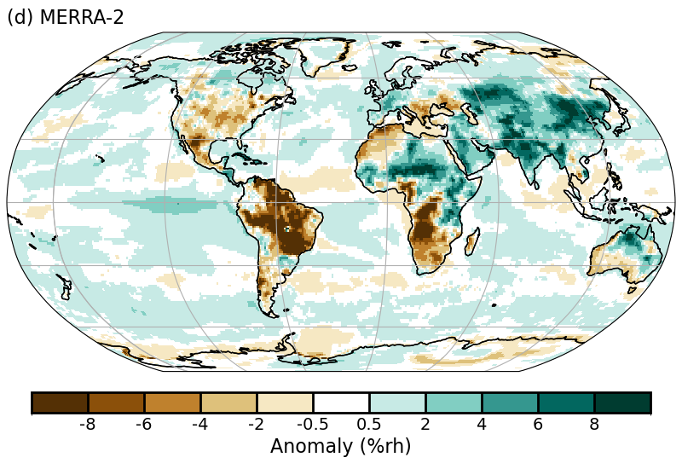
Figure S2.d.1.4 Surface relative humidity anomaly relative to 1991-2020 from MERRA-2.

d2 Humid Heat extremes
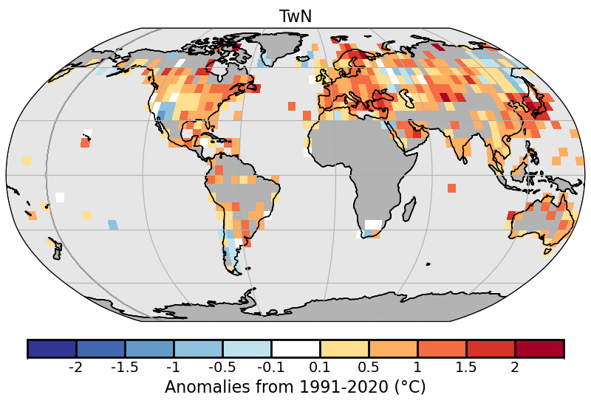
Figure S2.d.2.1. 2024 intensity of daily minimum humid heat aomalies (T_{w}N) as measured by the annual median anomaly of daily minimum wet-bulb temperature from HadISDH.extremes. White gridboxes (over land) represent regions with insufficient data.

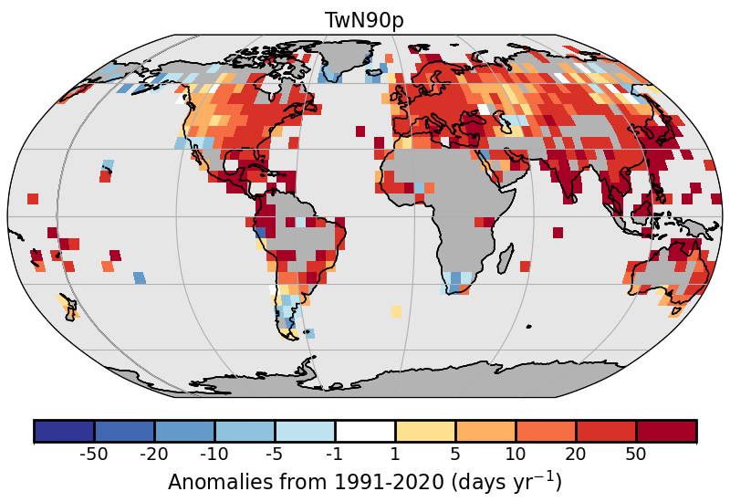
Figure S2.d.2.2 2024 frequency of high daily minimum humid-heat days (anomalies) as measured by the number of days where the daily minimum wet-bulb temperature exceeds the local daily 90th percentile (calculated over the 1991-2020 period) from HadISDH.extremes. White gridboxes (over land) represent regions with insufficient data.

d3 Total Column Water Vapor
d4 Upper Tropospheric Humidity
d5 Precipitation
d6 Land surface Precipitation Extremes
d7 Cloudiness
d Hydrological Cycle - Land
d8 Lake Water Level
d9 River Discharge
d10 Groundwater and Terrestrial Water Storage
d11 Soil Moisture
d12 Monitoring Drought using the Self Calibrating Palmer Drought Severity Index
d13 Global Land Evaporation
e Atmospheric Circulation
e1 Mean Sea Level Pressure and Related Modes of Variability
e2 Surface Winds
e3 Upper air winds
e4 Lightning
f Earth Radiation Budget
f1 Earth Radiation Budget at Top-of-Atmosphere
f2 Mauna Loa Clear-Sky Atmospheric Solar Transmission
g Atmospheric Composition
g1 Long-lived Greenhouse Gases
g2 Ozone-Depleting Gases
g3 Tropospheric Aerosols

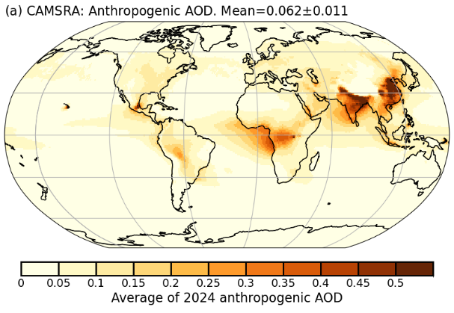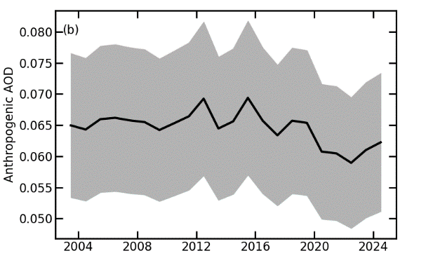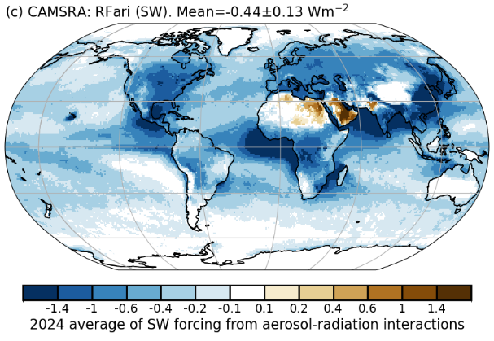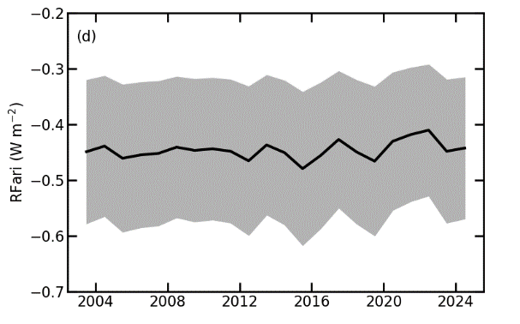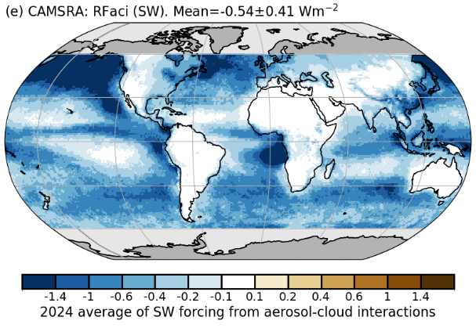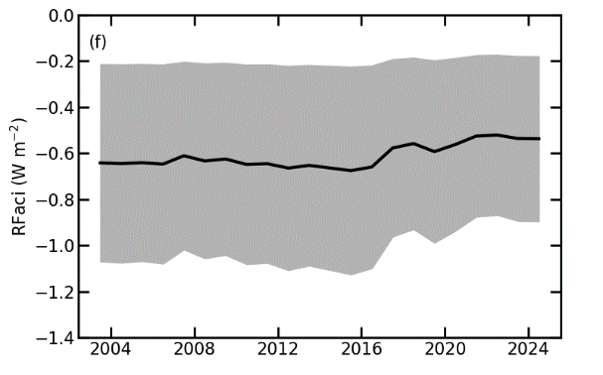
Supplement Fig.2.e.3.1: CAMSRA (a) 2024 average of anthropogenic aerosol optical depth (AOD); (b) global annual average of anthropogenic AOD from 2003 to 2024. Radiative forcing in the shortwave (SW) spectrum due to (c),(d) aerosol-radiation (RFari) and (e),(f) aerosol-cloud interactions (RFaci). The left column shows the distributions for the year 2024. The right column shows the time series of global averages for the period 2003-2024, with the mean +/- 1-σ uncertainties of these estimates shown in beige.

g4 Tropospheric Ozone
g5 Stratospheric Aerosols
g6 Stratospheric Ozone
g7 Stratospheric Water Vapor
g8 Carbon Monoxide
h Land Surface Properties
h1 Land Surface Albedo Dynamics

h2 Terrestrial Vegetation Dynamics
h3 Biomass Burning
h5 Vegetation Optical Depth
Sidebar – Super Extreme Land Surface Temperatures
Sidebar – Short-lived GHGs [to occur just before 2g]

