a Introduction
b Temperature
b1 Surface Temperature
b2 Lake Surface Temperatures
b3 Night Marine Air Temperatures
b4 Surface Temperature Extremes
b5 Tropospheric Temperature
b6 Stratospheric Temperature
b7 Equivalent Temperature
c Cryosphere
c1 Permafrost Temperatures and Active Layer Thickness
c2 Rock Glacier Velocity
c3 Alpine Glaciers
c4 Lake Ice Cover
c5 Northern Hemisphere Continental Snow Cover Extent
d Hydrological Cycle - Atmosphere
d1 Surface Humidity
d2 Humid Heat extremes
d3 Total Column Water Vapor
d4 Upper Tropospheric Humidity
d5 Precipitation
d6 Land surface Precipitation Extremes
d7 Cloudiness
d Hydrological Cycle - Land
d8 Lake Water Level
d9 River Discharge
d10 Groundwater and Terrestrial Water Storage
d11 Soil Moisture
d12 Monitoring Drought using the Self Calibrating Palmer Drought Severity Index
d13 Global Land Evaporation
e Atmospheric Circulation
e1 Mean Sea Level Pressure and Related Modes of Variability
e2 Surface Winds
e3 Upper air winds
e4 Lightning
f Earth Radiation Budget
f1 Earth Radiation Budget at Top-of-Atmosphere
f2 Mauna Loa Clear-Sky Atmospheric Solar Transmission
g Atmospheric Composition
g1 Long-lived Greenhouse Gases
g2 Ozone-Depleting Gases
g3 Tropospheric Aerosols
g4 Tropospheric Ozone
g5 Stratospheric Aerosols
g6 Stratospheric Ozone
g7 Stratospheric Water Vapor
g8 Carbon Monoxide
h Land Surface Properties
h1 Land Surface Albedo Dynamics
h2 Terrestrial Vegetation Dynamics
h3 Biomass Burning
h4 Phenology of Primary Producers
h5 Vegetation Optical Depth
Sidebar – Short-lived GHGs [to occur just before 2g?]
a Introduction
b Temperature
b1 Surface Temperature
b2 Lake Surface Temperatures
b3 Night Marine Air Temperatures
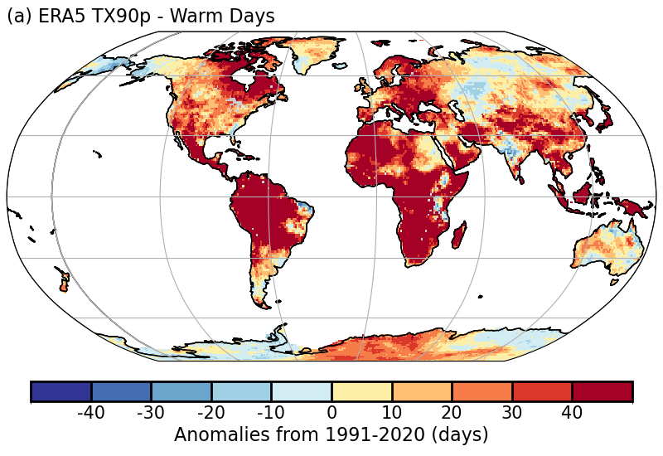
b4 Surface Temperature Extremes

Plate 2.1a ERA5 warm day threshold exceedance (TX90p)

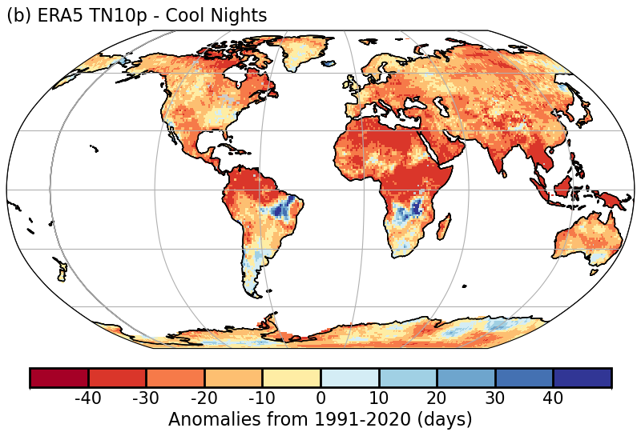
Plate 2.1b: ERA5 cool night threshold exceedance (TN10p)

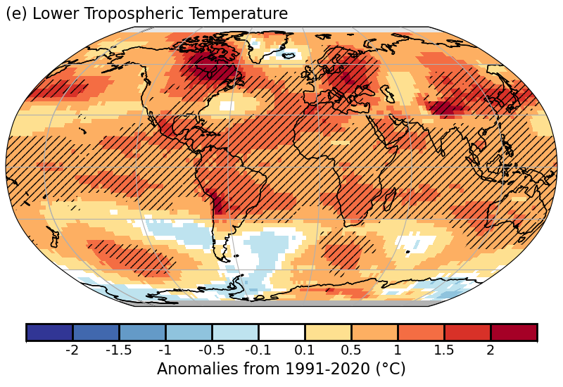
b5 Tropospheric Temperature

Plate 2.1f: Annual average of Remote Sensing Systems (RSS) and UAH lower-tropospheric temperature anomalies. Hatching denotes regions in which 2024 was the warmest year on record.

b6 Stratospheric Temperature
b7 Equivalent Temperature
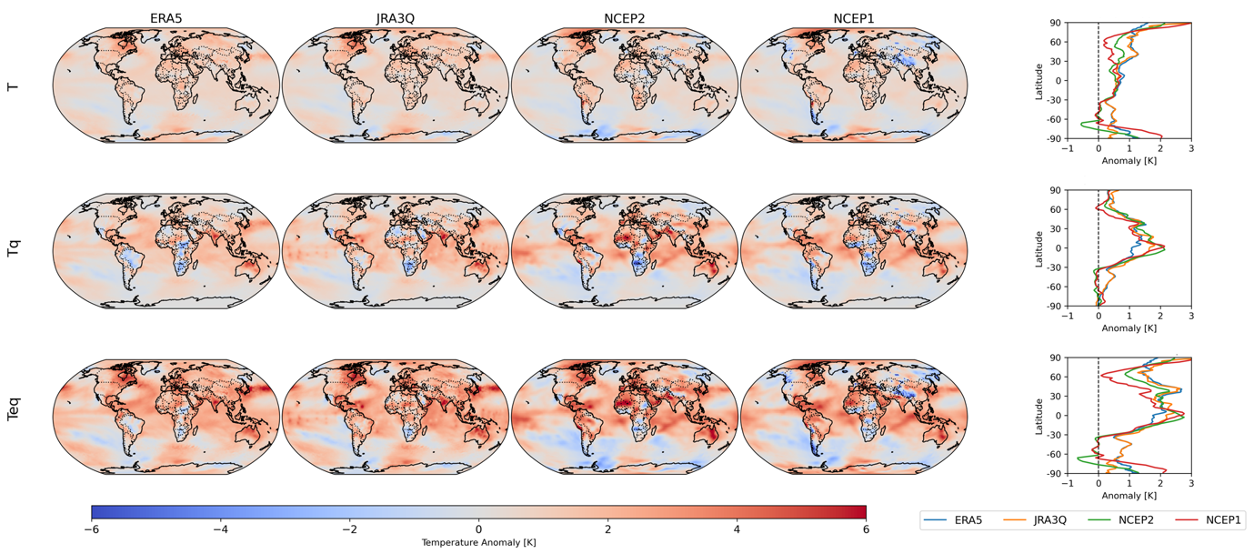


Plate 2.1X Global mean anomalies of Equivalent Temperature from ERA5 relative to the 1991-2020 baseline.

c Cryosphere
c1 Permafrost Temperatures and Active Layer Thickness
None
c2 Rock Glacier Velocity
None
c3 Alpine Glaciers
None
c4 Lake Ice Cover
None
c5 Northern Hemisphere Continental Snow Cover Extent
None
d Hydrological Cycle - Atmosphere
d1 Surface Humidity
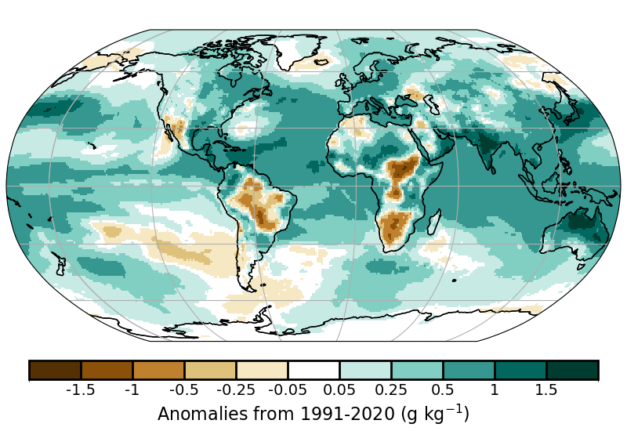
Plate 2.1a Surface specific humidity anomaly relative to 1991-2020 from ERA5.
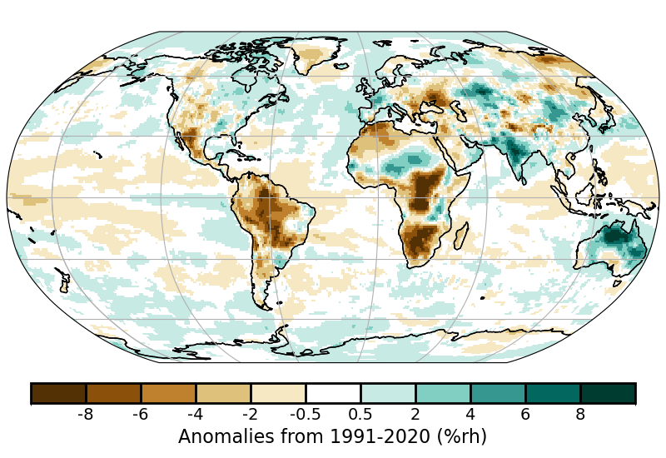
Plate 2.1b Surface relative humidity anomaly relative to 1991-2020 from ERA5.

d2 Humid Heat extremes

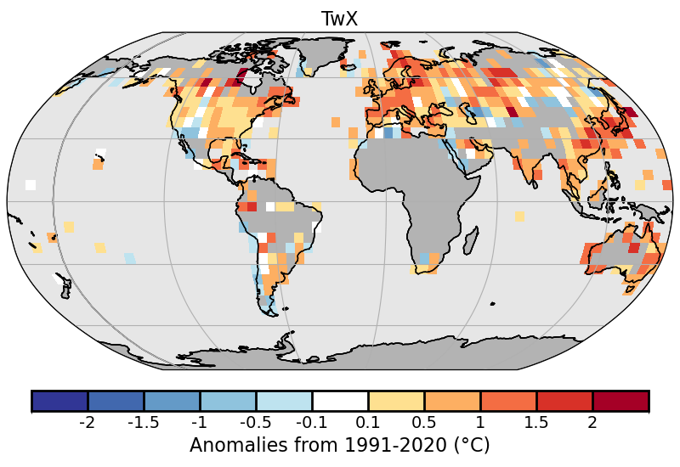
Plate 2.1a: 2024 humid-heat intensity as measured by the annual median anomaly of daily maximum wet-bulb temperature (T_{w}X) from HadISDH.extremes. White gridboxes (over land) represent regions with insufficient data.

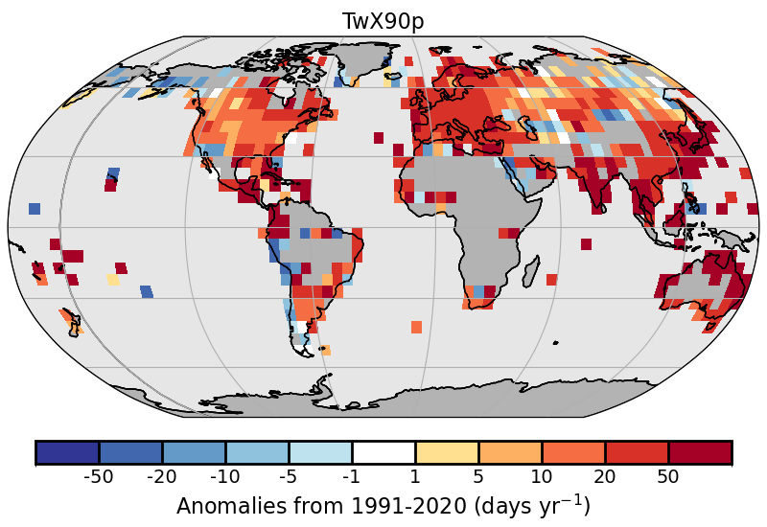
Plate 2.1b 2024 humid-heat frequency anomalies as measured by the number of days where the daily maximum wet-bulb temperature exceeds the local daily 90th percentile (T_{w}X90p, calculated over the 1991-2020 period) from HadISDH.extremes. White gridboxes (over land) represent regions with insufficient data.

d3 Total Column Water Vapor
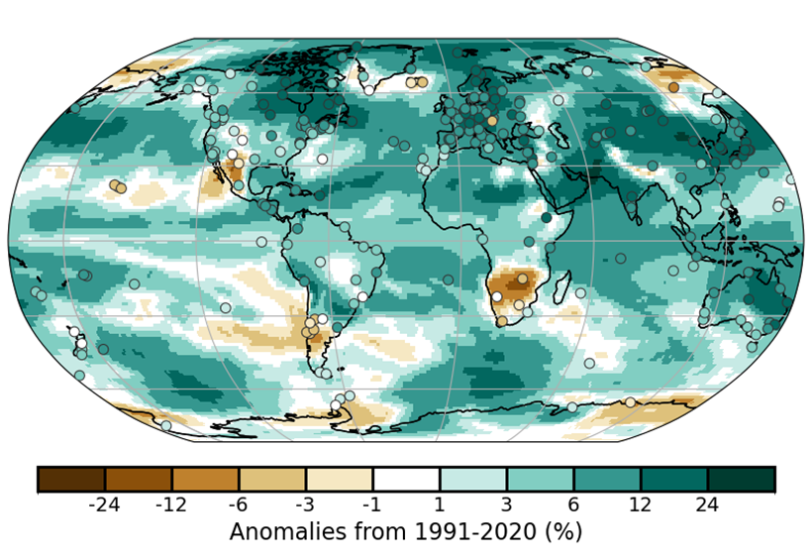
Plate 2.1i: TCWV anomalies (unit %) from JRA-3Q reanalysis (shading) and 236 ground-based GNSS stations (filled circles).

d4 Upper Tropospheric Humidity
d5 Precipitation

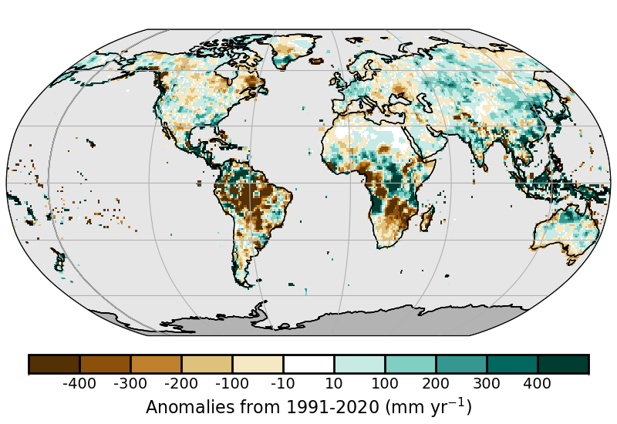
Plate 2.1a: Deviation from the long-term mean 1991-2020 for the annual total in 2024, brown indicates drier, blueish wetter than normal conditions. Data source: GPCC.

d6 Land surface Precipitation Extremes
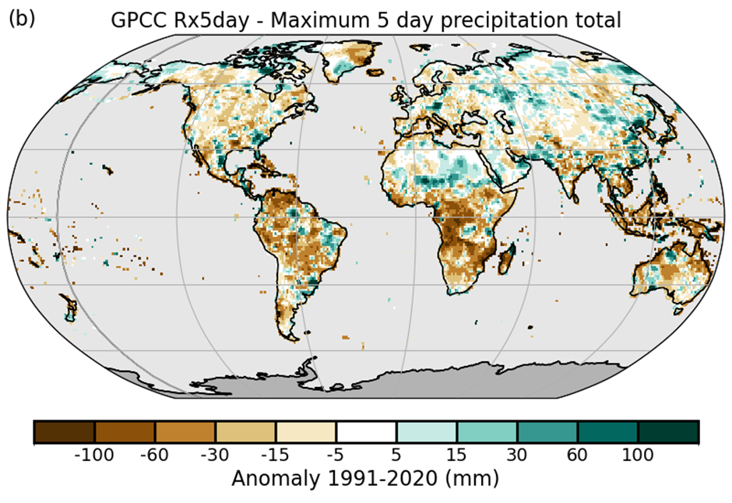
Plate 2.1a: Accumulated 5-day maxima (Rx5day) anomalies from 1991-2020, from GPCC (Ziese et al. 2022).

d7 Cloudiness
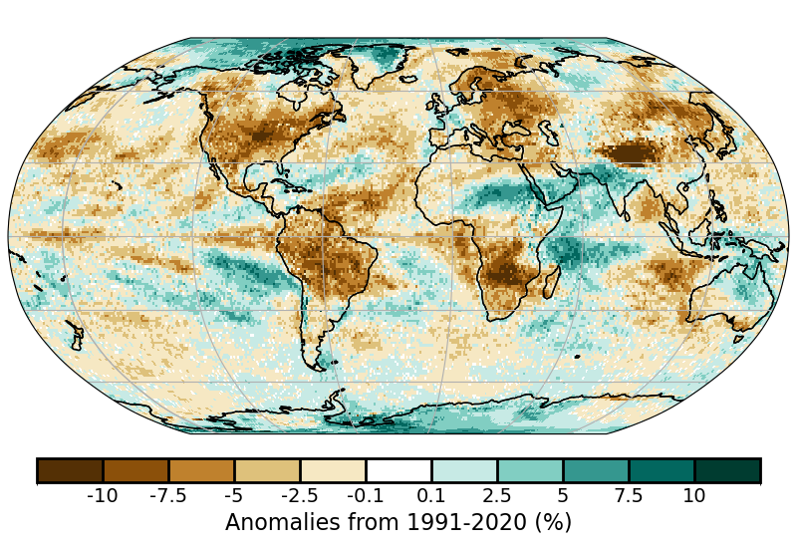
Plate 2.1X Global annual mean cloudiness (cloud fraction) anomalies for 2024 from PATMOS-x 6.0.

d Hydrological Cycle - Land
d8 Lake Water Level

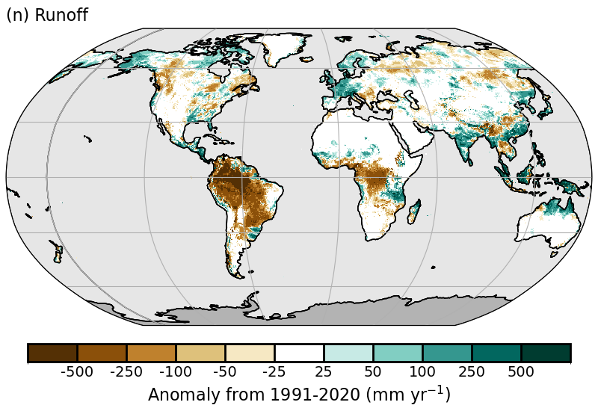
d9 River Discharge
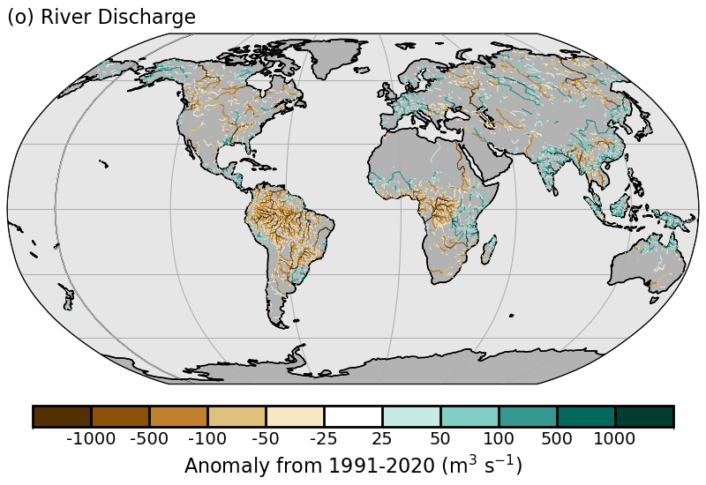
Plate 2.1q: GloFASv4 (Global Flood Awareness System) distribution of runoff anomalies (mm·yr⁻¹).
Plate 2.1r: GloFASv4 distribution of discharge anomalies (m3·s⁻¹).

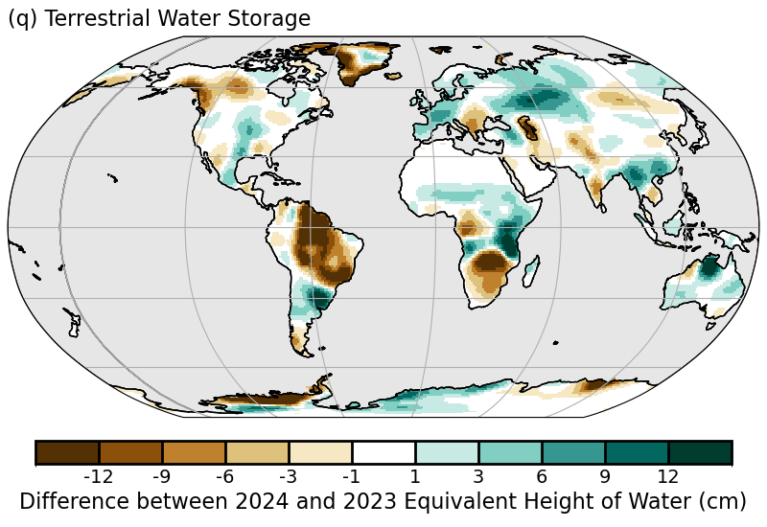
d10 Groundwater and Terrestrial Water Storage
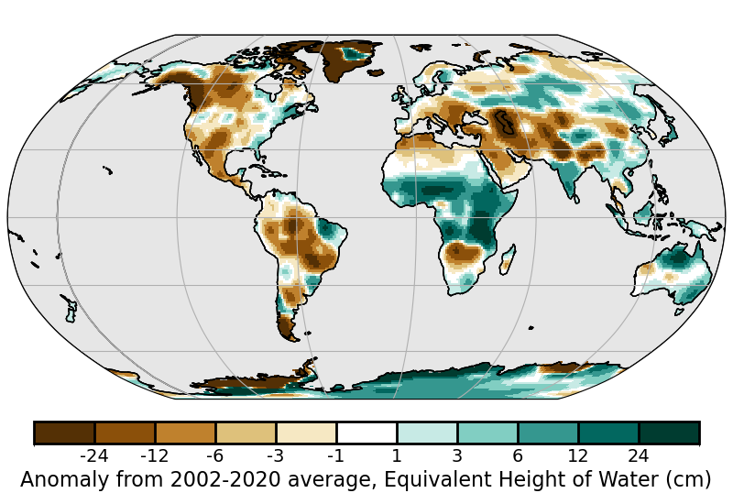
Plate 2.1q. Changes in annual-mean terrestrial water storage (the sum of groundwater, soil water, surface water, snow, and ice, as an equivalent height of water in cm) between 2024 and 2023, based on gravity observations from the GRACE-FO satellite mission.
Plate 2.1r. Anomalies in annual-mean terrestrial water storage in 2024 relative to the 2002-20 average, based on gravity observations from the GRACE-FO satellite mission.

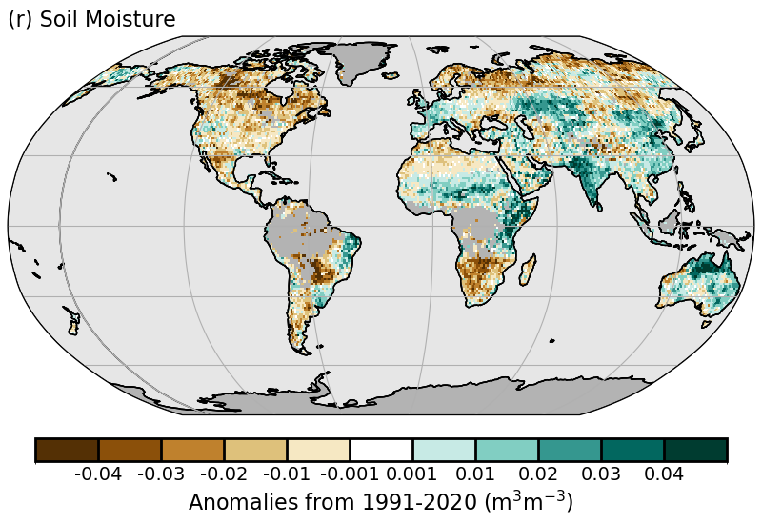
2.d.11 Soil Moisture
Plate 2.1r: C3S average surface soil moisture anomalies (m3 m−3). Data are masked where no retrieval is possible or where the quality is not assured and flagged, for example due to dense vegetation, frozen soil, or radio frequency interference;

2.d.12 Monitoring Drought using the Self Calibrating Palmer Drought Severity Index

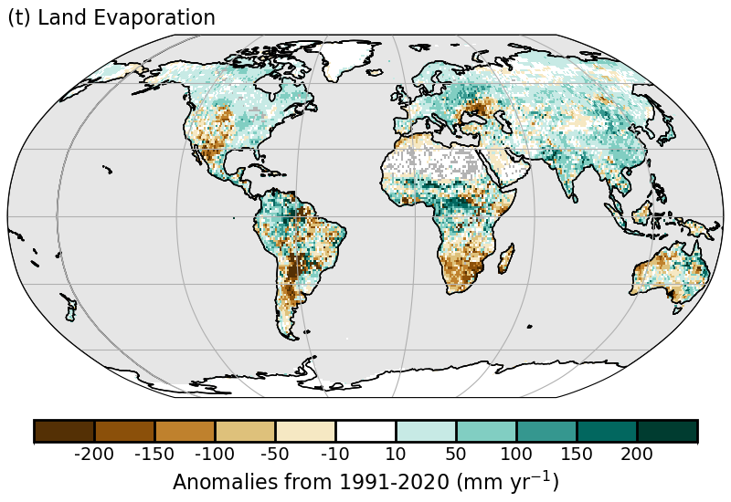
2.d.13 Global Land Evaporation
Plate 2.1t: GLEAM4 land evaporation anomalies (mm yr⁻¹; relative to 1991–2020).

2.e Atmospheric Circulation
2.e.1 Mean Sea Level Pressure and Related Modes of Variability
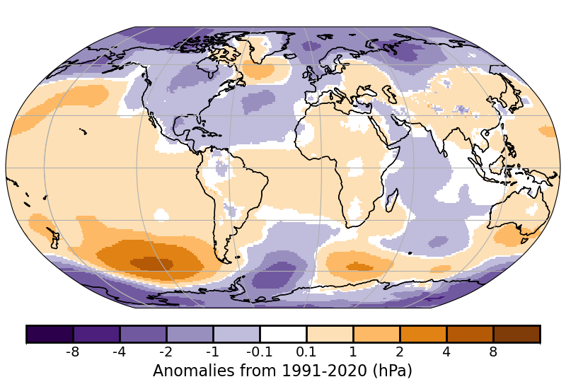
Plate 2.1: SLP anomalies from ERA5

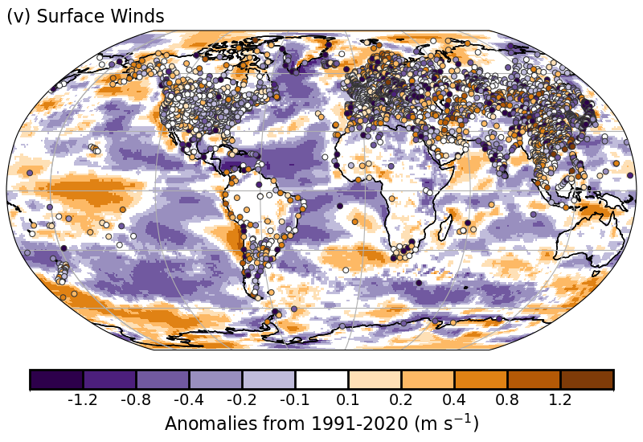
2.e.2 Surface Winds
Plate 2.1v: Surface Wind Speed anomalies (m s⁻¹) from the observational HadISD3 dataset (land, circles), the ERA5 reanalysis (land, shaded areas), and RSS merged satellite radiometer observations (ocean, shaded areas) for 2024 with respect to 1991-2020.

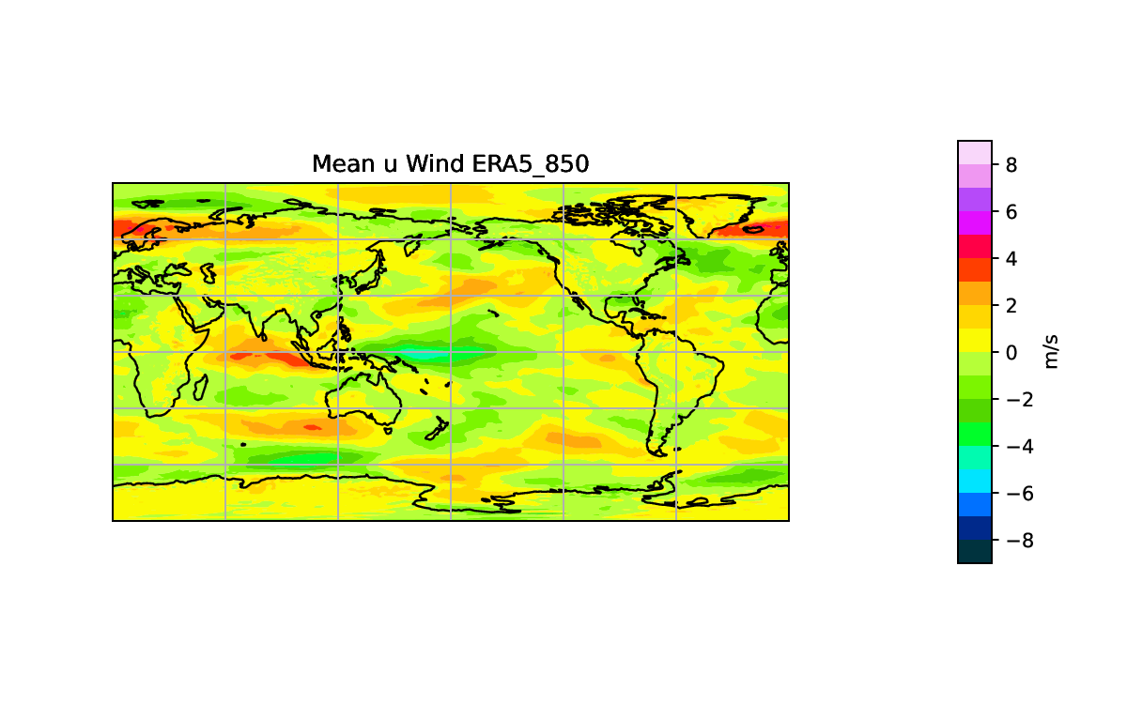
2.e.3 Upper air winds

Plate 2.1a: 850hPa eastward wind speed anomaly (from ERA5, with respect to 1991-2020 climatology) averaged over October-December 2024.
;

2.e.4 Lightning
None

f Earth Radiation Budget
f1 Earth Radiation Budget at Top-of-Atmosphere
None

f2 Mauna Loa Clear-Sky Atmospheric Solar Transmission
None

g Atmospheric Composition
g1 Long-lived Greenhouse Gases
g2 Ozone-Depleting Gases
g3 Tropospheric Aerosols
g4 Tropospheric Ozone
g5 Stratospheric Aerosols
g6 Stratospheric Ozone
g7 Stratospheric Water Vapor
g8 Carbon Monoxide

h Land Surface Properties
h1 Land Surface Albedo Dynamics

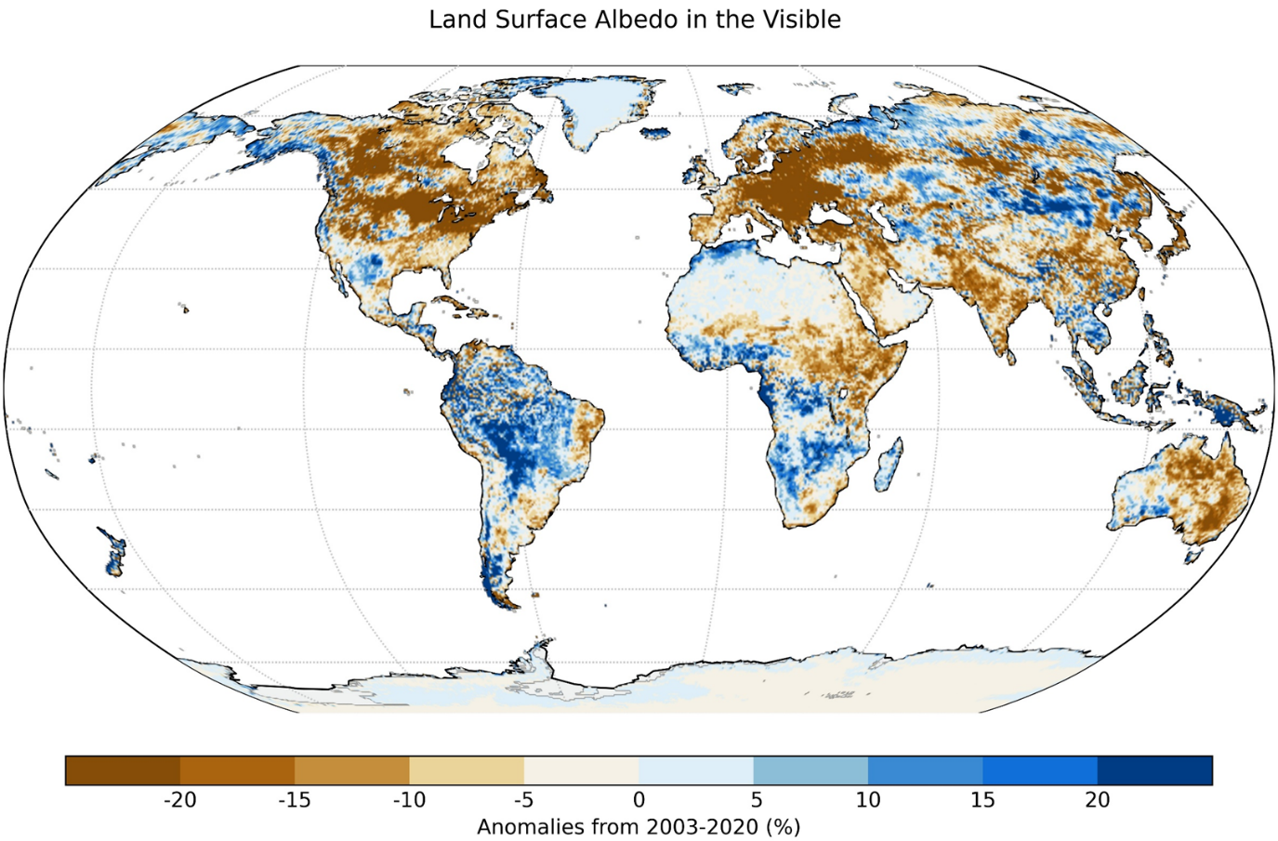Plate 2.1a: Land surface visible broadband albedo anomalies (%) in 2024 using a 2003-2020 reference period.
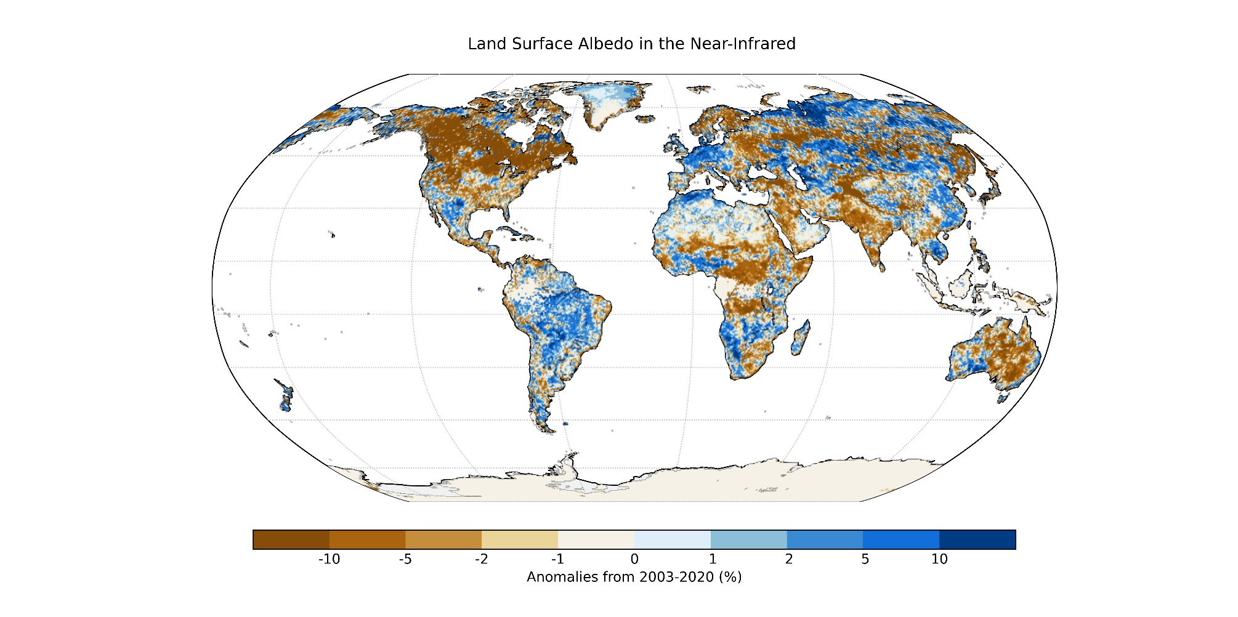
Plate 2.1b: Land surface near-infrared broadband albedo anomalies (%) in 2024 using a 2003-2020 reference period.

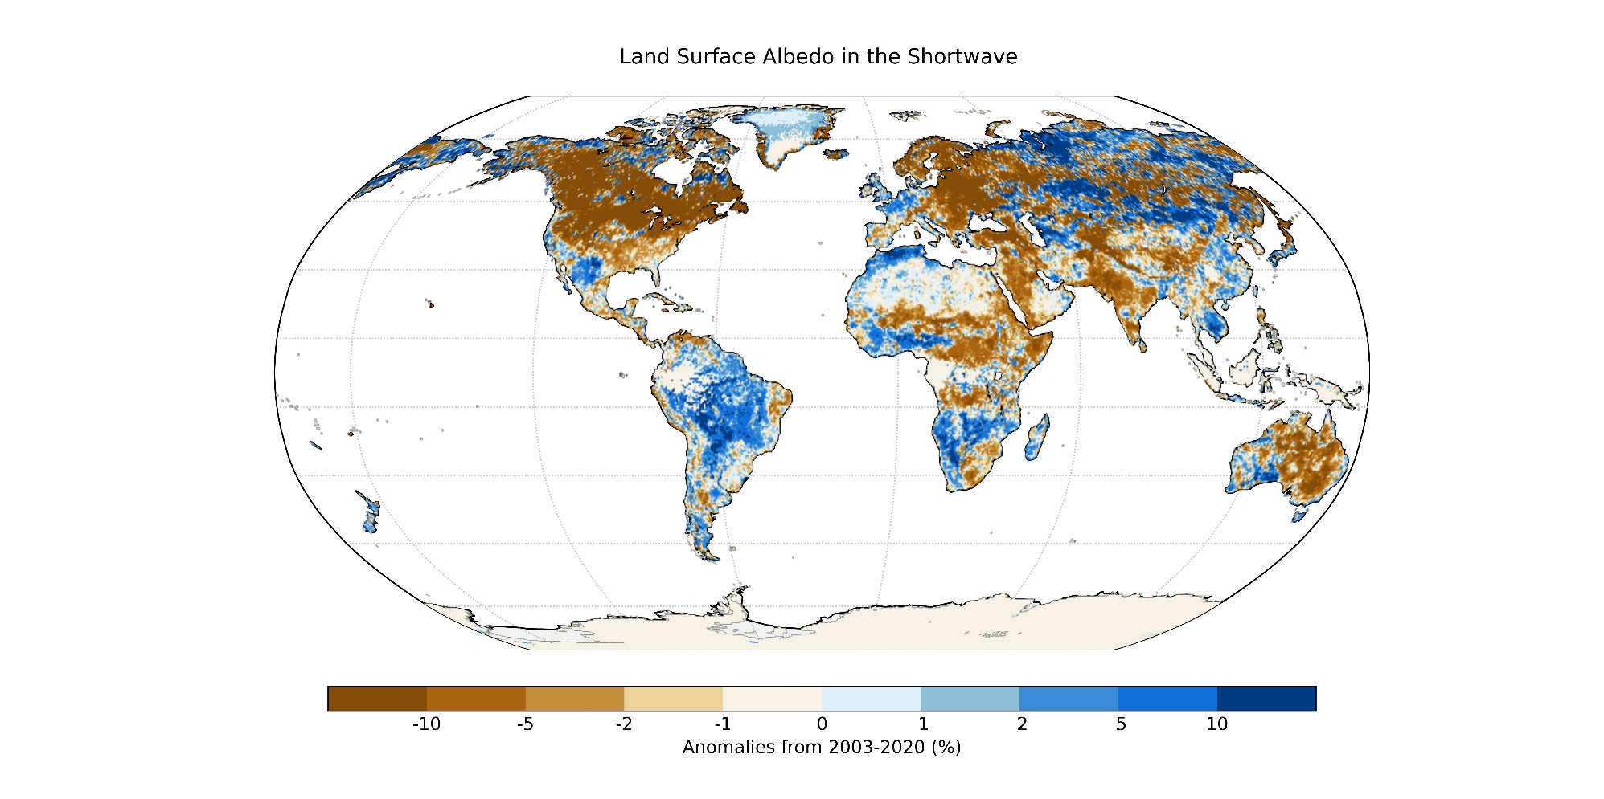Plate 2.1c: Land surface shortwave broadband albedo anomalies (%) in 2024 using a 2003-2020 reference period.

h2 Terrestrial Vegetation Dynamics
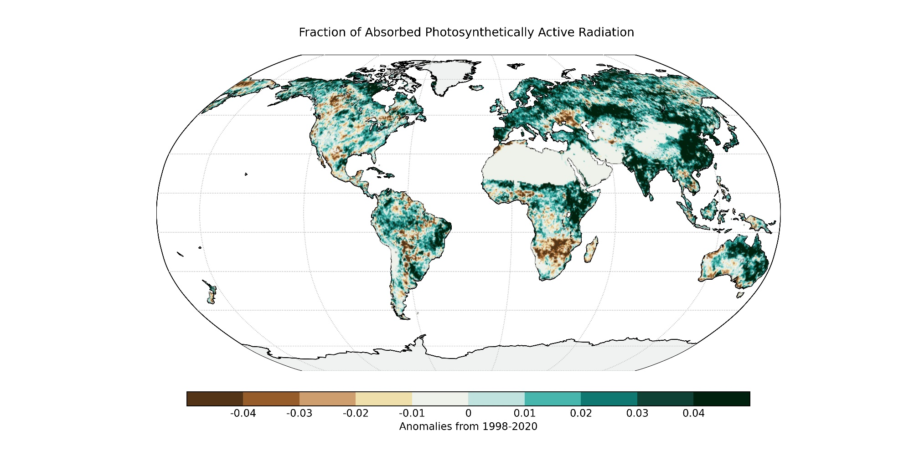
Plate 2x: FAPAR anomalies

h3 Biomass Burning

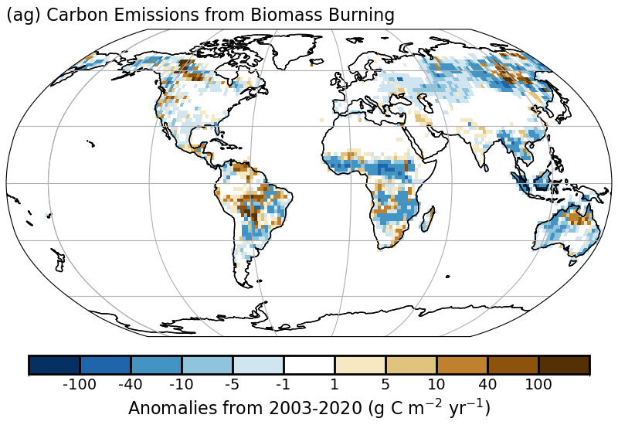
Plate 2.1: Anomaly map of biomass burning in terms of carbon consumption.

h4 Phenology of primary producers
None

h5 Vegetation Optical Depth
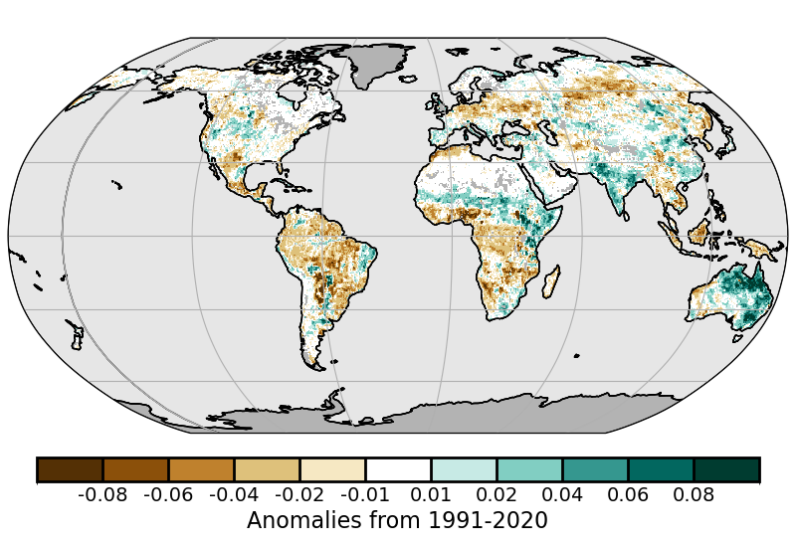

Plate 2.1. VODCA CXKu-band VOD Annual anomalies.

Sidebar – Short-lived GHGs [to occur just before 2g]

