Authors
Casado-Rodríguez, Jesús, European Commission Joint Research Centre, Ispra, Italy
Grimaldi, Stefania, European Commission Joint Research Centre, Ispra, Italy
Salamon, Peter, European Commission Joint Research Centre, Ispra, Italy
2.a.1 River discharge and runoff - J. Casado-Rodríguez, S. Grimaldi and P. Salamon
From the perspective of river discharge and runoff, 2024 was another dry year, continuing a trend of six consecutive years with below-normal global river discharge and four years of below-normal global runoff.
Globally, runoff in 2024 exhibited drier-than-usual conditions compared with the reference period 1991-2020 (Figure 2.a.1.1) However, this anomaly was not as pronounced as in 2023, which remains the driest year in the time series. A shift towards normal conditions was observed, likely associated with the transition from El Niño at the beginning of the year to a neutral phase (Oceanic Niño Index in Figure 2.a.1.1). Additionally, 2024 was characterised by an intense negative phase of the Pacific Decadal Oscillation (PDO), which showed its lowest values in the study period. Despite this overarching pattern, significant regional differences were observed (Plate 2.1a). The Amazon, La Plata and Congo basins experienced an extremely dry year (Toreti et al., 2024b). The anomaly in the Congo is partially attributed to an erroneous negative trend in the ERA5 precipitation over this region (ref to precip chapter, Lavers et al., 2022; Liu et al., 2024). Drought conditions also affected the Atlantic and Pacific coasts of North America, South-eastern Europe (Toreti et al., 2024a), Southeast Asia, and parts of Siberia. Conversely, Central America, Central and Northern Europe, the Indian subcontinent, the Pacific coast of Asia and insular Southeast Asia experienced wetter-than-usual conditions.
A similar pattern was observed in freshwater discharge into the oceans, which remained below normal overall, though with notable regional variations (Figure 2.a.1.2 and Plate2.1b). Discharge into the Arctic was slightly below normal, particularly in summer. The Mackenzie and Nelson rivers (North America), and the Lena river (Asia) experienced low discharge, whereas the Ob river (Asia) exhibited above-normal discharge. The Atlantic basin faced severe drought conditions, with the lowest discharge in the series. Negative anomalies persisted throughout the year, intensifying during winter when El Niño was present. Major rivers, including the Amazon, Paraná and Mississippi (America), as well as the Congo and Nile (Africa), had low discharge. An exception to this trend was the flooding that affected Rio Grande Do Sul (Brazil) in late April (Dijk et al., 2025). In contrast, the Indian Ocean experienced the highest discharge in the time series, with positive anomalies spanning both wet seasons, while values remained normal during dry seasons. Severe flooding impacted Bangladesh in August (Dijk et al., 2025). The Pacific Ocean exhibited also above-normal discharge, with the largest positive anomalies occurring between April and July.
The river discharge and runoff data used in this analysis derive from the historical simulation of the Global Flood Awareness System version 4 of the Copernicus Emergency Management Service (Joint Research Centre - European Commission, 2025). GloFASv4 employs the LISFLOOD-OS hydrological model (Burek et al., 2013), incorporating surface fields representing land characteristics (Choulga et al., 2024) and parameters calibrated against discharge records from nearly 2,000 stations, or regionalized where necessary. The historical simulation spans from 1979 to the present, utilizing a 3-arcminute grid and a daily temporal resolution. ERA5 reanalysis (Hersbach et al., 2020) serve as the meteorological forcing input.
References
Burek, P., van der Knijff, J., & de Roo, A., 2013: LISFLOOD. Distributed Water Balance and Flood Simulation Model. https://doi.org/10.2788/24719
Choulga, M., Moschini, F., Mazzetti, C., Grimaldi, S., Disperati, J., Beck, H., Salamon, P., & Prudhomme, C., 2024: Technical note: Surface fields for global environmental modelling. Hydrology and Earth System Sciences, 28(13), 2991–3036. https://doi.org/10.5194/hess-28-2991-2024
Dijk, V., Beck, H. E., Boergens, E., De Jeu, R. A. M., Dorigo, W. A., Edirisinghe, C., Forootan, E., Guo, E., Güntner, A., Hou, J., Mehrnegar, N., Mo, S., Preimesberger, W., Rahman, J., & Larraondo, P. R., 2025: Global Water Monitor 2024, Summary Report. www.globalwater.online
Hersbach, H., Bell, B., Berrisford, P., Hirahara, S., Horányi, A., Muñoz-Sabater, J., Nicolas, J., Peubey, C., Radu, R., Schepers, D., Simmons, A., Soci, C., Abdalla, S., Abellan, X., Balsamo, G., Bechtold, P., Biavati, G., Bidlot, J., Bonavita, M., … Thépaut, J. N., 2020: The ERA5 global reanalysis. Quarterly Journal of the Royal Meteorological Society, 146(730), 1999–2049. https://doi.org/10.1002/qj.3803
Joint Research Centre - European Commission, 2025: Global Flood Awareness System. https://global-flood.emergency.copernicus.eu/
Lavers, D. A., Simmons, A., Vamborg, F., & Rodwell, M. J., 2022: An evaluation of ERA5 precipitation for climate monitoring. Quarterly Journal of the Royal Meteorological Society, 148(748), 3152–3165. https://doi.org/10.1002/qj.4351
Liu, R., Zhang, X., Wang, W., Wang, Y., Liu, H., Ma, M., & Tang, G., 2024: Global-scale ERA5 product precipitation and temperature evaluation. Ecological Indicators, 166. https://doi.org/10.1016/j.ecolind.2024.112481
Toreti, A., Bavera, D., Acosta Navarro, J., Acquafresca, L., Azas, K., Barbosa, P., De Jager, A., Ficchì, A., Fioravanti, G., Grimaldi, G., Hrast Essenfelder, A., Magni, D., Mccormick, N., Salamon, P., Santos Nunes, S., & Volpi, D., 2024a: Drought in Europe July 2024. https://doi.org/10.2760/420832
Toreti, A., Bavera, D., Acosta Navarro, J., Acquafresca, L., Barbosa, P., De Jager, A., Ficchì, A., Fioravanti, G., Grimaldi, S., Hrast Essenfelder, A., Magni, D., Mccormick, N., Salamon, P., & Toreti, A., 2024b: Drought in the Amazon and the La Plata basins. https://doi.org/10.2760/9524487
Figures
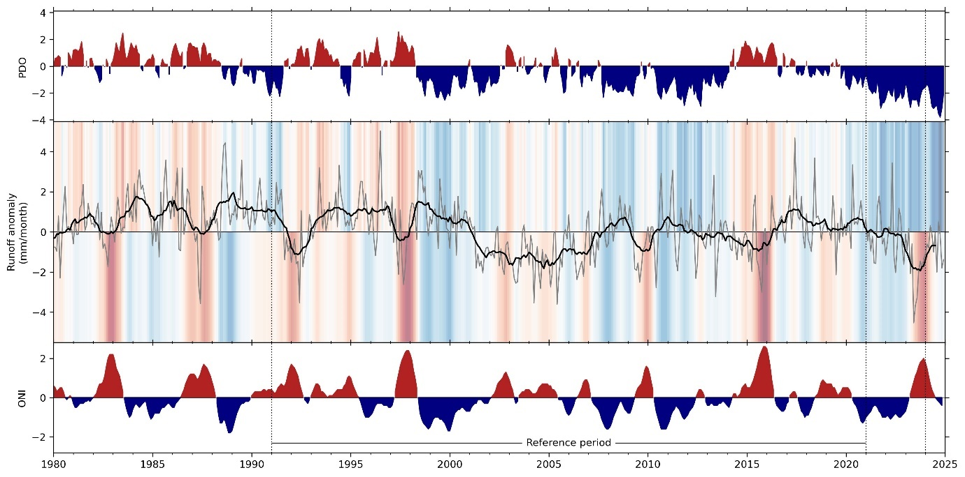
Fig 2.a.1.1: Interannual variability of global runoff (central panel) and its connections with the Pacific Decadal Oscillation (PDO; upper panel) and the Oceanic Niño Index (ONI; lower panel). In the central panel, the grey line represents the monthly time series, the black line the 12-month moving average, and the shading indicates the phase of the two indices (PDO in the upper part and ONI in the lower).
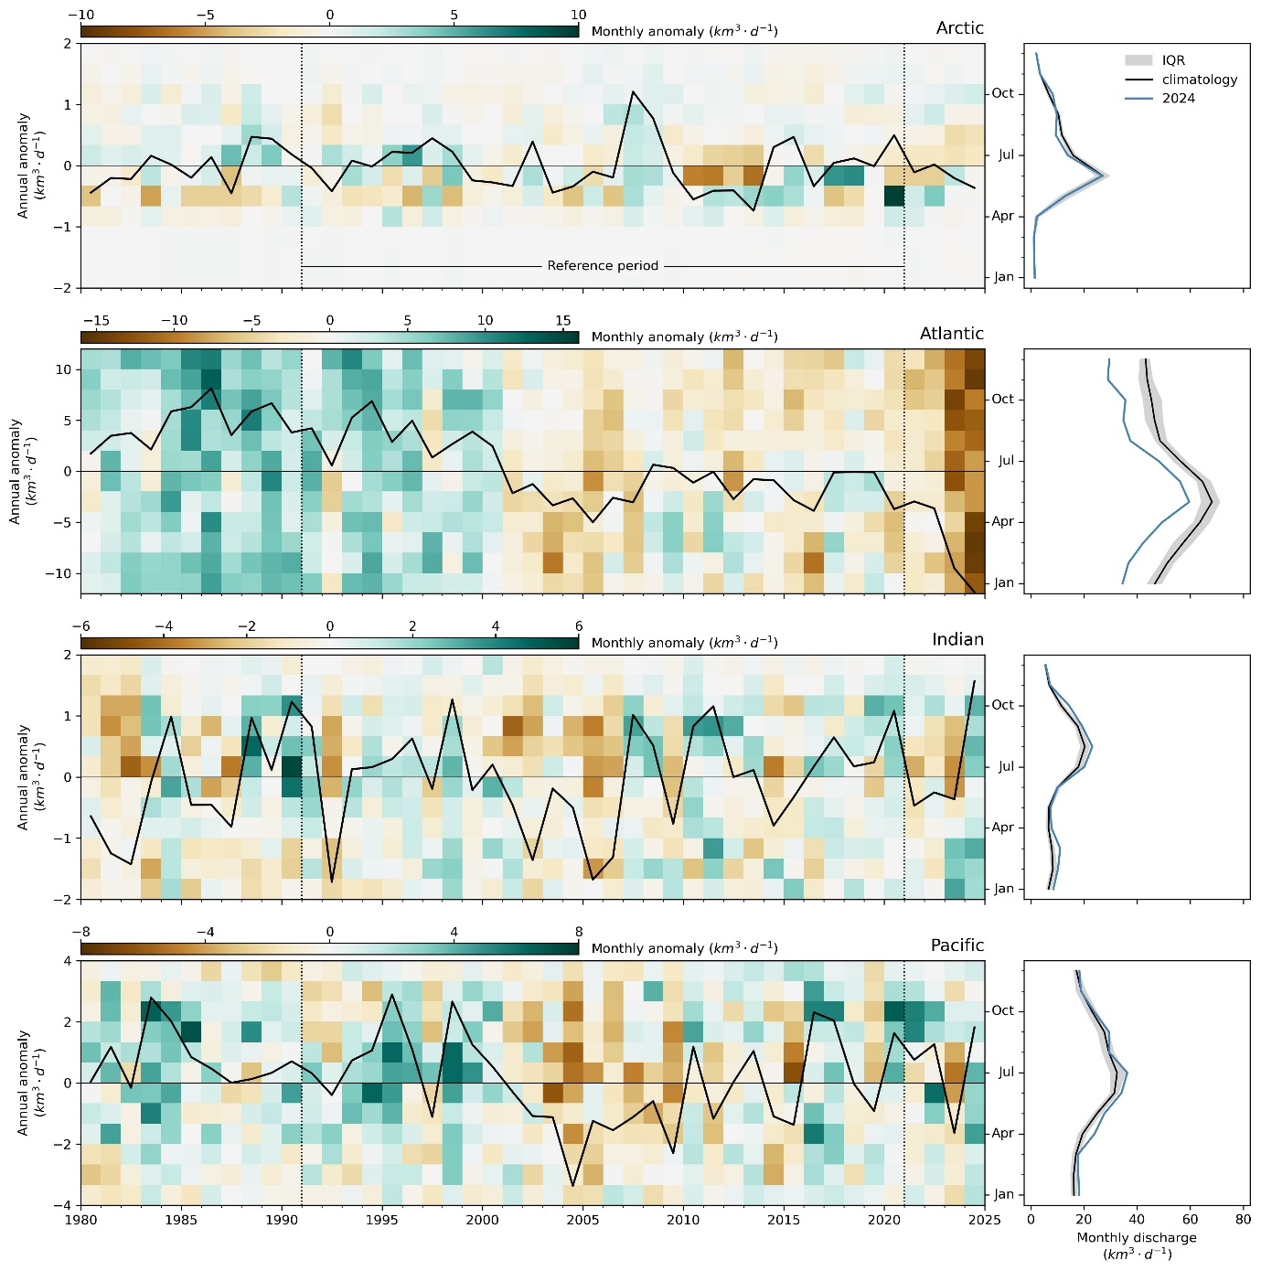
Fig 2.a.1.2: Interannual variability and seasonality of freshwater discharge to global ocean basins. In the left panels, the black line represents the annual discharge anomaly, and the background heatmap shows the monthly anomalies with respect to the reference seasonality. The right panels exhibit the seasonality, where the black line represents the climatological mean, the grey shading indicates the interquartile range in the climatology, and the blue line shows the seasonal variation in 2024.
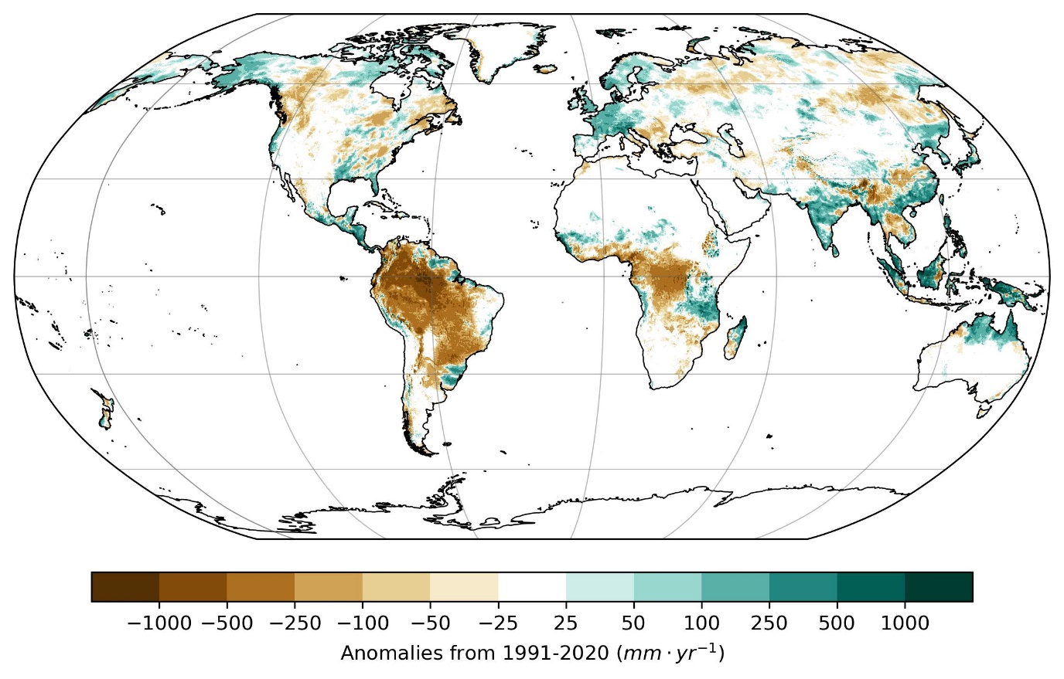
Plate 2.1a: GloFASv4 (Global Flood Awareness System) distribution of runoff anomalies (mm·yr⁻¹).
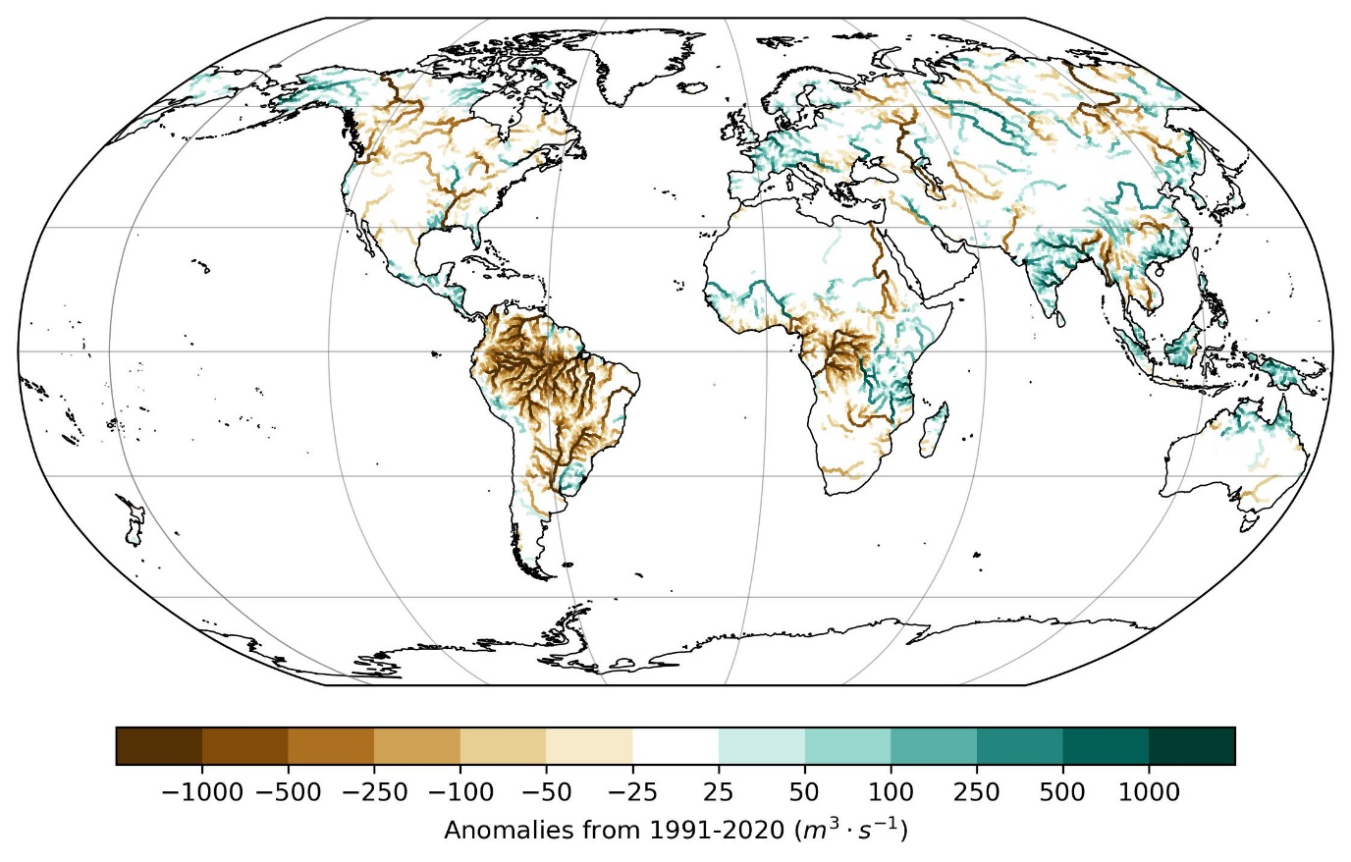
Plate 2.1b: GloFASv4 distribution of discharge anomalies (m3·s⁻¹).
Datasets used and their URLs
GloFASv4 historical run: https://ewds.climate.copernicus.eu/datasets/cems-glofas-historical?tab=overview
GloFASv4 surface fields and calibrated parameters: https://data.jrc.ec.europa.eu/dataset/68050d73-9c06-499c-a441-dc5053cb0c86
ERA5: https://cds.climate.copernicus.eu/datasets/reanalysis-era5-single-levels?tab=overview
Acknowledgements
GloFAS is part of the Copernicus Emergency Management Service which is funded by the European Union Space program.
Summary bullet points
- 2024 was a dry year from the perspective of runoff and river discharge.
- The Amazon and La Plata basins faced an unprecedented drought.
- Severe flooding affected Bangladesh, Afghanistan, Pakistan, Spain and Brazil.

