**Method**

The method is explained in detail in Burek and Smilovic (2023). An outline is given here:

1. The station is allocated to a high resolution (3 arcsec) flow direction grid. The automatic station allocation, follows the protocol of Lehner (2012).
2. Each station will have corresponding coordinates on the high-res flowdirection grid.
3. With the station coordinates and the high-res flow direction, we derive a shapefile of the station basin
4. On low resolution (1 arcmin for EFAS, 3 arcmin for Glofas) for all 25 surrounding coarse grid cells (surrounding the high-res coordinates) a shapefile is produced.
5. The shapefile with the highest similarity to the high-res shapefile is choosen

Figure 1 illustrates the method for l5 arcmin and for cell location No. 7, which is one 5′ cell south of the cell where the Passau/Inn station is located. Even if this cell does not represent the cell where the station is located, it fits the upstream area accordance and the best intersection-over-union ratio of all 25 cells around the station location.

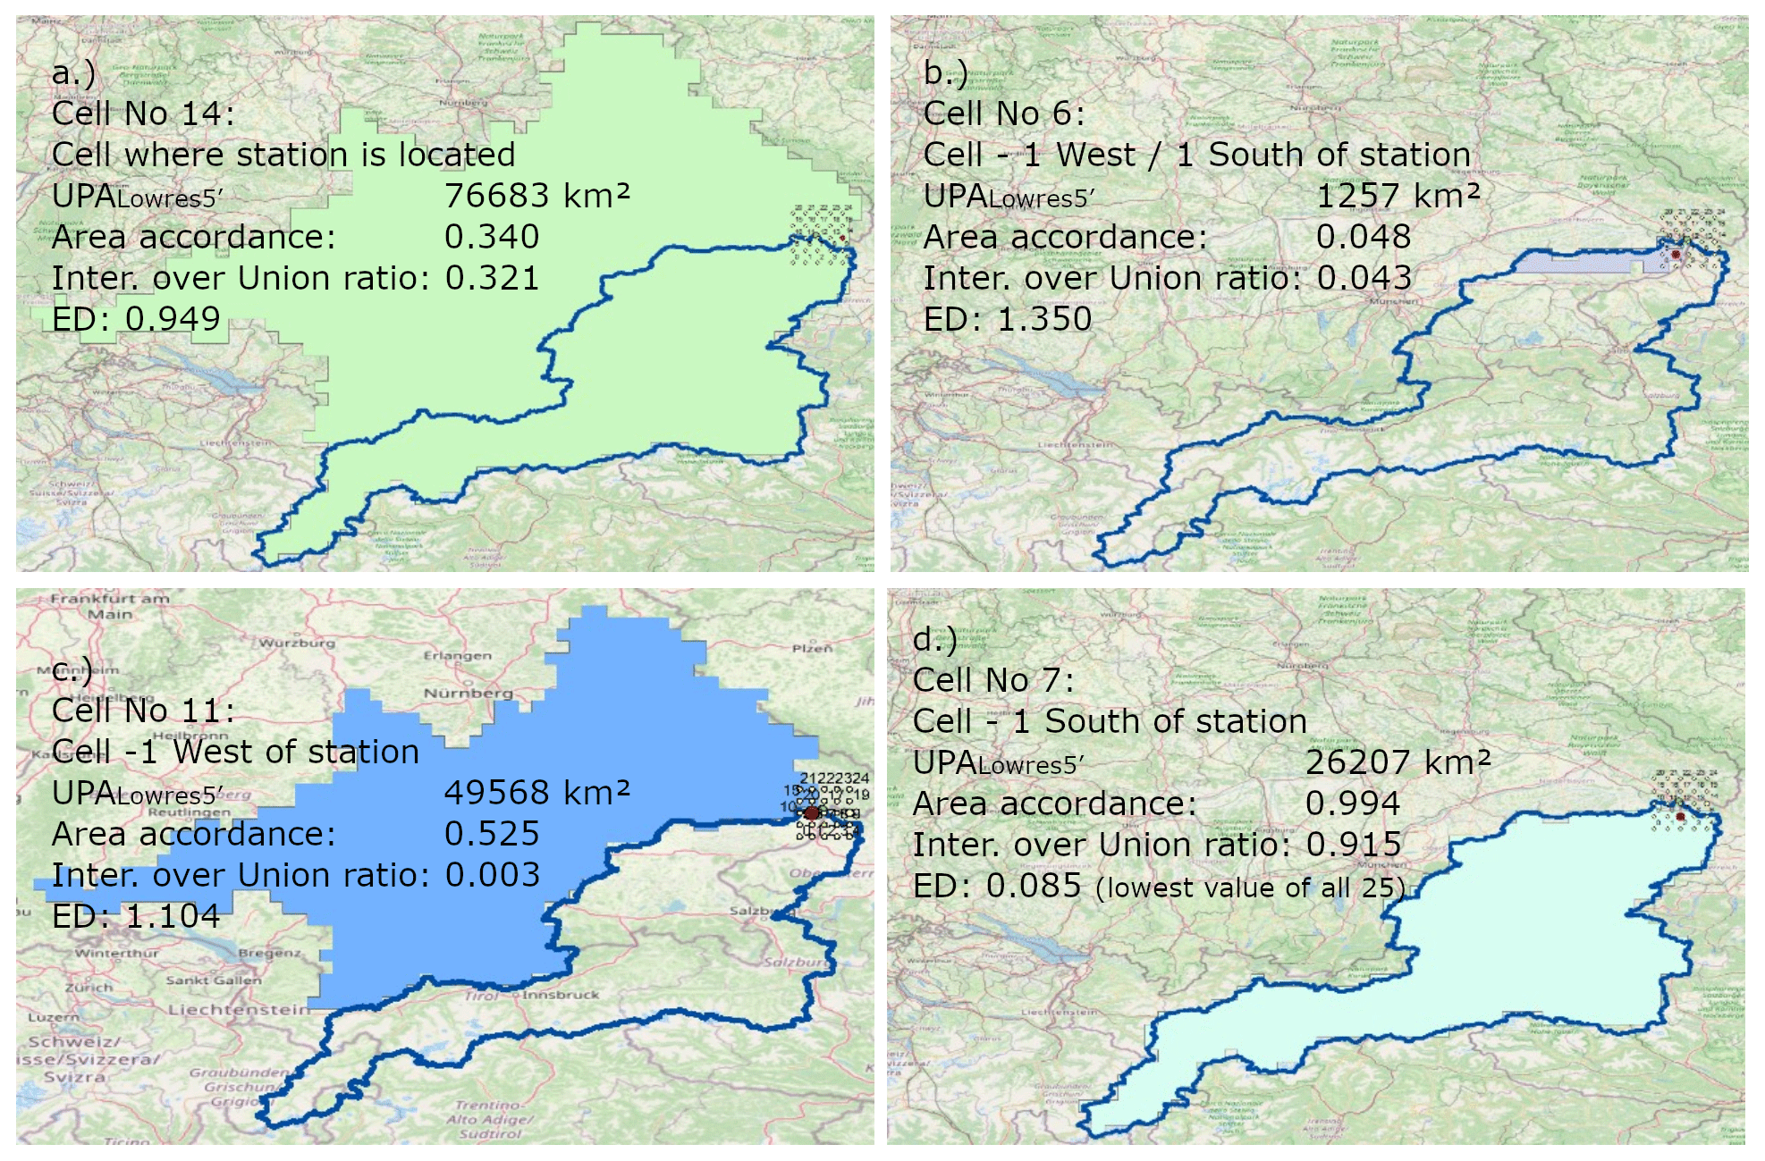

Fig 1: Concept of similarity for the Passau/Inn station, Germany – GRDC 6343900 with a high-resolution watershed map shown in blue outline and four different watershed maps based on a 5′ resolution network around the station location (from Burek and Smilovic, 2023)

**Datasets**

* Merit DEM (Yamazaki et al. 2017,2019)  
  <https://hydro.iis.u-tokyo.ac.jp/~yamadai/MERIT_DEM/>  
  3 arcsec data tiles combined to a European DEM (European extend of LISFLOOD EFAS)
* EU-Hydro (Copernicus Land Monitoring Service)  
  <https://land.copernicus.eu/en/products/eu-hydro>
* Shape files of river network. Rasterized by attribute Strahler to 3 arcsec European raster
* Resulting river network on 3 arcsec:
  + Burned in EU-Hydro network to improve the natural DEM
  + Merit DEM - 5 * Strahler EU-Hydro
  + Filled up with ArcGIS Hydro fill tool to make a hydrological sound DEM
  + Flow direction tool from ArcGIS to create river network
* EFAS river network LDD and Upstream area (Danube extend)
* Glofas river network LDD and Upstream area (Danube extend)

**Programs**

**1_findMeritcoord.py**

Using a high-resolution upstream area dataset (here: Merit data DEM + EU-hydro burned in)

to get the location of the station on a 3 arcsec network. The approach of Lehner (2012) and Burek and Smilovic (2023) is used here.

Input data:

ups_danube_3sec.tif: Upstream area on 3 arcsec

metastation_45.txt: Gloafas calibration stations from Metadata_calib_stations_Danube_EFASv5_GloFASv4.xlsx

Output: Glofas_Merit_2.txt

metastation_45.txt + high resolution location and upstream area

**2_makeshape.py**

Create high-res (3 arcsec) shape files of the basins.

Using the station points defined in 1_findMeritcoord.py for creating the shapefiles.

Python library pyflwdir is needed (Eilander et al. 2021)

<https://pypi.org/project/pyflwdir/0.5.2/>

Input data:

Glofas_Merit_2corr.txt (manual corrected output from 1_findMeritcoord.py)

Danube_fd.tif (3 arcsec river network)

Output:

../shape_glofas_3sec: 3 arcsec shape file of station basin

**4_basincom_1min.py**

Creates shapefiles in low-resolution and adds the station location at lower resolution to a list

Using the shapefile in high-resolution and compares it to the 25 neighboring shapefiles in low-resolution.

Selects the shapefile in low-resolution which is most similar to high-res

Python library pyflwdir is needed (Eilander et al. 2021)

<https://pypi.org/project/pyflwdir/0.5.2/>

Input data:

* Glofas_Merit_2corr.txt (manual corrected output from 1_findMeritcoord.py)
* Low resolution LDD and upstream area
* Shapefiles of high resolution

Output:

* Textfile copying Glofas_Merit_2corr.txt and adding the station location and area in low-res
* Shapefile in low resolution
* If location is different to the former EFAS/Glofas location, another shapefile is stored in shape_efas / shape_glofas.

Programs are stored in:

<https://github.com/iiasa/Lisflood/tree/main/calib_stations>

**Glofas**

Station 0436 Oberndorf, Danube

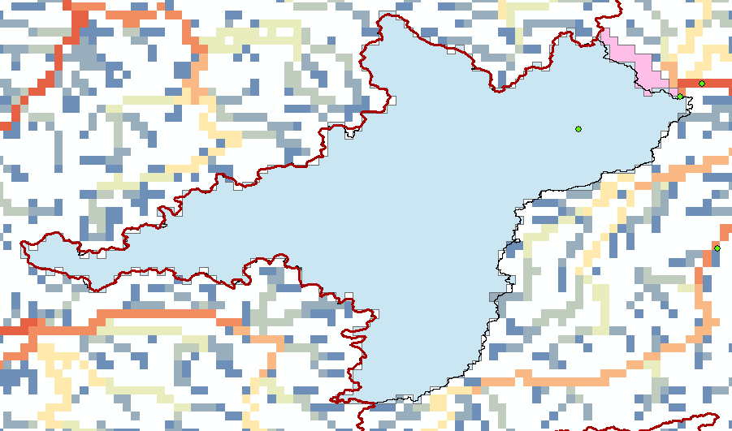

Fig 2: Station 436 – Oberndorf, Danube. In blue – shapefile of new calculated station basin. In pink – EFAS station shapefile (most parts below the blue shape). The EFAS station includes the river Schwarze Laber, which join the Danube after the station Oberndorf.

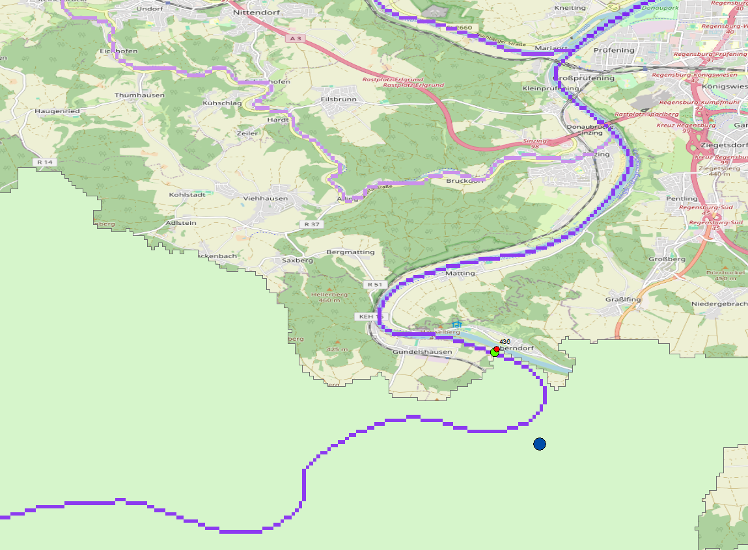

Fig 3: Detail of station 435. Red point – provided station location, green point – shifted station location to match high-res (3 arcsec) river network. Blue point – middle point of station location on 3 arcmin. Light green shape – high-res shape file on 3 arcsec.

Station 0517 - Tisza, Hungary

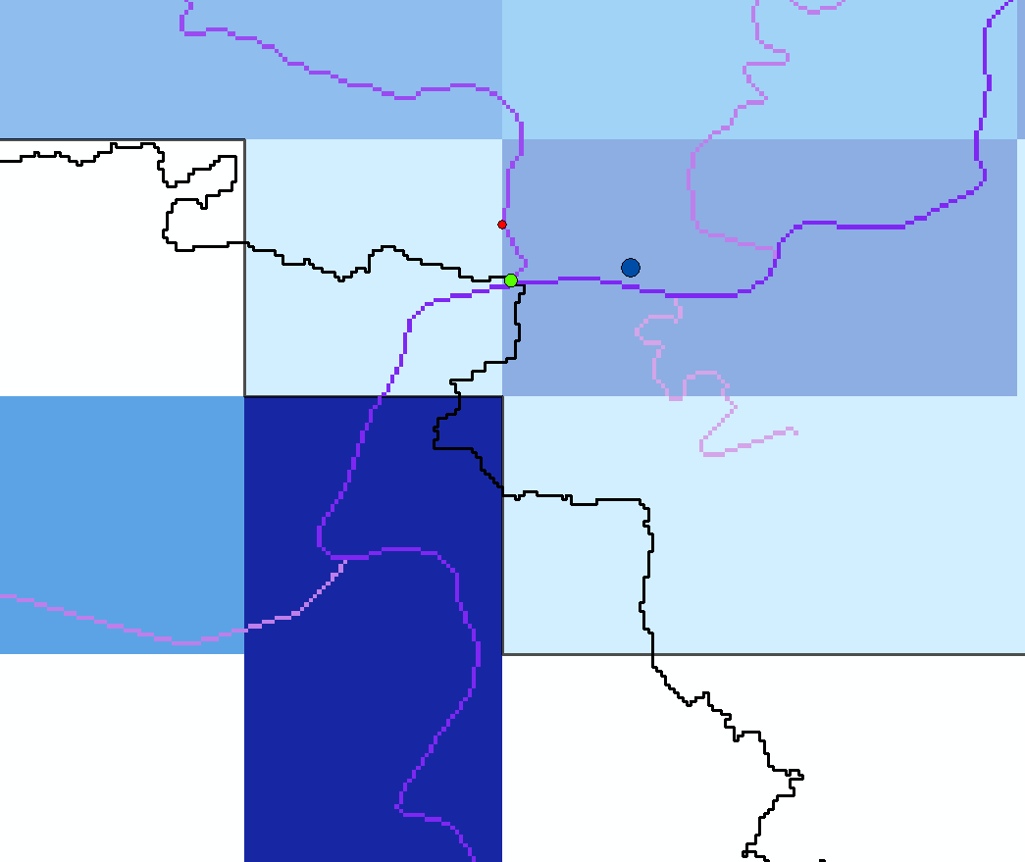

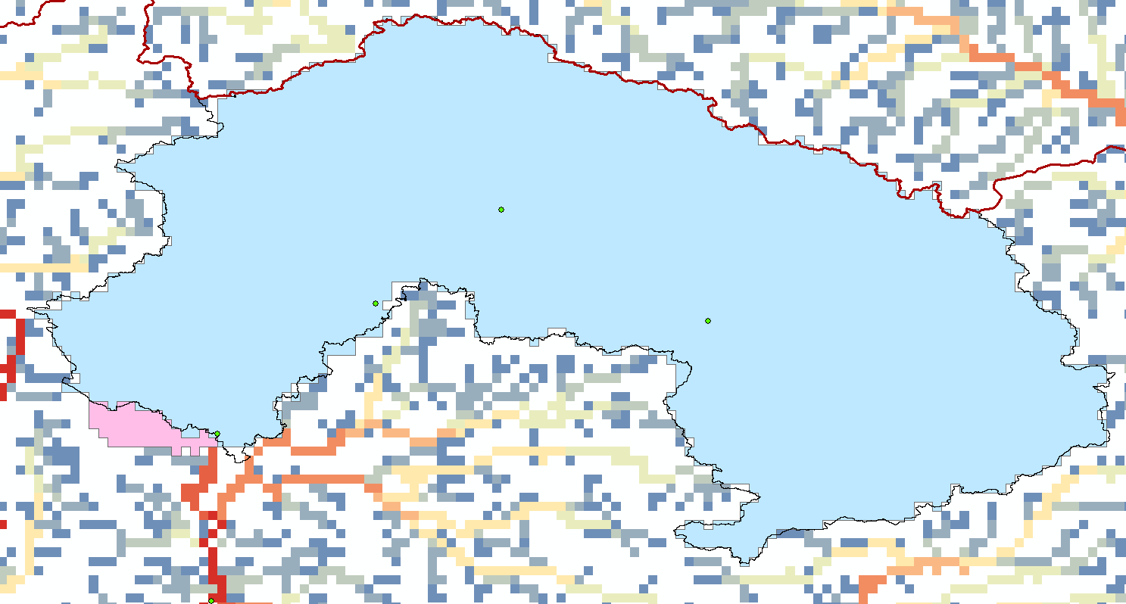

Fig 4: Station 517 – Tisza, Hungary. River is joining after the station 517. In Glofas this river is included in the river network of station 517.

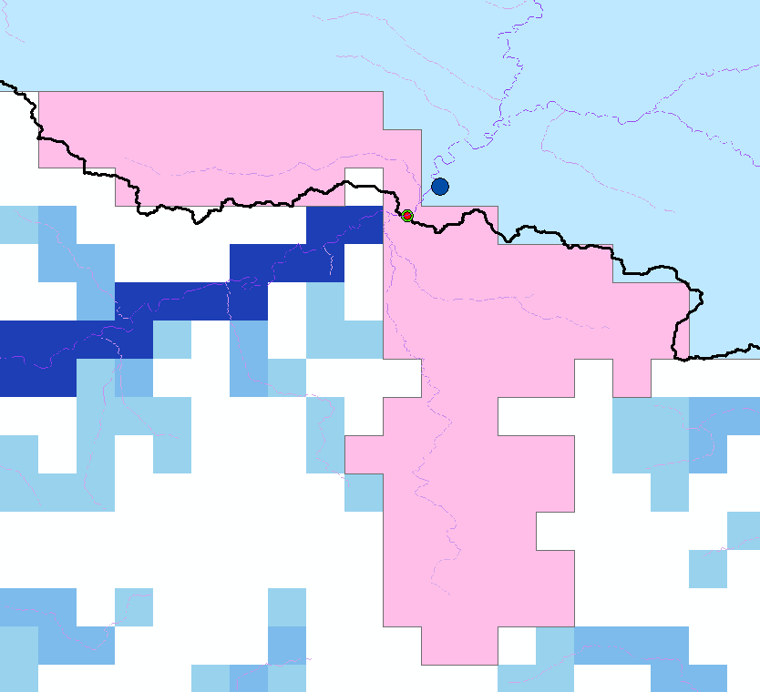Station 559 – Maros, Danube

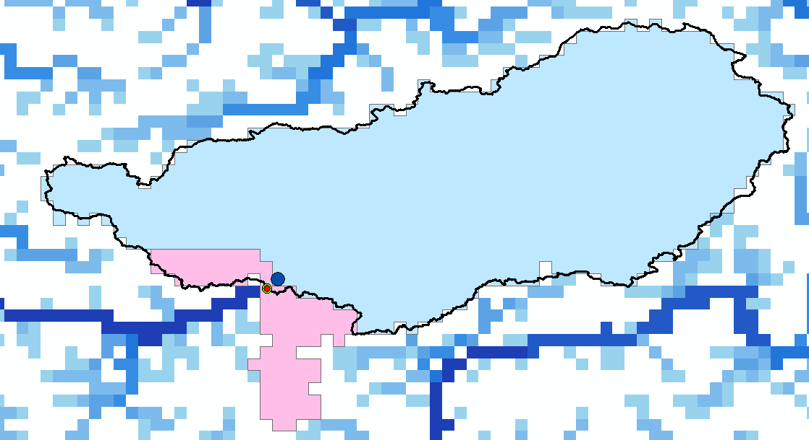

Fig 5: Station 559 – Maros, Danube, Romania. Here the river from west (Ampoi) is joining before the station and the river from south (Sebes) is joining after the station. But both rivers join into the same 3 arcmin cell. Here the similarity of shapes algorithm decides in favor for leaving out both tributaries than including both

**EFAS**

Station 660, Koros - Bekes, Hungary

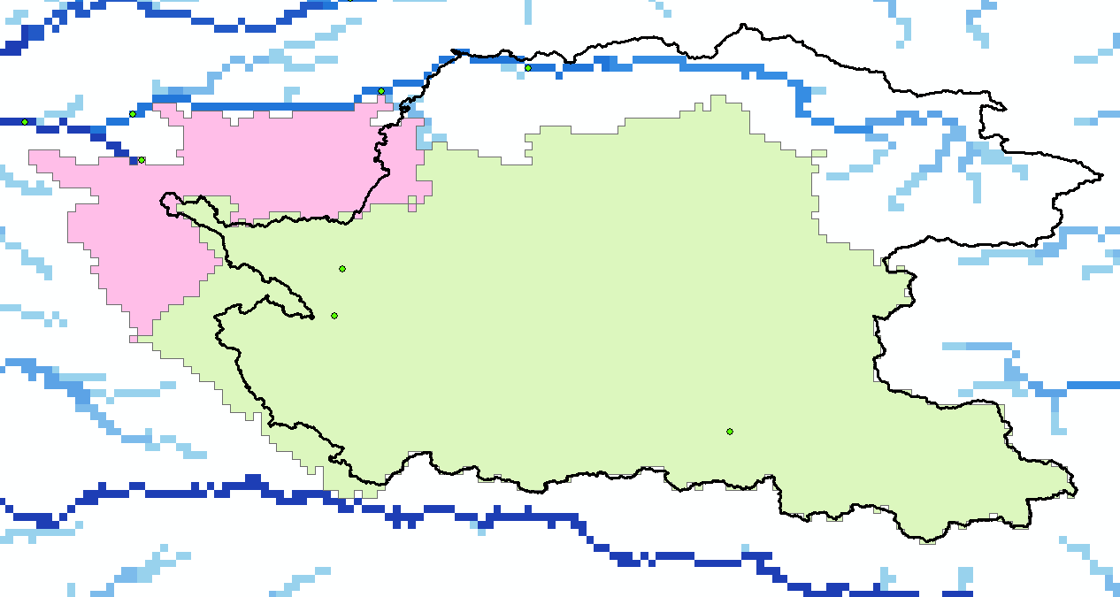

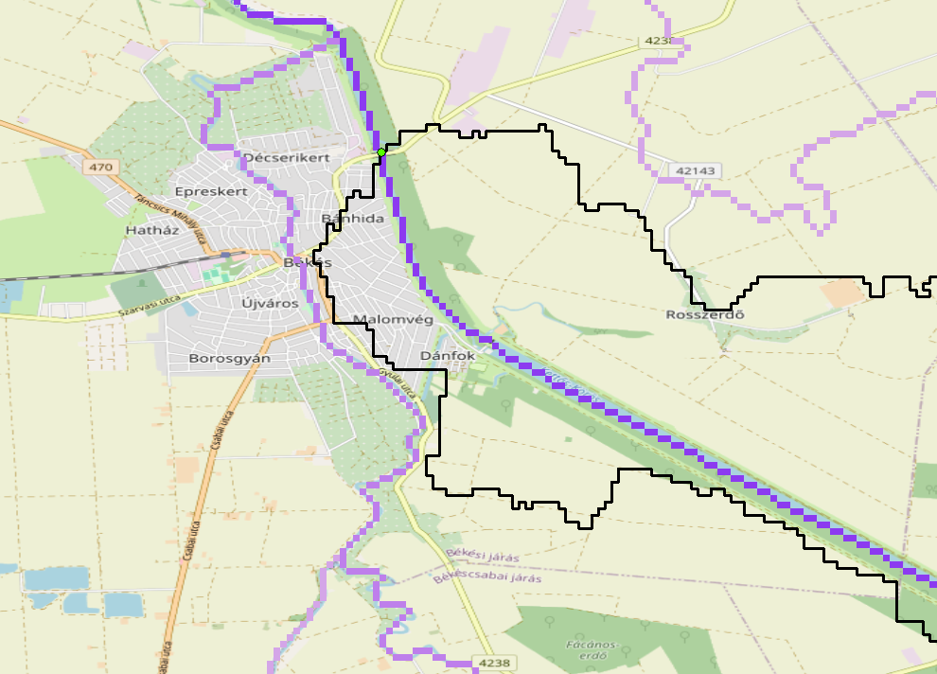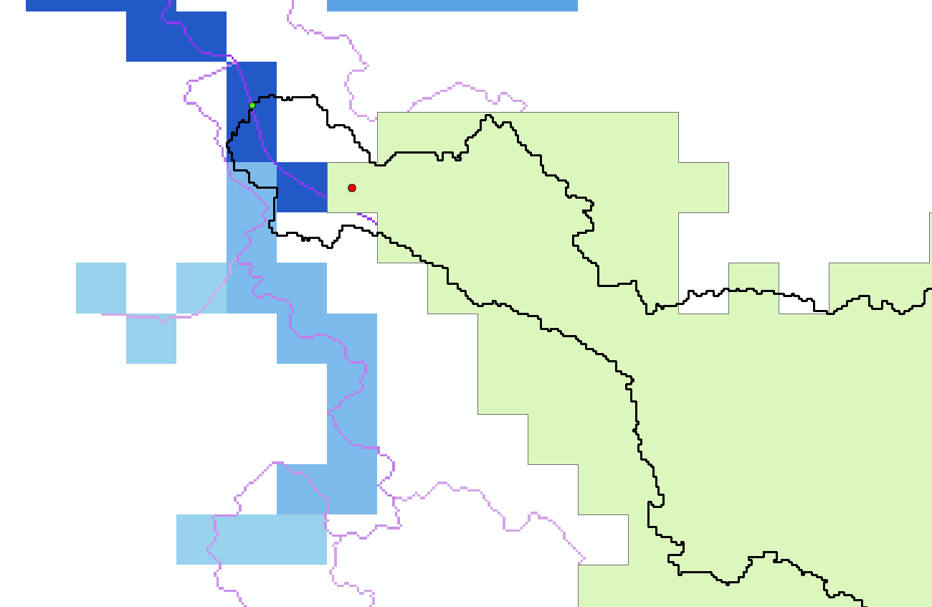

Fig 6: Station 660, Koros - Bekes, Hungary. The EFAS station location (shapefile in pink) includes much more than the new calculated station location. The black outline is the 3 arcsec basin. It seems that the 1 arcmin is corrected and does not include the north-eastern part. But the station in Bekes, does not include the rivers in the West and North-West.

Station 263, Danube - Bajina_Bata

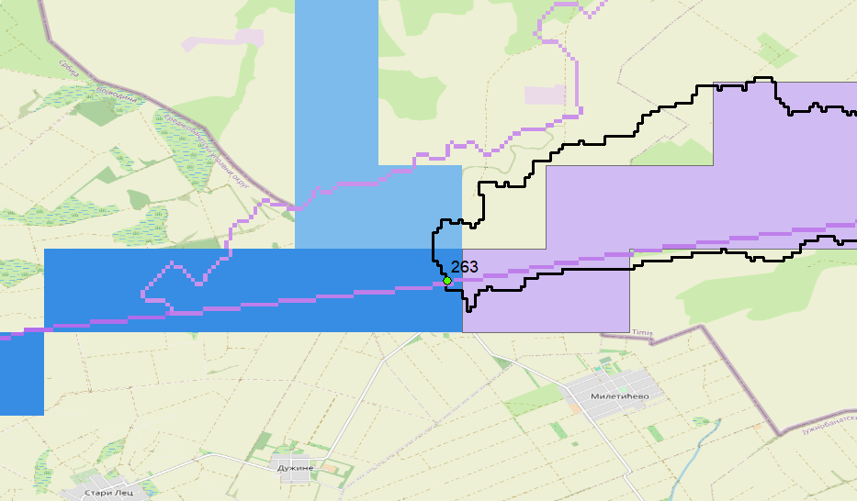

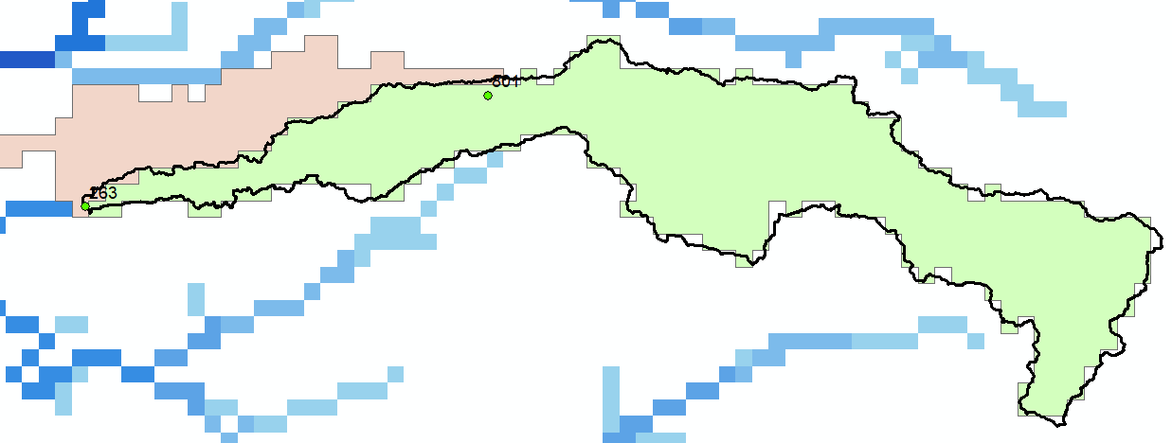

Fig 7: Station 263, Danube - Bajina_Bata. The EFAS station basin includes the river which joins downstream of the station location

**Summary**

**References**

Burek, P. and Smilovic, M.: The use of GRDC gauging stations for calibrating large-scale hydrological models, Earth Syst. Sci. Data, 15, 5617–5629, https://doi.org/10.5194/essd-15-5617-2023

Eilander, D., van Verseveld, W., Yamazaki, D., Weerts, A., Winsemius, H. C., and Ward, P. J.: A hydrography upscaling method for scale-invariant parametrization of distributed hydrological models, Hydrol. Earth Syst. Sci., 25, 5287–5313, <https://doi.org/10.5194/hess-25-5287-2021>

Lehner, B.: Derivation of watershed boundaries for GRDC gauging stations based on the HydroSHEDS drainage network – Technical Report prepared for the GRDC, Global Runoff Data Centre, Koblenz, Germany, 18, 2012.

Yamazaki D., D. Ikeshima, R. Tawatari, T. Yamaguchi, F. O'Loughlin, J.C. Neal, C.C. Sampson, S. Kanae & P.D. Bates A high accuracy map of global terrain elevations Geophysical Research Letters, vol.44, pp.5844-5853, 2017 doi: 10.1002/2017GL072874

Yamazaki, D., Ikeshima, D., Sosa, J., Bates, P. D., Allen, G. H., and Pavelsky, T. M.: MERIT Hydro: A High-Resolution Global Hydrography Map Based on Latest Topography Dataset, Water Resour. Res., 55, 5053–5073, 2019, <https://doi.org/10.1029/2019WR024873>