|  |  |  |  |  |  |
| --- | --- | --- | --- | --- | --- |
| Función | Método | Intervalo o puntos iniciales | Número total de iteraciones | Raíz $$x_{r}$$ | $$f(x_{r})$$ |
|  | Bisección | [0.2,0.6] | 15 | 0.38018798828124994 | 9.761970179544832e-06 |
| Falsa Pos. | [0.2,0.6] | 10 | 0.380187079523183 | 1.2125272988328106e-05 |
| Newton | 0.6 | 4 | 0.3801917455074926 | -9.132516964882598e-09 |
| Secante | 0.55,0.6 | 5 | 0.38019180119181045 | -1.5394744545815797e-07 |
|  | Bisección | [0.0,1.0] | 17 | 0.5852127075195312 | 2.313834669465109e-05 |
| Falsa Pos. | [0.0,1.0] | 7 | 0.5852101401288736 | 8.569213640896578e-06 |
| Newton | 1.0 | 4 | 0.5852086276370358 | -1.3726541681080562e-08 |
| Secante | 0.95,0.5 | 4 | 0.5852086325393028 | 1.409239125393924e-08 |
|  | | | | | |
|  | Bisección | [0.01,0.1] | 14 | 0.0644317626953125 | -0.00017861062069002287 |
| Falsa Pos. | [0.01,0.1] | 15 | 0.06443979198824211 | -0.0005619473390403584 |
| Newton | 0.01 | 5 | 0.06442801009693341 | 5.665264630749789e-07 |
| Secante | 0.01,0.015 | 7 | 0.06442802173265637 | 1.0930659044561253e-08 |

7.

8.

a) $n_{r}={\left[\frac{1}{0.710}\left(1440n_{r}^{-2}-0.088-0.0636n_{r}\right)\right]}^{-1}$

b) 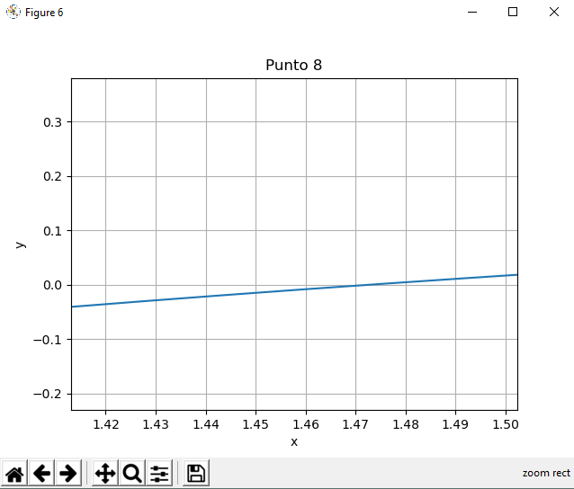

Basándome en la gráfica mostrada en la imagen anterior y el mínimo valor de x para el cual la función es 0 considero que el intervalo bb[1,1.5] es el adecuado pues se ve que corta en 1.47 al eje x.

c)

|  |  |  |  |
| --- | --- | --- | --- |
| Expresión **i** | | | |
| Iter |  |  |  |
| **0** | 2 | 1.58916005292062 | - |
| **1** | 1.58916005292062 | 1.5048900456558676 | 0.41083994707938 |
| **5** | 1.4737568287296574 | 1.4732047252731744 | 0.0018907336178102252 |
| **10** |  |  |  |
| **13** |  |  |  |
| Expresión **ii NO CONVERGE** | | | |
| Iter |  |  |  |
| **0** | 2 | -1.3050314465408803 |  |
| **1** |  |  |  |
| **5** |  |  |  |
| **10** |  |  |  |
| **13** |  |  |  |
| Expresión **iii** | | | |
| Iter |  |  |  |
| **0** | 2 | 1.7898 |  |
| **1** | 1.7898 | 1.6408009742307477 | 0.21019999999999994 |
| **5** | 1.4852790501636146 | 1.4775399010620938 | 0.007739149101520848 |
| **10** | 1.4730563901708529 | 1.4730054928539198 | 5.089731693308508e-05 |
| **13** |  |  |  |

9.

a) 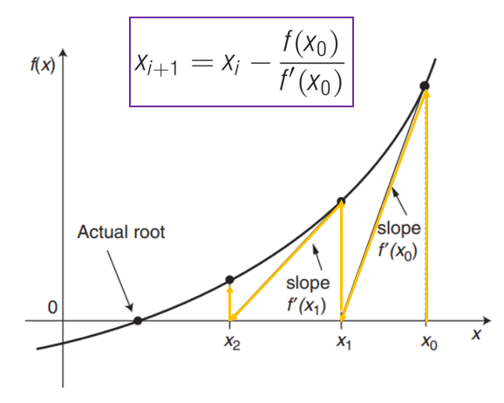

Método de Newton – Rapson.

Figura tomada de las presentaciones de clase

$$f\left(x\right)=-1.440n_{r}^{-2}+0.710n_{r}^{-1}+0.088+0.0636n_{r}$$

$$f´\left(x\right)=2.880n_{r}^{-3}-0.71n_{r}^{-2}+0.0636$$

$$x_{i+1}=x_{i}-\frac{f\left(x_{0}\right)}{f'(x_{0})}$$

b)

|  |  |  |  |
| --- | --- | --- | --- |
| ***Método de Newton*** | | | |
| Iter |  |  |  |
| **0** | 2 | 0. 2102 |  |
| **1** | 1.1458756603006908 | -0.3162079727098708 | 0.8541243396993092 |
| **3** | 1.4607898130103525 | -0.00787390490533553 | 0.012025154847689512 |
| **6** |  |  |  |
| **10** |  |  |  |

**NOTA: Los puntos que hacen falta acá se encuentran en el archivo Salazar_201816839.py**