API ROOT URL : <http://api.chatndate.com/web/api>

While using API in your java code, please keep this url in variable because root URL can be changed in future.

To test API I am using Chrom extension POST

These services are avaible with current API

• GET /users: list all users page by page;

• POST /users: create a new user;

• GET /users/123: return the details of the user 123;

• GET /profile: list all users profiles page by page;

• GET /profiles/123: return the full profile of the user 123;

Error handler:

In case of error you will get response in following format:

Here important is status code, which will point you exact issue with request, these status code are standards provided by all API services, so we will follow same. Message is custom attribute it will get more specific explanation of error.

{

"name": "Unprocessable entity",

"message": "{\"email\":[\"This email address has already been taken\"]}",

"code": 0,

"status": 422,

"type": "yii\\web\\HttpException"

}

Complete Error responses Guide

* 200: OK. Everything worked as expected.
* 201: A resource was successfully created in response to a POST request. The Location header contains the URL pointing to the newly created resource.
* 204: The request was handled successfully and the response contains no body content (like a DELETE request).
* 304: The resource was not modified. You can use the cached version.
* 400: Bad request. This could be caused by various actions by the user, such as providing invalid JSON data in the request body, providing invalid action parameters, etc.
* 401: Authentication failed.
* 403: The authenticated user is not allowed to access the specified API endpoint.
* 404: The requested resource does not exist.
* 405: Method not allowed. Please check the Allow header for the allowed HTTP methods.
* 415: Unsupported media type. The requested content type or version number is invalid.
* 422: Data validation failed (in response to a POST request, for example). Please check the response body for detailed error messages.
* 429: Too many requests. The request was rejected due to rate limiting.
* 500: Internal server error. This could be caused by internal program errors.

Webservice Objects

GET /users

Purpose: List all users by page

**User object URL :** <http://api.chatndate.com/web/api/users>

Here we will call user is object on user object we can perform several action our first action is list down all the users stored in database.

To access user object you need to call above user, It will return you list of users in json format, currently per feed limit is 20, we may increase or decrease per page limit

By calling above url it will return following feed

[

{

"id": 29,

"username": "test24",

"email": "test24@test.com",

"password_hash": "$2y$10$E16iAHFpdyQOc7CcgC683.uwsjld1pFZ16CVYUnxufBLYXKn0JGLC",

"auth_key": "KHCihqaEDqflQVDLWDqTIje4uvvB5-v5",

"confirmed_at": null,

"unconfirmed_email": null,

"blocked_at": null,

"registration_ip": "::1",

"created_at": 1462071188,

"updated_at": 1462071188,

"flags": 0,

"rabbitmq_routing_key": "29",

"rabbitmq_channel_name": "29"

},

{

"id": 30,

"username": "test25",

"email": "test25@test.com",

"password_hash": "$2y$10$TO9jdxyKMXFSid9xCX/4be4YvSXGrJbKHGyoxj4fAGFe6z.t63HvK",

"auth_key": "5m47cNzJEWpUl1TlugL9IkqIFv3c3qKr",

"confirmed_at": null,

"unconfirmed_email": null,

"blocked_at": null,

"registration_ip": "::1",

"created_at": 1462071263,

"updated_at": 1462071263,

"flags": 0,

"rabbitmq_routing_key": "30",

"rabbitmq_channel_name": "30"

}

]

**Header information for above request**

**Connection →**Keep-Alive

**Content-Length →**7586

**Content-Type →**application/json; charset=UTF-8

**Date →**Sun, 01 May 2016 03:03:58 GMT

**Keep-Alive →**timeout=5, max=100

**Link →**<http://localhost/ChatWeb/web/api/users?page=1>; rel=self, <http://localhost/ChatWeb/web/api/users?page=2>; rel=next, <http://localhost/ChatWeb/web/api/users?page=2>; rel=last

**Server →**Apache/2.4.9 (Win64) PHP/5.5.12

**X-Pagination-Current-Page →**1

**X-Pagination-Page-Count →**2

**X-Pagination-Per-Page →**20

**X-Pagination-Total-Count →**26

**X-Powered-By →**PHP/5.5.12

Header contained very useful information

**X-Pagination Tell us how many total record found respective to our query, what is our current page number**

<http://api.chatndate.com/web/api/users?page=2>

It will fetch next 20 feeds, because we have limit of 20 feeds per page

GET /users/30

Purpose: List individual users detail

**User object URL :** <http://api.chatndate.com/web/api/users/30>

This API’s working is same but rather then providing list of users in array it will give you json object for user with ID 30

Example:

{

"id": 30,

"username": "test25",

"email": "test25@test.com",

"password_hash": "$2y$10$TO9jdxyKMXFSid9xCX/4be4YvSXGrJbKHGyoxj4fAGFe6z.t63HvK",

"auth_key": "5m47cNzJEWpUl1TlugL9IkqIFv3c3qKr",

"confirmed_at": null,

"unconfirmed_email": null,

"blocked_at": null,

"registration_ip": "::1",

"created_at": 1462071263,

"updated_at": 1462071263,

"flags": 0,

"rabbitmq_routing_key": "30",

"rabbitmq_channel_name": "30"

}

POST /users

Purpose: Create new user

**User object URL :** <http://api.chatndate.com/web/api/users>

When you hit above API url with post data, This API assume you are trying to insert data in users object, which mean it is create new user request.

In this case you need to post data with following format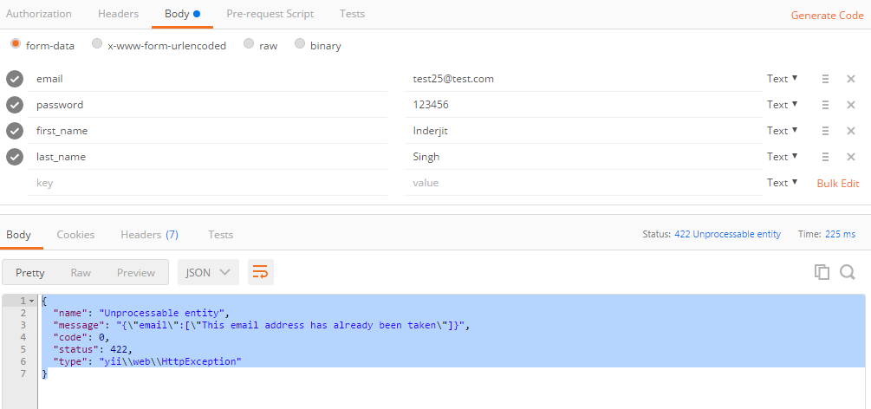

Currently I am taking just simple information

email

password

first_name

last_name

Because our High priority work is to build chat API, we will expand profile information later, I already created table to store users full profile but it will make our testing job hard if need to fill big form to create new user.So we will expand this Profile creation API later with more inputs.

Now we have API where you can create new user, list users, view user individually.

It will help us to reach chat screen, then our next move will be sending and receiving chat messages.

GET /profiles

Purpose: List all profiles of users by page

**User object URL :** http://api.chatndate.com/web/api/profiles

GET /profiles

Purpose: detail view of individual profile

**User object URL :** http://api.chatndate.com/web/api/profiles/30

Example:

{

"user_id": 30,

"first_name": "Inderjit",

"last_name": "Singh",

"gender": null,

"appellido_paterno": null,

"appellido_mother": null,

"places_country_id": null,

"places_state_id": null,

"places_city_id": null,

"address": null,

"language": null,

"dob": null,

"height_ft": null,

"weight_kg": null,

"profession": null,

"education": null,

"languages_spoken": null,

"description": null

}