To run the application, open a shell window or command prompt window, go to the directory where PFM2OSM.jar is and enter java –jar PFM2OSM.jar. You can also create a shortcut in your Desktop for this command.
A very simple GUI window pops up:
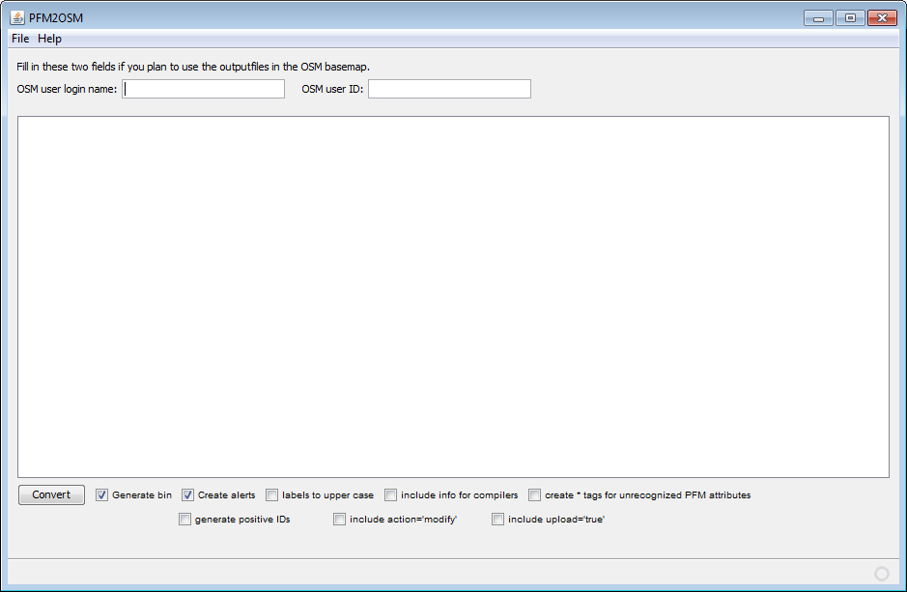
Just hit the “Convert” button to select the input .MP files and generate the OSM files.
If you are in Linux, you can check “Generate bin” to also generate the Navit binary maps (requires Navit and its Maptool compiler).
Check “Create alerts” to generate the Navit alert files for POIs such as speed traps and red light traps.
Check “labels to upper case” to change labels and geoindexing data to uppercase. Geoindexing data are text used for searches, such as city name.
Check “include info for compilers” to include map compiler-specific tags. For pure-OSM tags, left this unchecked.
Check “create * tags for unrecognized PFM attributes” to include tags named “*” to point out any unknown PFM found. This may be useful to find bugs or incorrect PFM parsing.
Check "generate positive IDs" to generate positive IDs in the output OSM, because only negative IDs are generated by default to facilitate upload using JOSM.
Check "include action='modify'" to enable the attribute action='modify' to all converted objects. This tells JOSM to upload and change all converted objects.
Check "include upload='true'" option to enable the attribute upload='true' in the main <osm> tag. This tells JOSM to upload the converted OSM file.
Fill in the fields “OSM user login name” and “OSM user id” with your account info in OSM system if you plan to use the generated data to update OSM basemap, since anonymous changes are not allowed. PFM2OSM does not perform checks nor logs in to OSM using that info. It just fills in the “user=” and “uid=” XML tags in the output as they are typed by you. You can safely left them blank for other OSM files uses.

