Representation 🡪 a formal system by which the information or data can be specified.

Abstracting 🡪 summarize or state the essence of the information concerned.

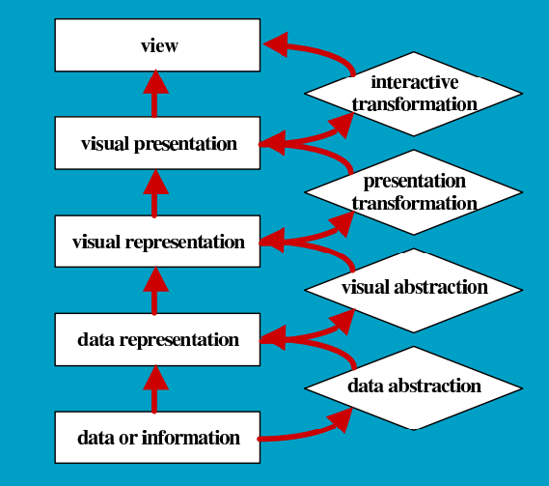

Jacques Bertin developed a practical approach for his data graphics that is based on the opinion that there is a basic visual unit and that there are ways of changing this basic unit.

The author refers to the fact that we must take into account that there are differences between data graphics and computational presentation when analyzing Bertin’s work.  
  
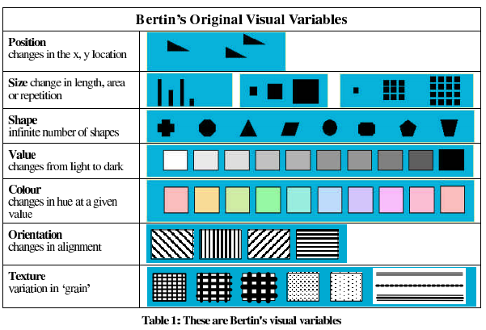

Selective 🡪 A visual variable is said to be selective if a mark changed in this variable alone makes it easier to select that changed mark from all other marks. *Is change in this visual variable alone enough to allow us to select it from a group?*

Associative 🡪 Visual variable is said to be associative if marks that are like in other ways can be grouped according to a change in this visual variable. (marks can all be made the same colour for example.) *Is a change in this visual variable enough to allow us to perceive them as a group?*

Quantative 🡪 If the relationship between two marks differing in this visual variable can be seen as numerical. Often seen as ratios of one mark to another. *Is there a numerical reading obtainable from changes in this visual variable?*

Order 🡪 A visual variable is said to be ordered if changes in this visual variable support ordered readings. For example less dark or more light. *Are changes in this variable perceived as ordered?*

Length 🡪 The length of a visual variable is the number of changes that can be used and still retain the task supporting characteristics that are usually associated with this visual variable. *Across how many changes in this visual variable are distinctions recognizable?*

**Position**

Position: Selective. Marks that are the same in all respects except for position can easily being distinguished and interpreted as different.

Position: Associative. Changes in positional visual variables can be used to create groups of marks that can be interpreted as belonging together.

Position: Quantitative. Position is frequently used to indicate a numerical value with an x and y axis.

Position: Order. Changes in position are readily orderable.

Position: Length. The positional variables have exceptional length in that a considerable number of changes in position are still perceived as distinct and therefore will still retain the task in supporting characteristics that are usually associated with position.

Position is the most versatile and most powerful visual variable.

**Size**

Only points, lines or planes can be changed in size without causing a change in the interpretation of the sign.

Size: Selective. A change in size is selective since if a sign is changed in size alone it will become distinct and therefore selectable from other signs.

Size: Associative. Changes in size can be used to create groups of signs that can be interpreted as belonging together.

Size: Quantitative: Size can sometimes be used to indicate a numerical value.

Size: Order. Changes in size are readily orderable.

Size: Length. Theoretically infinite but practically limited.

**Shape**

Shape: Selective. Shape is partially selective because it is a difficult task distinguishing it from other shapes.

Shape: Associative. Shape is considered partially associative.

Shape: Quantative. No.

Shape: Order. Signs that change in shape do not support ordered readings.

Shape: Length. Shape of a sign of a particular area can be varied indefinitely.

Representational power of shape comes from its infinite length and from symbolic interpretation.

**Value**

Changing a mark’s value is achieved by changes in darkness/lightness of the mark.

**Value: Selective.** Mark is selectable based on viewing its value.

**Value: Associative.** Changes in value are associative.

**Value: Numerative.** Changes in value do not provide numerical reading since the relationship between two signs differing in value only is not seen as numerical.

**Value: Order.** Value is ordered since changes in value support ordered readings.

**Value: Length.** Number of changes possible in value is theoretically infinite but practically limited.

**Colour**

**Colour: Selective.** Colour is selective since a mark changed in colour alone makes it easy to select from all other marks.

Colour: Associative. Colour is associative since marks can be grouped by it.

Colour: Quantative. No.

Colour: Order. No

Colour: Length. Yes. Number of changes indefinite only practically limited.

**Orientation**

**Orientation: Selective.** Orientation can be selective if the display does not use perspective and if the shape or pattern whose orientation is to be changed has a linear aspect.

**Orientation: Associative.** As with selection, orientation can be associative if the display does not use perspective and if the shape or pattern whose orientation is to be changed has linear aspect.

**Orientation: Quantitative.** No numerical value in orientation.

**Orientation: Order.** No

**Orientation: Length.** Theoretically infinite, practically useful to use only a few positions.

**Grane**

A change in grain is achieved by increasing the number of marks without changing the value.

**Grane: Selective.** Yes.

**Grane: Associative.** Grain is minimaly associative but as with selectivity the irritating effect can counteract the usefulness of this. Yes.

**Grane: Quantitative.** Grain does not support numerical interpretations.

**Grain: Order.** Grain is not ordered except if the changes in grain are often accompanied by changes in value.

**Grain: Length.** The larger the mark the more length there is for grain. Yes.

**Pattern.**

Turn to shape.

**Texture.**

**Texture: Selective:** Yes.

**Texture: Associative.**  Yes.

**Texture: Quantitative.** No.

**Texture: Order.** No.

**Texture: Length.** Yes.

Motion.

**Motion: Selective:** Yes.

**Motion: Associative.**  Yes.

**Motion: Quantitative.** No.

**Motion: Order.** Yes.

**Motion: Length.** Yes.