*Find a visualization not discussed in class or used in a homework and answer the following questions pertaining to that visualization. Attach the visualization as a screenshot in your submission.*

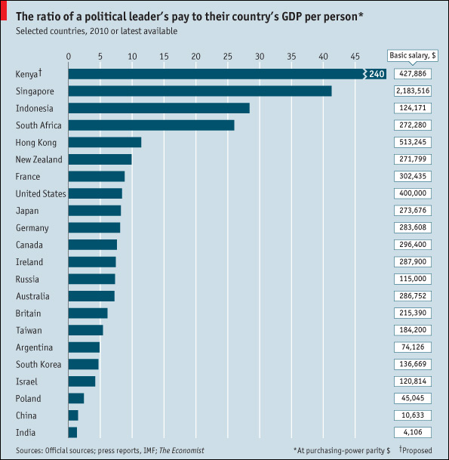

*Consider Bertin’s characterization of visual variables (position, size, shape, value, color, orientation, and texture). Pick 2 of Bertin’s visual variables, and discuss them in relation to your visualization.*

2.Position: The bars in the chart can clearly be distinguished by their position. The difference between the bar belonging to Kenya and the bar belonging to Singapore is clearly visible. The associative characteristic in this chart is that the bars are all placed right above each other, so we can see that they are comparable. The quantitative function of the visual variable position is also used well. By looking at the bars we immediately get a good idea of a certain numerical value: The salary of the country’s leader divided by the country’s GDP. There is definitely a good use for order in this chart. One of the bars could be moved slightly up/down or left/right, even though it would make little sense in this chart. Length also applies in this chart. The bars could be moved and they would still be seen as distinct.

Size: The size of the bars is definitely selective. We can see that Kenya’s bar is larger than the one belonging to Singapore and that helps us distinguish the two. The bars are associative because we place them in the same group due to their similar shape. Being quantitative is not a applicable to shapes according to Carpendale, so we won’t discuss this. Order is relevant because we can see that a larger bar is “worth more.” Length is also a factor because the bars could be made infinitely small or larger as long as they fit on the chart.

*Munzner proposed a nested model for visualization design and validation. Discuss/validate your visualization with respect to domain problem characterization and data/operation abstraction design.*

Domain problem characterization basically refers to the gap that exists between designers in users. Within the domain there is usually a standard vocabulary and a workflow in which the data is used where the designer could not be aware of. This data visualization is made by journalists of The Economist for readers of the The Economist. The journalists probably know what their readers are interested in. Therefore the journalists chose political leaders pay divided by national GDP as a topic because they thought readers would be interested in it.

About the data/operation abstraction design not much is known about this chart. In the chart it says its sources are “press reports, IMF”. So what I think the economist did is extract all these statistics and put them in a table.

*Based on Cleveland and McGill’s results, does your visualization embody good practices (i.e. can people accurately perform the tasks based on the encodings?)*

It does. By choosing a bar chart, as opposed to a pie chart, you can perceive patterns that result from the increased accuracy of perceptions based on position relative to that based on angle judgements.

*Do you agree that visualization is a functional art? Explain.*

I agree. It is functional because it conveys useful information to the user. It shows a message that the user would have never been able to obtain themselves by looking a raw data set.

It is also definitely an art because there is a large aesthetic factor. In data visualization, designers often don’t choose the most functional form when visually encoding the data. They also take into account that the form looks good. Therefore it is also an art.

*Ask yourself what the designer is trying to convey and think of three to four possible tasks this visualization should help you with. Does the visualization achieve any of your tasks? (To view an example, see Albert Cairo, pages 26-­28.)*

The designer is trying to convey that developed, rich countries do not pay their leaders the most relatively.

It helps me with the following tasks:

* Present
* Compare
* Correlation.

The graphic clearly portrays the variable leader income / GDP. Therefore is has clearly **presented** me one variable. Since I can position along a common scale, it helps me accurately judge the amount the leaders are payed. Therefore I can **compare** the nations and it helps me in this task. Finally it also helps me spot **correlation**. There doesn’t seem to be one though. Both rich and poor countries can pay their leaders excessive amounts.