1. Ware argues that human perception involves 2.5 dimensions. Given this assertion, when might a 3D visualization be useful and why?

When it is very clear that objects in the visualization are 3d. This is so because towards-away information is provided a lot less than up and sideways directions. This has to do with the fact that we cant see through a lot of objects. Therefore 3d visualizations must contain many pictorial depth cues. Also Ware describes that you can put objects in another dimension if you want them to stand out. Furthermore humans can be used to seeing certain objects in 3d, therefore it might be necessary to make these objects 3d in a visualization so that it seems more ‘normal’.

1. In Chapter 6, Ware presents some implications of pattern recognition and visual working memory on design. Provide an example that harnesses some of these principles (perhaps an advertisement, visualization, or interface) and discuss how the design takes these principles into account. Please include a screenshot, photo, or website URL.



The implications of pattern recognition and visual working memory on design that I will discuss are making objects easy to identify, novelty and meaning & emotions. The object that is made easy to identify are the borrels of chemicals in the background. This is done by using they chemical symbol. The novelty in this advertisement is the gun. It is not normal for chemists to be armed, so your attention is immediately drawn to it. Furthermore meaning and emotions play an important roll in this advertisement. By making most of the picture black and white and the serious faces of the characters, you immediately realize that show is serious. That it is not a comedy for example.

1. According to Bostock et. al., what are the primary advantages of D3? Based on your reading of the article, please provide an example of a type of visualization that would be easier and better implemented in D3 as opposed to HTML5, JSON, and Javascript. Please list the pros and cons of choosing D3 over pure HTML5, JSON and Javascript.

Advantages are:

* The ease in which transitions can be implemented. Considering the fact that dynamic graphics can have a great emotional impact on the user, this can be very useful.
* Its compatibility with developer tools.
* High collaborative potential through rapid iteration, added event listeners to another’s to coordinate views and the ability to view source on any visualization.
* Builds on key standards. This keeps D3 up to date with the evolving technological ecosystem of the web, improving expressiveness and accessibility.

Disadvantages are:

* D3 has a fairly steep learning curve.
* D3 might be slow for a large number of entries.

1. Of the visualization figures presented in Heer et. al., which do you find the most difficult to comprehend? Does the complexity of the figure interfere with the goal of visualization as described in the article? Include a screenshot of the figure you have chosen in your response and use principles that you have learned so far (i.e., from design, perception, and cognition) to justify your choice.

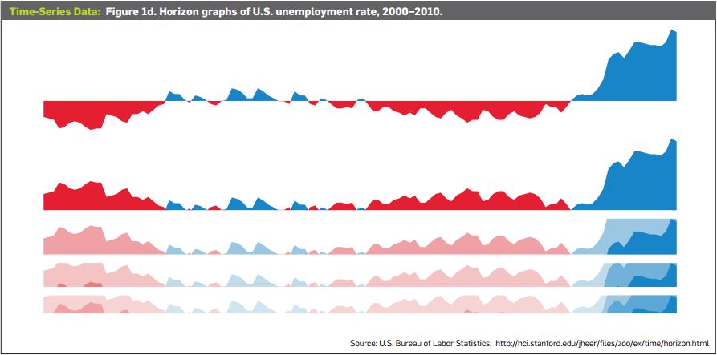

I think figure 1d is the most difficult to understand, although the image above helps understanding it. The blue and red surface keep on being chopped in half and represented by a darker tone of that color. Its complexity interferes with the goal of the visualization because it has now become harder to estimate the exact unemployment since you now have to add the surfaces up in your mind. From a design perspective it can be plausible to use this visualization, since it saves space. However from a perception and cognition standpoint, this is a bad choice.

1. Play around with the interactive graphs included in the Heer article. You need to open this page in a browser that runs Java. Focus on Figure 1A. To what extent do interactivity and transitions, elements that D3 optimizes, add to the clarity and message of the visualization? With the element of interactivity in mind, redesign and sketch the contents of figure 1A with one of the other visualization types described in the Heer article. Include a picture of a sketch of your idea, and describe how it supports comprehension and data exploration.

It is a good visualization. However from an interactivity point of view, it is super annoying that the y-axis keeps changing. This makes it impossible to view a trend over time and therefore ruins the clarity and message of the visualization. I would just make the graph as sketched below, with a constant y-axis.

