Stability of Headwater Streamflow Under Two Decades of Climate Change

ABSTRACT
Climate change is altering the inputs and outputs of the watershed water budget, and the assumption that streamflow varies within a stationary envelope no longer holds. Small, undisturbed watersheds have little storage to buffer these changes and are therefore sensitive integrators of hydrologic response. We analyzed trends in streamflow, temperature, precipitation, and gross primary productivity (GPP) at 166 first- and zero-order watersheds in the MacroSheds dataset across the conterminous United States (CONUS) over 2001–2023, using PRISM climate and MODIS annual GPP, and compared them with a spatially uniform reference grid of 5,212 points. Trends were estimated with Sen’s slope, and sites were grouped by expected net water demand (NWD) from the sign and significance of temperature, precipitation, and GPP trends. Warming was significant at 71 of 166 sites, whereas precipitation trends were significant at only 2 sites and GPP trends were uncommon and mixed in sign. Of 126 non-experimental sites, 46 had streamflow records sufficient for trend detection, and 6 showed a significant trend: 4 increasing, all within one Wisconsin lake-district domain, and 2 decreasing at arid, warming sites in California. MacroSheds sites broadly reproduce the grid’s distribution of NWD regimes. Where streamflow did respond, its direction followed long-term aridity, humid sites gaining flow and arid sites losing it, consistent with aridity as a first-order control. Sites lacking usable streamflow records were disproportionately arid, so the systems expected to respond most are the least observed; sustaining continuous monitoring in these regions is essential for detecting change.

INTRODUCTION

Background
Streamflow is a fundamental measurement in watershed science. Since the 1960’s, watershed science has used water budgeting to learn about how ecosystems function (Bormann & Likens, 1967). By measuring the water entering (precipitation) and leaving (evaporation, transpiration, and streamflow) a watershed, researchers can create watershed budgets, as represented in equation 1. Where Q is the streamflow, P the precipitation, and E, T, and S evaporation, transpiration, and storage, respectively.
$$equation 1:Q=P−(E+T+S)$$
This approach to budgeting works best in smaller watersheds, with limited storage and well-defined boundary conditions (Bormann & Likens, 1967; Likens et al, 1970). Paired-catchment experiments subsequently demonstrated that vegetation changes in these small systems produce detectable shifts in water yield (Bosch & Hewlett, 1982), establishing the sensitivity of headwater watersheds as analytical tools. However, climate change is acting on both the inputs and outputs of watershed budgeting over the last 40 years. With access to remotely sensed and gridded data, we can observe many changes across CONUS.
These changes are now well documented at continental scales. Over the past four decades, researchers have observed meaningful trends for each component of the water budget. Temperatures are increasing across most of the CONUS, increasing evaporation (Ji et al, 2014). Precipitation has become more variable, with more of it arriving in extreme events (Adler et al, 2017; Davenport et al, 2021). Concurrently, productivity from watersheds has been increasing across most of the CONUS (Zeng et al, 2018; Wang et al, 2021; Yang et al, 2023). Research also shows that the increasing water use efficiency (WUE) of those plants from carbon fertilization has leveled off, leading to increased transpiration as temperatures continue to rise (Li et al, 2023). These concurrent shifts in the water balance have prompted a broader reckoning: the long-held assumption that hydrologic systems fluctuate within a stationary envelope may no longer hold (Milly et al., 2008). If stationarity cannot be assumed, detecting and characterizing streamflow trends becomes essential.
Given all this change to inputs, it is reasonable to expect change in outputs, namely decreasing streamflow across many systems. Early trend analyses of USGS stations found the conterminous U.S. becoming wetter but less extreme, with increases concentrated in low and median flows rather than peak flows (Lins & Slack, 1999), with some of those changes appearing as step increases rather than gradual trends (McCabe & Wolock, 2002). In past work, streamflow in larger systems has shown variable responses to climate change, including more high and low flow days (Wang et al, 2024). Analysis of USGS gauges found from 1940-2022 found steeply increasing streamflow in the northeast and Midwest and little significant change elsewhere (USGS, 2023). Together, these studies establish that streamflow is responding to climate change at broad scales, but they leave open the question of what drives that response at the watershed level. Large watersheds are also affected by heavy anthropogenic use (by design for USGS gauges), muddling any insights into how fundamental elements of watershed attributes affect streamflow attenuation. To do so demands analysis of a diverse group of small watersheds with very limited anthropogenic influence and long running streamflow records. This study uses the MacroSheds dataset, a harmonized collection of long-running, small-watershed ecosystem studies across CONUS, to address that need. We focus on 2001–2023, the period over which a single-sensor satellite record of productivity is available alongside gridded climate and streamflow, so that every trend we report is evaluated over the same two decades. We organize the analysis around three questions:

Research Questions
RQ1: What are the trends in streamflow in the CONUS from small watershed ecosystem studies?
We expect that trends will closely follow climate trends, with more discharge in the upper Midwest and Northeast and less discharge in arid environments. We expect to see abundant change, as small watersheds have little space and time to attenuate signals from climate drivers.
R1A: What drives sensitivity or insensitivity of streamflow to changes in water balance?
We expect that aridity is the main driver of streamflow sensitivity. Arid, water-limited sites will be most sensitive to changes in incoming precipitation. Humid, energy limited sites will be most sensitive to changes in temperature.
RQ2: How well does the current suite of WS studies capture the landscape of climate change across the CONUS?
We expect that since existing watershed studies are broadly distributed, they are capturing most patterns of change. However, due to the assumptions preferred for these studies (high slopes, solid bedrocks, constant flow, non-arid) they will be biased towards sites with increasing flows.

METHODS

Open analysis
All data and analyses used in this effort are hosted publicly at https://github.com/rossyndicate/ms_physical_patterns (will version on submission).

Data sourcing
All streamflow data for this effort were sourced from MacroSheds, a harmonized dataset of small watershed ecosystem studies (Vlah et al, 2023). The dataset is well situated for this effort, as sites used for these kinds of studies tend to be small, undisturbed, and have long record lengths. Streamflow data was furnished by the contributing members to MacroSheds (Vlah et al, 2023). As sites in MacroSheds have varying quality of precipitation data, we used gridded, PRISM for rainfall and air temperature (PRISM Group, 2025).
To estimate GPP, we used the MODIS MOD17A3HGF annual GPP product (500 m resolution) as distributed by MacroSheds (variable gpp_global_500m_median), which reports the median annual GPP of the MODIS pixels within each watershed boundary for 2001–2023 [CITATION NEEDED: MOD17A3HGF product description]. An earlier version of this analysis used Landsat-derived GPP (USGS, 2025) at 30 m resolution over 1986–2022. That record is stitched together across successive Landsat missions, and GPP trends derived from it can reflect handoffs between sensors rather than change on the ground [CITATION NEEDED: Landsat mission-handoff artifacts in long-term vegetation trends]. We therefore replaced it with the single-sensor MODIS record and retain the Landsat product only as a point of comparison (see GPP product validation below).
MOD17 writes a fill value in place of GPP wherever land cover is classed as urban, barren, or water. MacroSheds does not mask this value before computing the watershed median, so watersheds dominated by these classes carry a constant fill value (65535, or 6.5535 after scaling) rather than a GPP estimate. We masked values at or above 6.55 to no-data, which removed 8 watersheds (in the Baltimore, Plum Island, and Santa Barbara domains) from GPP trend analysis and left 158 sites with a usable GPP record.
Two properties of the MODIS record bear on interpretation. First, MODIS pixels (500 m, 0.25 km²) are coarse relative to these catchments: the 166 MS sites have a median area of 3.07 km² (interquartile range 0.5–11.98 km²), and 24, 60, and 79 of the 166 are smaller than 1, 4, and 10 pixels, respectively. Landsat’s 30 m pixels were far better matched to catchment size; MODIS trades that spatial fidelity for a consistent single-sensor time series, and for the smallest watersheds its GPP signal reflects the surrounding landscape as much as the catchment itself. Second, MOD17A3HGF reports a calendar-year total. We assigned each value to the water year (October–September) of the same calendar year, an overlap of nine months; this offset has no bearing on trend estimation but means annual GPP and streamflow metrics are not aligned to exactly the same twelve months. MacroSheds does not state which MOD17A3HGF collection its GPP variable was derived from; the grid GPP described below was extracted from Collection 6.1.

Streamflow analysis
To determine how streamflow is changing across CONUS, we analyzed trends in daily streamflow data from MacroSheds sites (now called ‘MS sites’). First, using the ‘ndhplusTools’ package in R (Blodgett, 2023) we limited our analysis to first or zero order streams. Then, we limited streamflow records to water years 2001–2023, the period from the first full year of MODIS observations through the last year of the MOD17A3HGF record, and selected each site’s longest contiguous window within that period with no more than 40% missing data. This window is shorter than the streamflow record at many long-running sites, but it ensures that streamflow, climate, and GPP trends are all evaluated over the same years. To be included for trend analysis, site records were checked for completeness by water year for at least 4 streamflow observations per week (including rating derived) across at least 51 weeks out of the year. For sites with limited sampling/seasonally sampled snowmelt sites (such as Niwot Ridge in Colorado) were manually flagged and added back into the analysis.
MacroSheds also classifies each watershed as experimental (subject to deliberate manipulation, such as harvesting) or non-experimental. Of the 166 MS sites with complete climate records, 40 are experimental and 126 non-experimental; we focus on non-experimental sites when relating streamflow trends to climate.
We then computed annual hydrologic metrics for each site, including the ‘Magnificent 7’ (Archfield et al, 2014), total flow, mean flow, maximum and minimum flows, variance, and Richard-Baker index. We computed the same metrics monthly and seasonally for greater context in our analysis.
To include a site in trend analysis it needed at least 10 years of data that passed our completeness check, with no more than 40% missing data in connecting years.
For all metrics, we used Sen’s slope test, ‘zyp’ package in R (Bronaugh et al, 2023) to calculate trends and compute 95% confidence intervals around them.

Gridded sampling
To evaluate how well existing watershed studies represent the range of climate conditions across CONUS (RQ2), we constructed a spatially uniform reference set. We created a grid of 5,212 points fit to CONUS, from now on referred to as ‘grid sites’, and treated each point as a 1 km² (100 ha) square footprint. These points were chosen to be of similar size to our MS sites, but spread evenly throughout CONUS. For each footprint we extracted PRISM temperature and precipitation (1981–2024) (PRISM Group, 2025) and MODIS annual GPP from MOD17A3HGF Collection 6.1 (2001–2023) using Google Earth Engine, taking the mean of valid pixels within each square after masking the fill value and before applying the scale factor. Grid evapotranspiration, where used, is from the MODIS 8-day ET product [CITATION NEEDED: MODIS 8-day ET product]. Of the 5,212 points, 4,857 had complete trends for every grid variable (temperature, precipitation, GPP, and the ancillary ET and drought indices) and enter the NWD comparison.

Climate analysis
Using our PRISM data, we computed mean, maximum, minimum, and variance annually, for all MS and grid sites. Like with streamflow, we computed the same metrics aggregated monthly and seasonally for greater context, along with cumulative precipitation and precipitation intensity. Climate trends (temperature, precipitation, and GPP) for both MS and grid sites were computed on the same 2001–2023 window used for streamflow. For MS sites, trends were computed over each site’s longest continuous record of mean temperature data within that window, identified by finding the longest consecutive run of years with non-missing values; the median MS record spans the full window (23 years, 2001–2023). For grid sites, the entire 2001–2023 window was used.
We also computed an aridity index for each site by water year as the ratio of potential evapotranspiration to precipitation (PET/P), using the Daymet forcing data distributed with MacroSheds (the CAMELS-style Daymet product): water-year sums of daily PET divided by water-year sums of daily precipitation [CITATION NEEDED: Daymet / CAMELS-style forcing product]. We averaged this index over 2001–2023 to obtain a site climatology, and classify sites with mean PET/P greater than 1 as arid (water-limited) and those below 1 as humid (energy-limited). The classification is insensitive to the averaging window: climatologies computed over 1980–2020 and 2001–2023 agree closely (r = 0.999; median absolute shift 0.014; maximum 0.44), and only 1 of 166 sites (BLUE) changes humid/arid class (figure s4).
For all metrics, we used Sen’s slope test, ‘zyp’ package in R (Bronaugh et al, 2023) to calculate trends and compute 95% confidence intervals around them.

GPP product validation
Because replacing Landsat with MODIS changed both the sensor and the analysis window, we checked how each affected GPP trends. First, we compared relative GPP trends (percent per year) from the two products at each site over matched windows, fit with reduced major axis regression (figure s2). Landsat and MODIS GPP trends are positively but only moderately related (n = 113 sites, r = 0.52, slope 0.75), as are Landsat GPP and MODIS enhanced vegetation index (EVI) trends (n = 120, r = 0.58, slope 0.70). Second, we separated the effect of the window from the effect of the sensor by recomputing trend flags for each product on each window (figure s3). Across MS sites with a usable record in each product, Landsat GPP over 1986–2022 flagged 113 sites as increasing, 40 as non-significant, and 10 as decreasing; restricting Landsat to 2001–2021 changed these counts to 85, 57, and 21, so the shorter window alone moved 33 of the 113 (29%) Landsat-increasing sites to non-significant. Substituting MODIS on the same 2001–2021 window changed the counts to 16, 123, and 19: 64 of the 85 (75%) Landsat-increasing sites became non-significant and only 13 remained increasing. Extending MODIS to its full 2001–2023 record gives 29 increasing, 112 non-significant, and 17 decreasing. Of the 115 sites flagged as significant by either sensor on the common window, only 26 were significant in both (25 with the same sign). The widespread greening in the Landsat record was therefore mostly a sensor effect rather than a window effect, and we use the MODIS record for all GPP trends reported here.

Expected response groupings
In the past, researchers have relied on potential evapotranspiration (PET) as a measure of water demand in watersheds – combining changes in vegetation, temperature, and wetness (via vapor pressure deficit) (Zeng et al, 2018). However, PET relies on reference crop values to derive ET, which do not translate well to smaller, less anthropogenically affected systems (Heerwaarden et al, 2010). An alternative way to consider all these factors is through framing them in a systems perspective, using what we are calling ‘expected net water demand’ (NWD).
If a watershed has been trending hotter and drier (less precipitation), we can classify it as increasing NWD. If a watershed is getting cooler and wetter (more precipitation), it has decreasing NWD. Using equation 1, we expect watersheds with increasing NWD will have declining streamflow, shifts in vegetation speciation, and/or reduced productivity. As sites are small, headwater streams, storage was considered small and/or static for the analysis period.

RESULTS

Study coverage of NWD
Our analysis of grid and MS sites found that efforts across watershed science have done well at capturing the distribution of NWD regimes from 2001 to 2023 (figure 1). Warming is the dominant signal over this window: temperature increased significantly at 71 of 166 MS sites and decreased at none, whereas significant precipitation trends were nearly absent (1 increasing and 1 decreasing of 166). NWD is therefore split between sites with increasing demand and sites with no significant change in any driver. Of all 166 MS sites, 46.4% fall in the increasing (+) group, 42.8% show no change, 8.4% are variable (mixed signals), and 2.4% are decreasing (-); the grid distribution is similar, at 40.3% increasing, 52.4% no change, 4.1% variable, and 3.3% decreasing across the 4,857 grid cells with complete trends.
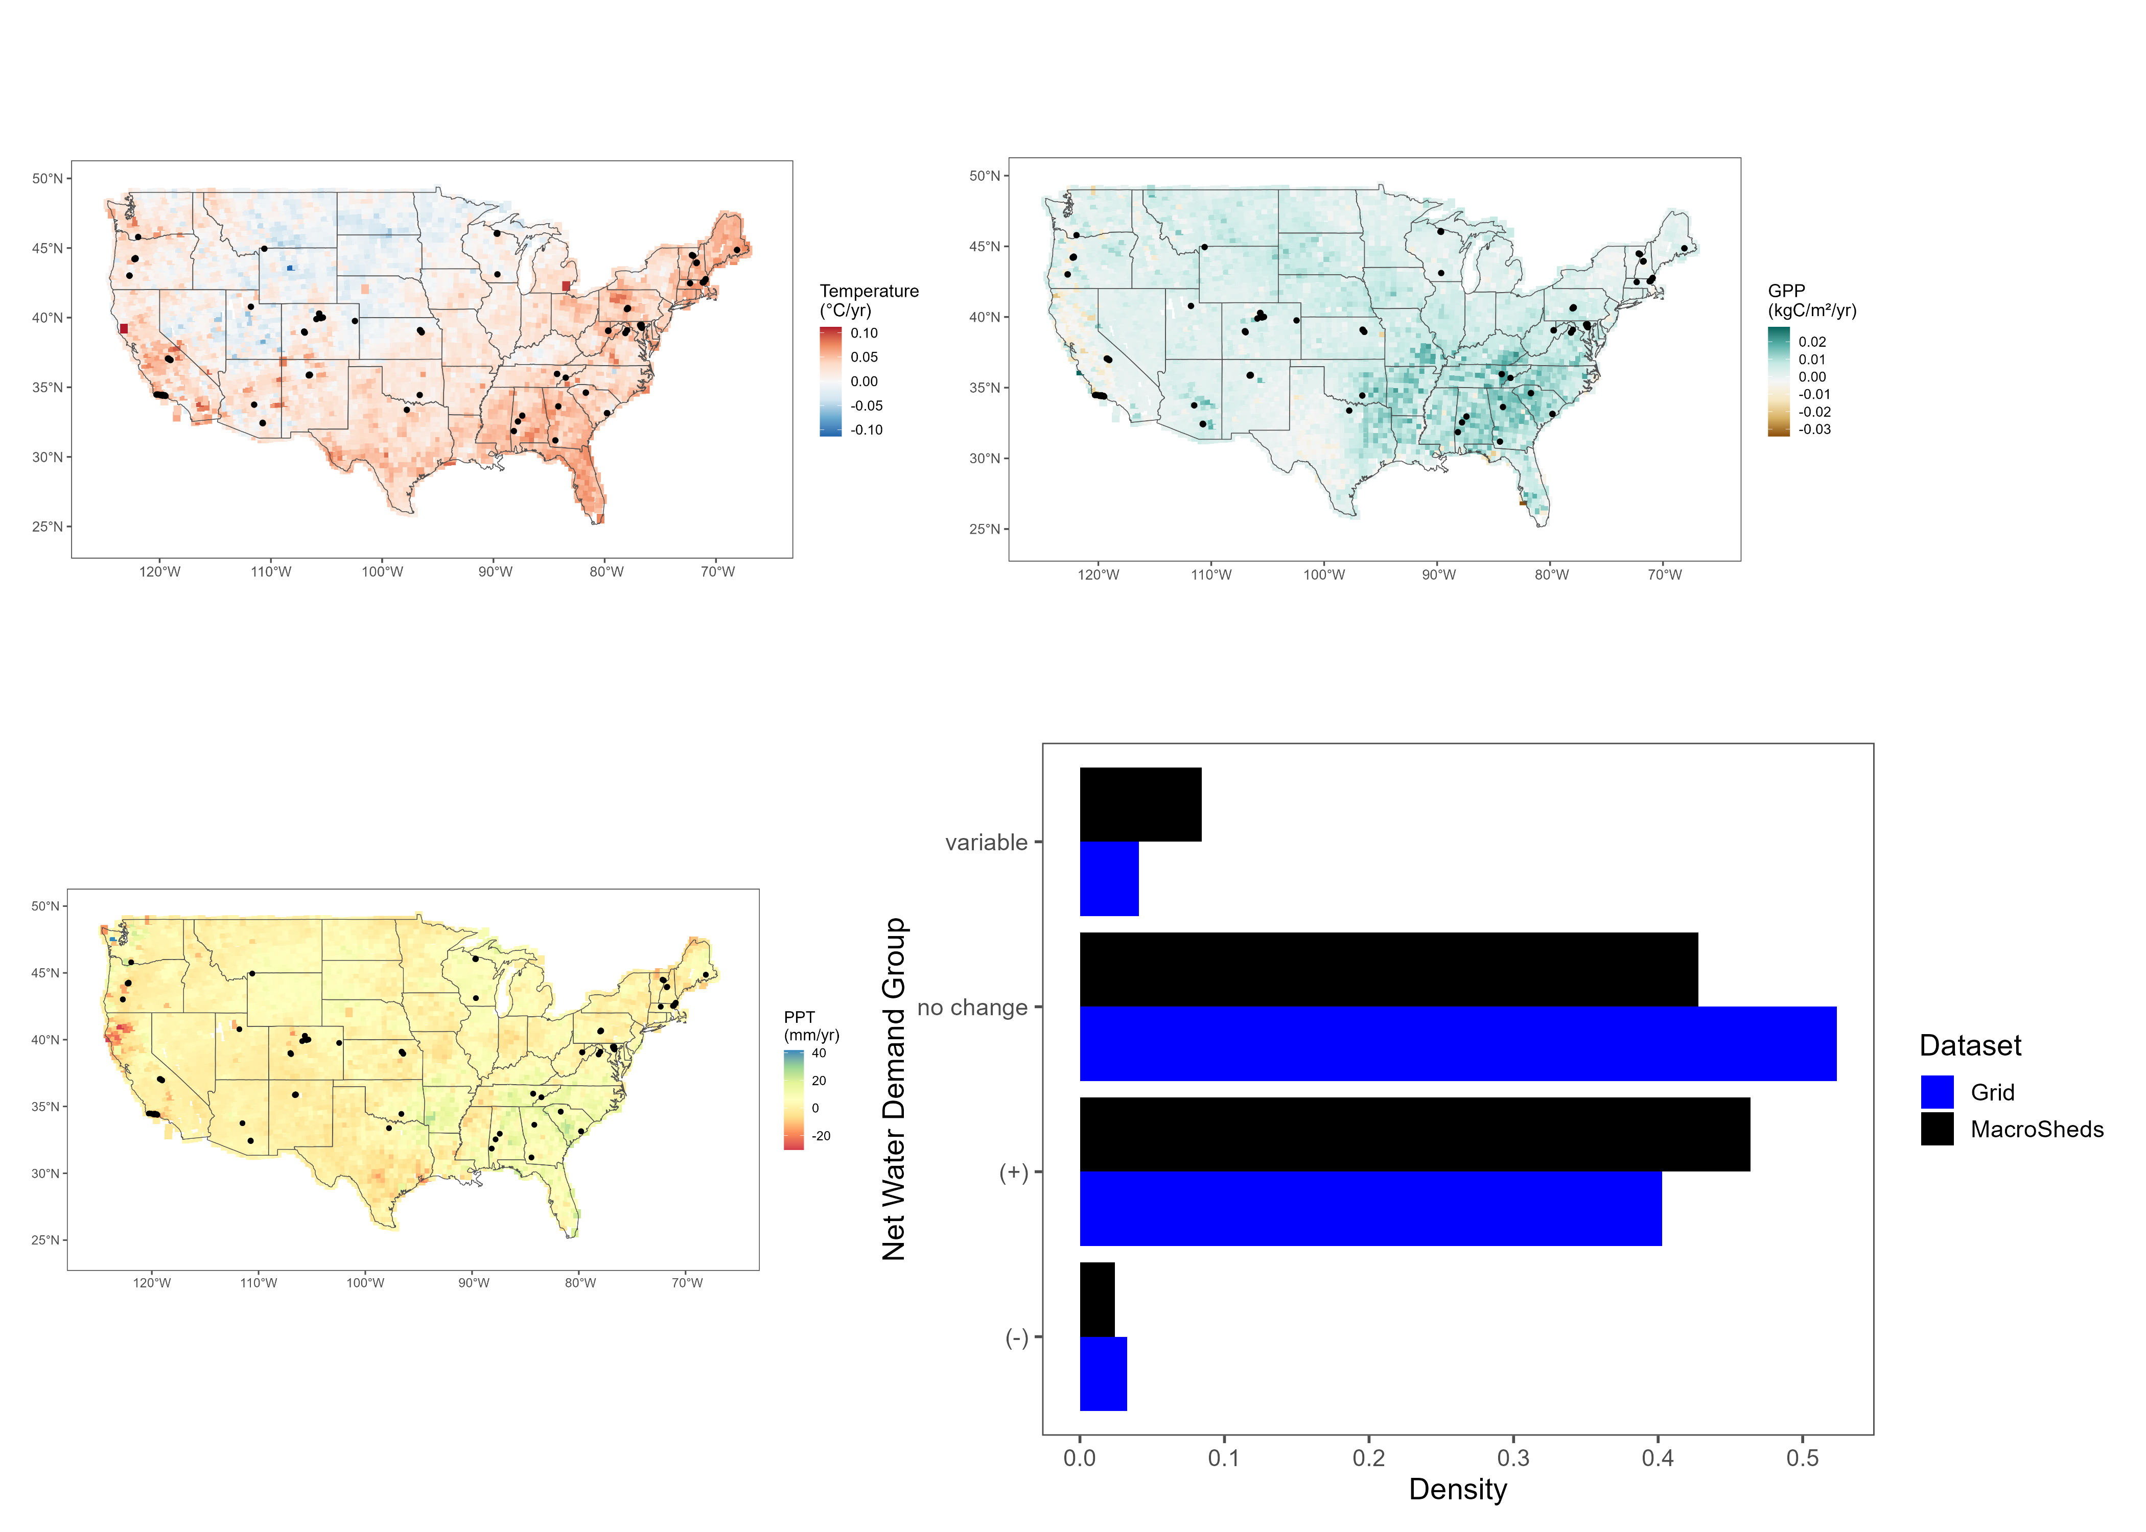
Figure 1. Trends in temperature (top left), precipitation (PPT, bottom left) and gross primary productivity (GPP, top right) from 2001 to 2023 for 5,212 equally spaced points throughout CONUS. MacroSheds (MS) sites are in black. The density plot (bottom right) shows the relative distribution of expected net water demand (NWD) groups for MS sites and for the 4,857 grid cells with complete trends over the same time period. Note that the studies within MS have a distribution similar to the grid, including the rare areas of decreasing NWD.
Decreasing NWD is rare in both sets. The 159 decreasing grid cells (3.3%) are spread across the Mountain (51), West (50), Midwest/Great Lakes (36), Plains (12), South/Southeast (7), and Northeast (3) regions rather than concentrated in any one of them, and most are classified as decreasing because of wetting without warming (98 cells) or browning alone (52 cells). MS captures this group with four sites (CP00 and RN01 at Santa Barbara, LowerJaramillo at Catalina-Jemez, and TECR from NEON), all of which are classified as decreasing solely because of browning; the wetting-driven decreases seen on the grid are not represented in MS.

Data availability and emerging patterns
To interpret streamflow trends, we first assessed the coverage and quality of our data across sites (figure 2). Temperature and precipitation trends are available for all 166 MS sites across the full 2001–2023 analysis period (median record length 23 years), and GPP trends for 158 of them; the remaining eight sites fall in urban land cover that the MODIS product reports as fill values. Streamflow records, however, vary widely in length and completeness. Matching climate and vegetation records with discharge data cut the usable pool roughly in half, from 166 to 79 sites overall, and by nearly two-thirds among non-experimental sites, from 126 to 46; it also shortened the median record to 19 years, with a median end year of 2020. A further seven sites with usable streamflow trends (Luquillo and Krycklan) lie outside CONUS and PRISM coverage and are excluded from the climate comparison. This loss disproportionately excluded arid and intermittent systems, where the largest hydrologic responses would be expected: non-experimental sites that retain a usable streamflow record have a median aridity index of 0.51 (22% arid, AI > 1), whereas those without one have a median of 1.16 (64% arid; Wilcoxon test, p = 1.8 × 10⁻⁵). The lost sites are led by the NEON (23), Catalina-Jemez (13), Santa Barbara (13), and East River (12) domains.
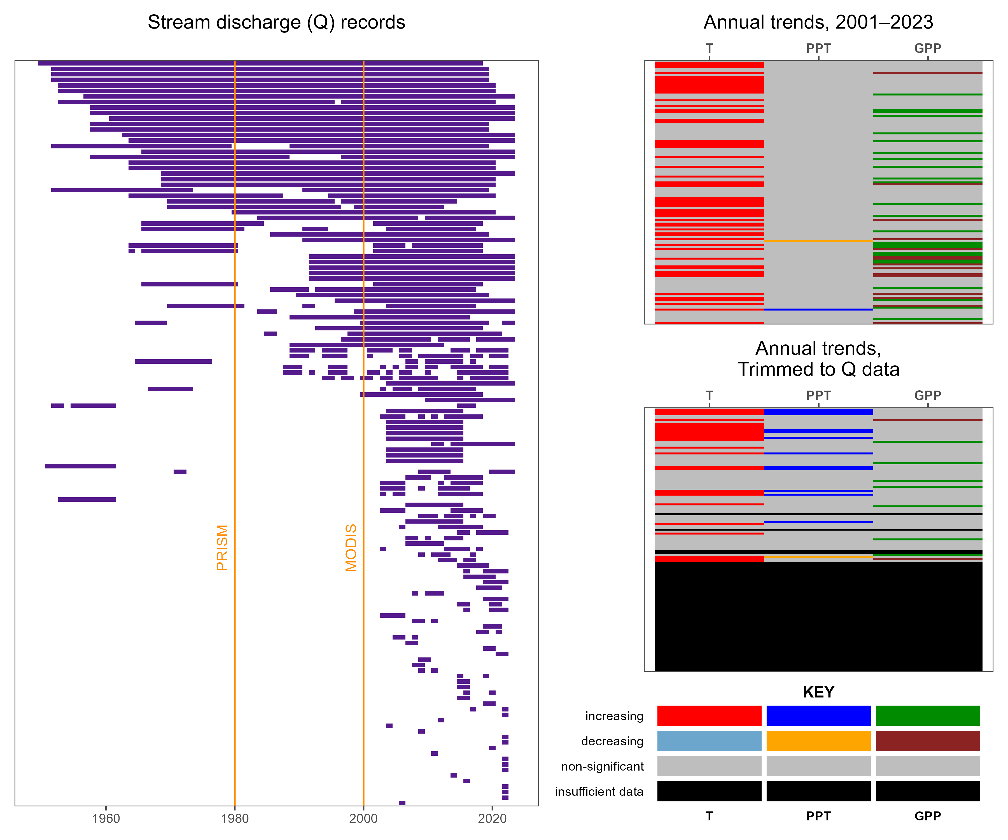
Figure 2. Effect of data limitation on the ability to assess drivers of streamflow trends. The left panel shows streamflow record coverage for each site, with rows sorted by record length and the launches of the PRISM (1980) and MODIS (2000) data products marked in orange. The top right panel shows stacked color bars of annual temperature, precipitation, and GPP trend flags for all sites over the full 2001–2023 window; the middle right panel shows the same flags after each site’s climate record is trimmed to its streamflow window. The key gives the trend classes (increasing, decreasing, non-significant, insufficient data). Note how we lose roughly half of our possible sites due to data limits, including the majority of arid sites. A flowchart of how this figure was produced is available in figure s1.
Even among the remaining sites with sufficient streamflow records, a counterintuitive pattern emerges: despite widespread warming and scattered changes in productivity, very few sites show corresponding changes in discharge. The following sections examine this disconnect in detail.

Trends in drivers and outputs
Our analysis of trends highlighted the importance of long-term climate setting in determining how systems respond to climate change. Generally, we saw very little response. Of 126 non-experimental MS sites, 46 had sufficient streamflow record for trend detection within the 2001–2023 window; only 6 of those (13%) showed significant streamflow trends (4 increasing, 2 decreasing) (figure 3). The four increasing sites (Allequash Creek, North Creek, Stevenson Creek, and Trout River) all belong to the Trout Lake domain in the Wisconsin lake district and should be read as one regional signal rather than four independent detections; none has a significant local trend in temperature, precipitation, or GPP (NWD group “—”). The two decreasing sites (AB00 and RS02) are both arid Santa Barbara streams that are warming without a significant change in precipitation or GPP (NWD group “H–”). Among experimental sites, streamflow decreased at KREW B204 and P303 and increased at Bear Brook WB and Santee WS77.
Because significant precipitation trends are essentially absent across the 166-site pool (1 increasing, 1 decreasing), the quadrants in figure 3 are defined by the sign of the Sen slope in temperature and precipitation rather than by its significance, and “drying” and “wetting” below refer to slope sign only. By sign, non-experimental sites split almost evenly between hotter-wetter (64) and hotter-drier (60), with one site each in the cooler-wetter and cooler-drier quadrants. Hotter-wetter sites tended to show no change in streamflow (30 non-significant, 4 increasing, 30 without a usable record), and where GPP changed it increased (22 greening, 0 browning, 37 non-significant). Hotter-drier sites, where we expected to see decreasing streamflow, showed little streamflow response (10 non-significant, 2 decreasing, 48 without a usable record) and diverging GPP responses (3 greening, 16 browning, 38 non-significant) (figure 3). Across all 158 sites with a usable MODIS record, GPP trends were mostly non-significant (29 greening, 17 browning, 112 non-significant).
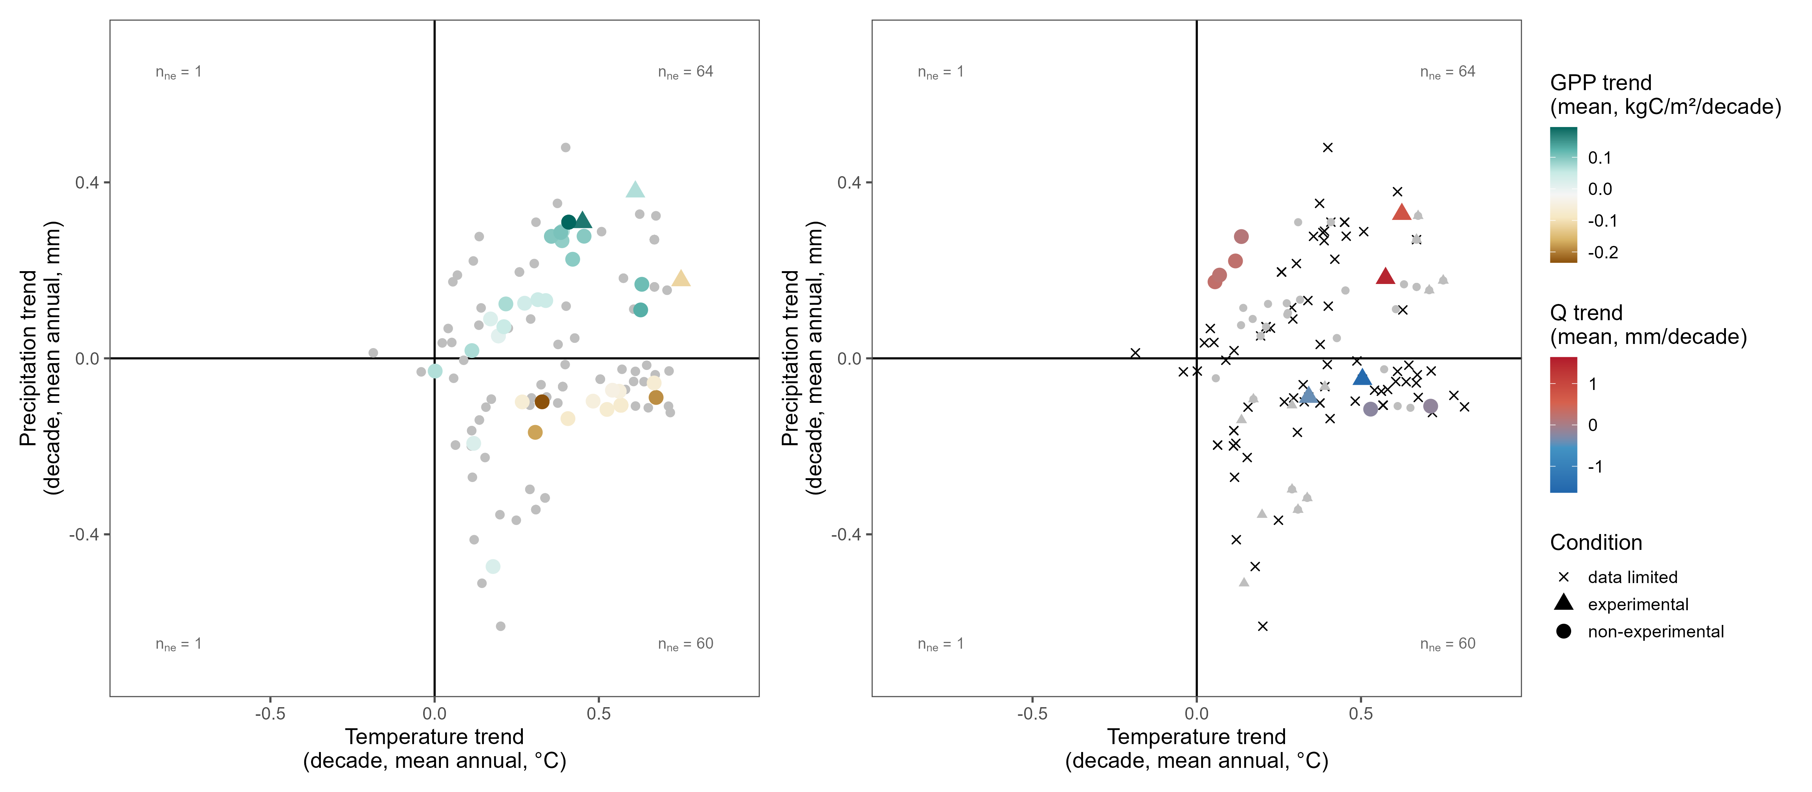
Figure 3. Mean annual precipitation trend vs mean annual temperature trend (per decade, 2001–2023) for MacroSheds sites, colored by GPP trend (left) and trend in Q (right). Triangles mark experimental watersheds, and n_{ne} is the number of non-experimental sites in each quadrant; quadrants are defined by the sign of the temperature and precipitation slopes, not their significance. Note that almost no precipitation trend is significant, and that decreasing precipitation in warming watersheds does not always lead to decreased GPP. Very few points show shifting Q despite changing temperature and GPP.
Given the scarcity of significant streamflow trends despite widespread warming, we next asked whether long-term aridity could explain which sites do respond. Using the aridity index (PET/P) computed from Daymet and averaged over 2001–2023, we grouped trends by mean aridity index (figure 4). Averaging over this window rather than the full Daymet record changes the humid/arid class of only 1 of 166 sites (figure s4).
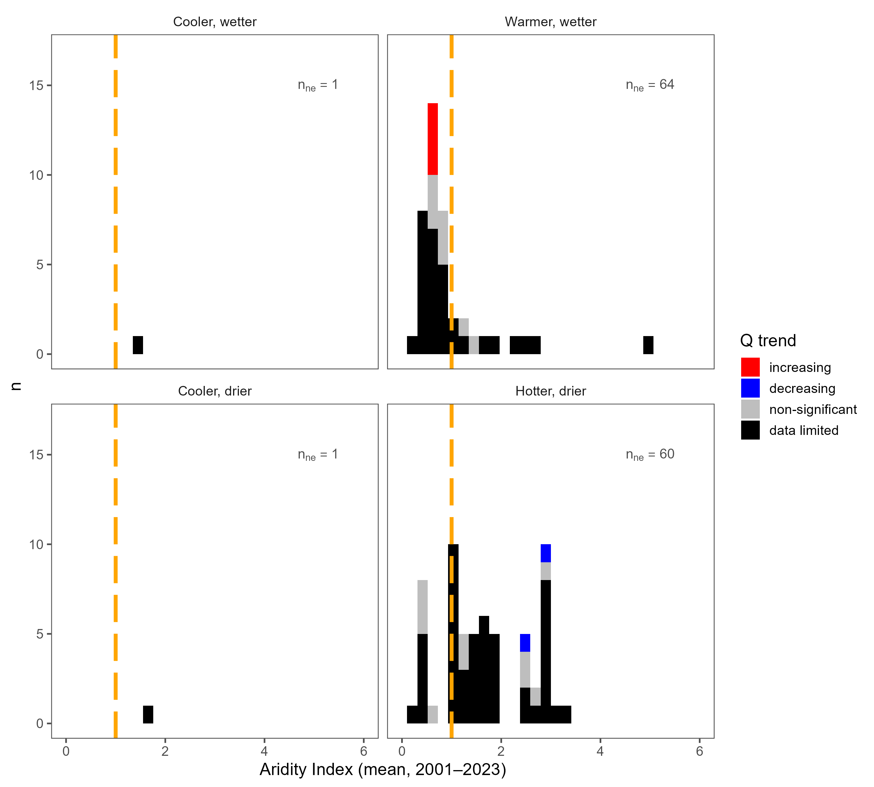
Figure 4. Histograms of mean aridity index (Daymet PET/P, 2001–2023) for MacroSheds sites, filled by streamflow trend flag and sorted into quadrants by the sign of the trends in MAP and MAT. Quadrants match the layout of figure 3 and n_{ne} is the number of non-experimental sites in each quadrant. An aridity index of 1 is marked in dashed orange; sites to the left of this line are considered humid and those to the right arid. Note that there are few trends in streamflow, with many sites lacking sufficient data, and that the sites lacking data are concentrated on the arid side of the line.
To formalize this relationship between climate setting and hydrologic response, we examined our results through the lens of Budyko theory [CITATION NEEDED: Budyko framework]. Assessing our trends in Budyko space, long-term climate history is consistent with the direction of the few responses we detect, although the sample is too small to test this formally. Both significant decreasing trends at non-experimental sites were detected at arid, water-limited Santa Barbara sites (AI = 2.9 and 2.5) that are gaining heat without a significant change in incoming water. The four increasing trends were all at humid, energy-limited Trout Lake sites (AI = 0.66–0.67) with no significant local trend in temperature, precipitation, or GPP; because they share a single domain and lack a significant climate driver in this window, we do not interpret them as a climate-driven response. The experimental sites follow the same aridity pattern, with decreasing flow at the arid KREW sites (AI = 1.24 and 1.35) and increasing flow at the humid Bear Brook and Santee sites (AI = 0.32 and 0.59), although treatments at these watersheds confound attribution to climate.

CONCLUSIONS
RQ1: What are the trends in streamflow in the CONUS from small watershed ecosystem studies?
There is little change. Of the 46 non-experimental sites with sufficient record, 6 (13%) show a significant streamflow trend over 2001–2023 (4 increasing, 2 decreasing), even though 71 of the 166 climate sites warmed significantly over the same window.
RQ1A: What drives sensitivity or insensitivity of streamflow to changes in water balance?
When streams do respond, the direction of the response is consistent with aridity. The two decreasing sites (AB00 and RS02 at Santa Barbara) are arid (aridity index 2.9 and 2.5) and warming with no change in precipitation: adding heat to water-limited sites yields less streamflow. The four increasing sites (Trout Lake) are humid, energy-limited sites (aridity index 0.66–0.67). Those four streams, however, share one lake-district domain in northern Wisconsin and show no significant local temperature or precipitation trend, so they represent one response rather than four independent ones, and our climate drivers do not explain it.
Aridity is clearly not the only control, as most sites show no significant change in streamflow. Over 2001–2023 sites are warming (71 of 166), while significant precipitation trends are essentially absent (2 of 166) and productivity trends are uncommon and split in sign (29 greening, 17 browning of 158); streamflow is not shifting with them.
RQ2: How well does the current suite of WS studies capture the landscape of climate change across the CONUS?
Existing efforts do well at capturing the distribution of climate change signals (figure 1), including the rare class of decreasing NWD: MS sites fall 46% increasing NWD, 43% no change, 8% variable, and 2% decreasing, against 40%, 52%, 4%, and 3% for the grid. The gap is in streamflow rather than climate coverage. Discharge records long enough for trend detection favor humid sites (figure 4): non-experimental sites with a usable streamflow record have a median aridity index of 0.51 (22% arid) versus 1.16 (64% arid) for those without (Wilcoxon rank-sum p = 1.8 × 10⁻⁵). These records need to be continued to better resolve trends.

DISCUSSION
Our synthesis reveals striking stability in streamflow across small watersheds over 2001–2023. Warming was widespread, with significant temperature increases at 71 of 166 sites and no cooling anywhere, yet only 13% of non-experimental sites with sufficient record (6 of 46) showed significant discharge trends. Over the same window, significant precipitation trends were essentially absent (2 of 166 sites) and productivity trends were uncommon and mixed in sign (29 greening, 17 browning of 158). Part of the stability, then, is that the water input itself has not shifted detectably in two decades; warming alone did not translate into hydrologic change. This apparent insensitivity reflects both stabilizing in-watershed processes and data limitations that constrain our ability to detect subtle responses.

Synthesis challenges
The data constraints illustrated in figure 2 were consistent barriers to our synthesis. Matching climate and vegetation records to discharge reduced the non-experimental pool from 126 sites to 46, and the loss was not random: sites with a usable streamflow record have a median aridity index of 0.51 (10 of 46 arid) versus 1.16 (51 of 80 arid) for those without (Wilcoxon rank-sum p = 1.8 × 10⁻⁵). The excluded sites are concentrated in a few domains (NEON, Catalina-Jemez, Santa Barbara, and East River account for 61 of the 80), and they disproportionately represent the arid and intermittent systems where the largest hydrologic responses would be expected.
Record length is a second constraint. Restricting every trend to the MODIS era gives 23-year climate records (2001–2023), and discharge records cut to that window have a median length of 19 years with a median end year of 2020. Twenty-three years is short for detecting a precipitation trend: only 2 of 166 MS sites and fewer than 6% of reference grid cells show one, whereas 40 of the same 166 sites did over the longer 1981–2024 PRISM record. Any streamflow response to slowly shifting precipitation is therefore unlikely to be detectable in our window; what we can say is that two decades of warming, on its own, did not move streamflow at most sites.
Continued monitoring at short-record sites, particularly in arid regions, is essential to build the record length needed for robust trend detection. In places where collection is underfunded or difficult, statistical extrapolation methods may partially fill gaps (like those used in Vlah et al, 2024), but cannot replace the insights from continuous measurement. Keeping these programs funded and running continuously is crucial for this sort of national scale synthesis and for monitoring water quality and quantity in water-scarce regions and regions where water availability is changing, but we’ve yet to collect enough data to detect it.
Remote-sensing limitations add a further caveat on the vegetation side. MOD17A3HGF is an annual product at 500 m, so a single pixel covers 0.25 km², while the median MS watershed is 3.07 km² (interquartile range 0.5–11.98 km²): 24 of 166 sites are smaller than one pixel, 60 are smaller than four, and 79 are smaller than ten. For those sites the watershed-median GPP is effectively one or a few mixed pixels that include land outside the catchment. Eight sites (five in Baltimore, one at Santa Barbara, and two at Plum Island) return the MOD17 urban/barren fill value and were masked, so they have no GPP trend. Orbit drift of the Terra platform in the last few years of the record can add small artifacts of its own [CITATION NEEDED: Terra orbit drift and its effect on late-record MODIS products], and MODIS GPP is a calendar-year total whereas discharge is aggregated by water year, so the two annual series are offset by a season. Landsat’s finer resolution would suit these small catchments better, but its multi-mission record carries trend artifacts that we could not separate from vegetation change (figures s2–s3) [CITATION NEEDED: sensor-transition artifacts in long-term Landsat vegetation trends]. These data constraints limit our power to detect change, but they do not fully account for the absence of trends at well-monitored sites. This raises a more fundamental question.

Why so little change?
The muted hydrologic responses observed are consistent with strong biotic buffering and/or highly dynamic water routing. Synthesis work from McMillan and others in 2025, found that aridity controlled the depth of water pathways, but that terrain and biomes controlled lateral flows.
Our earlier, Landsat-based analysis suggested that additional climatic demand was being absorbed by vegetation: 113 sites appeared to be greening over 1986–2022. That signal was mostly not robust to the choice of sensor. Shortening the Landsat window to 2001–2021 turns 33 of those 113 sites (29%) non-significant, and switching to MODIS on the same 2001–2021 window turns 64 of the 85 remaining Landsat-increasing sites (75%) non-significant (figures s2–s3). With MODIS over 2001–2023, only 29 of 158 sites are greening and 17 are browning. The earlier greening was therefore mostly a sensor effect, and with these data we cannot show that vegetation is taking up the extra demand. What the MODIS trends do show is that productivity, where it changes at all, follows water: among non-experimental sites, greening occurs at 22 sites and browning at none where the precipitation slope is positive, while browning occurs at 16 sites and greening at 3 where it is negative, even though those precipitation slopes are themselves rarely significant.
Vegetation buffering therefore remains a hypothesis rather than a result, but one consistent with the literature. Shifts in species composition, including woodification of non-forest systems, may decouple precipitation from discharge by increasing productivity without proportional increases in water use (Knapp et al, 2008; Fei et al, 2017). Such ecohydrological adjustments may delay or dampen streamflow response, though thresholds in soil water or species composition could alter this balance in the future. Testing this at headwater scale will require vegetation products that resolve catchments of a few square kilometers without sensor-transition artifacts.
When significant trends do occur, their direction aligns with expectations from aridity theory: the two water-limited sites (aridity index 2.9 and 2.5) show decreased flows under warming, and the four energy-limited sites (aridity index 0.66–0.67) show increased flows. The four experimental sites with significant trends follow the same split, with the two decreasing KREW sites arid (1.24 and 1.35) and the increasing Bear Brook and Santee sites humid (0.32 and 0.59), though treatments at those sites confound climate attribution. But six non-experimental sites, four of them in one lake district with no significant local climate trend, is a consistency check rather than a test. These results support aridity and Budyko-space frameworks as first-order predictors of the direction of change, while highlighting the need to incorporate vegetation dynamics explicitly. Expanding representation of arid regions in the streamflow record, and linking hydrologic synthesis with ecological monitoring, will be critical for anticipating future water availability.

Supplement
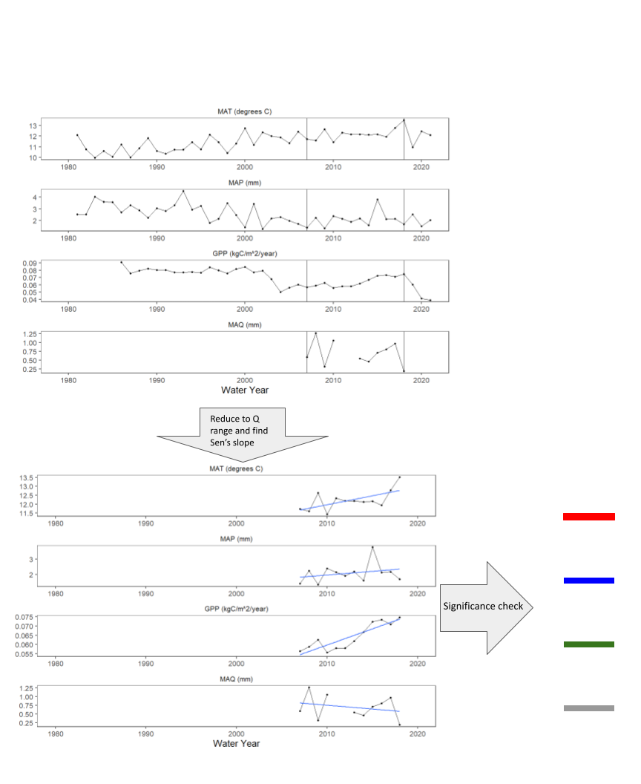
Figure s1. Example of how the colored bars in figure 2 were created. First, we computed a full, annual time-series of streamflow metrics across a range of years with at least 60% coverage (that is, no more than 40% missing data). Then remotely sensed and gridded data were cut to the range of years matching the streamflow ranges. Lastly, trends were computed using a Sen’s slope test and color coded by direction and significance.
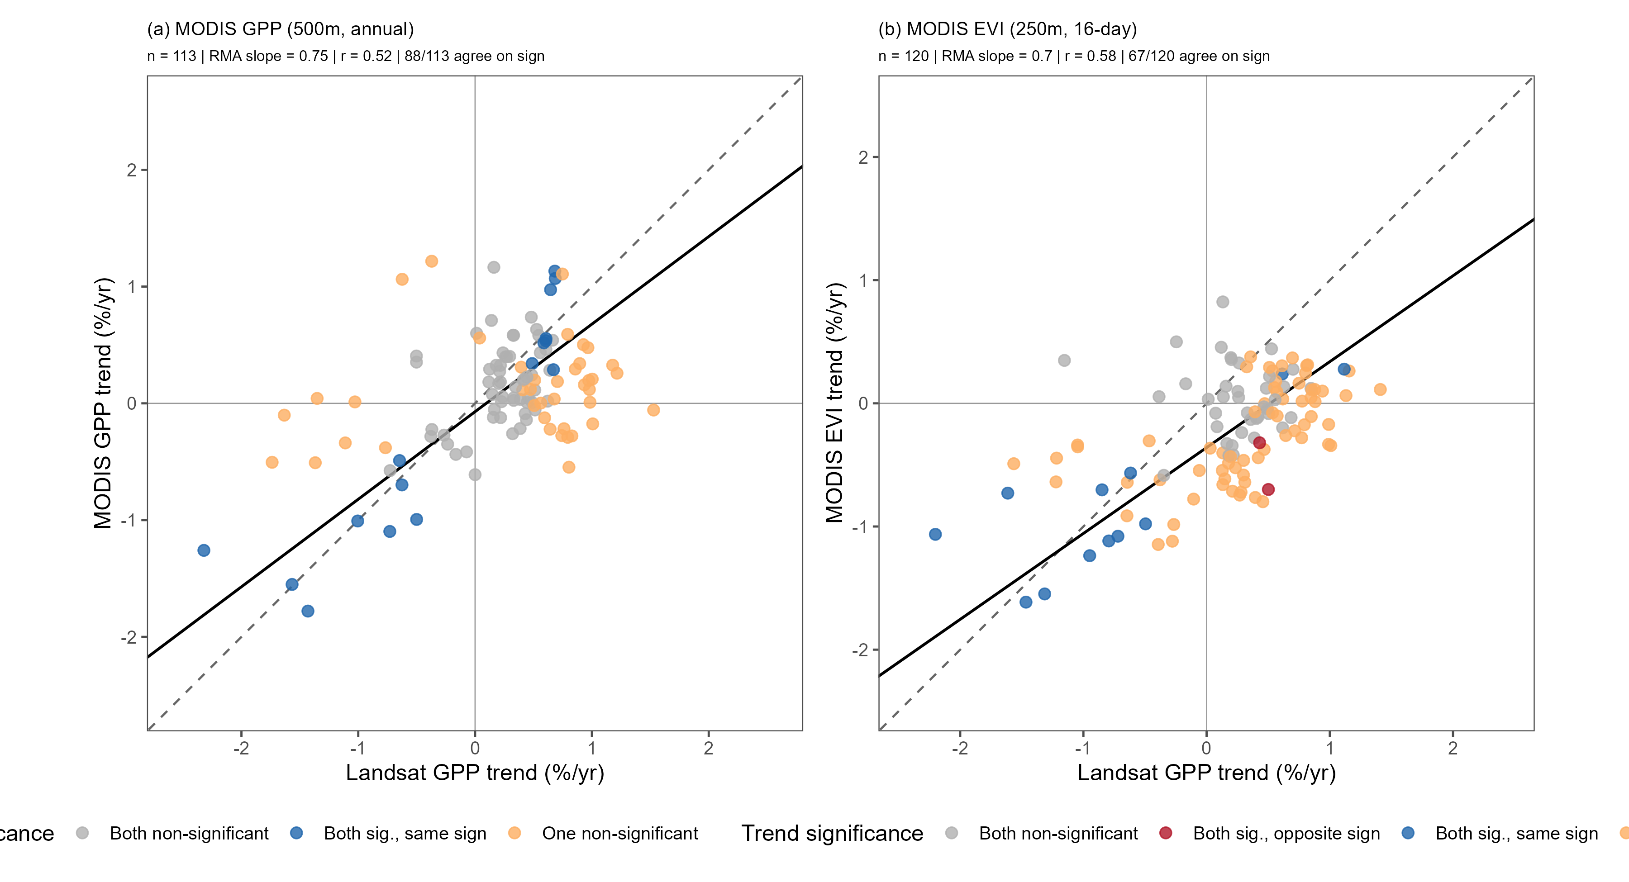
Figure s2. Comparison of per-site vegetation trends from Landsat and MODIS. Each point is one MS site; axes are relative Sen’s slopes (% yr⁻¹, slope divided by the site mean) computed with the same trend method as the main analysis over each site’s matched window of overlapping years (at least 10). Landsat GPP (NTSG, 30 m, 16-day) is compared against (a) MODIS GPP (MOD17A3HGF, 500 m, annual) and (b) MODIS EVI. Points are colored by the agreement of the significance flags: both significant with the same sign, both significant with opposite signs, both non-significant, or one non-significant. The dashed line is 1:1 and the solid line is a reduced major axis (RMA) fit. Landsat and MODIS GPP trends agree only moderately (n = 113, r = 0.52, RMA slope = 0.75), as do Landsat GPP and MODIS EVI trends (n = 120, r = 0.58, RMA slope = 0.70); an RMA slope below 1 means the MODIS trends span a narrower range than the Landsat trends at the same sites.
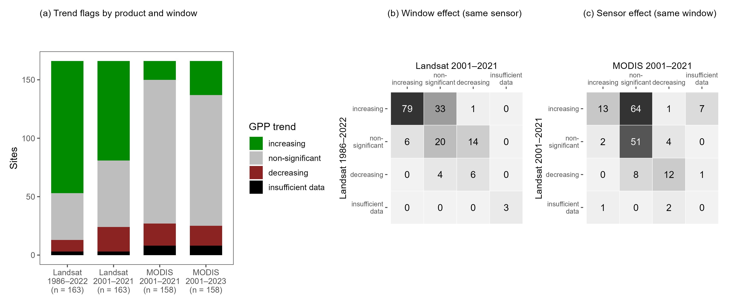
Figure s3. Separating the effect of the analysis window from the effect of the sensor on GPP trend flags at the 166 MS climate sites. (a) Trend flags (increasing, non-significant, decreasing, or insufficient data) for four runs: Landsat over its full 1986–2022 record, Landsat restricted to 2001–2021, MODIS over 2001–2021, and MODIS over the full 2001–2023 window used in the main analysis. Counts are 113 increasing / 40 non-significant / 10 decreasing for Landsat 1986–2022, 85 / 57 / 21 for Landsat 2001–2021, 16 / 123 / 19 for MODIS 2001–2021, and 29 / 112 / 17 for MODIS 2001–2023. (b) Window effect: the transition of each site’s flag from Landsat 1986–2022 (rows) to Landsat 2001–2021 (columns) on the same sensor. Shortening the window alone turns 33 of the 113 Landsat-increasing sites (29%) non-significant. (c) Sensor effect: the transition from Landsat 2001–2021 (rows) to MODIS 2001–2021 (columns) on the same window. Changing sensor alone turns 64 of the 85 Landsat-increasing sites (75%) non-significant, with 13 remaining increasing; of the 115 sites significant in either sensor over 2001–2021, 26 are significant in both, and 25 of those share the same sign. The Landsat-based greening was therefore mostly a sensor effect rather than a window effect. MODIS GPP here and in the main analysis is MOD17A3HGF (annual, 500 m) with the urban/barren/water fill value masked.
Sites in figure 4 are grouped by mean aridity index (Daymet potential evapotranspiration divided by precipitation, summed by water year) averaged over the 2001–2023 analysis window. The earlier version of this analysis grouped sites by a longer 1980–2020 climatology that predates the MODIS record. Because the humid/arid split at an aridity index of 1 is used to interpret the sign of the streamflow trends, we checked whether shortening the climatology to the MODIS era moves any site across that line (figure s4). It does not, for practical purposes: the two climatologies are almost perfectly correlated across the 166 sites (r = 0.999), the median absolute shift is 0.014, and the largest shift is 0.44. One site, BLUE (NEON), moves from 0.96 to 1.01 and crosses from humid to arid; NEON sites have no usable streamflow record in this analysis, so the change does not affect figure 4.
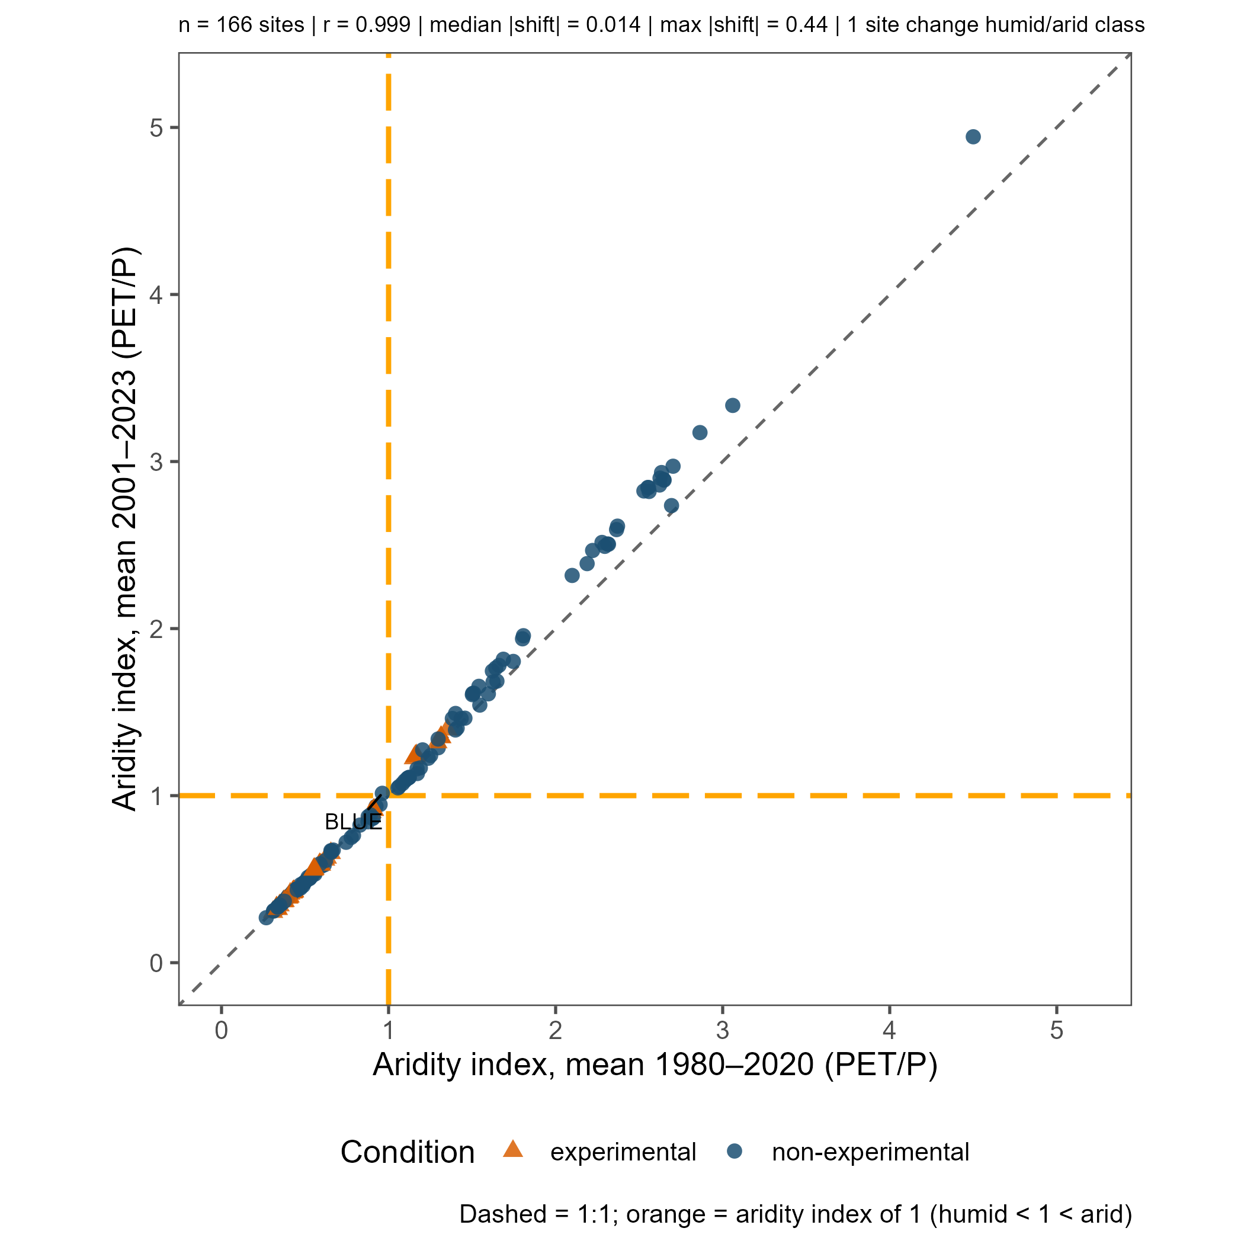
Figure s4. Site-mean aridity index over the pre-MODIS climatology (1980–2020, x axis) against the 2001–2023 analysis window (y axis) for the 166 MS climate sites, colored by experimental status. The dashed line is 1:1; orange lines mark an aridity index of 1 (humid below and to the left, arid above and to the right). The one site that changes class (BLUE) is labeled. n = 166, r = 0.999, median |shift| = 0.014, max |shift| = 0.44.

