Stability of Headwater Streamflow Under Four Decades of Climate Change

INTRODUCTION

Background
Streamflow is a fundamental measurement in watershed science. Since the 1960’s, watershed science has used water budgeting to learn about how ecosystems function (Bormann & Likens, 1967). By measuring the water entering (precipitation) and leaving (evaporation, transpiration, and streamflow) a watershed, researchers can create watershed budgets, as represented in equation 1. Where Q is the streamflow, P the precipitation, and E, T, and S evaporation, transpiration, and storage, respectively.
$$equation 1:Q=P-(E+T+S)$$
This approach to budgeting works best in smaller watersheds, with limited storage and well-defined boundary conditions (Bormann & Likens, 1967; Likens et al, 1970). However, climate change is acting on both the inputs and outputs of watershed budgeting over the last 40 years. With access to remotely sensed and gridded data, we can observe many changes across CONUS.
Looking at trends from 1980 to today, researchers have observed meaningful trends for each component of the water budget. Temperatures are increasing across most of the CONUS, increasing evaporation (Ji et al, 2014). Precipitation has become more variable, with more of it arriving in extreme events (Adler et al, 2017; Davenport et al, 2021). Concurrently, productivity from watersheds has been increasing across most of the CONUS (Zeng et al, 2018; Wang et al, 2021; Yang et al, 2023). Research also shows that the increasing water use efficiency (WUE) of those plants from carbon fertilization has leveled off, leading to increased transpiration as temperatures continue to rise (Li et al, 2023).
Given all this change to inputs, it is reasonable to expect change in outputs, namely decreasing streamflow across many systems. In past work, streamflow in larger systems has shown variable responses to climate change, including more high and low flow days (Wang et al, 2024). Analysis of USGS gauges found from 1940-2022 found steeply increasing streamflow in the northeast and Midwest and little significant change elsewhere (USGS, 2023). However, these large watersheds are also affected by heavy anthropogenic use (by design for USGS gauges), muddling any insights into how fundamental elements of watershed attributes affect streamflow attenuation. To do so demands analysis of a diverse group of small watersheds with very limited anthropogenic influence and long running streamflow records.

Research Questions
RQ1: What are the trends in streamflow in the CONUS from small watershed ecosystem studies?
We expect that trends will closely follow climate trends, with more discharge in the upper Midwest and Northeast and less discharge in arid environments. We expect to see abundant change, as small watersheds have little space and time to attenuate signals from climate drivers.
R1A: What drives sensitivity or insensitivity of streamflow to changes in water balance?
We expect that aridity is the main driver of streamflow sensitivity. Arid, water-limited sites will be most sensitive to changes in incoming precipitation. Humid, energy limited sites will be most sensitive to changes in temperature.
RQ2: How well does the current suite of WS studies capture the landscape of climate change across the CONUS?
We expect that since existing watershed studies are broadly distributed, they are capturing most patterns of change. However, due to the assumptions preferred for these studies (high slopes, solid bedrocks, constant flow, non-arid) they will be biased towards sites with increasing flows.

METHODS

Open analysis
All data and analyses used in this effort are hosted publicly at https://github.com/rossyndicate/ms_physical_patterns (will version on submission).

Data sourcing
All streamflow data for this effort were sourced from MacroSheds, a harmonized dataset of small watershed ecosystem studies (Vlah et al, 2023). The dataset is well situated for this effort, as sites used for these kinds of studies tend to be small, undisturbed, and have long record lengths. Streamflow data was furnished by the contributing members to MacroSheds (Vlah et al, 2023). As sites in MacroSheds having varying quality of precipitation data, we used gridded, PRISM for rainfall and air temperature (PRISM Group, 2025). To estimate GPP, we used LANDSAT estimates (USGS, 2025) averaged to each watershed boundary.

Streamflow analysis
To determine how streamflow is changing across CONUS, we analyzed trends in daily streamflow data from MacroSheds sites (now called ‘MS sites’). First, using the ‘ndhplusTools’ package in R (Blodgett, 2023) we limited our analysis to first or zero order streams. Then, we windowed all data from 1984 (the start of the LANDSAT mission) to 2024 (the latest year for which data is available). To be included for trend analysis, site records were checked for completeness by water year for at least 4 streamflow observations per week (including rating derived) across at least 51 weeks out of the year. For sites with limited sampling/seasonally sampled snowmelt sites (such as Niwot Ridge in Colorado) were manually flagged and added back into the analysis.
We then computed annual hydrologic metrics for each site, including the ‘Magnificent 7’ (Archfield et al, 2014), total flow, mean flow, maximum and minimum flows, variance, and Richard-Baker index. We computed the same metrics monthly and seasonally for greater context in our analysis.
To include a site in trend analysis it needed at least 10 years of data that passed our completeness check, with no more than 40% missing data in connecting years.
For all metrics, we used Sen’s slope test, ‘zyp’ package in R (Bronaugh et al, 2023) to calculate trends and compute 95% confidence intervals around them.

Gridded sampling
To investigate RQ2, we created a grid of 1,000 100 ha wide points fit to CONUS, from now on referred to as ‘grid sites’. These points were chosen to be of similar size to our MS sites, but spread evenly throughout CONUS.

Climate analysis
Using our PRISM data, we computed mean, maximum, minimum, and variance annually, for all MS and grid sties. Like with streamflow, we computed the same metrics aggregated monthly and seasonally for greater context, along with cumulative precipitation and precipitation intensity. For streamflow sites, climate data was matched to ranges of years with available streamflow data. For grid sites, the entire 1984-2024 window was used
We also computed aridity index annually for each site and as an average across all 40 years, using LANDSAT estimates of ET and PRISM for precipitation.
For all metrics, we used Sen’s slope test, ‘zyp’ package in R (Bronaugh et al, 2023) to calculate trends and compute 95% confidence intervals around them.

Expected response groupings
In the past, researchers have relied on potential evapotranspiration (PET) as a measure of water demand in watersheds – combining changes in vegetation, temperature, and wetness (via vapor pressure deficit) (Zeng et al, 2018). However, PET relies on reference crop values to derive ET, which do not translate well to smaller, less anthropogenically affected systems (Heerwaarden et al, 2010). An alternative way to consider all these factors is through framing them in a systems perspective, using what we are calling ‘expected net water demand’ (NWD).
If a watershed has been trending hotter and drier (less precipitation), we can classify it as increasing NWD. If a watershed is getting cooler and wetter (more precipitation), it has decreasing NWD. Using equation 1, we expect watersheds with increasing NWD will have declining streamflow, shifts in vegetation speciation, and/or reduced productivity. As sites are small, headwater streams, storage was considered small and/or static for the analysis period.

RESULTS

Study coverage of NWD
Our analysis of grid and MS sites found that efforts across watershed science have done well at capturing the distribution of NWD regimes from 1984 to today (figure 1). Most sites are increasing in NWD as our climate warms.
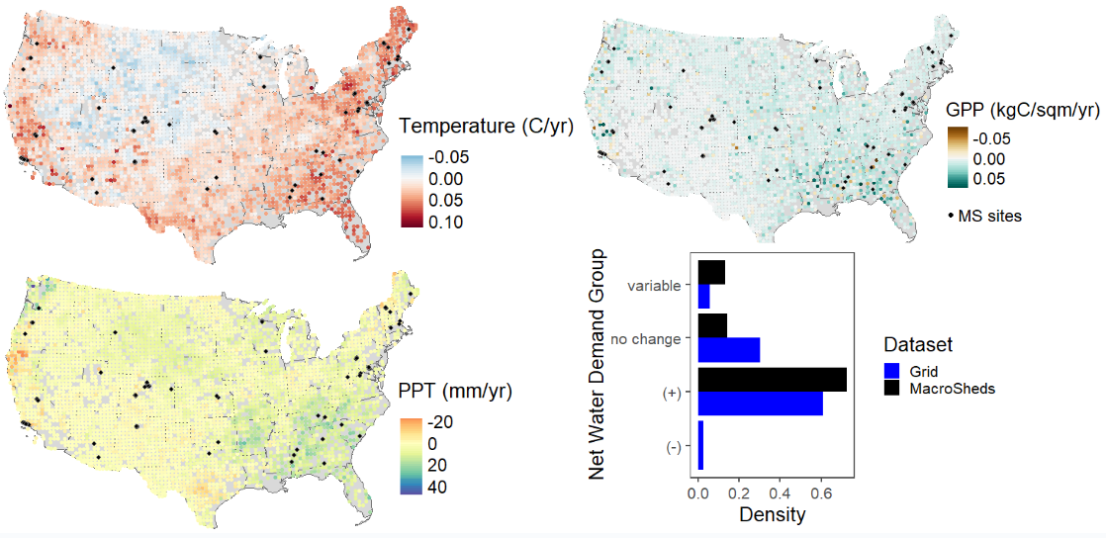
Figure 1 Trends in temperature (top left), precipitation (PPT, bottom left) and gross primary productivity (GPP, top right) for 1000 equally spaced points throughout CONUS. MacroSheds (MS) sites are in black. The histogram (bottom right) shows the relative distribution expected net water demand (NWD) trends for the same time period. Note that the studies within MS have a similar distribution to the grid, aside for failing to capture the rare areas with less expected NWD.
Importantly, studies included in MS do not capture any sites with decreasing NWD. These sites are rare and only appear in the upper Midwest.

Trends in drivers and outputs
Our analysis of trends highlighted the importance of long-term climate setting in determining how systems respond to climate change. Generally, we saw very little response. Out of 125 non-experimental MS records included, only 8 showed significant streamflow trends (3 increasing, 5 decreasing) (figure 2). Warming, wetting sites tended to show no change in streamflow and increasing productivity. Warming, drying sites (where we expected to see decreasing streamflow) showed little streamflow response and diverging GPP responses (figure 2).
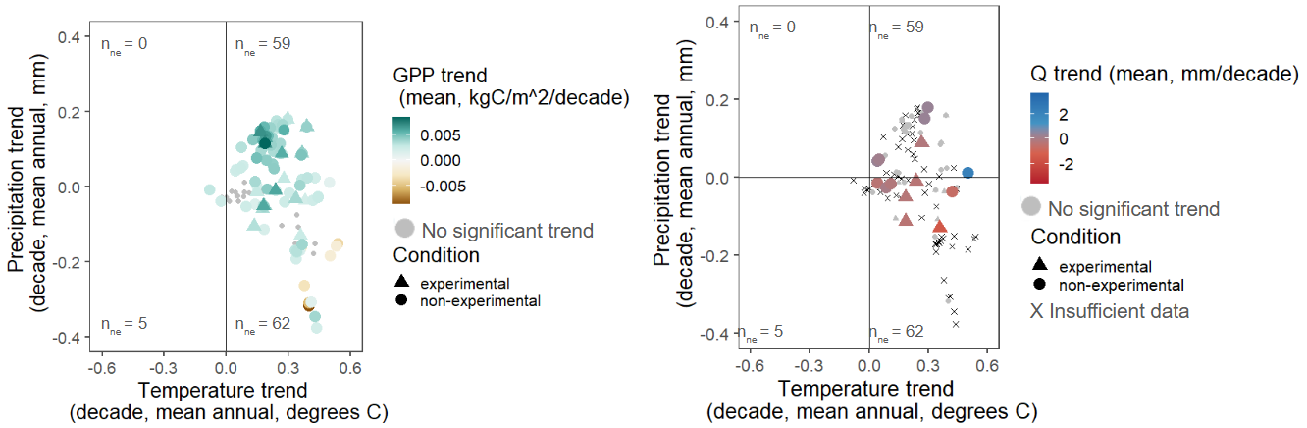
Figure 2 Mean annual precipitation trend vs mean annual temperature trends for Macrosheds sites colored by GPP (left) and trend in Q (right). Note that decreasing MAP in heating watersheds does not always lead to decreased GPP. Very few points show shifting Q despite changing precipitation, temperature and GPP.
Using our aridity data from LANDSAT, we grouped trends by mean aridity index (figure 3).
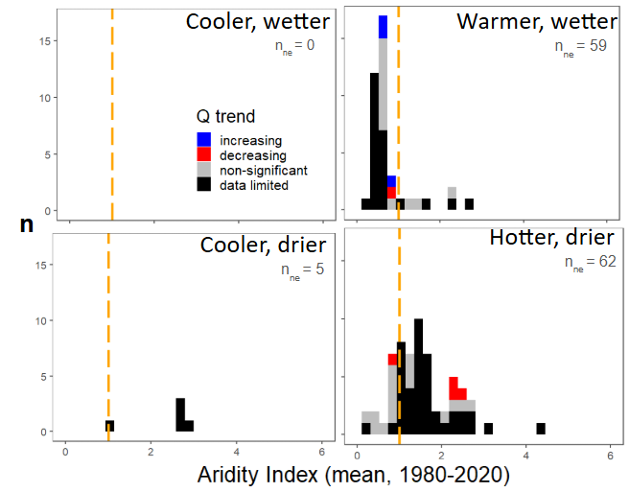
Figure 3 Histograms of site streamflow response sorted by trend in MAP and MAT. Quadrants match the layout of trends in figure 2 and n_{ne} is the number of non-experimental sites in each quadrant. Sites are grouped by mean aridity index from 1980-2020. Aridity index of 1 is marked in dashed orange. Sites to the left of this line are considered humid and those to the right arid. Note that there are few trends in streamflow, with many sites lacking sufficient data.
Assessing our trends in Budyko space, we can see that long term climate histories can help us predict how watersheds will respond to changing climate inputs. For example, three of the five decreasing streamflow trends were detected in arid sites that are getting additional heat and less water. Meanwhile, all three of the increasing trends were at energy-limited sites receiving more water.

CONCLUSIONS
RQ1: What are the trends in streamflow in the CONUS from small watershed ecosystem studies?
There is little change, with less than 1% of 126 sites shows a significant streamflow trend (3 increasing, 5 decreasing), despite all undergoing changing inputs and shifting vegetative demand.
RQ1A: What drives sensitivity or insensitivity of streamflow to changes in water balance?
When streams do respond to changing climate, aridity mostly explains that response. Adding water to energy limited sites yields more streamflow. Adding heat to energy limited sites yields less streamflow. A single site (GREEN4 at Niwot) bucks this trend, but it is a transitional site – with its aridity index oscillating over and under 1 throughout the analysis period.
Aridity is clearly not the only control, as most sites show no significant change in streamflow. Sites are getting hotter, drier, and more productive without shifts in streamflow.
RQ2: How well does the current suite of WS studies capture the landscape of climate change across the CONUS?
Existing efforts do well at capturing the predominant climate change signals (figure 1), but need to be continued to better resolve trends. Current efforts are only missing the small regions of reduced NWD (figure 1) and tend to favor less arid sites (figure 3).

DISCUSSION
Our synthesis reveals striking stability in streamflow across small watersheds, despite widespread warming, shifting precipitation regimes, and increasing vegetative demand. Fewer than 1% of sites showed significant discharge trends, and in most cases climate signals in temperature and precipitation did not translate into hydrologic change. This apparent insensitivity reflects both stabilizing in-watershed processes and data limitations that constrain our ability to detect subtle responses.

Synthesis challenges
Data quality and availability were consistent barriers to our efforts. Matching climate and vegetation records with discharge records reduced usable sites by nearly a third, disproportionately excluding arid and intermittent systems were expected responses are the largest.
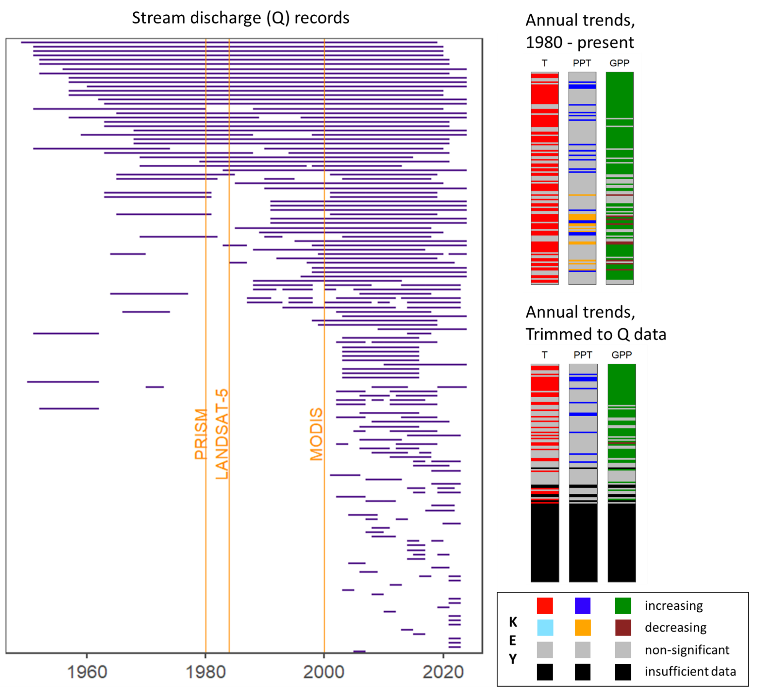
Figure 4 Effect of data limitation on ability to assess drivers of streamflow trends. The top panel shows how climate data was reduced to match streamflow data availability. The bottom panel shows the effects of that matching. On the bottom left, stacked color bars show the trends in climate and vegetation from remotely sensed data for the entire time series. Middle right shows the coverage of streamflow data by site, with data product launches demarked in orange. Bottom right shows the trends available when reduced to available streamflow data. Note how we lose almost half our possible sites due to data limits, including most sites with decreasing precipitation. An flowchart of how this chart was produced is available in figure s1.
Continued monitoring at short-record sites, particularly in the upper Midwest and arid regions, is essential to build the record length needed for robust trend detection. In places where collection is underfunded or difficult, statistical extrapolation methods may partially fill gaps (like those used in Vlah et al, 2024), but cannot replace the insights from continuous measurement. Keeping these programs funded and running continuously is crucial for this sort of national scale synthesis and for monitoring water quality and quantity in water-scarce regions and regions where water availability is changing, but we’ve yet to collect enough data to detect it.

Why so little change?
The muted hydrologic responses observed are consistent with strong biotic buffering and/or highly dynamic water routing. Synthesis work from McMillan and others in 2025, found that aridity controlled the depth of water pathways, but that terrain and biomes controlled lateral flows.
Increases in gross primary productivity under warming suggest that additional climatic demand is absorbed by vegetation rather than transferred to runoff. Shifts in species composition, including woodification of non-forest systems, may further decouple precipitation from discharge by increasing productivity without proportional increases in water use (Knapp et al, 2008; Fei et al, 2017). Such ecohydrological adjustments may delay or dampen streamflow response, though thresholds in soil water or species composition could alter this balance in the future.
When significant trends do occur, they align with expectations from aridity theory: energy-limited sites show increased flows with added precipitation, while water-limited sites show decreased flows under warming and drying. These results confirm the utility of aridity and Budyko-space frameworks as first-order predictors, while highlighting the need to incorporate vegetation dynamics explicitly. Expanding representation of arid and declining-NWD regions, and linking hydrologic synthesis with ecological monitoring, will be critical for anticipating future water availability.

Supplement
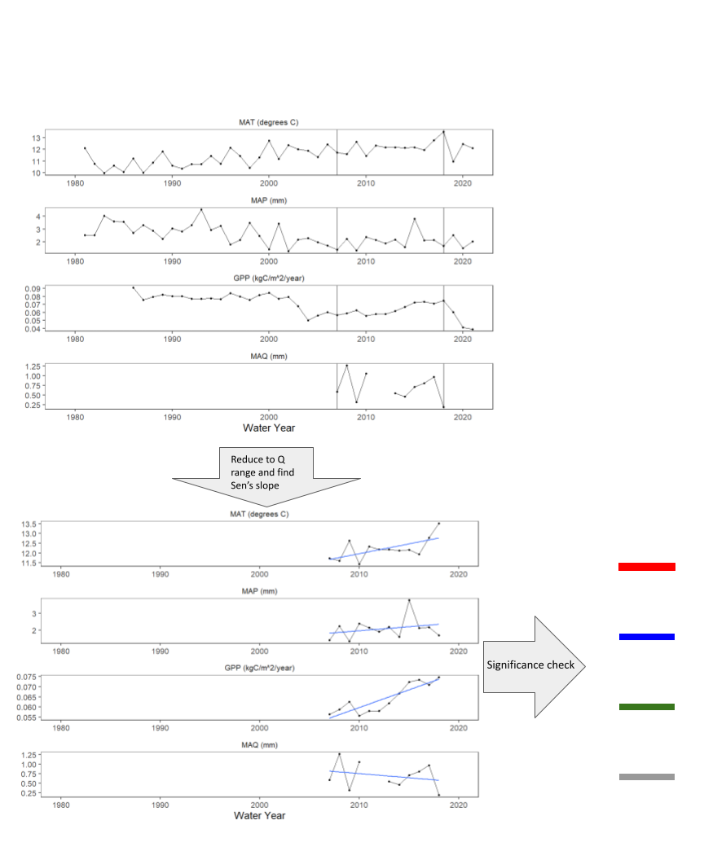
Figure s1: Example of how the colored bars in figure 4 were created. First, we computed a full, annual time-series of streamflow metrics across a range of years with at least 60% coverage. Then remotely and gridded data were cut to the range of years matching the streamflow ranges. Lastly, trends were computed using a Sen’s slope test and color coded by direction and significance.

