Macro-scale streamflow response in small, headwater catchments via data synthesis
INTRO
- Streamflow is a fundamental measurement in watershed science.
- Since the 1960’s, watershed science has used water budgeting to learn about how ecosystems function (Bormann & Likens, 1967).
- By measuring the water entering (precipitation) and leaving (evaporation, transpiration, and streamflow) a watershed, researchers can create watershed budgets, as represented in equation 1. Where Q is the streamflow, P the precipitation, and E, T, and S evaporation, transpiration, and storage, respectively.
- $equation 1:Q=P-(E+T+S)$
  - This approach to budgeting works best in smaller watersheds, with limited storage and well-defined boundary conditions (Bormann & Likens, 1967; Likens et al, 1970).
- Climate change is acting on both the inputs and outputs of watershed budgeting over the last 40 years.
  - With access to remotely sensed and gridded data, we can observe many changes across CONUS.
- Looking at trends from 1980 to today, researchers have observed meaningful trends for each component of the water budget.
  - Temperatures are increasing across most of the CONUS, increasing evaporation (Ji et al, 2014).
  - Precipitation has become more variable, with more of it arriving in extreme events (Adler et al, 2017; Davenport et al, 2021).
  - At the same time, productivity from watersheds has been increasing across most of the CONUS (Zeng et al, 2018; Wang et al, 2021; Yang et al, 2023)
    - and the water use efficiency (WUE) of those plants has leveled off (Li et al, 2023), leading to increased transpiration.
- Given all this change to inputs, we expect changes to streamflow outputs at a national scale.
  - Namely, we expect decreasing streamflow in many systems.
- Streamflow in larger systems has shown variable responses to climate change.
  - Including more high and low flow days (Wang et al, 2024).
  - Analysis of USGS gauges found from 1940-2022 found steeply increasing streamflow in the northeast and Midwest and little significant change elsewhere (https://www.epa.gov/climate-indicators/climate-change-indicators-streamflow)
- However, these large watersheds are also affected by heavy anthropogenic use (by design for USGS gauges), muddling any insights into how fundamental elements of watershed attributes affect streamflow attenuation.
- To do so demands analysis of a diverse group of small watersheds with very limited anthropogenic influence and long running streamflow records.
  - MacroSheds is exactly that dataset (Vlah et al, 2023)
- Research questions:
  - RQ1: What do we expect the trends in discharge to be for small watersheds?
  - RQ2: What are the trends in streamflow in the CONUS from small watershed ecosystem studies?
    - R2A: What drives sensitivity or insensitivity of streamflow to changes in water balance?
- RQ3: How well does the current suite of WS studies capture the landscape of climate change across the CONUS?
- Hypotheses
  - RQ1: We expect streamflow trends to follow in temperature, precipitation, and productivity. In broad terms, we expect that streamflow will decrease in regions that are heating, drying, and growing, and increase in cooling and wetting watersheds, along with areas seeing less vegetative growth.
  - RQ2: Trends will closely follow climate trends, with more discharge in the upper Midwest and Northeast and less discharge in arid environments. There will be abundant change, as small watersheds have little space and time to attenuate climate signals.
    - RQ2A: Aridity is the main driver of streamflow (in)sensitivity.
  - RQ3: Existing watershed studies are broadly distributed, capturing most patterns of change. However, due to the assumptions preferred for these studies (high slopes, solid bedrocks, constant flow, non-arid) they will be biased towards sites with increasing flows.

METHODS
Data sourcing
- MS data for streamflow (via site suppliers) (Vlah et al, 2023)
- PRISM for rainfall and air temperature (PRISM Group)
- LANDSAT for GPP (USGS)
Open analysis
- All data and analyses used in this effort are hosted publicly at https://github.com/rossyndicate/ms_physical_patterns (will version on submission)
Streamflow trends
- Calling these MS sites
- Use daily MS streamflow data
- Limit to sites that are order 0 or 1 using NHD V2.
- Windowed data to 1984 (start of LANDSAT mission) to 2024 (current).
- At each site, checked by water year for at least 4 streamflow observations per week (including rating derived) across at least 51 weeks out of the year.
  - For sites with limited sampling/seasonally sampled snowmelt sites (such as Niwot Ridge in CO) were manually flagged and added back into the analysis.
- Computed MAG7, total, mean, max, min, variance, Richard-Baker index annually.
  - Did same monthly and seasonally for greater context
- To include a site in trend analysis it needed at least 10 years of data, with no more than 40% missing data in connecting years.
- Used Sen’s slope test to calculate trends (‘zyp’ package in R) and compute 95% confidence intervals around them
Grid ‘sites’
- To answer RQ3, we created a grid of 1,000 100 ha wide points fit to CONUS.
- From now on referred to as grid sites
Climate trends
- Use PRSIM temperature and precipitation data
- Compute mean, max, min, variance for all at annual aggregation
  - Did same monthly and seasonally for greater context
  - Also cumulative precipitation and precipitation intensity
- For streamflow sites, climate data was matched with available streamflow data. For grid sites, the entire 1984-2024 window was used.
- Used Sen’s slope test to calculate trends (‘zyp’ package in R) and compute 95% confidence intervals around them
Expected response groupings
- In the past, researchers have relied on potential evapotranspiration (PET) as a measure of water demand in watersheds – combining changes in vegetation, temperature, and wetness (via vapor pressure deficit). However, PET relies on reference crop values to derive ET, which do not translate well to smaller, less anthropogenically affected systems
- An alternative way to consider all these factors is through framing them in the context of we are calling ‘expected net water demand’ (NWD).
  - If a watershed has been trending hotter and drier (less precipitation), we can classify it as increasing NWD. If a watershed is getting cooler and wetter (more precipitation), it has decreasing NWD.
  - Using equation 1, we expect watersheds with increasing NWD will have declining streamflow, shifts in vegetation speciation, and/or reduced productivity.
- As sites are small, headwater streams, storage was considered small and/or static for the analysis period
Additional metrics
- We also computed aridity index annually for each site and as an average across all 40 years.
RESULTS
- 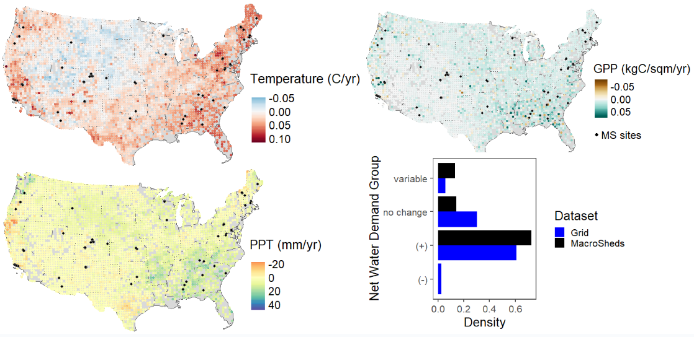
Figure 1 Trends in temperature (top left), precipitation (PPT, bottom left) and gross primary productivity (GPP, top right) for 1000 equally spaced points throughout CONUS. MacroSheds (MS) sites are in black. The histogram (bottom right) shows the relative distribution expected net water demand (NWD) trends for the same time period. Note that the studies within MS have a similar distribution to the grid, aside for failing to capture the rare areas with less expected NWD.
- 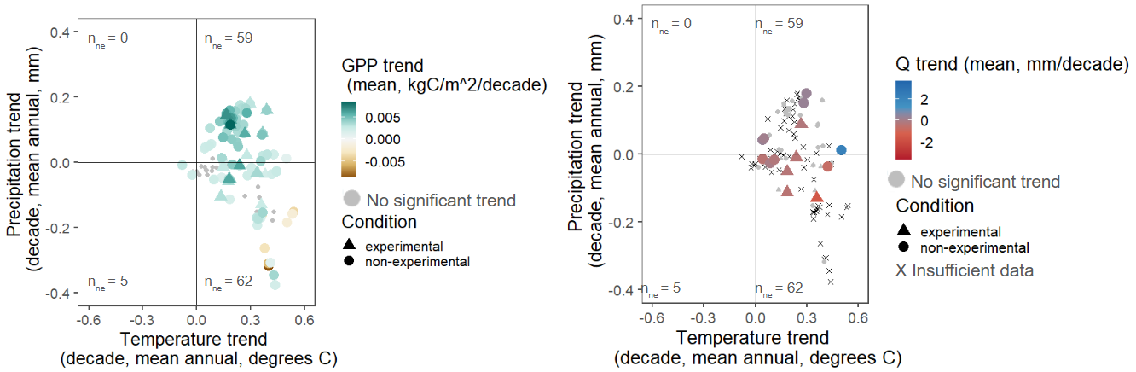
Figure 2 MAP vs MAT trends for Macrosheds sites colored by GPP (left) and trend in Q (right). Note that decreasing MAP in heating watersheds does not always lead to decreased GPP. Very few points show shifting Q despite changing precipitation, temperature and GPP.
- 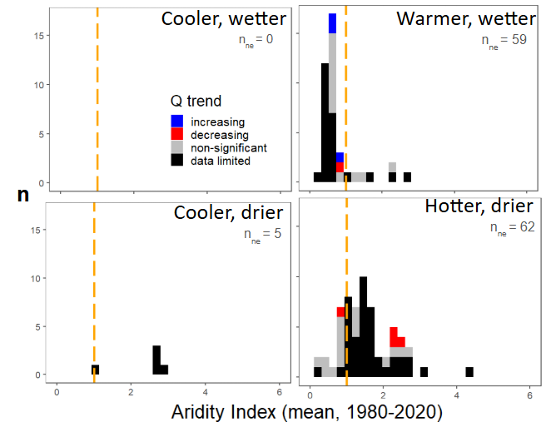
Figure 3 Histograms of site streamflow response sorted by trend in MAP and MAT. Quadrants match the layout of trends in figure 2 and n_{ne} is the number of non-experimental sites in each quadrant. Sites are grouped by mean aridity index from 1980-2020. Aridity index of 1 is marked in dashed orange. Sites to the left of this line are considered humid and those to the right arid. Note that there are few trends in streamflow, with many sites lacking sufficient data.
CONCLUSIONS
RQ1: What do we expect the trends in discharge to be for small watersheds?
- Based on trends in climate (figure 1), we expect to see widespread decreases in streamflow.
RQ2: What are the trends in streamflow in the CONUS from small watershed ecosystem studies?
- There is little change, only 8 sites have a significant streamflow trend (3 increasing, 5 decreasing), despite all undergoing changing inputs and shifting water demand
RQ2A: What drives sensitivity or insensitivity of streamflow to changes in water balance?
- When streams do respond, aridity mostly explains that response
  - Adding water to energy limited sites yields more Q
    - 1 site (GREEN4 at Niwot) bucks this trend, but it is a transitional site – with its aridity index oscillating over and under 1 throughout the analysis period.
  - Adding heat to energy limited sites yields less Q
- This is clearly not the only control, as most sites show no significant change in Q
- Sites are getting hotter, drier, and more productive without shifts in streamflow
RQ3: How well does the current suite of WS studies capture the landscape of climate change across the CONUS?
- Existing efforts do well at capturing the predominant climate change signals (figure 1)
- only missing the small regions of reduced water demand (figure 1)
DISCUSSION
Synthesis challenges
- Many sites we expect to see change at are limited by available streamflow data
- 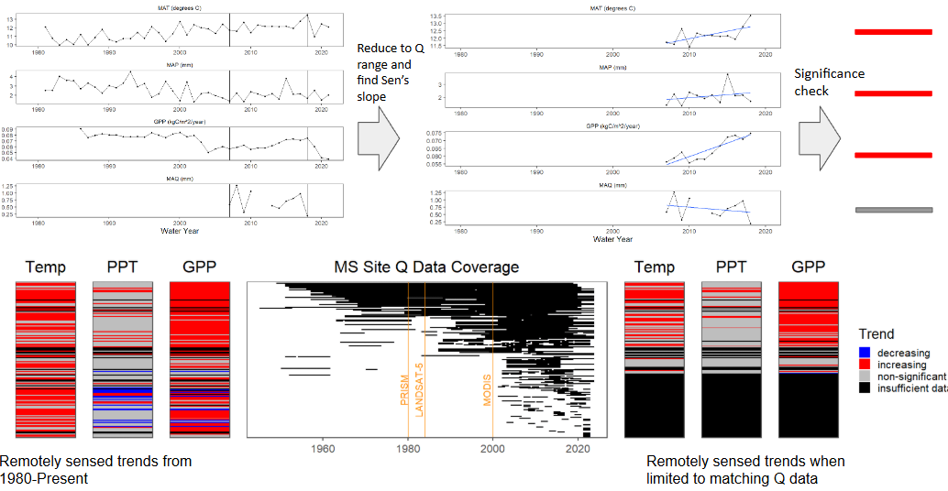
Figure 4 PLACEHOLDER WHILE FIXING COLORS Effect of data limitation on ability to assess drivers of streamflow trends. The top panel shows how climate data was reduced to match streamflow data availability. The bottom panel shows the effects of that matching. On the bottom left, stacked color bars show the trends in climate and vegetation from remotely sensed data for the entire time series. Middle right shows the coverage of streamflow data by site, with data product launches demarked in orange. Bottom right shows the trends available when reduced to available streamflow data. Note how we lose almost half our possible sites due to data limits, including most sites with decreasing precipitation.
- Continued collection at sites with <10 years of data show immense promise
- More sites in the upper Midwest and in arid climates are needed
  - Arid sites and sites with intermittent flow have been under sampled for decades due to their unique hydrology
- Keeping these programs funded and running continuously is crucial for this sort of national scale synthesis
  - Or, in austere times/when data collection is limited, statistical extrapolation efforts like Vlah et al 2024 (Leveraging gauge networks and strategic discharge measurements to aid the development of continuous streamflow records) could be used to fill in gaps
Why so little change?
- Clearly, even in small watersheds, climate trends are mediated by stabilizing in-watershed processes
- Possible vegetative attenuation of available soil water for runoff
  - Synthesis work from McMillan and others in 2025 (Global patterns in observed hydrologic processes) found that aridity controlled the depth of water pathways, but that terrain and biomes controlled lateral flows.
  - Woodification could lead to more GPP with equivalent (or less) LAI and water use (Knapp et al. 2008)
  - Species shifts could account for changes in water use as well (Fei et al, 2017)
  - Will need more detailed analysis of speciation and land cover to answer this question

