Stability of Headwater Streamflow Under Two Decades of Climate Change

ABSTRACT
Climate change is altering the inputs and outputs of the watershed water budget, and the assumption that streamflow varies within a stationary envelope no longer holds. Small, undisturbed watersheds have little storage to buffer these changes and are therefore sensitive integrators of hydrologic response. We analyzed trends in streamflow, temperature, precipitation, and gross primary productivity (GPP) at 142 first- and second-order (headwater) watersheds in the MacroSheds dataset across the conterminous United States (CONUS) over 2001–2023, using PRISM climate and MODIS GPP, and compared them with a spatially uniform reference grid of 5,212 points. Trends were estimated with Sen’s slope, and sites were grouped by expected net water demand (NWD) from the sign and significance of temperature, precipitation, and GPP trends. Warming was significant at 65 of 142 sites, whereas precipitation trends were significant at only 2 sites and GPP trends were uncommon and mixed in sign. Of 103 non-experimental sites, 49 had streamflow records sufficient for trend detection, 12 of them only for a fixed summer window, and 10 showed a significant trend: 6 increasing, at humid sites in a Wisconsin lake district and the Colorado alpine, and 4 decreasing at arid, warming sites in coastal California. MacroSheds sites broadly reproduce the grid’s distribution of NWD regimes. Where streamflow did respond, its direction followed long-term aridity, humid sites gaining flow and arid sites losing it, consistent with aridity as a first-order control. Within sites, year-to-year streamflow anomalies tracked precipitation almost one for one, responded to temperature mainly at arid sites, and responded to GPP by at most a few percent once precipitation and temperature were accounted for; the observed warming implies a decline in mean flow of about 3%, an order of magnitude below interannual variability. Sites lacking usable streamflow records were disproportionately arid, so the systems expected to respond most are the least observed; sustaining continuous monitoring in these regions is essential for detecting change.

INTRODUCTION

Background
Streamflow is a fundamental measurement in watershed science. Since the 1960s, watershed science has used water budgeting to learn about how ecosystems function (Bormann & Likens, 1967). By measuring the water entering (precipitation) and leaving (evaporation, transpiration, and streamflow) a watershed, researchers can create watershed budgets, as represented in equation 1, where Q is streamflow, P is precipitation, E and T are evaporation and transpiration, and ΔS is the change in storage over the period (positive when storage increases, negative when it is drawn down).
$$equation 1:Q=P-(E+T+ΔS)$$
This approach to budgeting works best in smaller watersheds, with limited storage and well-defined boundary conditions (Bormann & Likens, 1967; Likens et al, 1970). Paired-catchment experiments subsequently demonstrated that vegetation changes in these small systems produce detectable shifts in water yield (Bosch & Hewlett, 1982), establishing the sensitivity of headwater watersheds as analytical tools. However, climate change has been acting on both the inputs and outputs of watershed budgets for decades. With access to remotely sensed and gridded data, we can observe many of these changes across the conterminous United States (CONUS).
These changes are now well documented at continental scales. Over recent decades, researchers have observed meaningful trends for each component of the water budget. Temperatures are increasing across most of the CONUS (Ji et al, 2014). Warming raises atmospheric water demand because higher air temperature is generally accompanied by a higher vapor pressure deficit, so potential evaporation increases; actual evapotranspiration rises only where water is available to meet that demand. Precipitation has become more variable, with more of it arriving in extreme events (Adler et al, 2017; Davenport et al, 2021). Concurrently, plant productivity (gross primary productivity, GPP) has been increasing across most of the CONUS, in part because elevated atmospheric CO₂ stimulates photosynthesis (Zeng et al, 2018; Wang et al, 2021; Yang et al, 2023). Research also shows that the increasing water use efficiency (WUE) of those plants from carbon fertilization has leveled off, leading to increased transpiration as temperatures continue to rise where soil water is available (Li et al, 2023). These concurrent shifts in the water balance have prompted a broader reckoning: the long-held assumption that hydrologic systems fluctuate within a stationary envelope may no longer hold (Milly et al, 2008). If stationarity cannot be assumed, detecting and characterizing streamflow trends becomes essential for anticipating water availability and for understanding how watersheds are responding.
Given all this change in the terms of the water budget, it is reasonable to expect change in the output, namely decreasing streamflow across many systems. Early trend analyses of USGS streamflow stations found the conterminous U.S. becoming wetter but less extreme. Some of those changes appeared as step increases rather than gradual trends (McCabe & Wolock, 2002). In past work, streamflow in larger systems has shown variable responses to climate change, including more high and low flow days (Wang et al, 2024). Analysis of USGS gauges from 1940–2022 found steeply increasing streamflow in the Northeast and Midwest and little significant change elsewhere (USGS, 2023). Together, these studies establish that streamflow is responding to climate change at broad scales, but they leave open the question of what drives that response at the watershed level. Large watersheds are also affected by heavy anthropogenic use (by design for USGS gauges), muddling any insights into how fundamental elements of watershed attributes affect streamflow attenuation. Doing so demands analysis of a diverse group of small watersheds with very limited anthropogenic influence and long-running streamflow records. This study uses the MacroSheds dataset, a harmonized collection of long-running, small-watershed ecosystem studies across CONUS, to address that need. We focus on 2001–2023, the period over which a single-sensor satellite record of ecosystem productivity (GPP) is available alongside gridded climate and streamflow, so that every trend we report is evaluated over the same two decades. We organize the analysis around three questions:

Research Questions
RQ1: What are the trends in mean annual streamflow in the CONUS from small watershed ecosystem studies?
We expect that trends will closely follow climate trends, with more streamflow in the upper Midwest and Northeast and less streamflow in arid environments. We expect significant streamflow trends at most sites that show a significant trend in temperature or precipitation, because small watersheds have little space and time to attenuate signals from climate drivers.
RQ1A: What drives sensitivity or insensitivity of streamflow to changes in climate?
We expect that aridity is the main driver of streamflow sensitivity. Arid, water-limited sites will be most sensitive to changes in incoming precipitation. Humid, energy-limited sites will be most sensitive to changes in temperature.
RQ2: How well does the existing network of small-watershed study sites capture the landscape of climate change across the CONUS?
We expect that since existing watershed studies are broadly distributed, they are capturing most patterns of change. However, due to the assumptions preferred for these studies (high slopes, solid bedrock, constant flow, non-arid) they will be biased towards sites with increasing flows.

METHODS

Open analysis
All data and analyses used in this effort are hosted publicly at https://github.com/rossyndicate/ms_physical_patterns (a versioned release will be archived on submission).

Data sourcing
All streamflow data for this effort were sourced from MacroSheds (‘MS’), a harmonized dataset of small watershed ecosystem studies (Vlah et al, 2023). The dataset is well suited to this effort, as sites used for these kinds of studies tend to be small, undisturbed, and have long record lengths. Streamflow data were furnished by the contributing members of MacroSheds (Vlah et al, 2023). Because precipitation data quality varies among MacroSheds sites, we used gridded PRISM data for precipitation and air temperature (PRISM Group, 2025). Table 1 lists every data source and how it enters the analysis.
Table 1. Data sources and how each variable enters the analysis. MS, MacroSheds sites; grid, the 5,212-point CONUS reference grid. Trends are fit to one value per site and water year (October–September) over 2001–2023.
Variable | Source | Resolution | Time step | Aggregation used for trends | Sites | Window | Used for
Streamflow (Q) | MacroSheds discharge (Vlah et al, 2023) | gauge | daily | water-year mean daily flow (mm d⁻¹); summer-only sites: June–August mean | MS | 2001–2023 | streamflow trends; Figures 2–4
Air temperature (MS sites) | PRISM AN81d via MacroSheds, watershed median | 4 km | daily | water-year mean (°C) | MS | 2001–2023 | NWD groups; Figures 1–4
Air temperature (reference grid) | PRISM via Google Earth Engine | 4 km | annual (water year) | water-year mean (°C) | grid | 2001–2023 | NWD groups; Figure 1
Precipitation (MS sites) | PRISM AN81d via MacroSheds, watershed median | 4 km | daily | water-year mean daily (mm d⁻¹) | MS | 2001–2023 | NWD groups; Figures 1–4
Precipitation (reference grid) | PRISM via Google Earth Engine | 4 km | annual (water year) | water-year total (mm) | grid | 2001–2023 | NWD groups; Figure 1
GPP (MS sites) | MODIS MOD17A2HGF Collection 6.1 (8-day), summed over the water year in Google Earth Engine; watershed median (Running & Zhao, 2021) | 500 m | 8-day, summed to water years | water-year total (kg C m⁻² yr⁻¹); fill pixels masked | MS | 2001–2023 | NWD groups; Figures 1–3
GPP (reference grid) | MODIS MOD17A2HGF Collection 6.1 (8-day), summed over the water year in Google Earth Engine; mean of pixels in the 1 km² footprint | 500 m | 8-day, summed to water years | water-year total (kg C m⁻² yr⁻¹); fill pixels masked | grid | 2001–2023 | NWD groups; Figure 1
PET and P (Daymet) | MacroSheds CAMELS-compliant Daymet forcings (Thornton et al, 2022; Addor et al, 2017); PET by Priestley–Taylor with gridded alpha (Aschonitis et al, 2017) | 1 km | daily | water-year sums; PET/P averaged over 2001–2023 | MS | 2001–2023 | aridity classes; Figure 4
Landsat GPP | MacroSheds (USGS, 2025) | 30 m | 16-day | annual | MS | 1986–2022 | GPP product validation only (Table S1, figures s2–s3)
MODIS EVI | MODIS MOD13Q1 via MacroSheds, watershed median | 250 m | 16-day | annual | MS | 2001–2023 | GPP product validation only (figure s2)
To estimate gross primary productivity (GPP), we summed the 8-day MODIS MOD17A2HGF product (Collection 6.1, 500 m; Running et al, 2004; Running & Zhao, 2021) over each water year (October–September) in Google Earth Engine and took the median of the pixels within each watershed boundary for 2001–2023. MacroSheds also distributes a finer-resolution Landsat-derived GPP product (USGS, 2025; 30 m, 1986–2022), but that record is stitched together across successive Landsat missions, and GPP trends derived from it can reflect handoffs between sensors rather than change on the ground (Roy et al, 2016; Vogelmann et al, 2016). We therefore based all GPP trends on the single-sensor MODIS record and used the Landsat product only to test that choice (see GPP product validation below).
MOD17 writes a fill value in place of GPP wherever land cover is classed as urban, barren, or water. We masked these pixels before taking the watershed median, so a watershed has a GPP record wherever it contains vegetated pixels; one site (GFGL, in the Baltimore domain) has none and is excluded from GPP trend analysis, leaving 141 sites with a usable GPP record.
Two properties of the MODIS record bear on interpretation. First, MODIS pixels (500 m, 0.25 km²) are coarse relative to these catchments: the 142 MS sites range from 0.01 to 85 km² in area, with a median of 1.54 km² (interquartile range 0.41–6.24 km²), and 24, 60, and 79 of the 142 are smaller than 1, 4, and 10 pixels, respectively. Landsat’s 30 m pixels are far better matched to catchment size; MODIS trades that spatial fidelity for a consistent single-sensor time series, and for the smallest watersheds its GPP signal reflects the surrounding landscape as much as the catchment itself. Second, the 8-day composites start on fixed days of the year, so a water-year sum comprises the composites that begin between 1 October and 30 September; the few days of overlap at each end cancel, and GPP is aligned with the water-year streamflow and climate metrics. The grid GPP described below was summed the same way.

Streamflow analysis
To determine how streamflow is changing across CONUS, we computed annual metrics from daily streamflow records at MS sites and analyzed trends in the annual series. First, we restricted the analysis to headwater streams, defined as first- and second-order streams (Strahler, 1957; Meyer et al, 2007). Stream order was taken from the NHDPlus flowline nearest each gauge using the ‘nhdplusTools’ package in R (Blodgett, 2023). Because NHDPlus flowlines omit much of the headwater channel network (Fritz et al, 2013; Elmore et al, 2013), a gauge whose catchment was smaller than half the drainage area of its nearest flowline was treated as first-order. Then, we limited streamflow records to water years 2001–2023, the period from the first full year of MODIS observations through the last year of the MODIS record, and selected each site’s longest contiguous window within that period with no more than 40% missing data. This window is shorter than the streamflow record at many long-running sites, but it ensures that streamflow, climate, and GPP trends are all evaluated over the same years. To be included for trend analysis, site records were checked for completeness by water year for at least 4 streamflow observations per week (including rating derived) across at least 51 weeks out of the year. Gauges that operate only in the snow-free season (the Niwot Ridge sites in Colorado) cannot meet this criterion, and several year-round gauges fall one or two complete years short of it. For headwater sites that did not reach a usable record under the standard criterion, we instead used mean streamflow over a fixed June–August window, retaining water years with at least 80 observation days in that window and applying the same minimum of 10 years with no more than 40% missing. Fourteen sites entered the analysis this way (Table S2). We refer to them as summer-only sites, mark them in figures 2–4, and note that their trends describe summer flow (melt-season flow at Niwot Ridge, dry-season flow at Santa Barbara) rather than annual mean flow.
MacroSheds also classifies each watershed as experimental (subject to deliberate manipulation, such as harvesting) or non-experimental. Of the 142 MS sites with complete climate records, 39 are experimental and 103 non-experimental; we focus on non-experimental sites when relating streamflow trends to climate.
We then computed annual hydrologic metrics for each site, including the ‘Magnificent 7’ (Archfield et al, 2014), total flow, mean flow, maximum and minimum flows, variance, and the Richards-Baker flashiness index. We computed the same metrics monthly and seasonally for greater context in our analysis.
To include a site in trend analysis it needed at least 10 years of data that passed our completeness check, with no more than 40% missing data in connecting years.
For all metrics, we used Sen’s slope, implemented in the ‘zyp’ package in R (Bronaugh et al, 2023), to calculate trends and 95% confidence intervals around them. Significance was judged from the 95% confidence interval of the Sen slope, which ‘zyp’ derives from the variance of Kendall’s S (Sen, 1968); a series was classed as increasing or decreasing when the interval excluded zero and non-significant otherwise. No prewhitening was applied.
Because 23 water years is a short window for trend detection, we also asked how streamflow responds to interannual variation in its drivers without assuming a monotonic change. For every non-experimental headwater site with at least six water years meeting the completeness criteria above within 2001–2023, we converted mean daily streamflow (log-transformed), total precipitation, mean temperature, and MODIS GPP to within-site anomalies (z-scores), standardizing the drivers over all 23 years and streamflow over the site’s complete years. We summarized across sites the within-site Spearman correlation between the streamflow anomaly and each driver, including the GPP anomaly after the precipitation signal, and then the precipitation and temperature signals, had been removed from both series by regression. We then fitted linear mixed models to the pooled site-years (‘lme4’; Bates et al, 2015) with fixed effects for the three driver anomalies, random slopes by site, and a random intercept by water year to absorb region-wide wet and dry years, and compared sites with mean PET/P below and above 1. A log–log form of the same model gives precipitation and GPP elasticities of streamflow and, as exp(b) − 1, the proportional change in streamflow per °C. Sites with at least six complete summers but fewer than six complete water years were analyzed separately on June–August flow.

Gridded sampling
To evaluate how well existing watershed studies represent the range of climate conditions across CONUS (RQ2), we constructed a spatially uniform reference set. We created a grid of 5,212 points fit to CONUS, from now on referred to as ‘grid sites’, and treated each point as a 1 km² (100 ha) square footprint. These points were chosen to be of similar size to our MS sites, but spread evenly throughout CONUS. For each footprint we extracted annual PRISM temperature (mean) and precipitation (total) for water years 1981–2024 (PRISM Group, 2025) and water-year MODIS GPP summed from the 8-day MOD17A2HGF composites (Collection 6.1, 2001–2023) using Google Earth Engine, taking the mean of valid pixels within each square after masking the fill value and applying the product’s 0.0001 scale factor (MOD17 stores GPP as integers; multiplying by 0.0001 gives kg C m⁻² per composite). Of the 5,212 points, 4,859 had complete temperature, precipitation, and GPP trends and were used in the comparison with MS sites.

Climate analysis
From the daily PRISM series we computed, for each MS site and water year (October–September), mean daily temperature and mean daily precipitation; these annual series are the basis of all temperature and precipitation trends reported here. For grid sites we used one PRISM value per water year: mean temperature and total precipitation. Climate trends (temperature, precipitation, and GPP) for both MS and grid sites were computed on the same 2001–2023 window used for streamflow. For MS sites, trends were computed over each site’s longest continuous record of mean temperature data within that window, identified by finding the longest consecutive run of years with non-missing values; the median MS record spans the full window (23 years, 2001–2023). For grid sites, the entire 2001–2023 window was used.
We also computed an aridity index (AI) for each site by water year, defined as in the Budyko framework as the ratio of potential evapotranspiration to precipitation (PET/P; the reciprocal of the P/PET convention used in climatology), using the Daymet forcing data distributed with MacroSheds (the MacroSheds ‘CAMELS Daymet forcings’ product, which reproduces the CAMELS forcing variables from Daymet for each MacroSheds watershed): water-year sums of daily PET divided by water-year sums of daily precipitation, with PET computed by the Priestley–Taylor method using the gridded alpha coefficients of Aschonitis et al (2017) (Thornton et al, 2022; Addor et al, 2017). We averaged this index over 2001–2023 to obtain a site climatology, and classify sites with mean PET/P greater than 1 as arid (water-limited) and those below 1 as humid (energy-limited). The classification is insensitive to the averaging window: climatologies computed over 1980–2020 and 2001–2023 agree closely (r = 0.999; median absolute shift 0.011; maximum 0.31), and no site changes humid/arid class (figure s4).
Trends and confidence intervals for all climate metrics were computed as for streamflow, using Sen’s slope in the ‘zyp’ package (Bronaugh et al, 2023).

GPP product validation
Because the choice of MODIS over Landsat changes both the sensor and the available analysis window, we checked how each affects GPP trends. First, we compared relative GPP trends (percent per year) from the two products at each site over matched windows, fit with reduced major axis regression (figure s2). Landsat and MODIS GPP trends are positively but only moderately correlated (n = 139 sites, r = 0.63, slope 0.74), as are Landsat GPP and MODIS enhanced vegetation index (EVI) trends (n = 140, r = 0.55, slope 0.65). Second, we separated the effect of the window from the effect of the sensor by recomputing trend flags for each product on each window (figure s3). Across MS sites with a usable record in each product, shortening the Landsat window alone moved 31% of Landsat-greening sites to non-significant, whereas switching sensor on the same window moved 81% (Table S1, figure s3). The widespread greening in the Landsat record was therefore mostly a sensor effect rather than a window effect, and we use the MODIS record for all GPP trends reported here.

Expected response groupings
Potential evapotranspiration (PET) is the usual measure of atmospheric water demand; it integrates temperature, radiation, and humidity (via vapor pressure deficit) (Zeng et al, 2018), but it describes demand on a reference surface and does not respond to changes in the vegetation that actually transpires, and reference-crop formulations translate poorly to natural vegetation (Heerwaarden et al, 2010). An alternative way to consider all these factors is through framing them in a systems perspective, using what we are calling ‘expected net water demand’ (NWD).
NWD is a qualitative balance between atmospheric demand for water and its supply. Demand rises with warming (a proxy for rising vapor pressure deficit) and with increasing vegetation productivity (greening, a significant increase in GPP); supply falls with declining precipitation. A watershed with significant warming, drying, or greening and no opposing trend is classed as increasing NWD (+); one with significant cooling, wetting, or browning (a significant decrease in GPP) and no opposing trend is decreasing NWD (−); a watershed with no significant trend in any driver is ‘no change’; mixed combinations are ‘variable’ (Table 2). Using equation 1, we expect watersheds with increasing NWD will have declining streamflow, shifts in vegetation composition, and/or reduced productivity. Over multi-year windows we treat the change in storage (ΔS) as small relative to the other terms, the standard closure assumption for long-term water-balance analysis; this is an assumption about the averaging period, not catchment size, and a persistent trend in groundwater storage would violate it.
Table 2. Assignment of the 27 possible combinations of trend flags to expected net water demand (NWD) groups. Each site is coded by its temperature flag (H warming, C cooling, – no significant trend), precipitation flag (W wetting, D drying, –) and GPP flag (G greening, B browning, –), in that order. Combinations in which every significant driver raises demand or lowers supply (warming, drying, greening) are increasing NWD; combinations in which every significant driver lowers demand or raises supply (cooling, wetting, browning) are decreasing NWD; sites with no significant trend in any driver are no change; combinations with drivers in both directions are variable (the one exception, HDB, which does not occur in our data, is grouped with increasing NWD).
Expected NWD group | Combinations of significant trend flags (temperature, precipitation, GPP)
Increasing (+) | H–– (warming only); HD–; H–G; HDG; HDB; –D– (drying only); –DG; ––G (greening only)
Decreasing (−) | C–– (cooling only); CW–; C–B; CWB; –W– (wetting only); –WB; ––B (browning only)
No change | ––– (no significant trend in any driver)
Variable (mixed signals) | HW–; HWG; HWB; H–B; –WG; –DB; C–G; CWG; CD–; CDG; CDB

RESULTS

Study coverage of NWD
Our analysis of grid and MS sites found that the existing network of small-watershed study sites has done well at capturing the distribution of NWD regimes from 2001 to 2023 (Figure 1). Warming is the dominant signal over this window: temperature increased significantly at 65 of 142 MS sites and decreased at none, whereas significant precipitation trends were nearly absent (1 increasing and 1 decreasing of 142). NWD is therefore split between sites with increasing demand and sites with no significant change in any driver. Of all 142 MS sites, 47.9% fall in the increasing (+) group; 40.8% show no change; 9.9% are variable (mixed signals), and 1.4% are decreasing (-); the grid distribution is similar, at 41.1% increasing, 51.5% no change, 4.2% variable, and 3.2% decreasing across the 4,859 grid cells with complete trends.
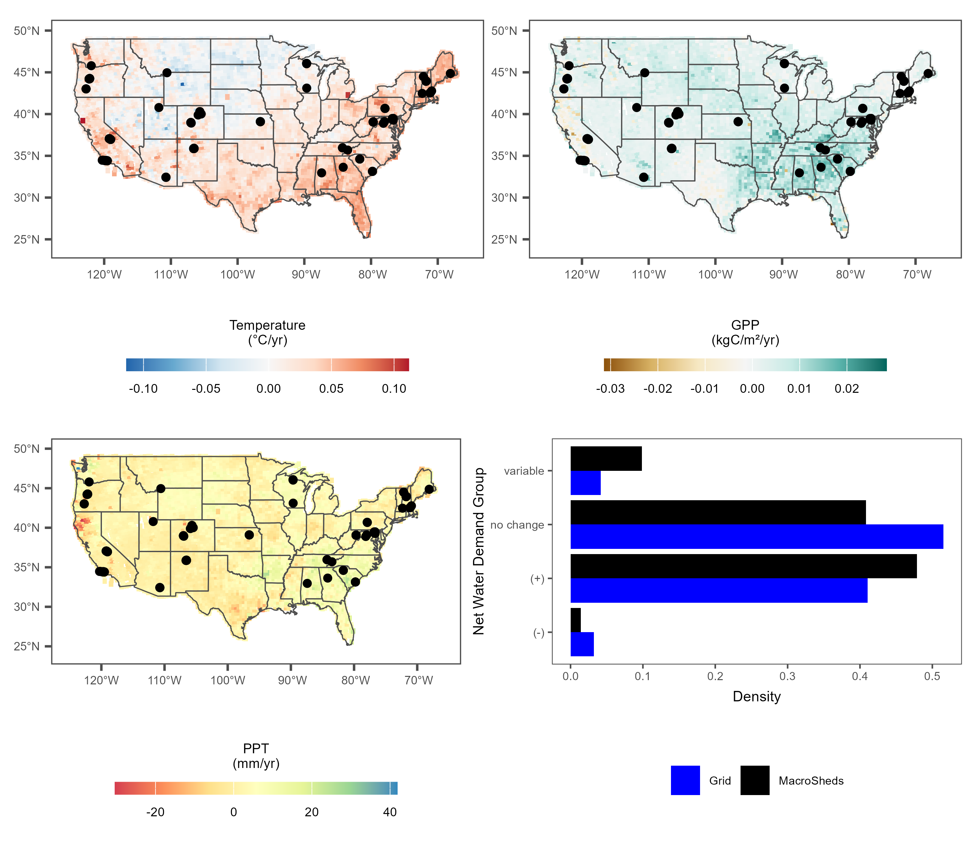
Figure 1. Trends in mean annual temperature (top left), annual precipitation (PPT, bottom left) and gross primary productivity (GPP, top right) from 2001 to 2023 for 5,212 equally spaced points throughout CONUS. MacroSheds (MS) sites are in black. The density plot (bottom right) shows the relative distribution of expected net water demand (NWD) groups for MS sites and for the 4,859 grid cells with complete trends over the same time period. Note that the MS sites have a distribution similar to the grid, although only two MS sites fall in the rare decreasing-NWD class.
Decreasing NWD is rare in both sets. The 157 decreasing grid cells (3.2%) are spread across the Mountain (51), West (51), Midwest/Great Lakes (37), Plains (9), South/Southeast (6), and Northeast (3) regions rather than concentrated in any one of them, and most are classified as decreasing because of wetting without warming (93 cells) or browning (a significant decrease in GPP) alone (58 cells); the remaining 6 are cooling without a precipitation or GPP trend. MS captures this group with two sites (SM01 and SM04 at Santa Barbara), both classified as decreasing because of browning alone; the wetting-driven decreases seen on the grid are not represented in MS.

Data availability and emerging patterns
To interpret streamflow trends, we first assessed the coverage and quality of our data across sites (Figure 2). Temperature and precipitation trends are available for all 142 MS sites across the full 2001–2023 analysis period (median record length 23 years), and GPP trends for 141 of them; the remaining site (GFGL) has no vegetated MODIS pixel. Streamflow records, however, vary widely in length and completeness. Matching climate and vegetation records with streamflow data cut the usable pool from 142 to 83 sites overall (14 of them summer-only sites), and by about half among non-experimental sites, from 103 to 49; it also shortened the median record to 18 years, with a median end year of 2019. Sites outside CONUS (Luquillo and Krycklan) lie outside PRISM coverage and were excluded before trend analysis. This loss disproportionately excluded arid and intermittent systems, where the largest hydrologic responses would be expected: non-experimental sites that retain a usable streamflow record have a median aridity index of 0.52 (20% arid, AI > 1), whereas those without one have a median of 1.20 (70% arid; Wilcoxon rank-sum test, p = 2.1 × 10⁻⁴). The lost sites are led by the NEON (15), East River (12), Catalina-Jemez (10), and Santa Barbara (7) domains.
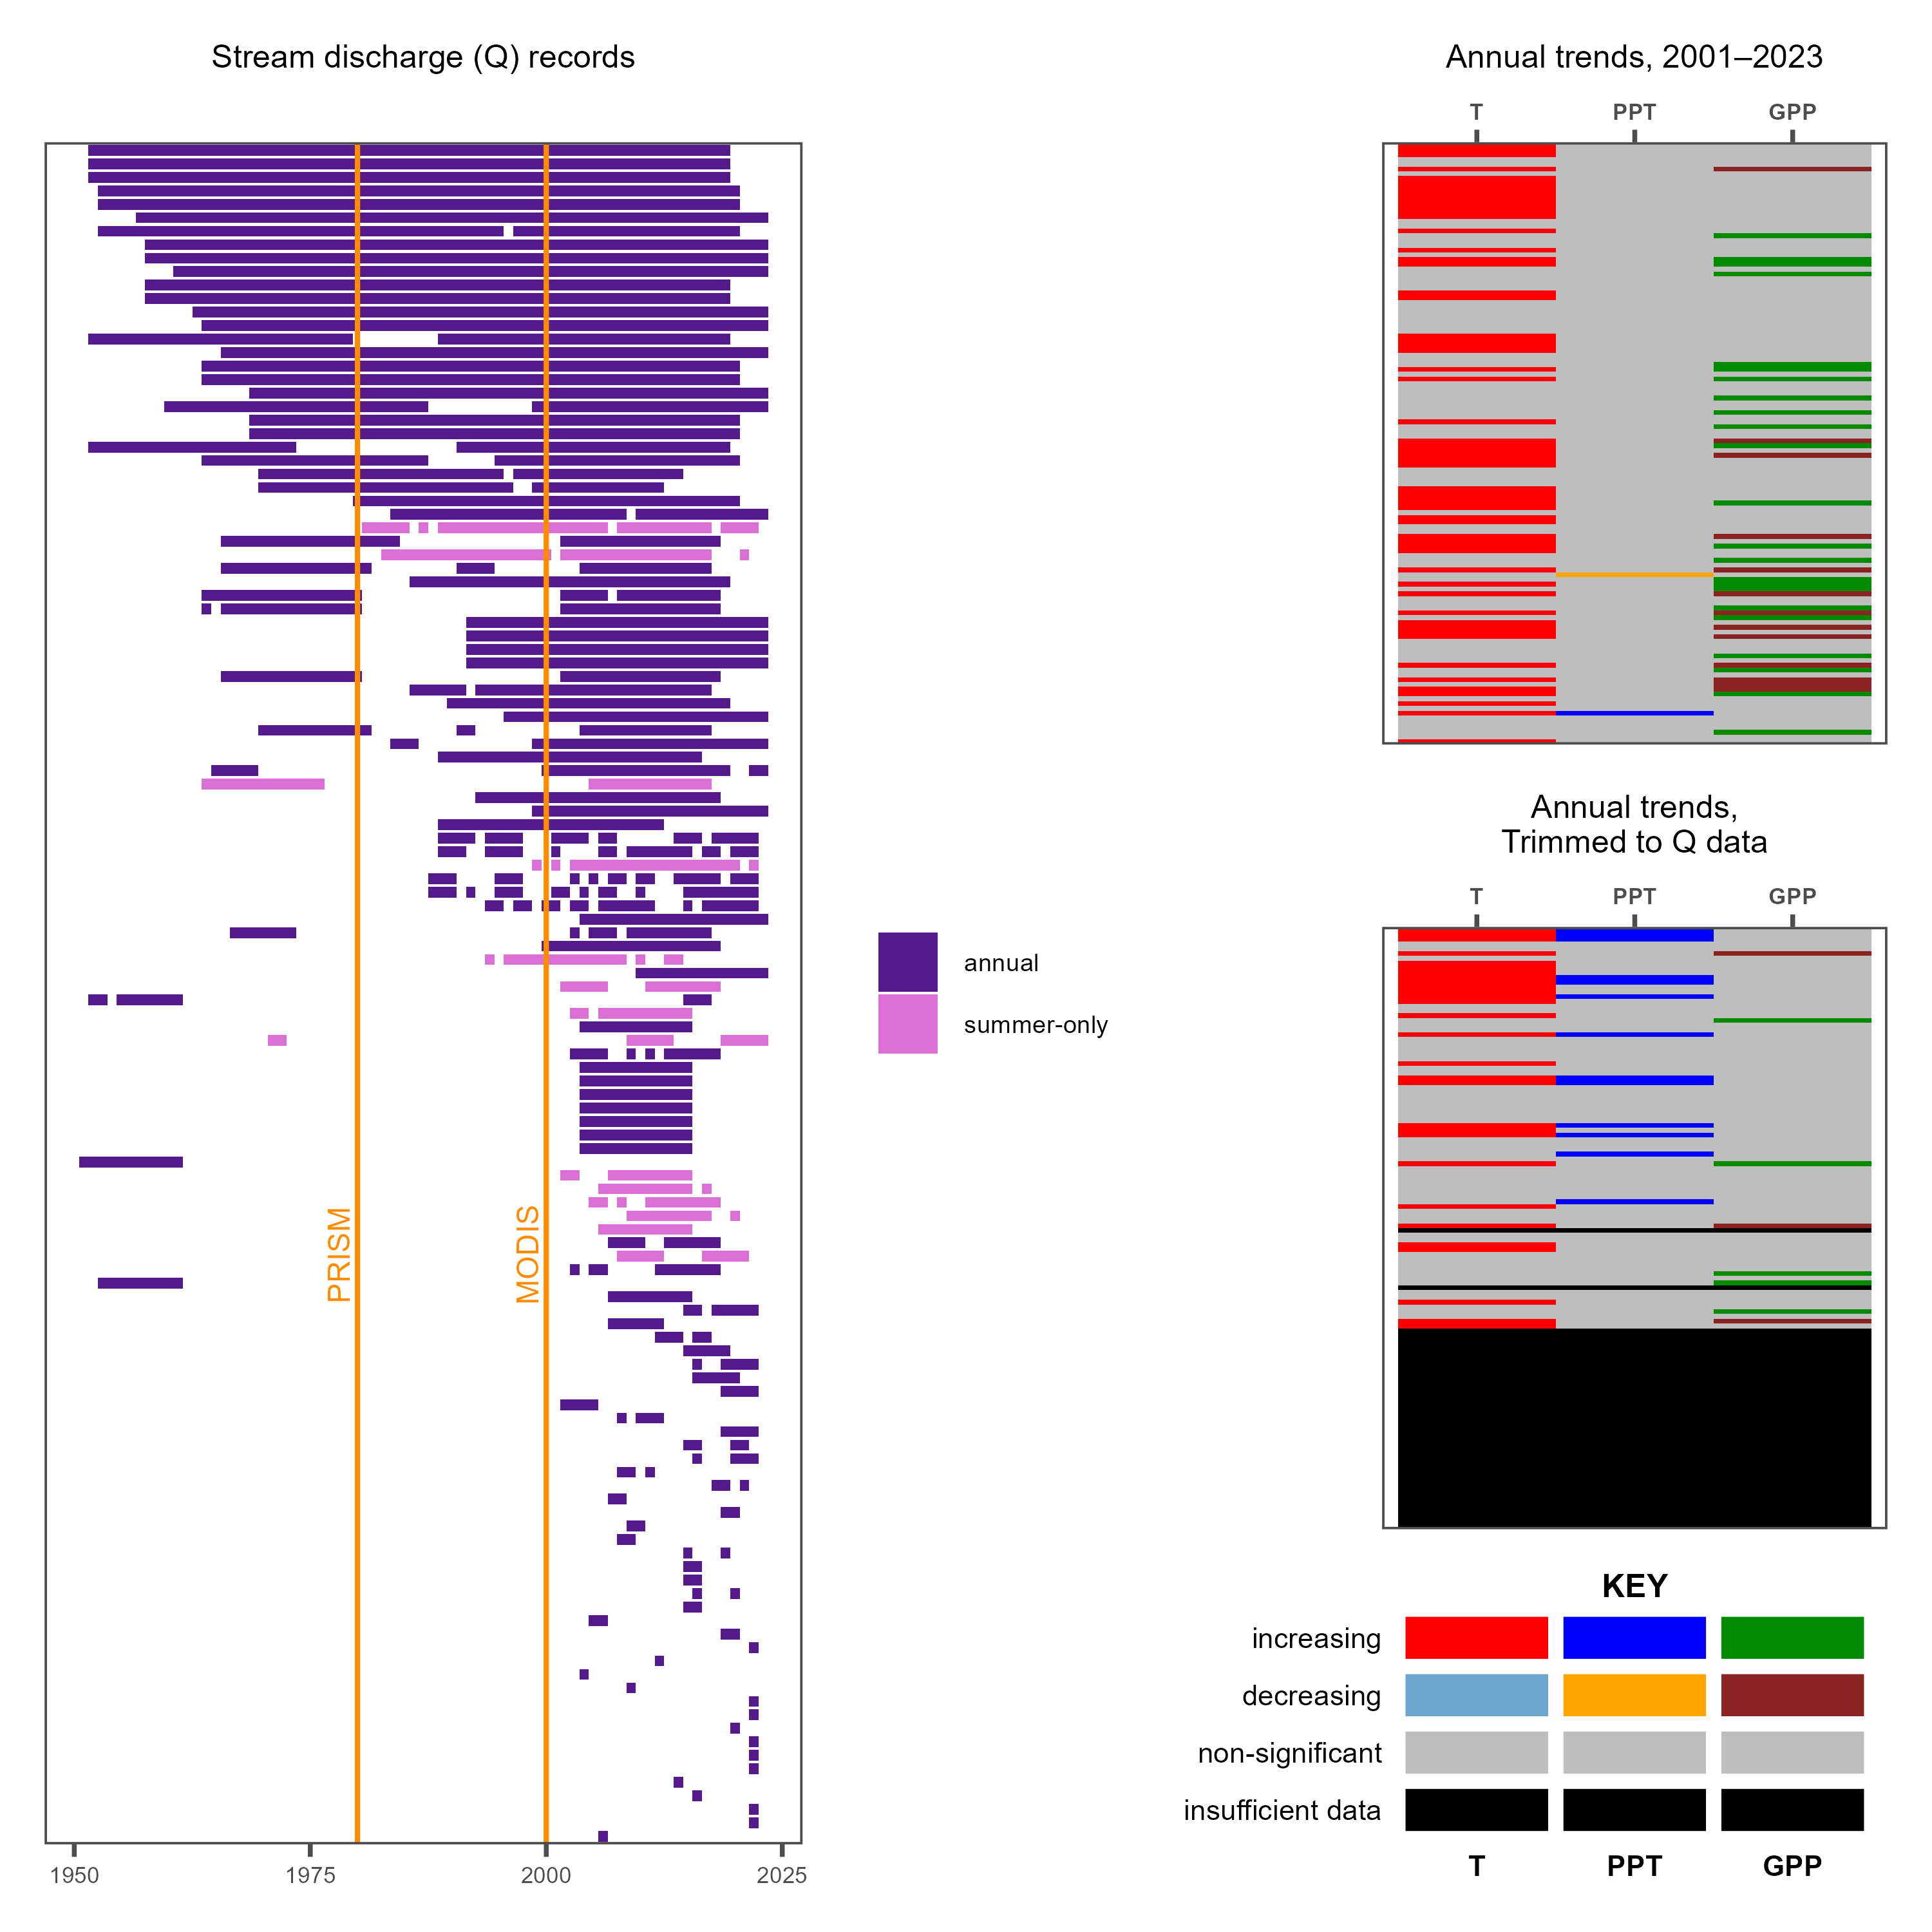
Figure 2. Effect of data limitation on the ability to assess drivers of streamflow trends. The left panel shows streamflow record coverage for each site, with rows sorted by record length; for summer-only sites (Table S2) the summer-window years used for their trend are shown in light purple and the launches of the PRISM (1980) and MODIS (2000) data products marked in orange. The top right panel shows stacked color bars of annual temperature, precipitation, and GPP trend flags for all sites over the full 2001–2023 window; the middle right panel shows the same flags after each site’s climate record is trimmed to its streamflow window. The key gives the trend classes (increasing, decreasing, non-significant, insufficient data). Note how we lose roughly half of our possible sites due to data limits, including the majority of arid sites. A flowchart of how this figure was produced is available in figure s1.
Even among the remaining sites with sufficient streamflow records, a counterintuitive pattern emerges: despite widespread warming and scattered changes in productivity, very few sites show corresponding changes in streamflow (figure 3). The following sections examine this disconnect in detail.

Trends in drivers and outputs
Our analysis of trends highlighted the importance of long-term climate setting in determining how systems respond to climate change. Generally, we saw very little response. Of 103 non-experimental MS sites, 49 had sufficient streamflow record for trend detection within the 2001–2023 window (37 on the annual metric and 12 as summer-only sites); 10 of those (20%) showed significant streamflow trends (6 increasing, 4 decreasing) (figure 3). The six increasing sites fall in two clusters: three Trout Lake streams in the Wisconsin lake district (Allequash Creek, North Creek, and Stevenson Creek), which should be read as one regional signal rather than three independent detections, and three summer-only alpine gauges at Niwot Ridge, Colorado (GREEN5, MARTINELLI, and NAVAJO). None of the six has a significant local trend in temperature, precipitation, or GPP (NWD group “—”). The four decreasing sites (AB00, RS02, BC02, and HO00) are all arid Santa Barbara streams that are warming without a significant change in precipitation (NWD group “H–”; HO00 is also browning, group “H–B”); BC02 and HO00 are summer-only sites, so their trends are in dry-season flow. Among experimental sites, streamflow decreased at KREW B204 and P303 and increased at Bear Brook WB and Santee WS77. The Niwot trends are marginal, with lower confidence bounds just above zero.
Because significant precipitation trends are essentially absent across the 142-site pool (1 increasing, 1 decreasing), the quadrants in figure 3 are defined by the sign of the Sen slope in temperature and precipitation rather than by its significance, and “drying” and “wetting” below refer to slope sign only. By sign, non-experimental sites split almost evenly between hotter-wetter (50) and hotter-drier (51), with one site each in the cooler-wetter and cooler-drier quadrants. Hotter-wetter sites tended to show no change in streamflow (27 non-significant, 6 increasing, 17 without a usable record), and GPP, where it changed, increased (18 greening, 0 browning, 31 non-significant). Hotter-drier sites, where we expected to see decreasing streamflow, showed little streamflow response (12 non-significant, 4 decreasing, 35 without a usable record) and diverging GPP responses (3 greening, 14 browning, 34 non-significant) (figure 3). Across all 141 sites with a usable MODIS record, GPP trends were mostly non-significant (25 greening, 15 browning, 101 non-significant).
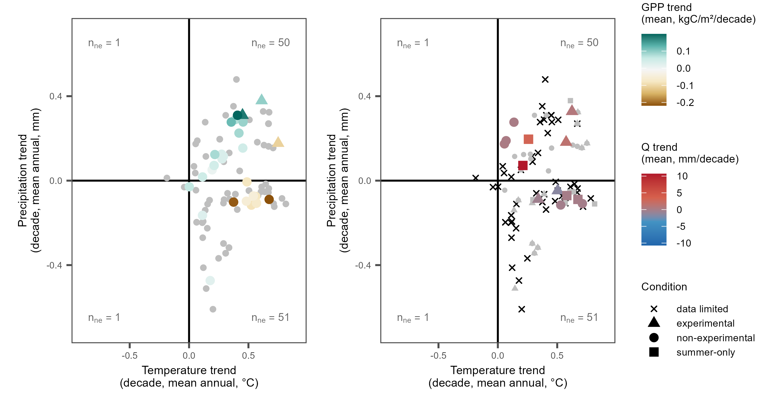
Figure 3. Mean annual precipitation trend vs mean annual temperature trend (per decade, 2001–2023) for MacroSheds sites, colored by GPP trend (left) and trend in Q (right). Triangles mark experimental watersheds, squares mark summer-only sites (trend in June–August mean flow; Table S2), and n_{ne} is the number of non-experimental sites in each quadrant; quadrants are defined by the sign of the temperature and precipitation slopes, not their significance. Note that almost no precipitation trend is significant, and that decreasing precipitation in warming watersheds does not always lead to decreased GPP. Very few points show shifting Q despite changing temperature and GPP.
Given the scarcity of significant streamflow trends despite widespread warming, we next asked whether long-term aridity could explain which sites do respond. We grouped sites by their mean aridity index (PET/P from Daymet, averaged over 2001–2023; figure 4). Averaging over this window rather than the full Daymet record changes the humid/arid class of no site (figure s4).
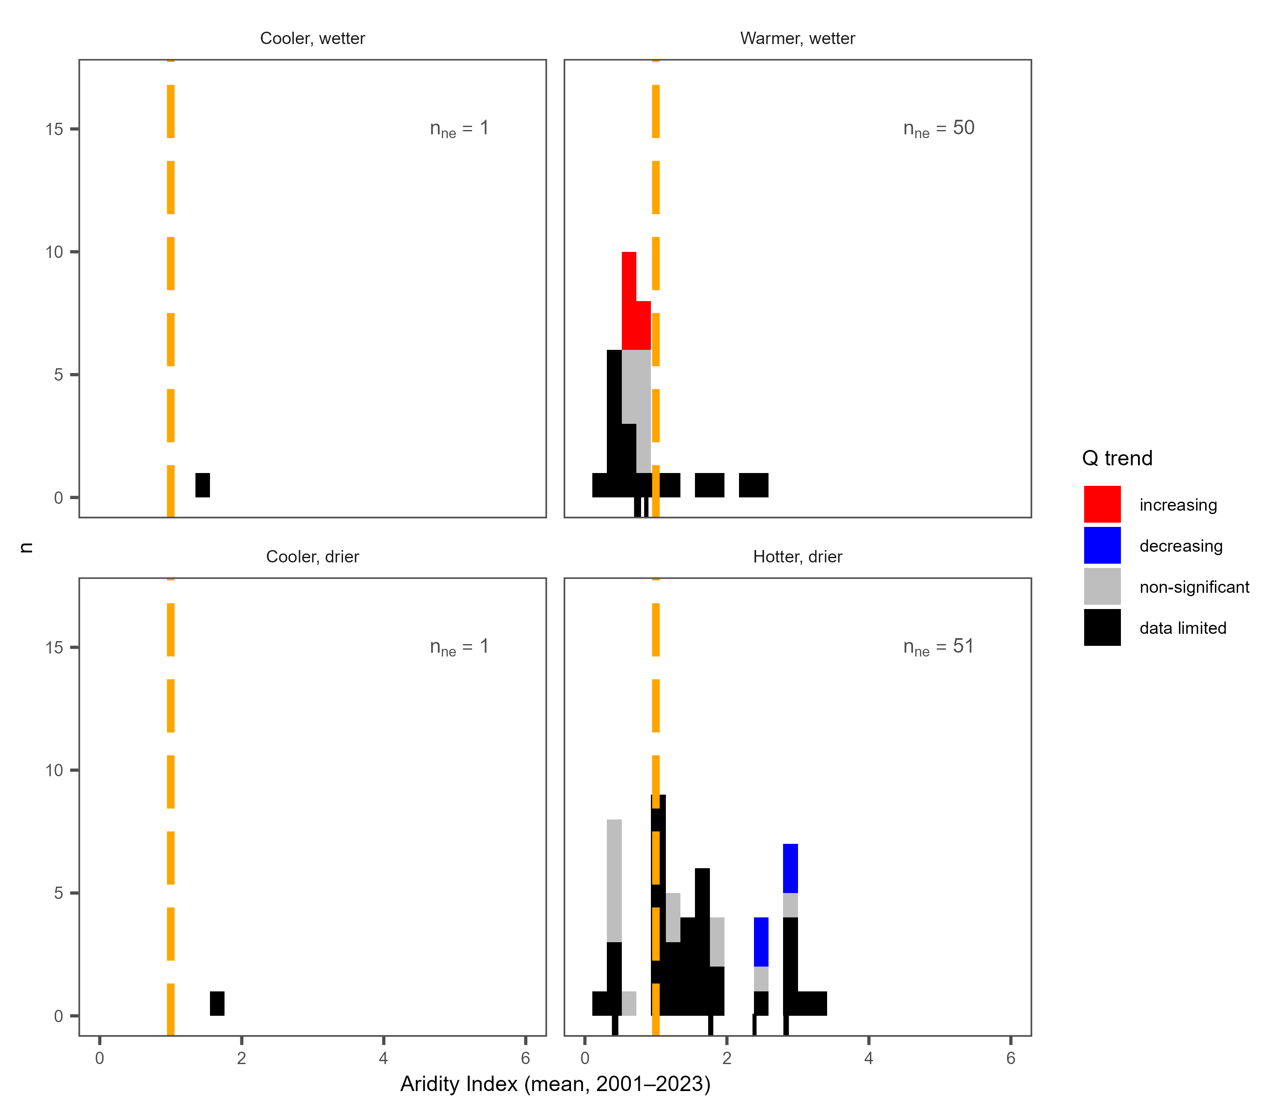
Figure 4. Histograms of mean aridity index (Daymet PET/P, 2001–2023) for MacroSheds sites, filled by streamflow trend flag and sorted into quadrants by the sign of the trends in MAP and MAT. Quadrants match the layout of figure 3 and n_{ne} is the number of non-experimental sites in each quadrant. An aridity index of 1 is marked in dashed orange; sites to the left of this line are considered humid and those to the right arid. Note that there are few trends in streamflow, with many sites lacking sufficient data, and that the sites lacking data are concentrated on the arid side of the line. Ticks along the lower axis mark summer-only sites (Table S2).
To formalize this relationship between climate setting and hydrologic response, we examined our results through the lens of Budyko theory (Budyko, 1974). Assessing our trends in Budyko space, long-term climate history is consistent with the direction of the few responses we detect, although the sample is too small to test this formally. All four significant decreasing trends at non-experimental sites were detected at arid, water-limited Santa Barbara sites (AI = 2.4–2.9) that are gaining heat without a significant change in incoming water. The six increasing trends were all at humid, energy-limited sites, three Trout Lake streams (AI = 0.66–0.67) and three Niwot Ridge summer-only gauges (AI = 0.72–0.86), none with a significant local trend in temperature, precipitation, or GPP; because each cluster shares a single domain and lacks a significant climate driver in this window, we do not interpret them as a climate-driven response. The experimental sites follow the same aridity pattern, with decreasing flow at the arid KREW sites (AI = 1.24 and 1.35) and increasing flow at the humid Bear Brook and Santee sites (AI = 0.32 and 0.59), although treatments at these watersheds confound attribution to climate.

Interannual response of streamflow to its drivers
Streamflow anomalies at the 44 non-experimental headwater sites with six or more complete water years (740 site-years; 35 humid, 9 arid) tracked precipitation almost one for one. The within-site Spearman correlation between the streamflow and precipitation anomalies had a median of 0.79 (interquartile range 0.66–0.88), was positive at every site, and was significant at 86% of them (figure 5a, b). Temperature had a weaker, opposite effect that depended on aridity: the median correlation was −0.11 at humid sites but −0.73 at arid sites, where it was negative at all nine sites and significant at seven. GPP anomalies alone showed no consistent relation to streamflow (median ρ = −0.06; 60% of sites negative; Wilcoxon p = 0.33; figure 5a). Removing the precipitation signal from both series left a weak negative association (median ρ = −0.09; 74% of sites negative; p = 0.001) that was strongest at the arid sites (median −0.27), and removing temperature as well weakened it further (median ρ = −0.07; 61% of sites negative; p = 0.03): −0.03 at humid sites (p = 0.34) and −0.21 at the nine arid sites, where it was significant at one site (figure 5c). The pooled fits make the contrast plain: precipitation alone explains 59% (humid) and 61% (arid) of the variance in the streamflow anomaly (figure 5b), whereas GPP, once precipitation and temperature are removed, explains less than 1% of the variance that remains (figure 5c).
The pooled mixed model gave the same ordering (722 site-years at the 43 sites with usable GPP; figure 5d). A one-standard-deviation wetter year raised the streamflow anomaly by 0.72 SD (95% CI 0.66–0.77), a warmer year lowered it by 0.10 SD (0.04–0.15), and a greener year lowered it by 0.04 SD (CI −0.09 to 0.01; likelihood-ratio test for adding GPP, p = 0.28). The fixed effects explained 57% of the variance in the streamflow anomaly. Adding the previous year’s precipitation added a carry-over effect of 0.20 SD (0.15–0.25) and made the GPP coefficient marginally negative (−0.05, CI −0.10 to −0.01). The temperature effect was 0.27 SD per SD stronger at arid than at humid sites (interaction p = 0.004), whereas the GPP effect did not differ between classes (p = 0.87). In proportional terms the precipitation elasticity of streamflow was 1.4 (1.2–1.7) overall, 1.3 at humid and 1.6 at arid sites; streamflow fell by 6% per °C (1–11%) overall, by 3% per °C (0.2–5%) at humid sites and by 36% per °C (4–57%) at the nine arid sites; and the GPP elasticity was −0.20 (−0.51 to 0.10) overall and −0.26 (−0.49 to −0.03) at humid sites, so a year 10% greener than normal carried at most a few percent less flow. Other streamflow metrics behaved alike: high flows (95th percentile) followed precipitation as closely as mean flow (median ρ = 0.72), low flows (5th percentile) less so (0.36), the date by which half of the annual flow had passed came earlier in warmer years at every site (median ρ = −0.21), and GPP, after adjustment for precipitation and temperature, had a median |ρ| of 0.11 or less for every metric (Table S3). At the 13 sites with at least six complete summers but fewer than six complete water years, June–August flow was more weakly tied to water-year precipitation (median ρ = 0.39) and again showed no consistent GPP relation (median ρ = −0.20; p = 0.24).
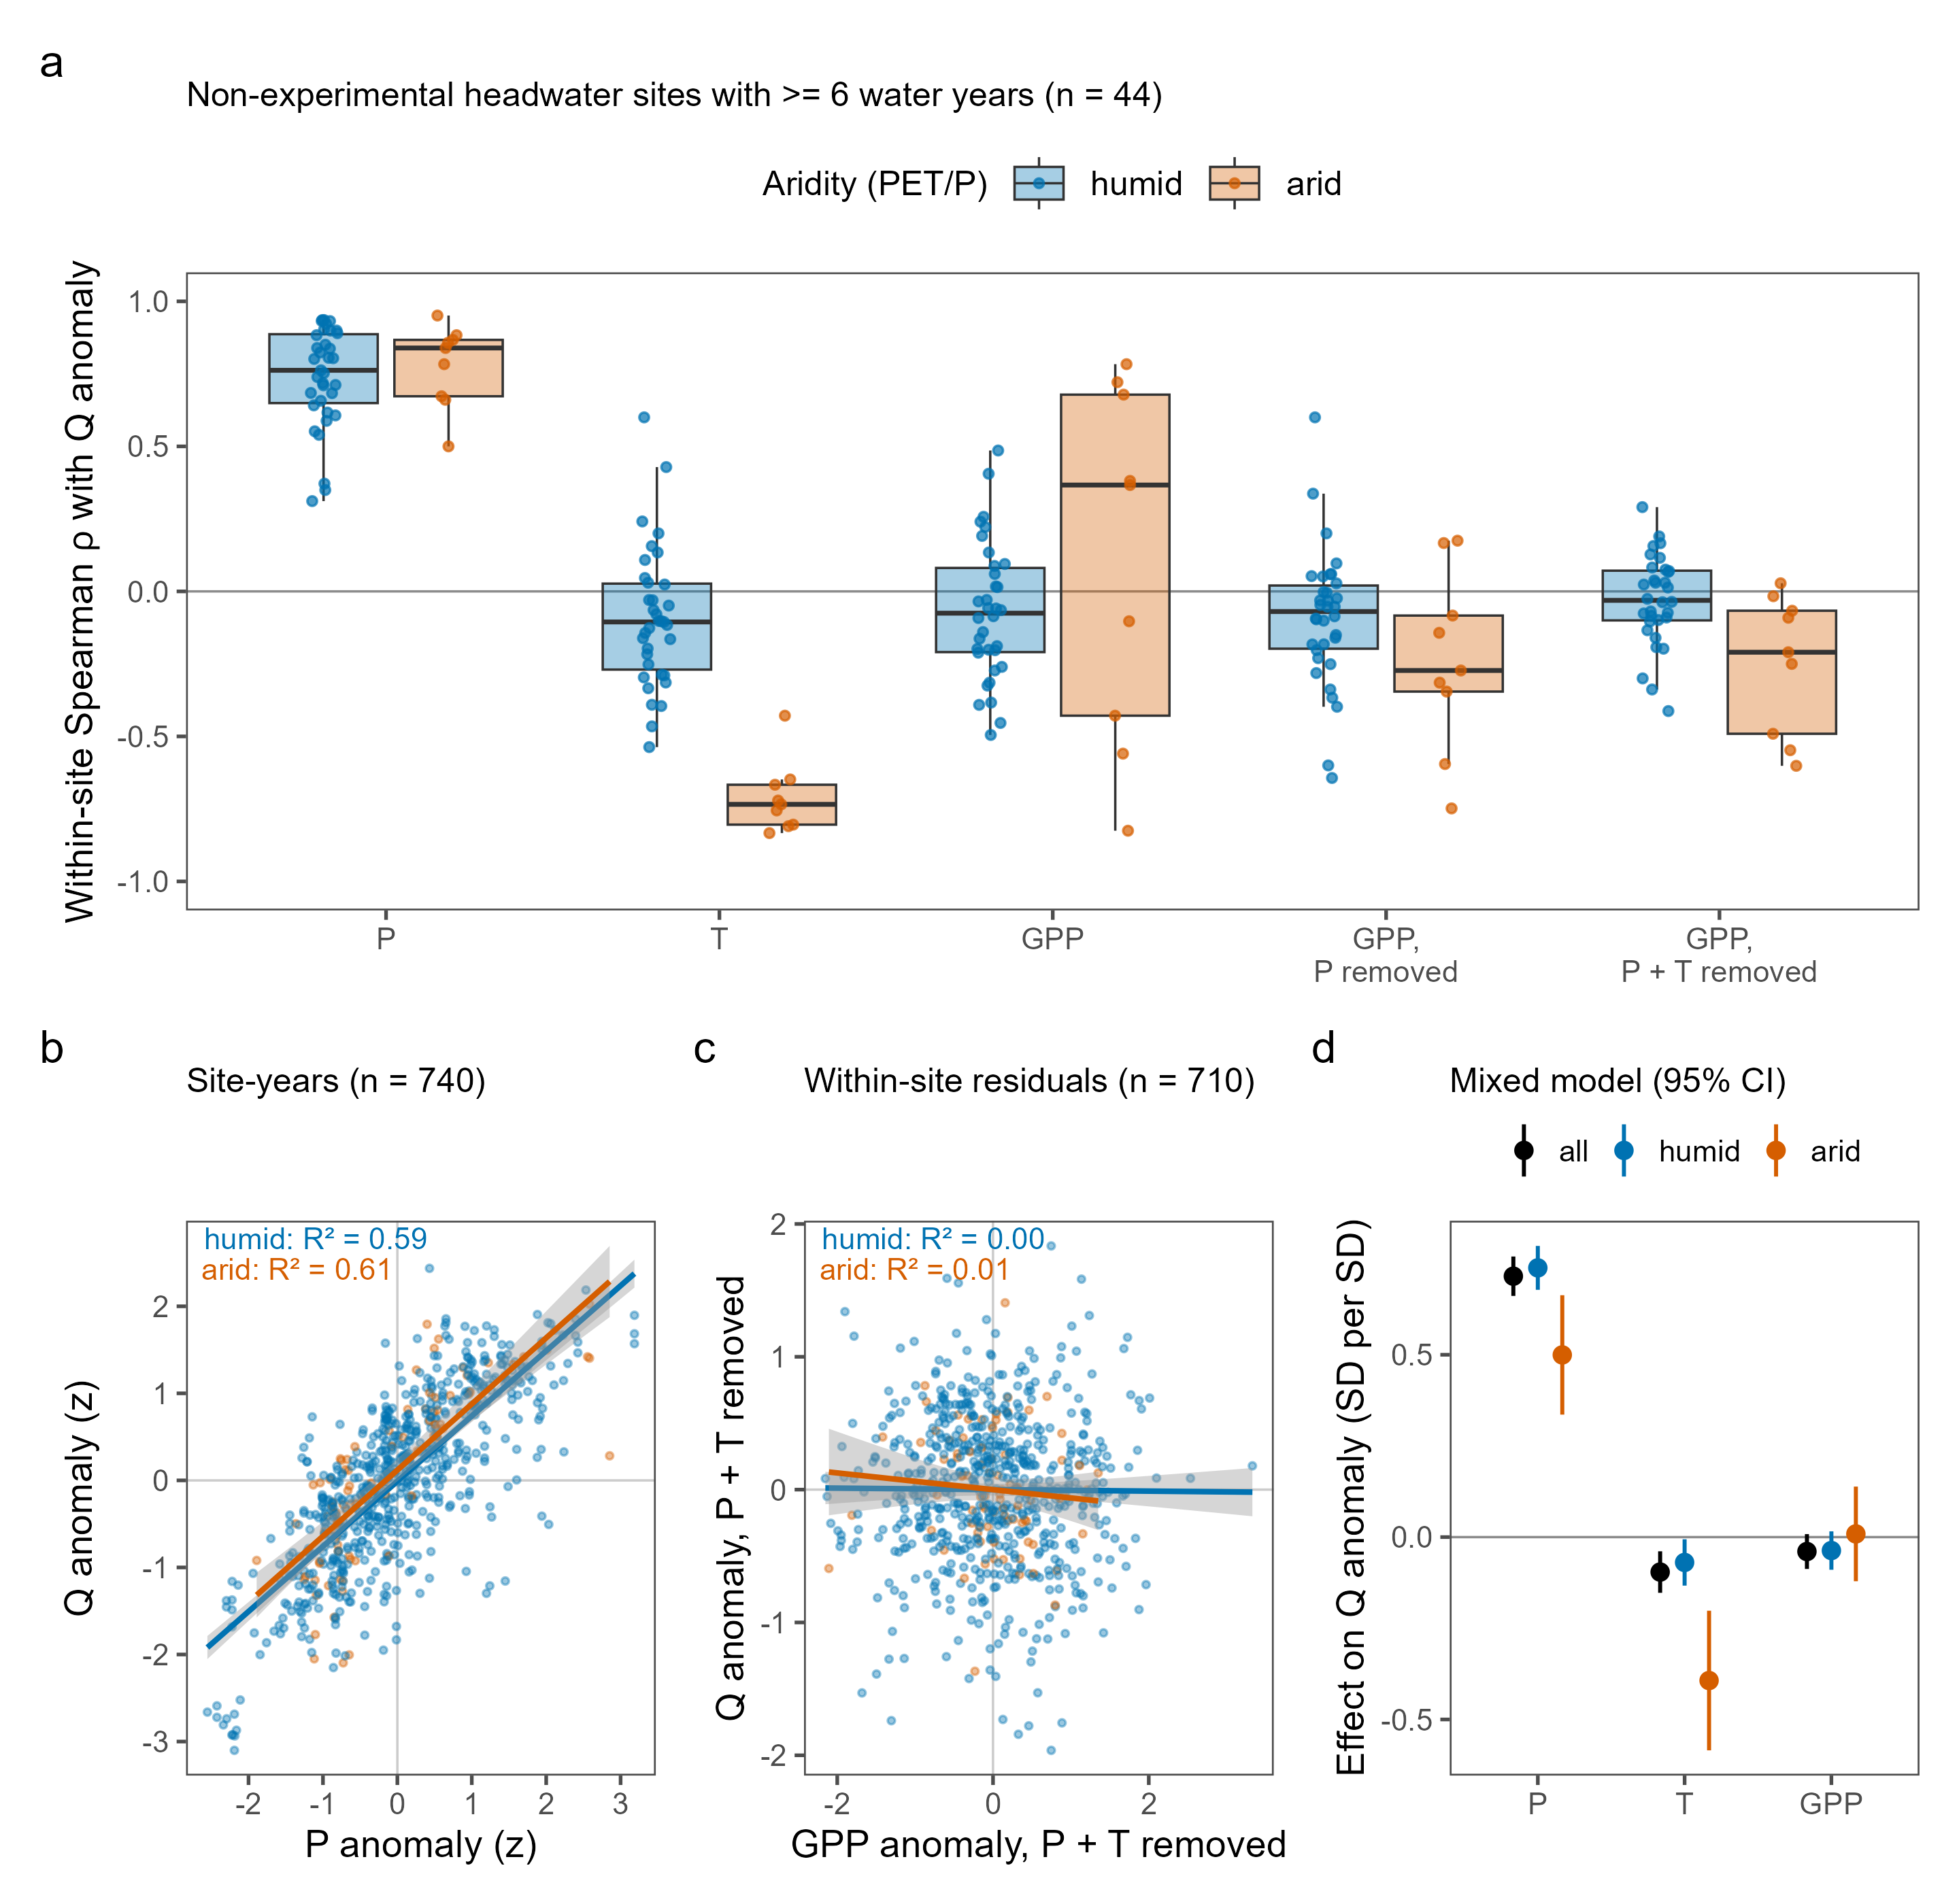
Figure 5. Interannual response of headwater streamflow to its drivers at non-experimental sites with at least six complete water years in 2001–2023, colored by mean aridity (PET/P < 1 humid, ≥ 1 arid). (a) Within-site Spearman correlation between the water-year streamflow anomaly and the anomalies of precipitation (P), temperature (T) and MODIS GPP, and between streamflow and GPP after the precipitation signal, or the precipitation and temperature signals, had been regressed out of both; one point per site (n = 44; 43 with usable GPP). (b) Pooled site-year anomalies (z-scores within site) of streamflow against precipitation (n = 740) with ordinary least-squares fits by aridity class and their R². (c) Streamflow against GPP after the within-site precipitation and temperature signals have been removed from both (n = 710 site-years), with the same fits. (d) Fixed effects (± 95% CI) from linear mixed models of the streamflow anomaly on the three driver anomalies with random slopes by site and a random intercept by water year, fitted to all 43 sites and to each aridity class.

CONCLUSIONS
RQ1: What are the trends in mean annual streamflow in the CONUS from small watershed ecosystem studies?
There is little change. Of the 49 non-experimental sites with sufficient record, 10 (20%) show a significant streamflow trend over 2001–2023 (6 increasing, 4 decreasing), even though 65 of the 142 climate sites warmed significantly over the same window.
RQ1A: What drives sensitivity or insensitivity of streamflow to changes in climate?
When streams do respond, the direction of the response is consistent with aridity. The four decreasing sites (all at Santa Barbara) are arid (aridity index 2.4–2.9) and warming with no change in precipitation: adding heat to water-limited sites yields less streamflow. The six increasing sites are humid, energy-limited sites (aridity index 0.66–0.86) in two clusters, a lake district in northern Wisconsin (Trout Lake) and the Colorado alpine (Niwot Ridge, summer-only records). Neither cluster shows a significant local temperature or precipitation trend, so they represent two regional responses rather than six independent ones, and our climate drivers do not explain them. Year to year, the full site pool shows why: streamflow anomalies follow precipitation almost one for one (elasticity 1.4), respond to temperature mainly where PET/P exceeds 1, and respond to GPP by at most a few percent once precipitation and temperature are accounted for (figure 5).
Aridity is clearly not the only control, as most sites show no significant change in streamflow. Over 2001–2023 sites are warming (65 of 142), while significant precipitation trends are essentially absent (2 of 142) and productivity trends are uncommon and split in sign (25 greening, 15 browning of 141); streamflow is not shifting with them.
RQ2: How well does the existing network of small-watershed study sites capture the landscape of climate change across the CONUS?
Existing efforts do well at capturing the distribution of climate change signals (figure 1), including the rare class of decreasing NWD: MS sites fall 48% increasing NWD, 41% no change, 10% variable, and 1% decreasing, against 41%, 52%, 4%, and 3% for the grid. The gap is in streamflow rather than climate coverage. Streamflow records long enough for trend detection favor humid sites (figure 4): non-experimental sites with a usable streamflow record have a median aridity index of 0.52 (20% arid) versus 1.20 (70% arid) for those without (Wilcoxon rank-sum p = 2.1 × 10⁻⁴). These records need to be continued to better resolve trends.

DISCUSSION
Our synthesis reveals striking stability in streamflow across small watersheds over 2001–2023. Warming was widespread, with significant temperature increases at 65 of 142 sites and no cooling anywhere, yet only 20% of non-experimental sites with sufficient record (10 of 49) showed significant streamflow trends. Over the same window, significant precipitation trends were essentially absent (2 of 142 sites) and productivity trends were uncommon and mixed in sign (25 greening, 15 browning of 141). Part of the stability, then, is that the water input itself has not shifted detectably in two decades; warming alone did not translate into hydrologic change. This apparent insensitivity reflects both stabilizing in-watershed processes and data limitations that constrain our ability to detect subtle responses.

Synthesis challenges
The data constraints illustrated in figure 2 were consistent barriers to our synthesis. Matching climate and vegetation records to streamflow reduced the non-experimental pool from 103 sites to 49, and the loss was not random: sites with a usable streamflow record have a median aridity index of 0.52 (10 of 49 arid) versus 1.20 (38 of 54 arid) for those without (Wilcoxon rank-sum p = 2.1 × 10⁻⁴). The excluded sites are concentrated in a few domains (NEON, East River, Catalina-Jemez, and Santa Barbara account for 44 of the 54), and they disproportionately represent the arid and intermittent systems where the largest hydrologic responses would be expected.
Record length is a second constraint. Restricting every trend to the MODIS era gives 23-year climate records (2001–2023), and streamflow records cut to that window have a median length of 18 years with a median end year of 2019. Twenty-three years is short for detecting a precipitation trend: only 2 of 142 MS sites and fewer than 6% of reference grid cells show one, whereas 36 of the same 142 sites do over the full 1981–2024 PRISM record. Any streamflow response to slowly shifting precipitation is therefore unlikely to be detectable in our window; what we can say is that two decades of warming, on its own, did not move streamflow at most sites.
Continued monitoring at short-record sites, particularly in arid regions, is essential to build the record length needed for robust trend detection. In places where collection is underfunded or difficult, statistical extrapolation methods may partially fill gaps (like those used in Vlah et al, 2024), but cannot replace the insights from continuous measurement. Keeping these programs funded and running continuously is crucial for this sort of national-scale synthesis and for monitoring water quality and quantity in water-scarce regions and regions where water availability is changing, but we have yet to collect enough data to detect it.
Remote-sensing limitations add a further caveat on the vegetation side. MODIS GPP has a 500 m pixel, so a single pixel covers 0.25 km², while the median MS watershed is 1.54 km² (interquartile range 0.41–6.24 km²): 24 of 142 sites are smaller than one pixel, 60 are smaller than four, and 79 are smaller than ten. For those sites the watershed-median GPP is effectively one or a few mixed pixels that include land outside the catchment. One site (GFGL, in Baltimore) has no vegetated MODIS pixel and therefore no GPP trend. Landsat’s finer resolution would suit these small catchments better, but its multi-mission record carries trend artifacts that we could not separate from vegetation change (figures s2–s3) (Roy et al, 2016; Vogelmann et al, 2016). These data constraints limit our power to detect change, but they do not fully account for the absence of trends at well-monitored sites. This raises a more fundamental question.

Why so little change?
The muted hydrologic responses observed are consistent with strong biotic buffering and/or highly dynamic water routing. Recent synthesis work found that aridity controls the depth of water pathways, while terrain and biome control lateral flows (McMillan et al, 2025).
The interannual sensitivities are what the Budyko framework predicts for a mostly energy-limited set of catchments: streamflow responds to precipitation with an elasticity above one that rises with aridity, temperature matters where evaporative demand exceeds supply (PET/P > 1) and barely at all where it does not, and canopy productivity in a given year changes streamflow by at most a few percent once precipitation and temperature are accounted for. They also explain the absence of streamflow trends: combining each site’s temperature trend with these sensitivities, the warming observed over the window (median 0.9 °C across the 44 sites) implies a median change in mean streamflow of −3%, against a median interannual standard deviation of streamflow of 35%, and no site in this pool had a significant precipitation trend.
A Landsat-based view of these watersheds would suggest that additional climatic demand is being absorbed by vegetation: the Landsat GPP record flags 100 of the 142 sites as greening over 1986–2022 (figure s3). That signal is mostly not robust to the choice of sensor. Shortening the Landsat window to 2001–2021 turns 31 of those 100 sites (31%) non-significant, and switching to MODIS on the same 2001–2021 window turns 59 of the 73 remaining Landsat-increasing sites (81%) non-significant (figures s2–s3). With MODIS over 2001–2023, only 25 of 141 sites are greening and 15 are browning. The Landsat greening is therefore mostly a sensor effect, and with these data we cannot show that vegetation is taking up the extra demand. What the MODIS trends do show is that productivity, where it changes at all, follows water: among non-experimental sites, greening occurs at 18 sites and browning at none where the precipitation slope is positive, while browning occurs at 14 sites and greening at 3 where it is negative, even though those precipitation slopes are themselves rarely significant.
Vegetation buffering therefore remains a hypothesis rather than a result, but one consistent with the literature. Shifts in species composition, including woodification of non-forest systems, may decouple precipitation from streamflow by increasing productivity without proportional increases in water use (Knapp et al, 2008; Fei et al, 2017). Such ecohydrological adjustments may delay or dampen streamflow response, though thresholds in soil water or species composition could alter this balance in the future. Testing this at headwater scale will require vegetation products that resolve catchments of a few square kilometers without sensor-transition artifacts.
When significant trends do occur, their direction aligns with expectations from aridity theory: the four water-limited sites (aridity index 2.4–2.9) show decreased flows under warming, and the six energy-limited sites (aridity index 0.66–0.86) show increased flows. The four experimental sites with significant trends follow the same split, with the two decreasing KREW sites arid (1.24 and 1.35) and the increasing Bear Brook and Santee sites humid (0.32 and 0.59), though treatments at those sites confound climate attribution. Ten non-experimental sites, six of them in two domains with no significant local climate trend, lack the power for a true test. These results support aridity and Budyko-space frameworks as first-order predictors of the direction of change, while highlighting the need to incorporate vegetation dynamics explicitly. Expanding representation of arid regions in the streamflow record, and linking hydrologic synthesis with ecological monitoring, will be critical for anticipating future water availability.

SUPPLEMENT
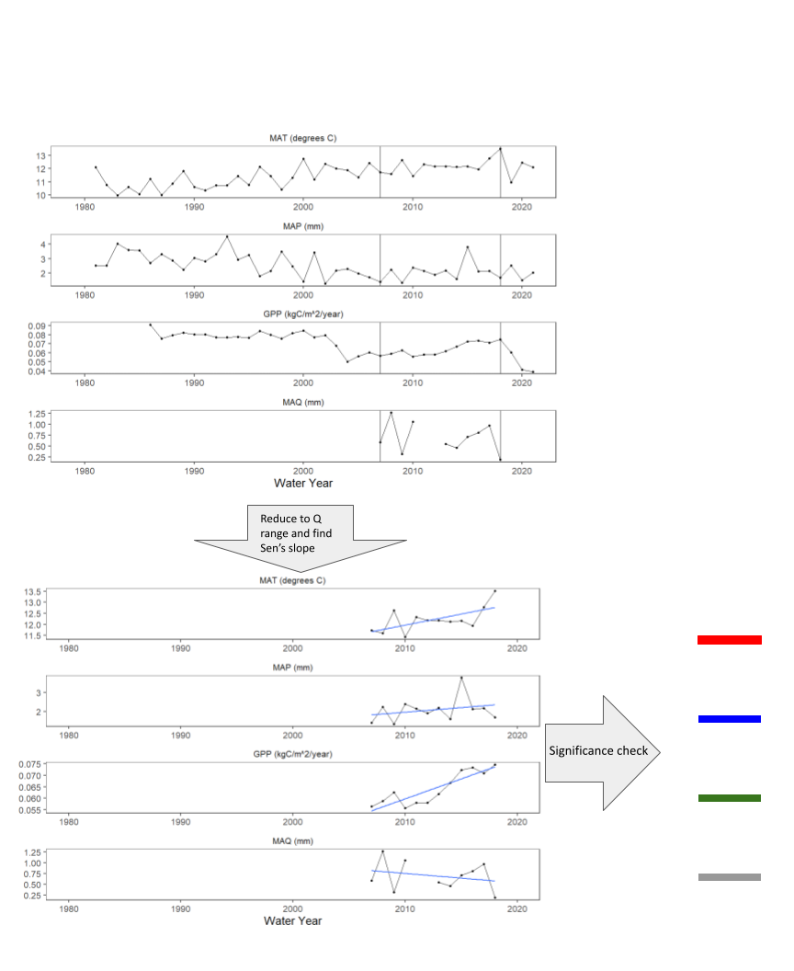
Figure s1. Example of how the colored bars in figure 2 were created. First, we computed a full, annual time-series of streamflow metrics across a range of years with at least 60% coverage (that is, no more than 40% missing data). Then remotely sensed and gridded data were cut to the range of years matching the streamflow ranges. Lastly, trends were computed using a Sen’s slope test and color coded by direction and significance.
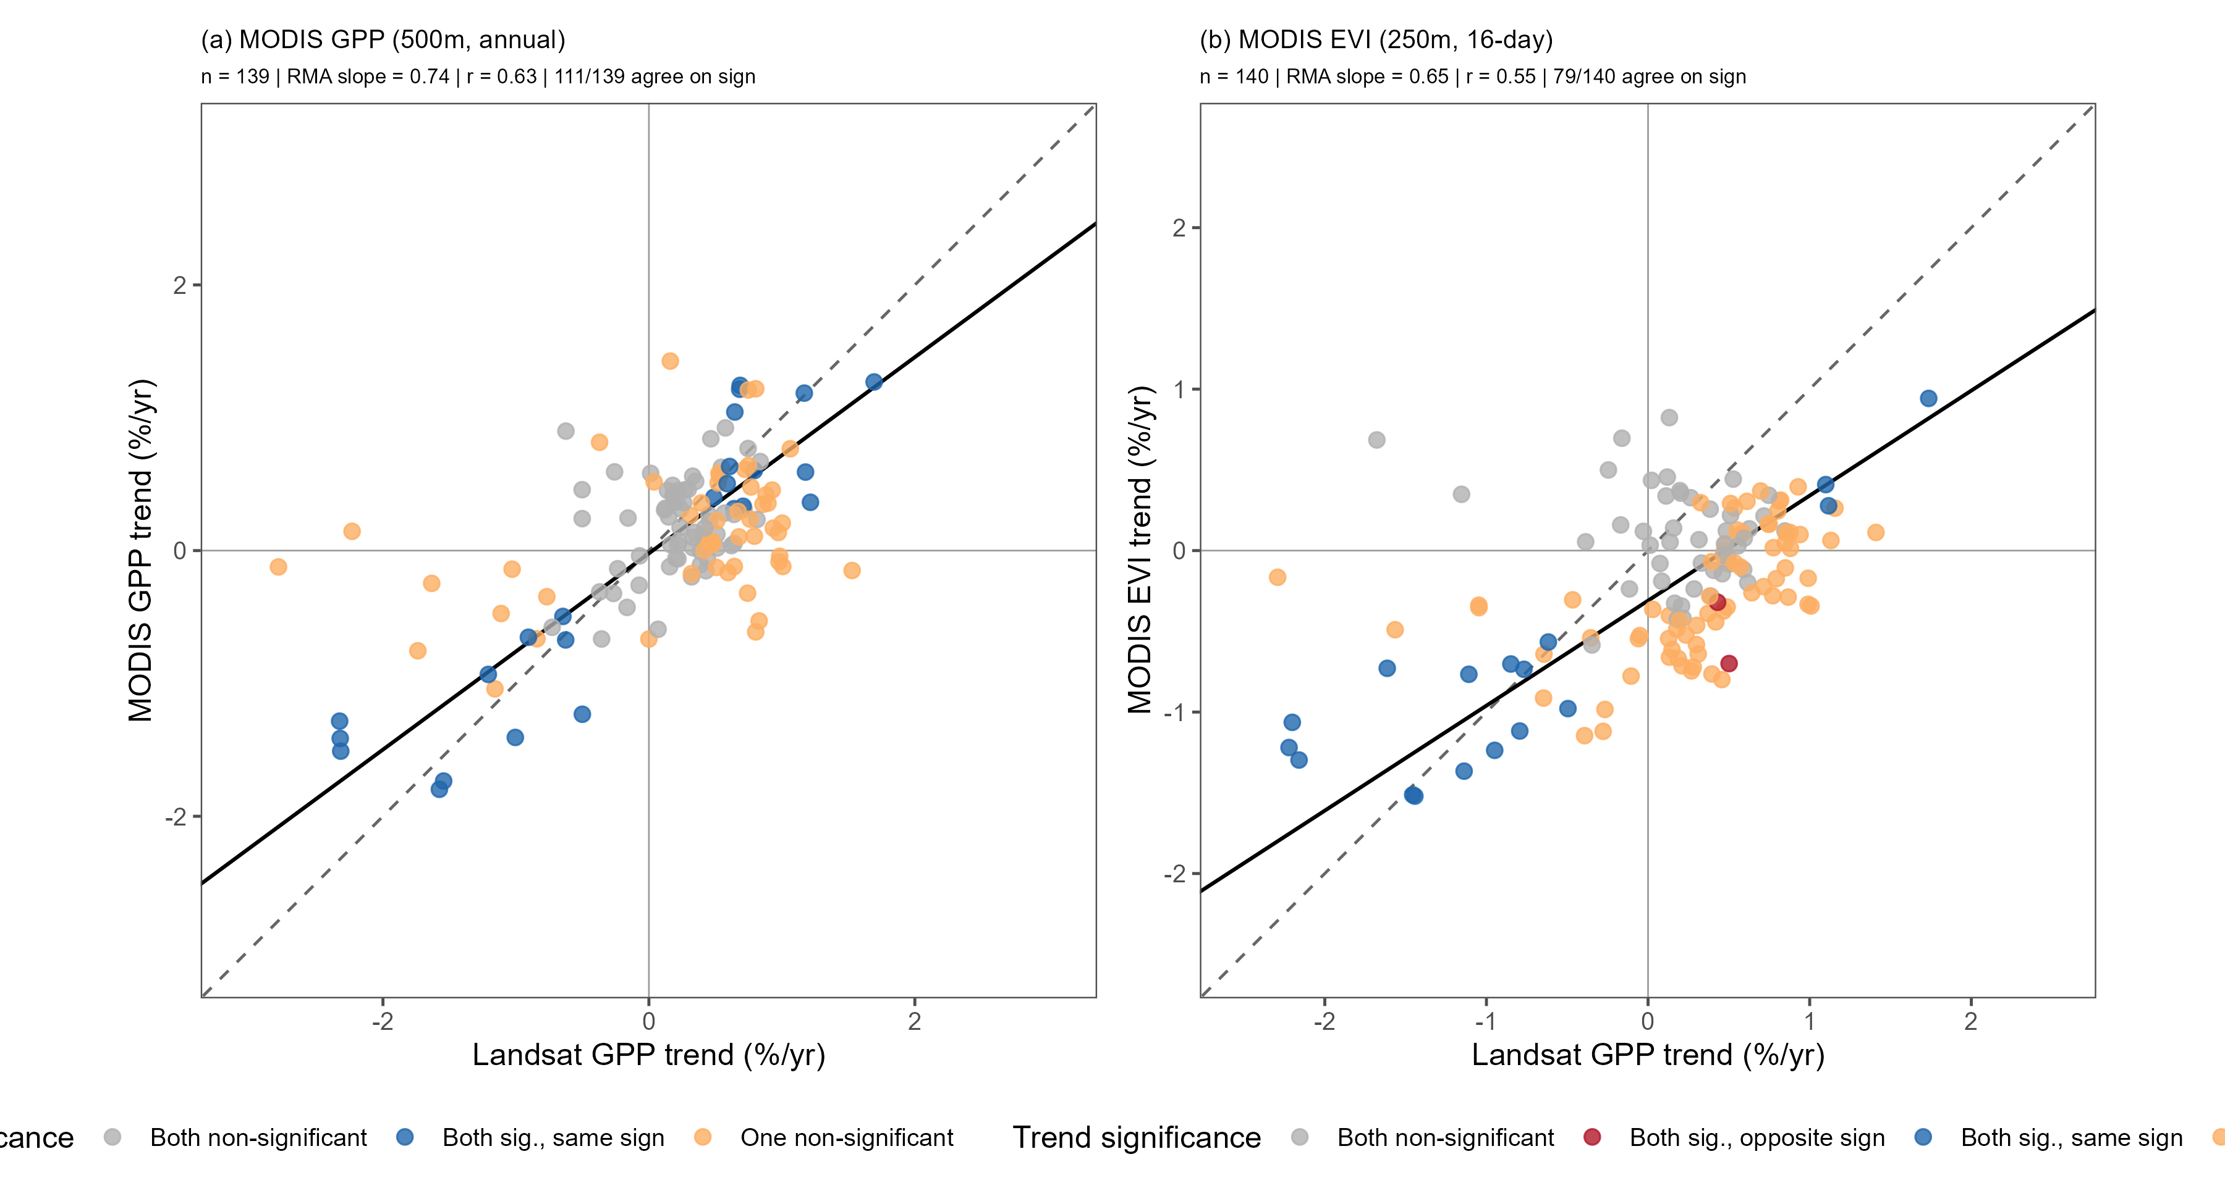
Figure s2. Comparison of per-site vegetation trends from Landsat and MODIS. Each point is one MS site; axes are relative Sen’s slopes (% yr⁻¹, slope divided by the site mean) computed with the same trend method as the main analysis over each site’s matched window of overlapping years (at least 10). Landsat GPP (NTSG, 30 m, 16-day) is compared against (a) MODIS GPP (MOD17A2HGF, 500 m, summed to water years) and (b) MODIS EVI. Points are colored by the agreement of the significance flags: both significant with the same sign, both significant with opposite signs, both non-significant, or one non-significant. The dashed line is 1:1 and the solid line is a reduced major axis (RMA) fit. Landsat and MODIS GPP trends agree only moderately (n = 139, r = 0.63, RMA slope = 0.74), as do Landsat GPP and MODIS EVI trends (n = 140, r = 0.55, RMA slope = 0.65); an RMA slope below 1 means the MODIS trends span a narrower range than the Landsat trends at the same sites.
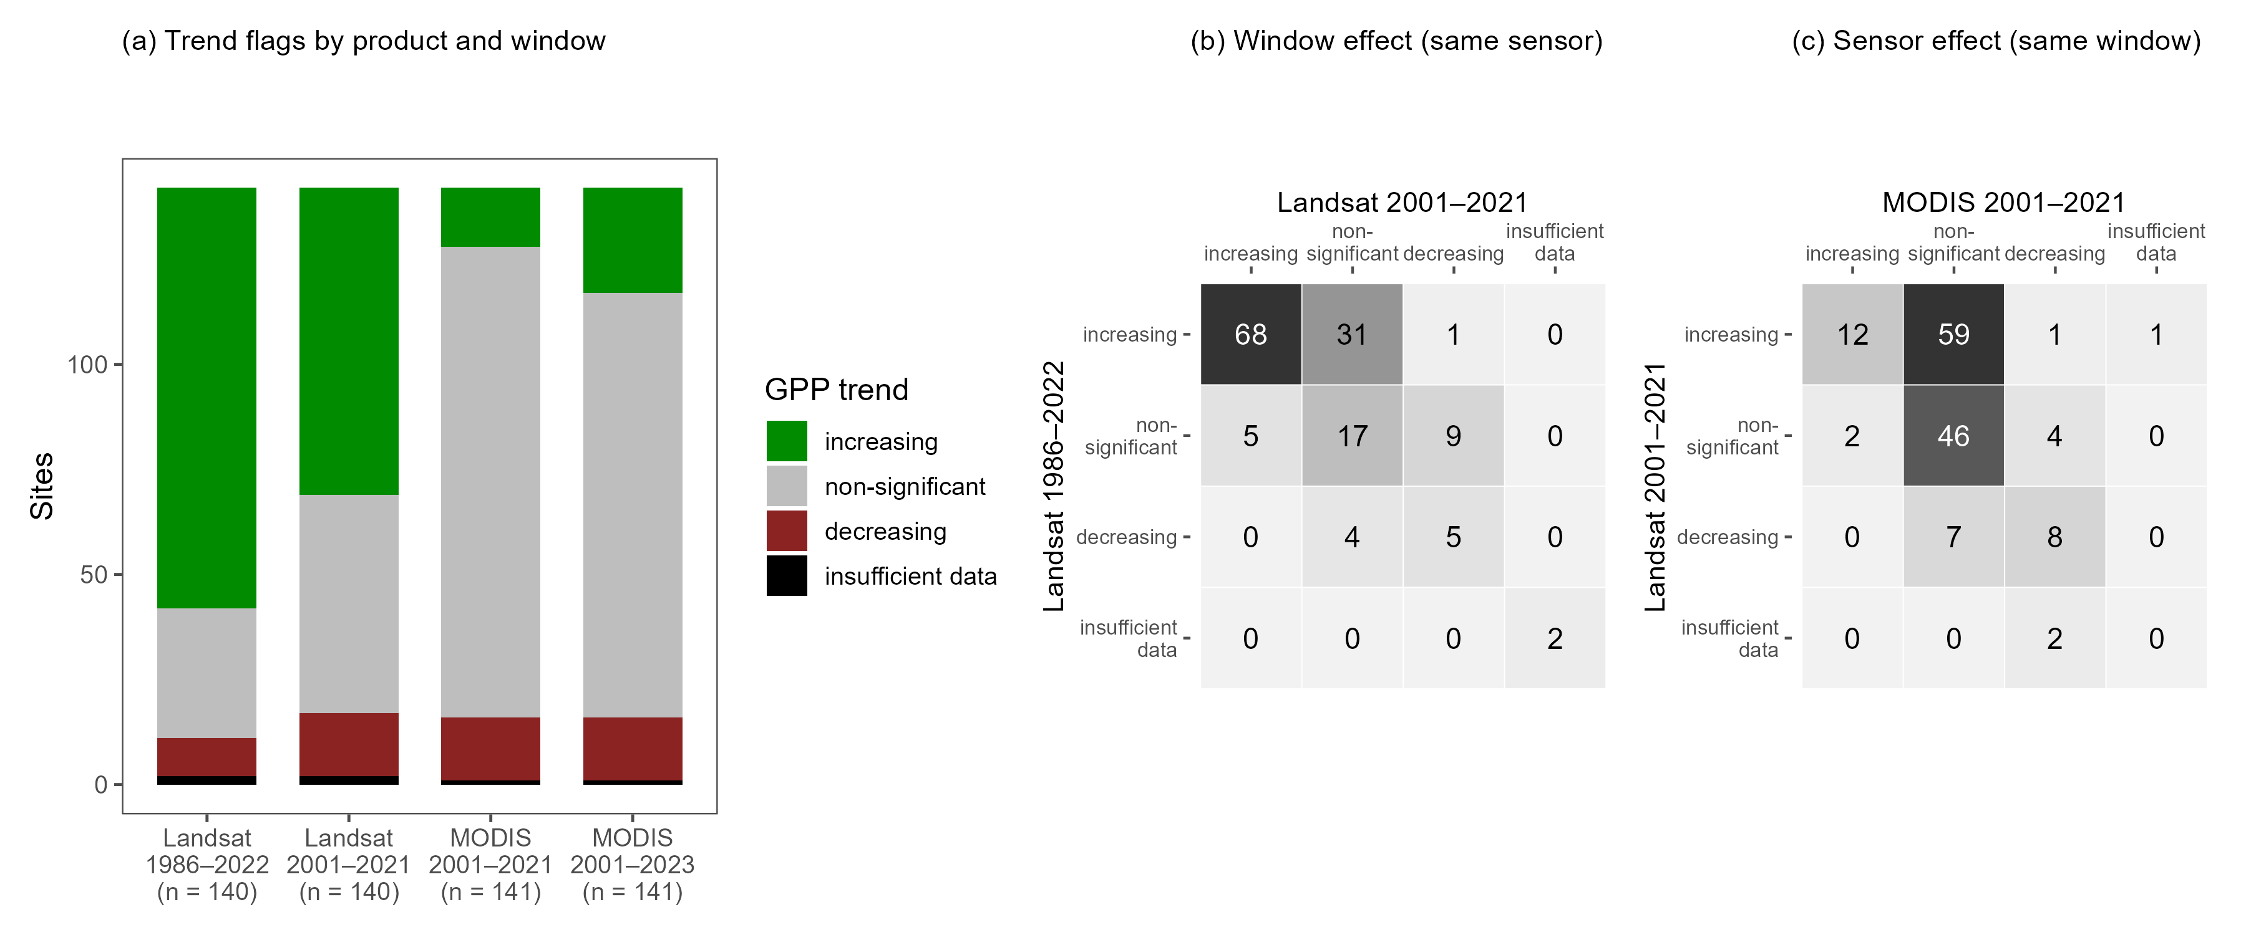
Figure s3. Separating the effect of the analysis window from the effect of the sensor on GPP trend flags at the 142 MS climate sites. (a) Trend flags (increasing, non-significant, decreasing, or insufficient data) for four runs: Landsat over its full 1986–2022 record, Landsat restricted to 2001–2021, MODIS over 2001–2021, and MODIS over the full 2001–2023 window used in the main analysis. Counts are 100 increasing / 31 non-significant / 9 decreasing for Landsat 1986–2022, 73 / 52 / 15 for Landsat 2001–2021, 14 / 112 / 15 for MODIS 2001–2021, and 25 / 101 / 15 for MODIS 2001–2023 (sites with insufficient data: 2, 2, 1, and 1). (b) Window effect: the transition of each site’s flag from Landsat 1986–2022 (rows) to Landsat 2001–2021 (columns) on the same sensor. Shortening the window alone turns 31 of the 100 Landsat-increasing sites (31%) non-significant. (c) Sensor effect: the transition from Landsat 2001–2021 (rows) to MODIS 2001–2021 (columns) on the same window. Changing sensor alone turns 59 of the 73 Landsat-increasing sites (81%) non-significant, with 12 remaining increasing; of the 96 sites significant in either sensor over 2001–2021, 21 are significant in both, and 20 of those share the same sign. The Landsat-based greening was therefore mostly a sensor effect rather than a window effect. MODIS GPP here and in the main analysis is the water-year sum of MOD17A2HGF (8-day, 500 m) with the urban/barren/water fill pixels masked.
Table S1. GPP trend flags at the 142 MS climate sites for each product and window (Sen slope, 95% confidence interval excluding zero). Window effect: 31 of the 100 Landsat-greening sites (31%) become non-significant when the Landsat record is shortened to 2001–2021. Sensor effect: 59 of the 73 Landsat-greening sites on 2001–2021 (81%) become non-significant under MODIS on the same window, and 12 remain greening. Of the 96 sites significant in either sensor on 2001–2021, 21 are significant in both and 20 share the same sign. MODIS GPP is the water-year sum of MOD17A2HGF.
Product and window | Increasing | Non-significant | Decreasing | Insufficient data
Landsat 1986–2022 | 100 | 31 | 9 | 2
Landsat 2001–2021 | 73 | 52 | 15 | 2
MODIS 2001–2021 | 14 | 112 | 15 | 1
MODIS 2001–2023 | 25 | 101 | 15 | 1
Sites in figure 4 are grouped by mean aridity index (Daymet potential evapotranspiration divided by precipitation, summed by water year) averaged over the 2001–2023 analysis window. A longer climatology (1980–2020) that predates the MODIS record is also available from Daymet. Because the humid/arid split at an aridity index of 1 is used to interpret the sign of the streamflow trends, we checked whether restricting the climatology to the analysis window moves any site across that line (figure s4). It does not: the two climatologies are almost perfectly correlated across the 142 sites (r = 0.999), the median absolute shift is 0.011, and the largest shift is 0.31. No site changes class.
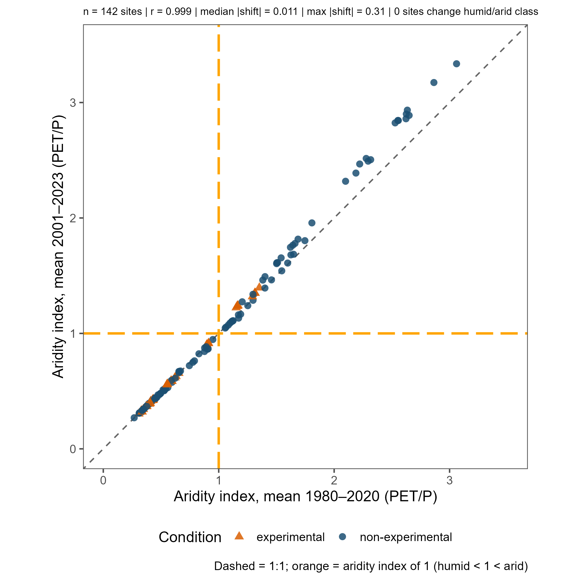
Figure s4. Site-mean aridity index over the longer 1980–2020 climatology (x axis) against the 2001–2023 analysis window (y axis) for the 142 MS climate sites, colored by experimental status. The dashed line is 1:1; orange lines mark an aridity index of 1 (humid below and to the left, arid above and to the right). No site changes class. n = 142, r = 0.999, median |shift| = 0.011, max |shift| = 0.31.
Table S2. Sites admitted on the summer-only metric (mean streamflow over June–August; see Methods). ‘Complete water years’ are water years 2001–2023 that pass the standard completeness criterion (at least 4 observations per week in at least 51 weeks); 10 are required for the annual metric. Zero-flow fractions are the share of observed days with zero discharge over 2001–2023. Summer-window years are the water years with at least 80 June–August observation days on which the trend was fit.
Site | Domain | Status | Area (km²) | Why the standard criterion was not met | Summer-window years (n) | Trend in summer flow
GREEN5 | Niwot Ridge | non-experimental | 1.44 | Alpine gauge frozen in winter; observations June–September only (median 139 days per water year); no complete water year | 2006–2017 (11) | increasing
MARTINELLI | Niwot Ridge | non-experimental | 0.03 | Alpine gauge frozen in winter; observations June–September only (median 122 days); no complete water year | 2002–2021 (17) | increasing
NAVAJO | Niwot Ridge | non-experimental | 0.47 | Alpine gauge frozen in winter; observations June–September only (median 120 days); no complete water year | 2001–2014 (11) | increasing
SADDLE | Niwot Ridge | non-experimental | 0.15 | Alpine gauge frozen in winter; observations May–September only (median 132 days); no complete water year | 2001–2022 (20) | non-significant
GREEN4 | Niwot Ridge | non-experimental | 2.24 | Alpine gauge, seasonal through 2008 and year-round from 2009; 9 complete water years, one short of the minimum | 2001–2022 (20) | non-significant
BC02 | Santa Barbara | non-experimental | 13.0 | Seasonally dry coastal stream (zero flow on 8% of observed days) with record gaps; 8 complete water years | 2005–2018 (11) | decreasing
HO00 | Santa Barbara | non-experimental | 11.1 | Year-round coastal stream with record gaps; 9 complete water years | 2002–2018 (13) | decreasing
SP02 | Santa Barbara | non-experimental | 8.0 | Seasonally dry coastal stream (zero flow on 20% of observed days) with record gaps; 9 complete water years | 2009–2023 (10) | non-significant
HistoryGrove | Catalina-Jemez | non-experimental | 3.2 | Winter record gaps; 2 complete water years | 2008–2021 (10) | non-significant
UpperJaramillo | Catalina-Jemez | non-experimental | 2.2 | Winter record gaps; 5 complete water years | 2009–2020 (10) | non-significant
cart_creek | Plum Island | non-experimental | 4.7 | Scattered record gaps; 6 complete water years | 2003–2015 (12) | non-significant
saw_mill_brook | Plum Island | non-experimental | 3.2 | Scattered record gaps, mostly in winter; 2 complete water years | 2002–2015 (11) | non-significant
P300 | KREW | experimental | 4.6 | Record limited to 2006–2015; 9 complete water years | 2006–2015 (10) | non-significant
WS78 | Santee | experimental | 52.4 | Intermittent coastal-plain stream (zero flow on 17% of observed days) with record gaps; 9 complete water years | 2005–2017 (13) | non-significant
Table S3. Median within-site Spearman correlation between the water-year anomaly of each streamflow metric and the anomalies of precipitation (P), temperature (T) and MODIS GPP, and of GPP after the P signal (GPP | P) or the P and T signals (GPP | P, T) had been removed from both series, across the 44 non-experimental headwater sites with at least six complete water years (43 with usable GPP; 41 for GPP | P, T; 42, 41 and 40 for low flow). Timing is the day of the water year by which half of the annual flow had passed, so a negative T correlation means earlier in warmer years.
Streamflow metric | P | T | GPP | GPP | P | GPP | P, T
Mean flow | 0.79 | −0.16 | −0.06 | −0.09 | −0.07
Total flow | 0.79 | −0.16 | −0.09 | −0.17 | −0.09
Median flow | 0.57 | −0.07 | −0.04 | −0.03 | −0.05
High flow (95th percentile) | 0.72 | −0.21 | −0.03 | −0.09 | −0.11
Low flow (5th percentile) | 0.36 | −0.21 | −0.06 | −0.11 | −0.06
Flashiness (Richards-Baker index) | 0.31 | 0.04 | 0.09 | 0.03 | −0.02
Runoff ratio | 0.33 | −0.28 | −0.06 | −0.15 | −0.08
Timing (day half of annual flow passed) | 0.11 | −0.21 | −0.19 | −0.18 | −0.03

