GOVOS
Government Operations System
Professional Project Report — Ministerial Edition
Product strategy • Technical architecture • Phase 1 execution • Pilot readiness • Phase 2 vision

NORTH STAR
Connect government work — from issue to owner, SLA, action, verified outcome and leadership visibility.

Prepared for internal planning, senior-government presentation and execution alignment
Date: 01 September 2026

01 • GOVERNANCE

Document Control & Executive Decision Page
━━━━━━━━━━━━━━━━━━━━━━━━━━━━━━━━━━━━━━━━━━━━━━━━━━━━━━━━━━━━━━━━━━━━━━━━━━━━━━━━
Item | Decision / Record
Document | GovOS Professional Project Report — Ministerial Edition
Purpose | Single reference for product strategy, engineering alignment, project reporting and executive presentation preparation
Current implementation baseline | ~35% Phase 1 maturity per codebase audit; exact feature status requires evidence from repository and runtime tests
Phase 1 | Secure, multi-tenant municipal operating backbone
Phase 2 | Real-world evidence capture + AI/spatial intelligence
Current gating decision | Harden and reconcile the foundation before destructive database migration or backend cutover

EXECUTIVE DECISION REQUEST
Proceed with M0.5 Codebase Hardening → M2 Schema Reconciliation/Validation → controlled backend migration, with no Phase 2 activation during foundation work.

Executive message
GovOS should be positioned as a unified operating layer for government—not as another grievance portal. The product connects citizen service, field operations, departments, assets, projects, documents, SLAs, GIS and reporting so that government leadership can see what needs action and what was actually completed.

02 • STRATEGY

1. Executive Summary
━━━━━━━━━━━━━━━━━━━━━━━━━━━━━━━━━━━━━━━━━━━━━━━━━━━━━━━━━━━━━━━━━━━━━━━━━━━━━━━━
THE GOVERNMENT OPERATING QUESTION
“What is happening, who owns it, what is overdue, what was completed, and what requires leadership action?”

The current GovOS specification establishes a multi-tenant municipal platform with six personas and strict role boundaries enforced by RBAC and MTAS. The technical walkthrough defines a target architecture of React/Vite, Spring Boot, NestJS, FastAPI, PostgreSQL/RLS, Redis and OpenSearch. fileciteturn0file0L1-L27

What GovOS should solve
Government pain point | GovOS response | Outcome
Fragmented information | Connect complaints, assets, projects, documents and people | Single operational picture
Manual follow-up | Owner + SLA + escalation + activity trail | Accountability
Unclear completion | Completion record + verification state | Trustworthy reporting
Department silos | Common work/status/metric model | Cross-department visibility
Delayed leadership reporting | Live dashboards + standardized reports | Faster decisions

Strategic positioning
GovOS does not need to replace every existing government application. It should connect operational workflows, expose exceptions, and provide an accountable management layer.

03 • CASE FOR CHANGE

2. Problem & Opportunity
━━━━━━━━━━━━━━━━━━━━━━━━━━━━━━━━━━━━━━━━━━━━━━━━━━━━━━━━━━━━━━━━━━━━━━━━━━━━━━━━
The product opportunity is not simply digitization. Government already uses digital tools for specific functions in many contexts. The harder problem is that operational information can remain fragmented across departments, workflows and reporting mechanisms. GovOS is designed to make the work visible end-to-end.
Operational question | Today’s fragmented model | GovOS model
What is pending? | Multiple reports / follow-up calls | One actionable queue
Who owns it? | Department records / manual assignment | Named owner and scope
Is it late? | Manual tracking | SLA timer + escalation
Was it actually completed? | Status update / report | Completion + verification
What is the city’s hotspot? | Separate map/report views | GIS-linked operating view
What needs leadership attention? | Periodic reporting | Exception-oriented command center

VALUE PROPOSITION
From “data exists somewhere” → to “the right decision-maker sees the right action at the right time.”

04 • PRODUCT ARCHITECTURE

3. GovOS Product Definition
━━━━━━━━━━━━━━━━━━━━━━━━━━━━━━━━━━━━━━━━━━━━━━━━━━━━━━━━━━━━━━━━━━━━━━━━━━━━━━━━
The current product is defined as a multi-tenant Web Operating System for municipal and civic governance. It is intended to provide an integrated control plane for local government administration, citizen complaint lifecycles, asset tracking, project management and real-time civic intelligence. fileciteturn0file0L9-L11
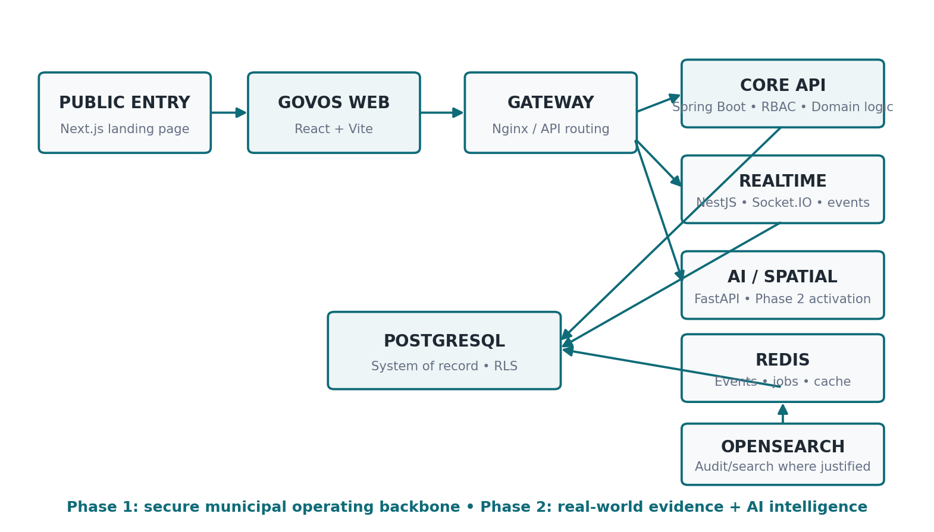
Figure 1. Target GovOS platform architecture; Phase 1 secures the municipal operating backbone, while AI/spatial activation is reserved for Phase 2. Source: project technical walkthrough. fileciteturn0file0L13-L27

Design principles
- One authoritative owner for each responsibility.
- Tenant boundaries are security boundaries, not UI filters.
- Work is measurable: owner, status, deadline, evidence, verification, outcome.
- Existing operational functionality is preserved during migration.
- Phase 2 intelligence extends Phase 1 workflows rather than creating a parallel product.

05 • USERS

4. Stakeholders & Personas
━━━━━━━━━━━━━━━━━━━━━━━━━━━━━━━━━━━━━━━━━━━━━━━━━━━━━━━━━━━━━━━━━━━━━━━━━━━━━━━━
The specification defines six core personas operating within strict RBAC and multi-tenant boundaries. fileciteturn0file1L3-L8
Persona | Scope | Primary responsibility | Key value
SUPER_ADMIN | Cross-tenant | Provision tenants, platform health, global audit | Platform governance
TENANT_ADMIN | Single municipality | Configure system, staff, performance and reports | Municipal control
DEPT_HEAD | Department within tenant | Assets, projects, documents, analytics | Department execution
OFFICER | Assigned ward(s) | Field work, complaint updates, citizen interaction | Execution at source
ROLE_REP | Ward/constituency | Read-only oversight, hotspots, SLA awareness | Public accountability
CITIZEN | Own profile/records | Submit, track and rate complaints | Service access

Executive implication
The dashboard must be different for each persona. The platform is not a single generic portal; its value comes from delivering the right scope, action and information to each role.

06 • HOW GOVOS WORKS

5. Operating Model & Work Lifecycle
━━━━━━━━━━━━━━━━━━━━━━━━━━━━━━━━━━━━━━━━━━━━━━━━━━━━━━━━━━━━━━━━━━━━━━━━━━━━━━━━
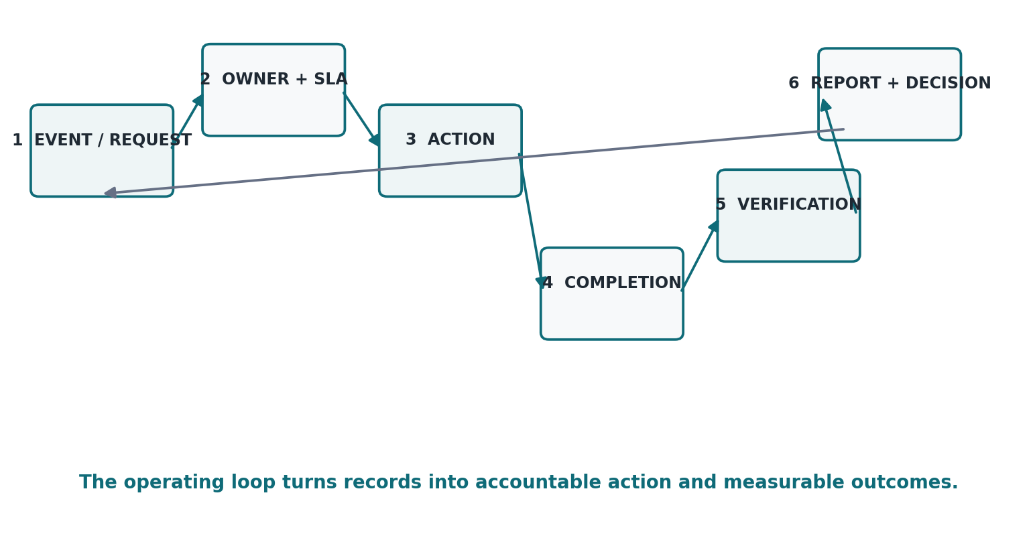
Figure 2. GovOS operating loop: event → owner → SLA → action → completion → verification → insight.
Stage | System responsibility | Management question
1. Intake | Create a governed record | What happened?
2. Routing | Identify owner, department, ward and SLA | Who owns it?
3. Execution | Capture status/activity | What is being done?
4. Completion | Record outcome and required evidence | What was done?
5. Verification | Validate completion where required | Did it actually meet the requirement?
6. Closure | Close or reopen with reason | Is the matter truly finished?
7. Insight | Roll up metrics and exceptions | What should leadership act on?

A key Phase 1 design decision: “WORK_COMPLETED” and “VERIFIED_COMPLETED” are different states. This prevents reporting from becoming a simple self-declaration.

07 • SCOPE

6. Phase 1 Functional Module Blueprint
━━━━━━━━━━━━━━━━━━━━━━━━━━━━━━━━━━━━━━━━━━━━━━━━━━━━━━━━━━━━━━━━━━━━━━━━━━━━━━━━
Domain | Phase 1 capability | Priority | Outcome
Foundation | Auth, RBAC, tenant management, users, departments, wards | P0 | Safe platform base
Citizen service | Citizen profiles, complaints, tracking, notifications | P0 | End-to-end service journey
Field operations | Officer assignment, mobile-first work queue, completion | P0 | Operational execution
Accountability | SLA, escalation, audit, completion/verification | P0 | Measurable accountability
Department ops | Assets, projects, documents/Peshi | P1 | Department control
Visibility | GIS, analytics, command center, exports | P1 | Leadership insight
Platform quality | Testing, observability, deployment, recovery | P0/P1 | Pilot readiness

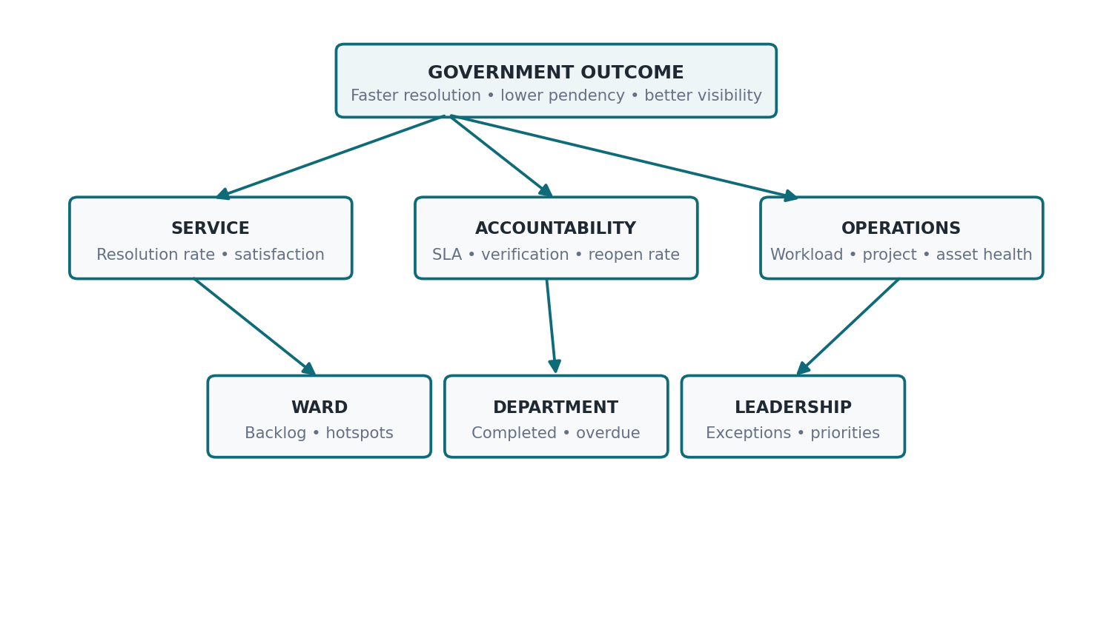
Figure 3. KPI hierarchy for moving from operational events to leadership decisions.

08 • TECHNOLOGY

7. Technical Architecture & Engineering Standards
━━━━━━━━━━━━━━━━━━━━━━━━━━━━━━━━━━━━━━━━━━━━━━━━━━━━━━━━━━━━━━━━━━━━━━━━━━━━━━━━
The project walkthrough defines the target ecosystem as a React/Vite Web OS shell, Spring Boot core API, NestJS realtime/notifications, FastAPI AI/spatial service, PostgreSQL/RLS, Redis and OpenSearch. fileciteturn0file0L13-L27
Component | Authoritative responsibility | Phase 1 stance
govos-web | Government operational UI | Preserve and harden
public-landing-page | Public product/entry experience | Keep separate from core operations
govos-core-api | Business logic, REST, RBAC, tenant context, domain services | Become authoritative core
govos-realtime | Realtime events and notification delivery | Move realtime ownership here
govos-ai | AI/spatial capabilities | Keep Phase 2 activation gated
PostgreSQL | System of record, constraints, RLS | Harden + migrate safely
Redis | Events, background jobs/cache where appropriate | Introduce deliberately
OpenSearch | Audit/search where justified | Do not overbuild prematurely

Engineering rule: no duplicate business ownership. One responsibility → one authoritative service. The legacy Express backend is migration source code, not a second permanent business platform.

09 • REALITY CHECK

8. Current Implementation Baseline
━━━━━━━━━━━━━━━━━━━━━━━━━━━━━━━━━━━━━━━━━━━━━━━━━━━━━━━━━━━━━━━━━━━━━━━━━━━━━━━━
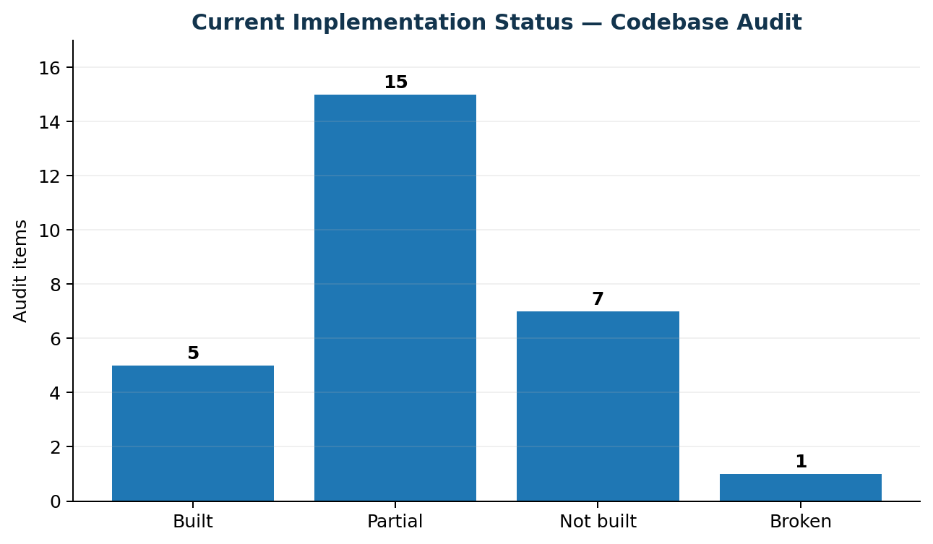
Figure 4. Current implementation maturity snapshot derived from the codebase audit. It is a planning estimate, not a production certification.
Area | Audit status | Interpretation
Complaints | BUILT | Working prototype / Express-backed end-to-end flow
Citizen / Officer flows | BUILT | Good foundation, requires hardening and backend consolidation
Dashboard | PARTIAL | UI present; backend aggregation maturity incomplete
RBAC | PARTIAL | UI + basic API claims; security enforcement incomplete
Multi-tenancy | NOT BUILT | Critical production blocker
Assets / Projects / Documents | NOT BUILT | Required Phase 1 modules
SLA automation | PARTIAL | Deadline logic exists; active worker/escalation missing
Security / testing | PARTIAL / NOT BUILT | Requires dedicated hardening and test foundation

Current state verdict: GovOS is a promising functional prototype with a strong UI and core complaint workflow, but the foundation is not yet safe for real multi-municipality production.

10 • ENGINEERING CONTROL

9. M0.5 Codebase Hardening & Cleanup
━━━━━━━━━━━━━━━━━━━━━━━━━━━━━━━━━━━━━━━━━━━━━━━━━━━━━━━━━━━━━━━━━━━━━━━━━━━━━━━━
M0.5 is a controlled hardening milestone between audit and major migration. Its purpose is to make the codebase understandable, secure and testable without rewriting the product.
Workstream | Required action | Exit criterion
Inventory | Identify modules, APIs, dependencies, duplicates, dead code candidates | Clear KEEP / REFACTOR / MIGRATE / DEPRECATE map
Security | Remove hardcoded secrets, isolate mock OTP, tighten authorization and config | No known production secrets in source
Frontend | Clean duplicate components/API logic without redesign | Stable role journeys + lint/type checks
Backend | Clarify module boundaries and service ownership | No ambiguous business ownership
API | Standardize validation/error patterns | Consistent API contract documented
Database | Audit schema/Flyway conflicts; no destructive migration yet | Canonical schema decision documented
Testing | Add baseline tests for critical current behavior | Regression safety net exists

M0.5 is complete only when the team knows what every important part of the system does, who owns it, how it is secured, and how to change it without breaking core behavior.

11 • SECURITY BOUNDARY

10. M2 Multi-Tenant Database Foundation
━━━━━━━━━━━━━━━━━━━━━━━━━━━━━━━━━━━━━━━━━━━━━━━━━━━━━━━━━━━━━━━━━━━━━━━━━━━━━━━━
Multi-tenancy is a core product principle. The specification requires strict role boundaries and MTAS, while the audit found that the active schema currently lacks tenant isolation. fileciteturn0file1L3-L8
Control | Target design | Validation
Tenant entity | Canonical tenants table with municipality metadata | Schema + uniqueness checks
Tenant ownership | Explicit ownership for every tenant-scoped entity | Tenant integrity matrix
RLS | Database-level row isolation | Positive + negative SQL tests
Application context | Spring sets tenant context per transaction | Integration tests
Super Admin | Explicit cross-tenant privilege | Dedicated security tests
Legacy records | Map known ownership; quarantine uncertain records | Record-count + mapping reconciliation
Settings | SYSTEM default + tenant override model | Resolution tests
Rollback | Versioned migration + safe rollback/checkpoint | Restore/rehearsal test

M2 gate: NO live database execution until schema reconciliation, migration scripts and validation tests are reviewed and approved.

12 • DELIVERY PLANNER

11. Phase 1 Execution Roadmap
━━━━━━━━━━━━━━━━━━━━━━━━━━━━━━━━━━━━━━━━━━━━━━━━━━━━━━━━━━━━━━━━━━━━━━━━━━━━━━━━
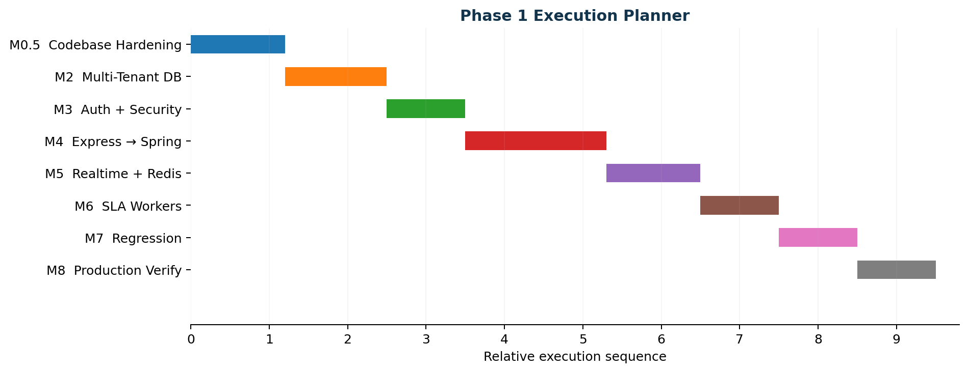
Figure 5. High-level Phase 1 execution sequence.
Milestone | Focus | Deliverable | Gate
M0.5 | Codebase hardening | Inventory, ownership, security, tests, config | Review report
M2 | Tenant foundation | Canonical schema, RLS, migration + validation | Database approval
M3 | Auth & security | Spring Security, JWT, role enforcement | Security tests
M4 | Backend migration | Express domains ported to Spring Boot | E2E parity
M5 | Realtime | NestJS + Redis event ownership | Event tests
M6 | SLA workers | Warnings, breaches, escalation | Timing tests
M7 | Regression | Critical role journeys + security suite | Release candidate
M8 | Production verification | Build, deployment, observability, recovery | Pilot-ready

13 • MANAGEMENT

12. Reporting, Completion & Command Center
━━━━━━━━━━━━━━━━━━━━━━━━━━━━━━━━━━━━━━━━━━━━━━━━━━━━━━━━━━━━━━━━━━━━━━━━━━━━━━━━
The current requirements already expect dashboards, analytics, reports, SLA monitoring and role-specific views. Tenant Admins are explicitly expected to monitor complaints, citizens, projects and assets and generate monthly reports. fileciteturn1file1L61-L72
Report | Core metrics | Audience | Decision enabled
Daily command brief | Critical items, SLA risk, overdue work, pending approvals | Commissioner / Admin | What needs attention today?
Department performance | Received, started, completed, verified, breached, reopened | Dept Head / Admin | Where is the bottleneck?
Ward performance | Complaint volume, resolution, hotspots, project activity | Admin / Rep | Which geography needs intervention?
Project health | Progress %, spend, delays, risks | Dept Head / Admin | Which projects need escalation?
Asset health | Maintenance status, overdue assets, repeated issues | Dept Head | Where is maintenance risk?
Document bottleneck | Current desk, age, overdue files | Admin / Dept Head | Where is process delay?

DEPARTMENT COMPLETION REPORT
Received → In Progress → Work Completed → Verified Completed → SLA Compliant → SLA Breached → Reopened → Backlog → Average Resolution Time

14 • ASSURANCE

13. Security, Governance & Trust
━━━━━━━━━━━━━━━━━━━━━━━━━━━━━━━━━━━━━━━━━━━━━━━━━━━━━━━━━━━━━━━━━━━━━━━━━━━━━━━━
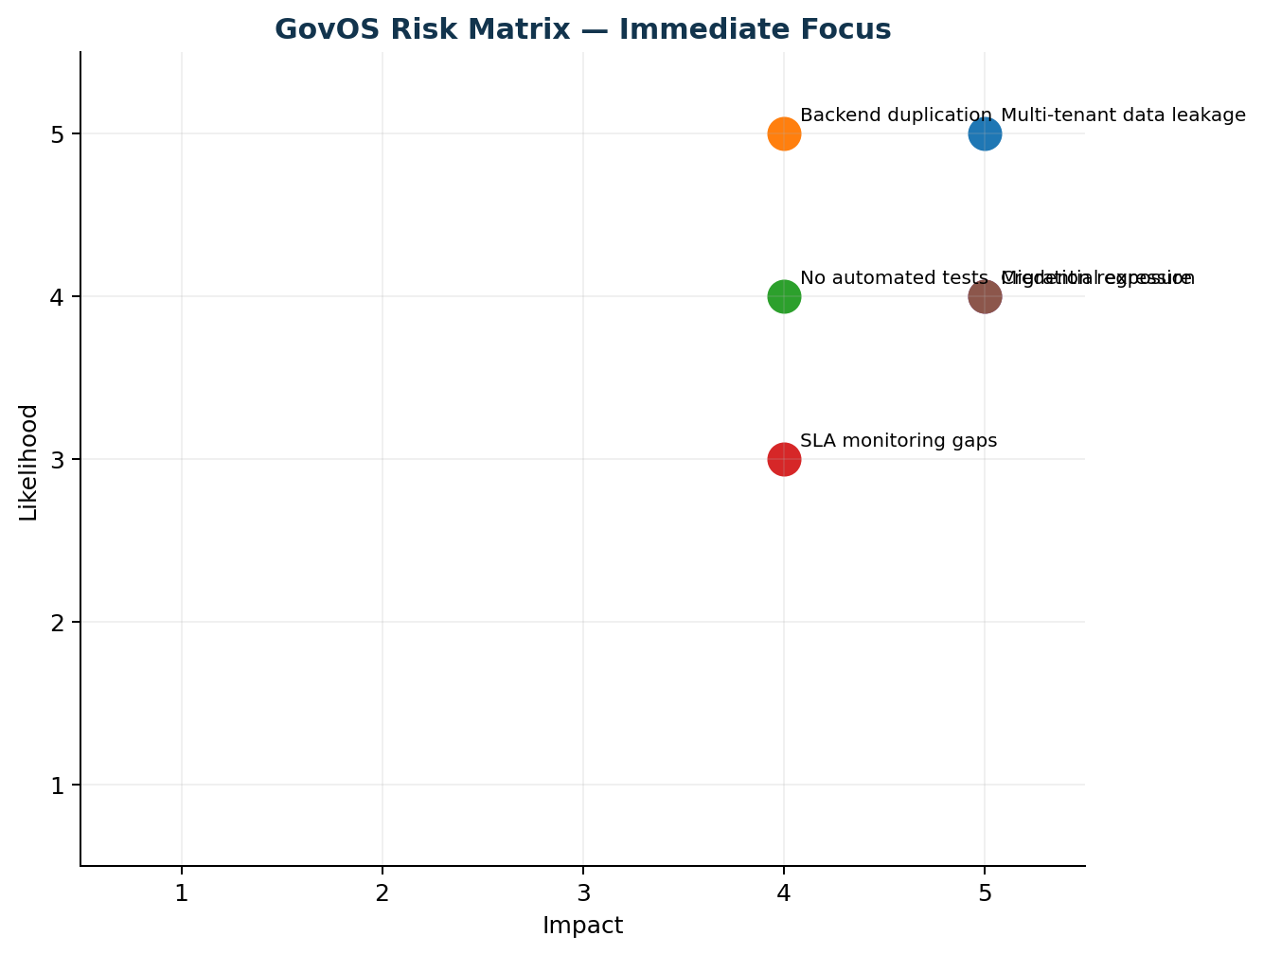
Figure 6. Phase 1 risk register: foundational security and architecture risks are immediate priorities.
- Tenant isolation must be enforced at the data layer, not only in UI routes.
- Backend authorization must be server-side and consistent across all domains.
- Secrets must live in environment/secure configuration, not source code.
- Critical operations require audit trails and controlled state transitions.
- Production readiness requires tests for authentication, RBAC, tenant isolation, SLA and critical workflows.
- Legacy code must be retired only after equivalent behavior is verified.

15 • GO-TO-MARKET

14. Pilot & Government Adoption Strategy
━━━━━━━━━━━━━━━━━━━━━━━━━━━━━━━━━━━━━━━━━━━━━━━━━━━━━━━━━━━━━━━━━━━━━━━━━━━━━━━━
The first pilot should be framed around operational outcomes, not the number of screens. A pilot municipality should demonstrate a small number of complete end-to-end journeys across departments and show measurable visibility improvements.
Pilot track | Demonstration | Success evidence
Citizen service | Complaint → assignment → action → verified completion | Resolution time, SLA compliance
Field operations | Officer queue + mobile updates + work completion | Backlog reduction, field activity
Department control | Assets/projects/documents + departmental reporting | Overdue items visible and actionable
Leadership | Command center + ward/department view | Daily priority view replaces manual consolidation
Governance | RBAC + tenant isolation + audit | Security/access tests pass

PRESENTATION MESSAGE
“GovOS is not another dashboard. It is the operating layer that connects the work behind the dashboard.”

16 • FUTURE VISION

15. Phase 2 — Real-World Evidence & AI Intelligence
━━━━━━━━━━━━━━━━━━━━━━━━━━━━━━━━━━━━━━━━━━━━━━━━━━━━━━━━━━━━━━━━━━━━━━━━━━━━━━━━
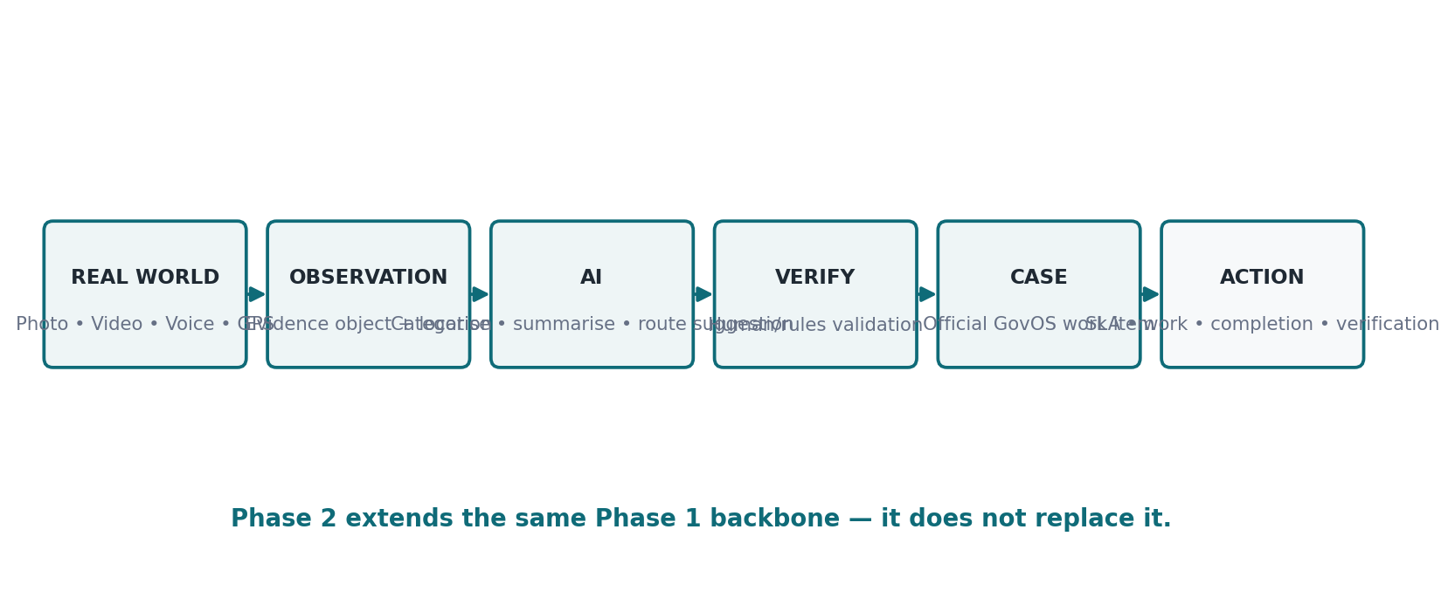
Figure 7. Phase 2 reserve: real-world observation → evidence → AI assistance → governed case workflow.
PHASE 2 IS DELIBERATELY PARKED
Video/photo/voice reporting, AI categorisation, media intelligence, observation intelligence and predictive governance are not part of the current foundation build.

When activated, Phase 2 should feed the same Phase 1 backbone: capture → triage → official case → assignment → SLA → action → completion → verification → closure. This prevents the AI layer from becoming a separate, disconnected product.

17 • PITCH

16. Minister / Senior-Government Presentation Storyline
━━━━━━━━━━━━━━━━━━━━━━━━━━━━━━━━━━━━━━━━━━━━━━━━━━━━━━━━━━━━━━━━━━━━━━━━━━━━━━━━
Slide | Message | Visual
1 | Government has many data points; the challenge is connected operational visibility | Problem map
2 | GovOS is a unified operating layer | Architecture
3 | Six roles, one accountable system | Persona matrix
4 | Every issue becomes owned work with an SLA | Lifecycle
5 | Completion is reported and, where required, verified | Completion/verification diagram
6 | Departments become measurable without manual consolidation | KPI tree
7 | Leadership gets a command center focused on exceptions | Command center mock
8 | Security and tenant isolation are foundational | Security architecture
9 | Phase 1 delivery roadmap | Planner / Gantt
10 | Pilot: prove measurable operational improvement | Pilot scorecard
11 | Phase 2 adds real-world evidence + AI | Future architecture
12 | Decision requested: approve controlled pilot/foundation execution | Decision slide

PITCH DISCIPLINE
Lead with public value and administrative outcomes. Technology should explain how the outcomes are made reliable—not become the headline.

18 • EXECUTIVE CONTROL

17. Critical Risks & Decisions
━━━━━━━━━━━━━━━━━━━━━━━━━━━━━━━━━━━━━━━━━━━━━━━━━━━━━━━━━━━━━━━━━━━━━━━━━━━━━━━━
Risk / Decision | Why it matters | Required action
Split-brain backend | Two business implementations create drift and security ambiguity | One authoritative business backend; migrate incrementally
Tenant isolation | Data leakage would be unacceptable | Schema + RLS + app enforcement + tests
Legacy data mapping | Incorrect tenant assignment damages trust | Ownership reconciliation before migration
Overbuilding microservices | Raises complexity before need exists | Keep domain modular; separate only where justified
Phase 2 creep | AI work can consume foundation bandwidth | Keep Phase 2 backlog gated
Unverified completion | Inflates performance reporting | Completion vs verification states


Figure 8. The implementation challenge is primarily foundation maturity, not product vision.

19 • DECISION

18. Final Recommendation
━━━━━━━━━━━━━━━━━━━━━━━━━━━━━━━━━━━━━━━━━━━━━━━━━━━━━━━━━━━━━━━━━━━━━━━━━━━━━━━━
RECOMMENDATION
Continue M0.5 now. Do not execute database migration or major feature expansion until the hardening and schema reconciliation gates are cleared.

GovOS target state
- Secure multi-tenant municipal platform.
- One authoritative business backend.
- Consistent RBAC and server-side authorization.
- Connected complaints, citizens, officers, assets, projects and documents.
- SLA, escalation, completion and verification as operational primitives.
- Leadership command center built around exceptions, trends and accountability.
- Phase 2 intelligence layer ready to plug into the same workflow backbone.

The one-line proposition
“GovOS connects government work—from issue to accountable action, verified outcome and leadership decision.”

Source baseline: the supplied GovOS technical walkthrough and User Personas, Workflows & Lifecycles specification. Technical and execution recommendations in this report are planning recommendations and should be validated against the live repository before implementation.

20 • REFERENCE

Appendix A. Source Baseline & Glossary
━━━━━━━━━━━━━━━━━━━━━━━━━━━━━━━━━━━━━━━━━━━━━━━━━━━━━━━━━━━━━━━━━━━━━━━━━━━━━━━━
Term | Meaning
MTAS | Multi-Tenant Architecture System
RBAC | Role-Based Access Control
RLS | PostgreSQL Row-Level Security
SLA | Service Level Agreement / target resolution time
Work Completed | Executor reports that work has been completed
Verified Completed | Authorised validation accepts the completion
Phase 1 | Secure municipal operating backbone
Phase 2 | Real-world evidence + AI/spatial intelligence

Primary source references
GovOS — Web Operating System for Civic Governance: Platform Architecture & Technical Walkthrough. The source describes the target architecture, multi-tenant model, technical components, current split-brain state, migration roadmap and user workflows. fileciteturn0file0L5-L8
GovOS — User Personas, Workflows & Lifecycles. The source defines six personas, their scopes, capabilities, lifecycles, the complaint lifecycle and SLA thresholds, module access matrix and notification triggers. fileciteturn0file1L3-L28 fileciteturn0file1L218-L268 fileciteturn0file1L270-L306

