*Using the SWAT Model to Assess Shifts in Ecosystem Services Resulting from Climate and Land use Change*

**Abstract**

**1 Introduction**

As humans confront the increasingly heavy footprint our activities leave on the earth’s ecosystems, it is important to focus attention on the services we obtain from them (Costanza 1997, MA 2005). Fresh water provision, water purification, and flood mitigation are a few examples of hydrologic services which are critical to functioning societies. However, as the human population grows, and built infrastructure replaces natural ecosystems, the capacity for ecosystems to produce these hydrologic services diminishes. While some ecosystem services are replaceable, most are either expensive to replicate or cannot be replicated with current technologies. Therefore, the tradeoffs between the numerous ecosystem services provided by natural capital and the social benefits of development must be quantified.

In order to assess these tradeoffs, models are used to determine the impacts of management decisions, land use change, and climate change on the provisioning of ecosystem services. Models currently being developed with this purpose in mind include the Integrated Valuation of Ecosystem Services and Tradeoffs (InVEST) and the ARtificial Intelligence for Ecosystem Services (ARIES) model (Vigerstol and Aukema 2011). Each of these models provides information on the source of ecosystem services, and who the beneficiaries of those services would be. However, these tools are still in their infancy. The ARIES model is currently still in development, and as of this writing is still unavailable for download. InVEST’s freshwater model provides output at the annual scale, and its developers recommend aggregating data up to the decadal scale for accurate results, representing a limitation when assessing hydrologic services which vary seasonally.

With these limitations in mind, researchers are investigating the feasibility of adapting more mature models which provide more robust biophysical results but were not developed with ecosystem services in mind. The Soil and Water Assessment Tool (SWAT) is a watershed model that has been in development for approximately 20 years and has the capacity to accurately represent a suite of both terrestrial and in-stream processes. It has been used to help water managers develop TMDLs, conduct climate and land use change studies, and assess the impacts of implementing agricultural BMPs (Gassman 2010). More recently, researchers interested in assessing water-related ecosystem services have begun using SWAT to study services such as nutrient and sediment retention, flood protection, and water provision (Logsdon & Chaubey 2013).

This paper’s aim is to demonstrate the usefulness of SWAT in measuring shifts in hydrologic services resulting from climate change, land use change, and management decisions. This study investigates hydrologic services in the Tualatin and Yamhill sub-basins in North West Oregon. We use SWAT to answer the following research questions: 1) How will climate and land use change alter the flow regime in these basins? 2) How will these changes affect the sediment and nutrient transport throughout the watershed? How will hydrologic services such as water purification and supply be affected in the future? And finally, how will these changes vary over space in the basin?

Our results are not meant to be conclusive. While we present spatially explicit results, it is our opinion that this represents a proof of concept for managers, investigators, and policy makers interested in a model which can provide a robust analysis of hydrologic services. Unlike other ecosystem service models, SWAT is data intensive, and requires significant technical expertise to properly run and interpret results. However, the heavy price may be worth it for its detailed output.

**2 Study Site**

The Tualatin and Yamhill rivers are part of the larger Willamette basin, which is a large fertile valley formed by the Willamette River. While the region is dominated by agriculture, areas closer to the Portland Metro region have seen rapid development over the past century. Since both basins are fed by headwaters in the Coast Range (Figure 1), which are relatively low elevation peaks, the hydrologic regime is largely precipitation dominated. The region has a modified marine climate which results in high winter flows, and low summer flows. With warming air temperatures expected in the future, hotter summers and warmer winters are expected. Previous studies have shown that this could bring wetter winters, as less snow accumulates, and drier summers when there is less snow pack to contribute. A detailed description of the climate and hydrologic regimes can be found in Psaris & Chang (unpublished).

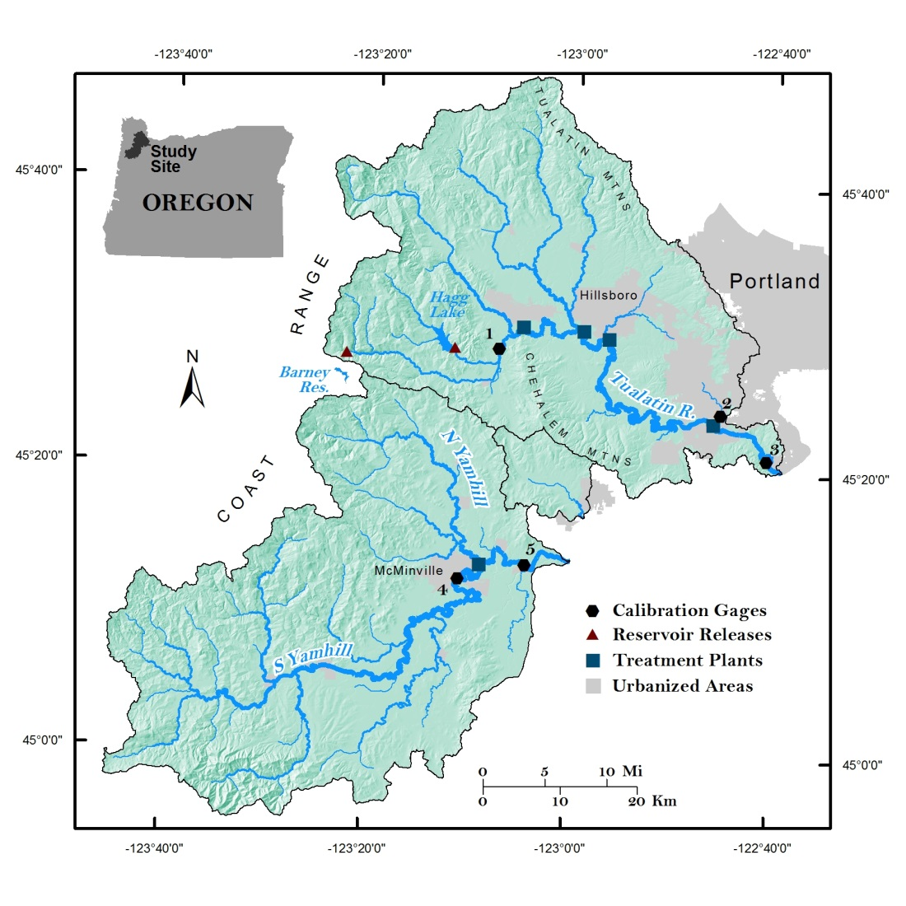

**3 Climate Change**

|  |  |
| --- | --- |
| F:\MikeP\Research\H20eco\U_IDAHO\Maps\Temp_chng_win.jpg | **F:\MikeP\Research\H20eco\U_IDAHO\Maps\Temp_chng_sum.jpg** |
| F:\MikeP\Research\H20eco\U_IDAHO\Maps\Precip_chng_win.jpg | F:\MikeP\Research\H20eco\U_IDAHO\Maps\Precip_chng_sum.jpg |
| Figure 2: | |

|  |
| --- |
|  |
| **Figure 4:** Area weighted changes in precipitation and temperature for each of the three climate scenarios (Low=GFDL-ESM2M, Medium=MIROC5, High=HadGEM2-ES) split by season (Winter=DJF, Summer=JJA). |

**3 SWAT Model Calibration**

The SWAT model was calibrated in a previous study. Details of the calibration can be found in Psaris & Chang (unpublished), but final results are documented again in Table 1. It should be noted that total phosphorus has poor calibration results. While this is problematic, we suggest that evaluating the relative change can still supply some idea of what may be expected in the future. Therefore, we cautiously submit scenario results for total phosphorus and discuss the uncertainties involved in the results for all constituents.

**4 Methods**

**5 Scenario Results**