Lab03

Introduction
In this lab, you will explore sequence similarity searches using FASTA and BLAST, focusing on how database choice and algorithm parameters influence search results and statistical interpretation.
During this dry lab, you are expected to document all work, including:
- The tools used
- Parameters selected
- Data outputs obtained
- Your interpretation of how and why the results change
Starting with Lab 03, there are three submissions due on myCourses:
Discussion 3.1
Discussion 3.2
Activity 3

Searching databases with FASTA (Discussion 3.1)

FASTA Web Server

Use the University of Virginia FASTA web interface:

https://fasta.bioch.virginia.edu/fasta_www2/fasta_www.cgi

You will run protein::protein FASTA searches and explore how different parameters affect the output.

Background: the ktup Parameter

Read the following short explanation before starting:

https://fasta.bioch.virginia.edu/mol_evol/ktup_info.html

The ktup parameter controls the initial word size used by FASTA and has a strong effect on search sensitivity and speed.

Procedure

1. Choose a Query Sequence

Use a protein sequence we have previously analyzed in class or lab
(e.g., Elongation Factor 1 alpha, EF-1α; Human Heat Shock Protein, HSP70).

Examples:
Human elongation factor 1 alpha
https://www.ncbi.nlm.nih.gov/protein/P68104.1
Human HSP
https://www.ncbi.nlm.nih.gov/protein/NP_006588.1

2. Run FASTA (Protein vs Protein)

On the FASTA server:
• Select FASTA protein::protein as the program
• Paste your query sequence in FASTA format

3. Select Search Parameters

Choose a combination of parameters, including:
- Database
(e.g., UniProt, Human/UniProt, Mouse/UniProt, C. elegans/UniProt)
- Scoring matrix
(e.g., BLOSUM50, BLOSUM62, BLOSUM80)
- ktup value
•ktup = 1
•ktup = 2

Make sure to check “Show Histogram” to visualize the distribution of similarity scores.

4. Parameter Exploration

Using the same query sequence, perform multiple searches while:
- Changing only one parameter at a time
- Keeping all other parameters constant

For each run:
- Record all input parameters
- Record key output values
- Reflect on what changed and why

Hint: you can pick “far apart” parameters (databases from a non-related taxon, scoring matrices, etc) to better view any changes.
Hint: Organize your results in a table summarizing:
•Database
•Scoring matrix
•ktup
•Key output metrics

Example
Using the human elongation factor 1 alpha (462 aa)
https://www.ncbi.nlm.nih.gov/protein/P68104.1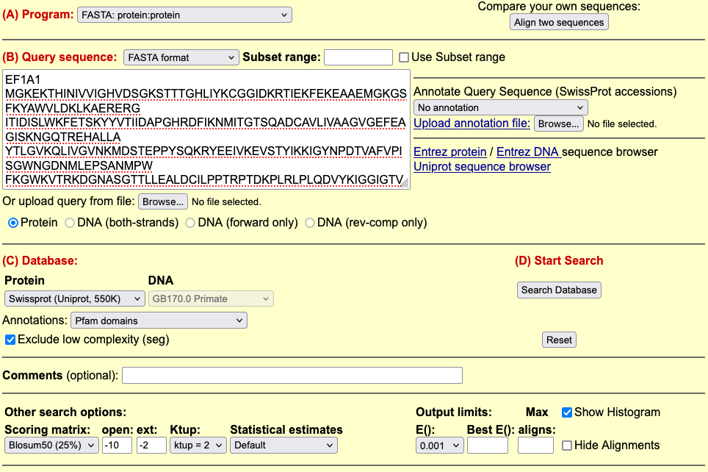

What to Analyze and Report

For each search, examine and comment on the following:
- Database characteristics
  - Number of sequences
  - Number of residues
- Score distribution
  - Histogram shape
  - Normalized similarity scores
  - Number of sequences per score range
  - E-values (expected number of random matches)
- Top hits
  - Best score(s) in the hit list
  - Corresponding E-values
  - Biological interpretation of these matches
- Performance
  - How does scan time change?
  - When does it increase or decrease?
  - How is this related to database size and ktup?

Discussion 3.1
Once you finish, submit the report with explanations to myCourses (in the Assignments section). You do not need to copy/paste (or screenshot) the full histograms or hit tables. Focus instead on parameter choices, key results, clear explanations, and interpretation.

NCBI BLAST (Discussion 3.2)

Let’s go back to NCBI search with blast algorithms
https://www.ncbi.nlm.nih.gov/

Concrete, biologically meaningful query: Netrin receptor
Again, we need some query sequences we would like to check. We will use the netrin receptor sequence from Homo sapiens (NP_005206.2).
Search for “NP_005206.2” and find the fasta format. You can copy and paste it in the NCBI blastp window query. Or go to the right panel to Analyze this sequence > Run BLAST.

Let’s go over the options/parameters one more time. Modify the following:
Database: Reference proteins (Refseq)
Expect threshold: 0.001
Word size: 3
Filter: low complexity regions

Why are we modifying these?
For each option, explain what kind of matches are being favored or excluded compared to the default BLASTp settings.

Go over the result sections one by one:

Descriptions//Graphic Summary//Alignments//Taxonomy

In the Graphic Summary section, what new information are we getting about the length, coverage, and conservation of the protein across hits?

What is the taxonomic distribution of the BLAST hits?
Are the matches restricted to a particular clade, or broadly distributed across taxa?
What does this suggest about the evolutionary conservation of the netrin receptor?

Predicted protein (?)
Now, let’s move on to a different GenBank accession number: BAJ99511.1
https://www.ncbi.nlm.nih.gov/protein/BAJ99511.1/

What can you tell about that specific entry? How it was sequenced. From what? See all the metadata associated with the gene.

•It has a gene name or just a locus tag
•It has links to the underlying nucleotide record or bioproject/bioproject
•The “source organism” is a real organism vs. a metagenome or environmental sample
•There are publications linked to it
Inspect all fields, particularly the “Source,” “Definition,” and “Features” section, and contrast them with the curated human netrin receptor record (which had an NP_ prefix and RefSeq status).
The accession prefix “BAJ” is not a RefSeq accession (RefSeq proteins have prefixes like NP_, XP_, WP_, or similar). Instead, “BAJ…” suggests a GenBank protein sequence record, usually derived from automated annotation of an assembly. These are common for newly sequenced organisms or draft genome projects.
Could you run a similar blastp (like the one above)? Use the “Non-redundant protein sequences” Database for this search. Again, go over all the BLAST result sections…do you find something odd?

Collect all your BLAST search discussion points (Netrin receptor & Predicted protein) into Discussion 3.2.

Discussion 3.2
Once you finish, submit the report to myCourses (in Assignments).

BLAST (Activity 3)
Open Lab03_BLASTP-steps-s.ipynb notebook, go through the code, and answer the questions.
Activity 3
Once you finish, submit the report (PDF) to myCourses (in Assignments).

