Lab05

Introduction

Phylogenetic analysis of mitochondrial cytochrome b gene (partial) sequences in chamois (mountain ungulate in Eurasia).
- Parsimony
- Branch and Bound
- Bootstrap
- Consensus trees

Document all work during the dry lab for each exercise, defining all your tools and input parameters, data output, and interpretation.

From Lab05, there are three Assignments to be submitted to myCourses:
Discussion 5.1
Discussion 5.2
Activity 5.1

Following the paper in https://pubmed.ncbi.nlm.nih.gov/18796461, you are going to build a phylogenetic tree of cytb sequences (nucleotides).

  - In Perusal: https://app.perusall.com/courses/bioinformatics-algorithms-spring25

  - Read Materials and Methods & Results
    - Check for my comments
    - Feel free to post questions & comments in Perusal

  - Download sequences from GenBank (multi fasta file)
    - There are 20 sequences (haplotypes)
    - 2 sequences as outgroups

  - Have everything ready:
    - Files (fasta)
    - software: PHYLIP, MEGA, Tree viewer (Lab00)
    - PHYLIP – MAC users:
Download http://phylipweb.github.io/phylip/download/phylip-3.695-osx.dmg
Copy folder in your directory
Go to /../phylip-3.695/exe
Copy linkmac from source dir: cp ../src/linkmac .
chmod +x linkmac
Execute linkmac: ./linkmac

Steps:

- Sequence files in fasta format.
  - Get the sequences from the article.
Tip: Search by Nucleotide in NCBI “cytochrome b AND rupicapra[orgn]”
Too many sequences?
Pro-Tip: Select one of the haplotypes (349 bp) and click on PopSet. Sorry, no more PopSet is available at NCBI. Try instead:
Search bar under Nucleotide: EU836150, EU836151, ..., EU836169

  - Rename fasta headers: only nine characters: Population+haplotype (eg. AsiCytb22, that would be Rupicapra r. asiatica haplotype cytb-22).

- Alignment.

- Input file in phylip format.

- THIS should have been done already in Lab04

- Build trees!

Workflow for a phylogenetic analysis using the PHYLIP program package: https://phylipweb.github.io/phylip/

An excellent guide to using PHYLIP with molecular data is available:
https://phylipweb.github.io/phylip/tuimala3.pdf

Another good PHYLIP practical guide:
https://vcru.wisc.edu/simonlab/bioinformatics/programs/phylip/doc/main.html

- DNAPARS estimates phylogenies by the parsimony method using nucleic acid sequences.
- DNAPENNY finds all most parsimonious phylogenies for nucleic acid sequences by branch-and-bound search.
- SEQBOOT accepts the PHYLIP file as input and sequences are bootstrapped a user-defined number of times.
- PROTDIST/DNADIST calculate distance matrices
- NEIGHBOR program joins nodes and branches according to the calculated values.
*NEIGHBOR uses a fontfile file to produce an output tree as text. You can use any fonts (font1, font2, …, font6) available in PHYLIP. But you can rename it to “fontfile”.
- TREEVIEW or TreeTool allow the user to manipulate the tree (e.g. re-rooting, making branch rearrangements, and changing fonts).
- CONSENSE program reduces the 1000 trees to the one that includes only those nodes that are present in the majority of the trees in the set of all possible trees and indicates the bootstrap values by the nodes.

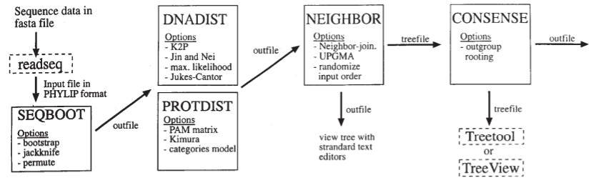
Source: Bioinformatics, Baxevanis.

Parsimony phylogenetic trees
The programs available for DNA parsimony are dnapars and dnapenny. The differences between these DNA parsimony programs are in the algorithm. dnapars searches for the most parsimonious tree by an heuristic algorithm, which does not guarantee that the shortest tree is found. Program dnapenny uses the branch-and-bound algorithm, which guarantees that the shortest tree is found, but takes quite a much computer time.

Use cytochrome b alignment (phylip format) with pseudogene-cytb (GenBank EF158834) as outgroup (20 haplotypes plus outgroup sequence).
Open the program dnapars. Check the menu; what options do you identify? Which setting do you need to set for the analysis?
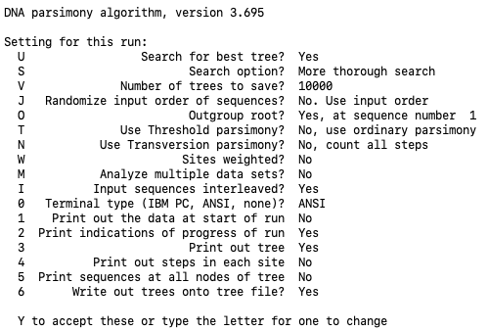

Check both output files: outtree and outfile. RENAME each file based on input data and analysis. Have you modified any of the options? Place that info in the name of the file, too!
Open the outfile file. How many steps has the most parsimonious tree? Could you describe what this value means in your own words?
Open the tree (outtree) in Newick format in a tree viewer (FigTree is better!) and save it as a PDF or JPEG after organizing the overall view.

Now, switch to dnapenny (Branch and Bound) with your dataset. Again, check the menu; what options do you identify? Which one are “new” (versus dnapars)? Run the parsimony analysis and check the outfile. What do you see? What is different from dnapars outfile? And the outtree? What would happen in you open the outtree in FigTree? Save a tree in pdf/jpeg.

Discussion 5.1
Build two trees, one parsimony and one with Branch and Bound. Write down the steps and parameters (methods) you used. (Once you finish, submit the report with explanations to myCourses (in Assignments).

Bootstrapping and consensus tree.

Generate multiple datasets from an alignment using bootstrap resampling. Using seqboot in PHYLIP and cytb alignment with the outgroup, we are going to generate 100 replicates (datasets):

R How many replicates? 100

It will ask you for a random number (odd). Pick an odd random number. Just
keep in mind that using the same random number produces the same result every time.

Go and check the outfile. What do you see? What has seqboot (bootstrapping) generated?

Prepare to run the multiple dataset with dnadist and neighbor.

You need to run these steps with the same parameters (JC/Kimura…Neighbor-Joining…transition transversion ratio, etc…) as Activity 4.1. Otherwise, you will need to repeat the phylogeny with the setting in bootstrapping!!! I told you, you need to document every analysis for yourself!

In dnadist:
M
Multiple data sets or multiple weights? (type D or W)
100
(type D or W)
D
How many data sets?
100

Check the outfile.

Now, you have the matrices (yes, plural!) ready for neighbor. Let’s set it for Neighbor-Joining, with 100 data sets. Take a look at outfile and outtree.

These datasets (trees in newick format) can be combined in a consensus tree with the program consense. Use the outtree file from neighbor for running consense. Finally, check your consensus tree from 100 random sets. Inspect the final outtree…what are the numbers for the nodes? Open the tree file (newick) in your favorite tree viewer…you know FigTree, and work on the visualization. You need (MUST) to show the bootstrap values on the nodes.

Is this a REAL tree?
What do we need to do with those (bootstrap) values?

Discussion 5.2
Build two trees, one consensus tree with bootstrap values and one real tree (Activity 4.1) with the bootstrap values. Write down the steps and parameters (methods) you used. (Once you finish, submit the report with explanations to myCourses (in Assignments).

Activity assignment: retake the fasta file with Lab04-Rupicapra_ND1_Capra.fasta ND1 haplotypes (or the alignment in phylip if you have it). Run the bootstrap analysis (seqboot), with 100, 500 or 1000 replicates, and generate a consensus tree (consense). Export (pdf) the final trees, one with consensus and bootstrap values and one with real tree and bootstrap values.

Activity 5.1
Once you finish, submit the report to myCourses (in Assignments).

