Go to this link to download MongoDB <https://www.mongodb.com/download-center#community>

Screenshot below

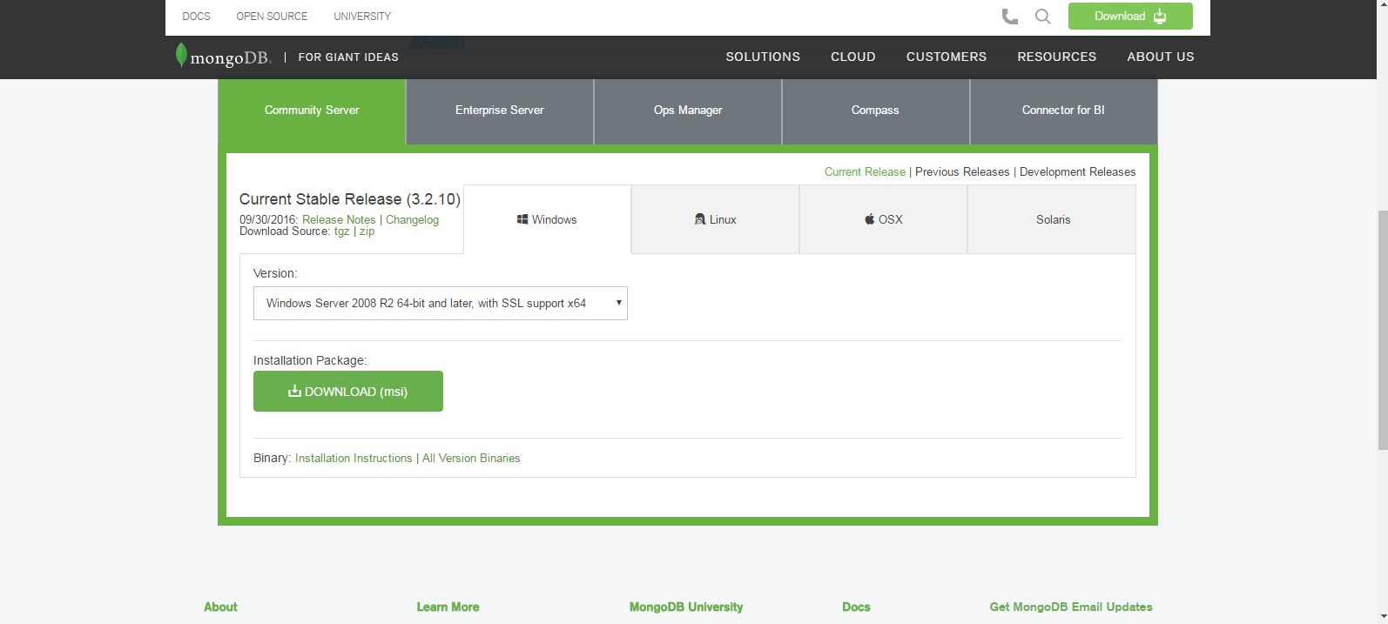

<https://docs.mongodb.com/manual/tutorial/install-mongodb-on-windows/>

**# mongodb commands**

1. Open windows command line as administrator
2. The following will start mongodb connection locally

C:\mongodb\bin>mongod.exe --dbpath="c:\mongodb\data\db"

use ProductPrice

db.productPriceInfo.find().pretty();

3.Open windows command line as administrator

4.The following will start mongodb terminal to execute monogodb commands

Open windows command line as administrator

C:\mongodb\bin>mongo.exe

MongoDB shell version: 3.2.9

connecting to: test

> show dbs

MyRetail 0.000GB

PriceInfo 0.000GB

ProductPrice 0.000GB

local 0.000GB

test 0.000GB