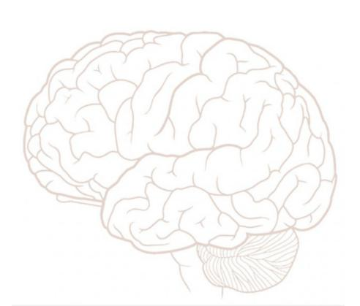Stanford Synapse:

Brain Injury Peer Support Group

Our goal is to support individuals with brain injury and post-concussion syndrome in the mid-peninsula community. We host meetings and social activities to provide opportunities for individuals & caregivers to connect and learn from one another.

**When**: Select Saturdays 1-2:30pm

**Where**: Stanford Hoover Pavilion, Room 308

211 Quarry Road, Palo Alto

If you are interested in attending please call us at 650-319-6110 or

email us at stanfordbraininjury@gmail.com.

Website: http://synapsebi.stanford.edu/

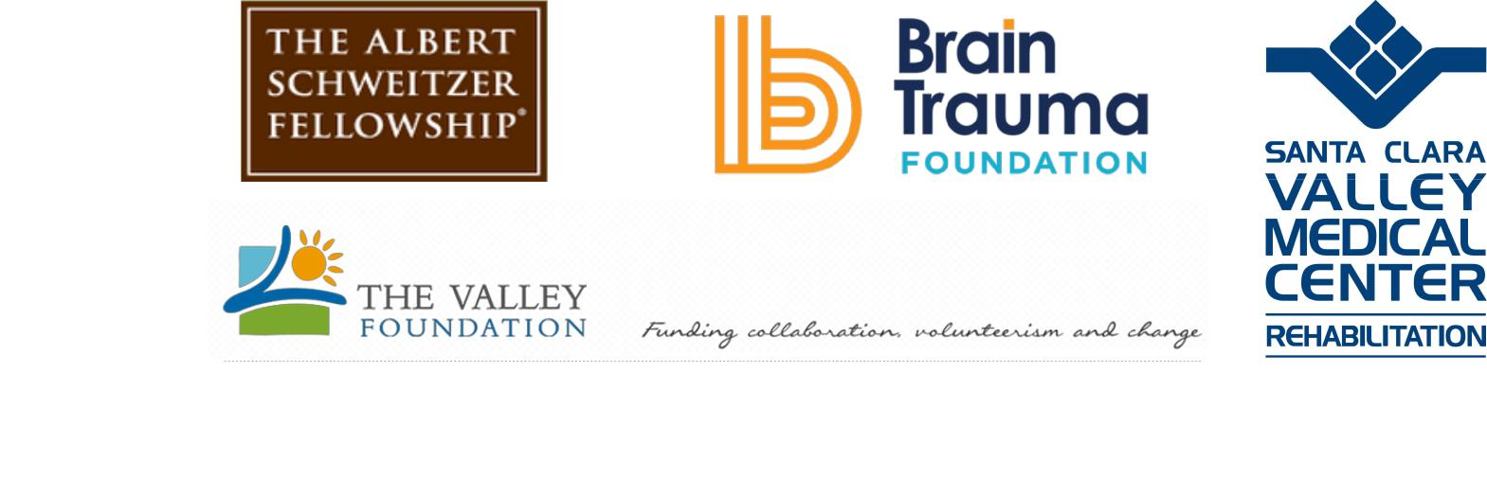

**Autumn 2017-Spring 2018 Meeting Dates:** November 19, December 3, December 30*, January 13, January 27, February 10, February 24, March 10, March 24, April 7, April 21, May 5, May 19

*=Optional depending on interest

*Made possible with support from:*

*:*