**Lab Week 2 NAME:** Case Chrisbacher

Due: Wednesday, September 9, 2020

Part1 (**10 Pts)**:

|  |  |  |  |  |
| --- | --- | --- | --- | --- |
| a | b | c | d | f |
| 0 | 0 | 0 | 0 | 1 |
| 0 | 0 | 0 | 1 | 0 |
| 0 | 0 | 1 | 0 | 0 |
| 0 | 0 | 1 | 1 | 1 |
| 0 | 1 | 0 | 0 | 0 |
| 0 | 1 | 0 | 1 | 1 |
| 0 | 1 | 1 | 0 | 1 |
| 0 | 1 | 1 | 1 | 0 |
| 1 | 0 | 0 | 0 | 0 |
| 1 | 0 | 0 | 1 | 1 |
| 1 | 0 | 1 | 0 | 1 |
| 1 | 0 | 1 | 1 | 0 |
| 1 | 1 | 0 | 0 | 1 |
| 1 | 1 | 0 | 1 | 0 |
| 1 | 1 | 1 | 0 | 0 |
| 1 | 1 | 1 | 1 | 1 |

**5.** SOP = (~a)*(~b)*(~c)*(~d) + (~a)*(~b)*(c)*(d) + (~a)*(b)*(~c)*(d) + (~a)*(b)*(c)*(~d) + (a)*(~b)*(~c)*(d) + (a)*(~b)*(c)*(~d) + (a)*(b)*(~c)*(~d) + (a)*(b)*(c)*(d)

6. 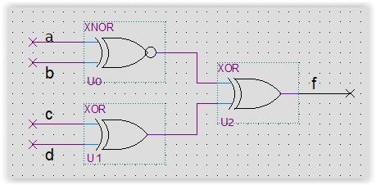page2image117139392page2image117081984

|  |  |  |  |  |
| --- | --- | --- | --- | --- |
| a | b | c | d | f |
| 0 | 0 | 0 | 0 | 1 |
| 0 | 0 | 0 | 1 | 0 |
| 0 | 0 | 1 | 0 | 0 |
| 0 | 0 | 1 | 1 | 1 |
| 0 | 1 | 0 | 0 | 0 |
| 0 | 1 | 0 | 1 | 1 |
| 0 | 1 | 1 | 0 | 1 |
| 0 | 1 | 1 | 1 | 0 |
| 1 | 0 | 0 | 0 | 0 |
| 1 | 0 | 0 | 1 | 1 |
| 1 | 0 | 1 | 0 | 1 |
| 1 | 0 | 1 | 1 | 0 |
| 1 | 1 | 0 | 0 | 1 |
| 1 | 1 | 0 | 1 | 0 |
| 1 | 1 | 1 | 0 | 0 |
| 1 | 1 | 1 | 1 | 1 |

7. Yes, the truth tables do match, the Verilog simulation is running the gate displayed in problem six.

**Complete the Lab:**

Values (8 pts): 0000, 0011, 0101, 0110, 1001, 1010, 1100, 1111

= (~a)*(~b)*(~c)*(~d) + (~a)*(~b)*(c)*(d) + (~a)*(b)*(~c)*(d) + (~a)*(b)*(c)*(~d) + (a)*(~b)*(~c)*(d) + (a)*(~b)*(c)*(~d) + (a)*(b)*(~c)*(~d) + (a)*(b)*(c)*(d)

The Verilog description of the circuit is the exact same as the Sum of Products, because they are both describing the same schematic.