

# E-Reg Consulting - Business Website, Bootstrap

## <http://www.e-regconsulting.com/>

## 1. Introduction

* A brief introduction to your website idea. State the goals of the project.
  + Give a needed update to a real-world clients’ existing website. A friend of mine does environmental services consulting and his website is BAD
    - Add responsiveness, SEO, and a modern look & feel while staying lightweight
  + Write all code from scratch (no templates)
  + Store in online repo (GitHub)
* The values / benefits (tangible and intangible) this application can bring to a company/organization/end user
  + Greater impact for new and existing clients searching for the E-reg’s goods and services
  + Communicate a modern aesthetic and polished image to reinforce expertise

## 2. Expected List of Features

* A brief list of features that you expect your website to support
  + Single Page style
    - Modern, sleek, minimal, easy to navigate
  + Mobile-responsive (Phone, Tablet, Desktop)
    - Necessity for modern website
  + Hero/Jumbotron-style home screen
    - Emotionally impactful, aesthetically pleasing
  + Fixed/Sticky Navbar below hero image
    - Ease of navigation, current/relevant design
  + Services section w/ cards (animate/flip on click to reveal details)
    - Marketing
  + About Us section
    - Create trust, share credentials, tell a story
  + Testimonials section
    - Continue to build trust
  + Contact Us section w/ Bootstrap form
    - Site finishes with call to action w/ form and option to place a call

## 3. Market Survey

1. [www.libertyes.com](http://www.libertyes.com)- extremely outdated, similar to client
2. [www.anamarinc.com](http://www.anamarinc.com) – more up to date than client
   1. Large headers, multiple pages, social links, news feed, blog
3. [www.miami-environmental.com](http://www.miami-environmental.com)
   1. Early 2000s design, single page, weird math question as security for contact us form
4. [www.airmd.com](http://www.airmd.com)
   1. Modern design, responsive, slideshow banner, certifications on banner, FAQ section, cookies message
5. [www.cmenvironmentalfl.com](http://www.cmenvironmentalfl.com)
   1. Nav bar with elements that are not aligned, services cards section with cheesy pop-in animation, wall of text About Us section, two blog entries, mission statement footer

## 4. References

* *Give references to any material / websites / books, et cetera, relevant to your website idea*

I’m going to base my design *somewhat* around this template I found on Bootsnipp, but trying to code all from the ground up to minimize total lines of code (the template is very heavy weight, SASS, etc). Mainly incorporating a big hero graphic, services card, a testimonials section, and Bootstrap-styled form. Screenshots of the design I’m working on so far:

Original Website:

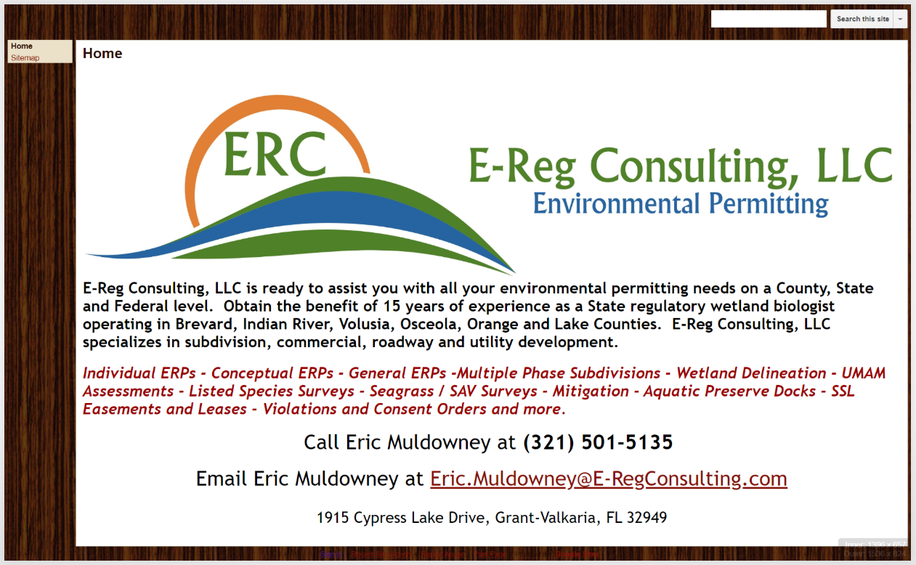

Landing:

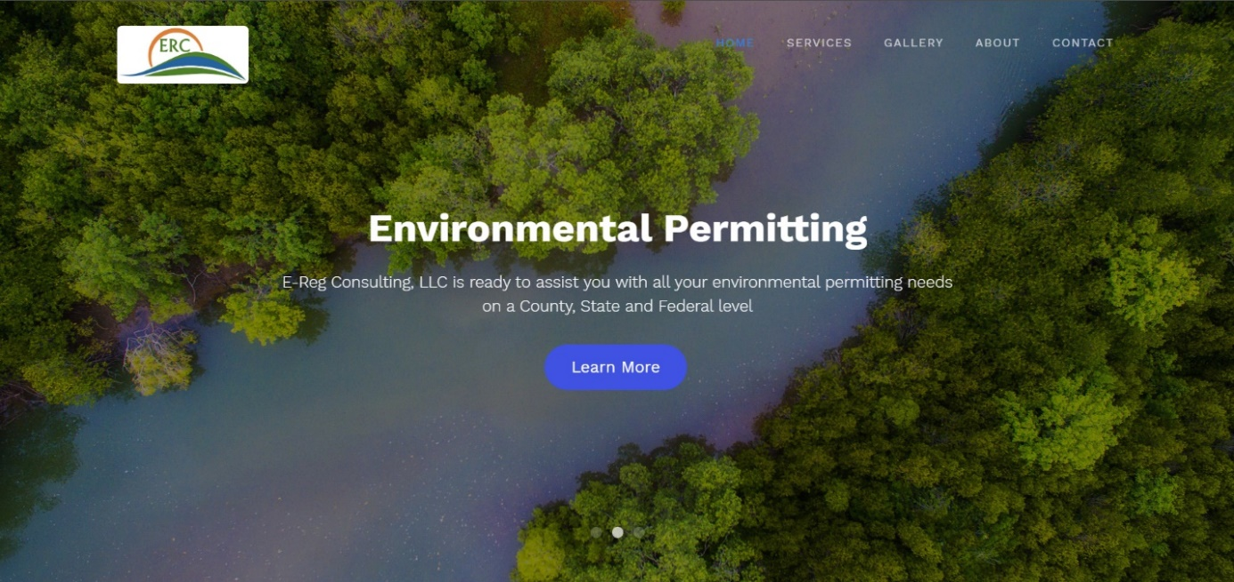

About Us:

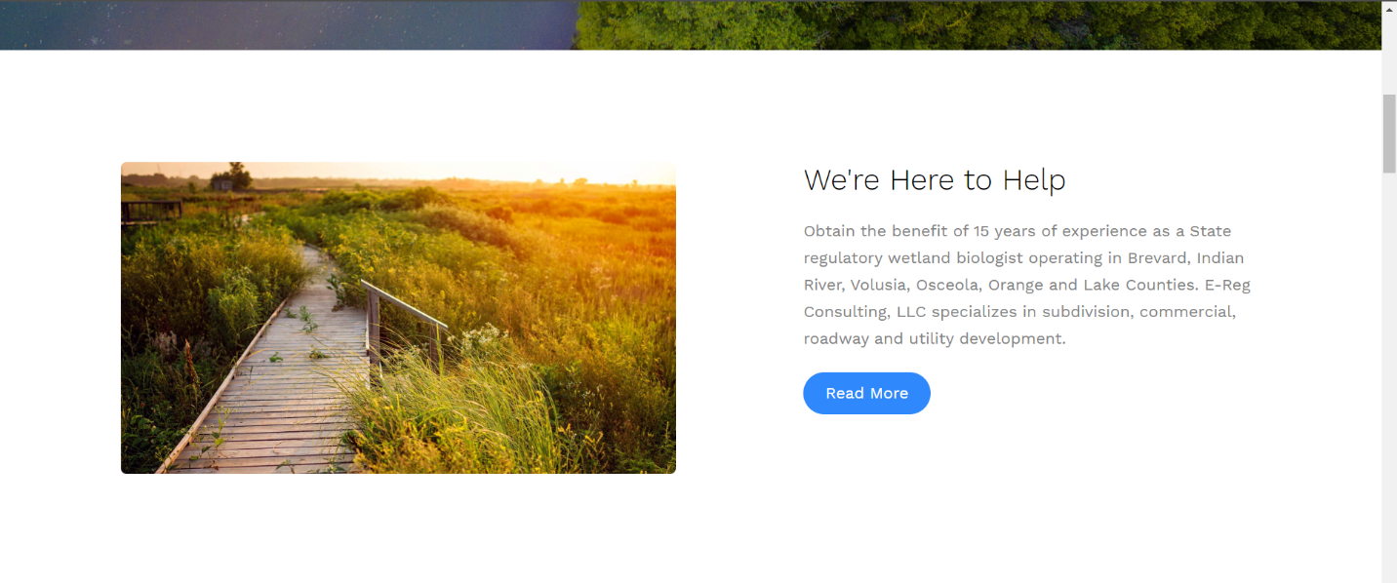

Services: *(will update icons and change color site-wide to green)*

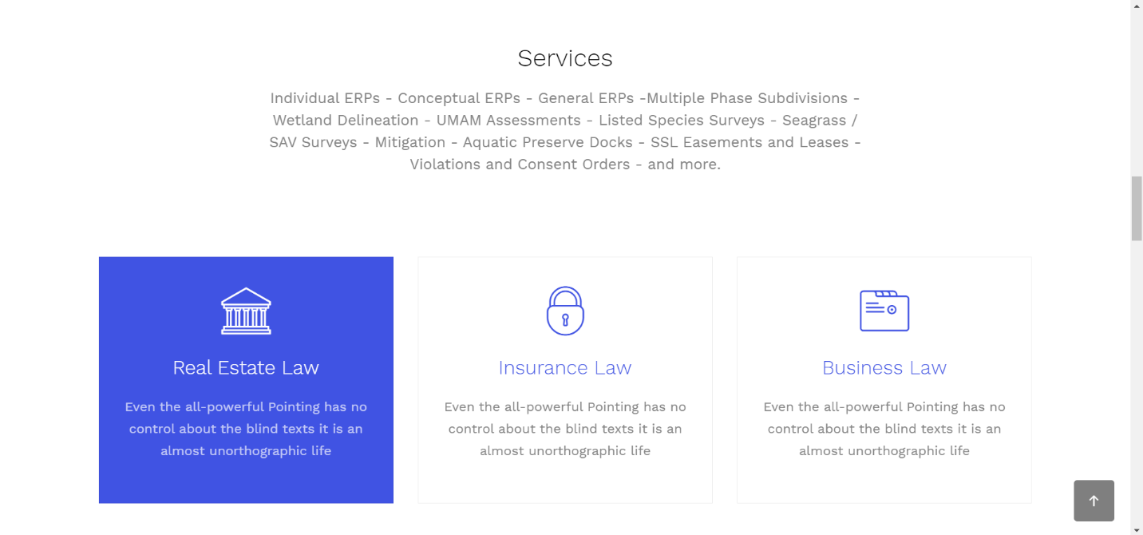

Testimonials:

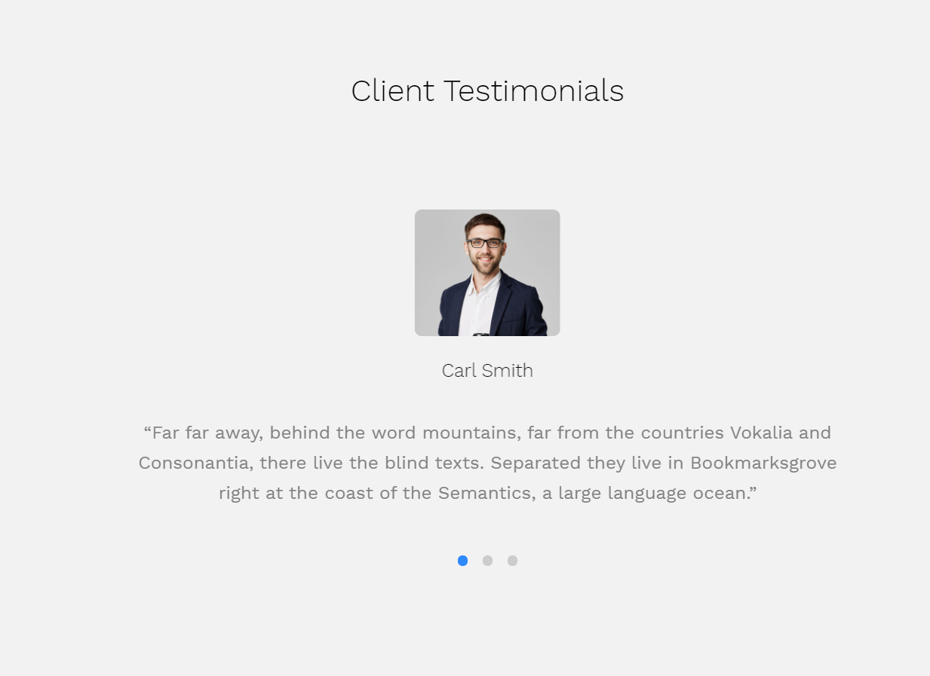

Contact Us Form:

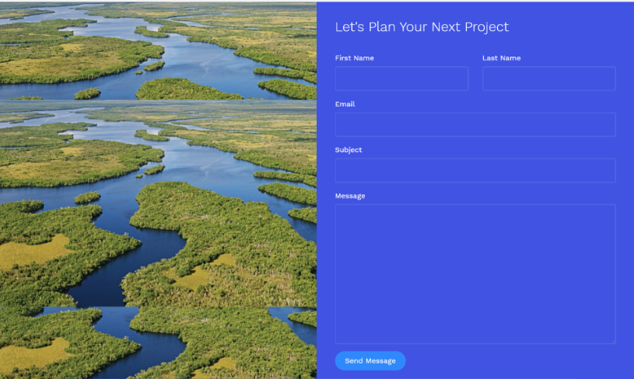

* Give the links to the websites relevant to your idea that you listed in the section above:

(See next page)

Liberty ES – Ponte Vedra Beach, FL

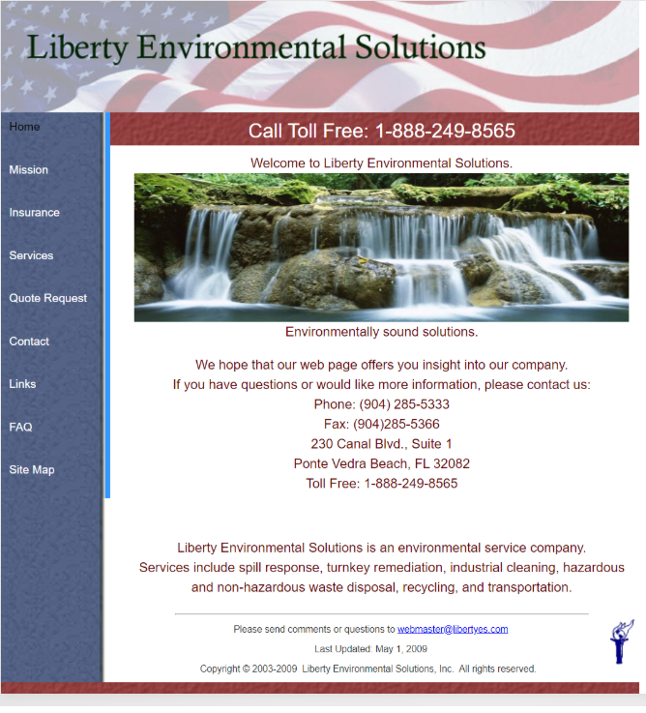

Anamar ES – Gainesville, FL

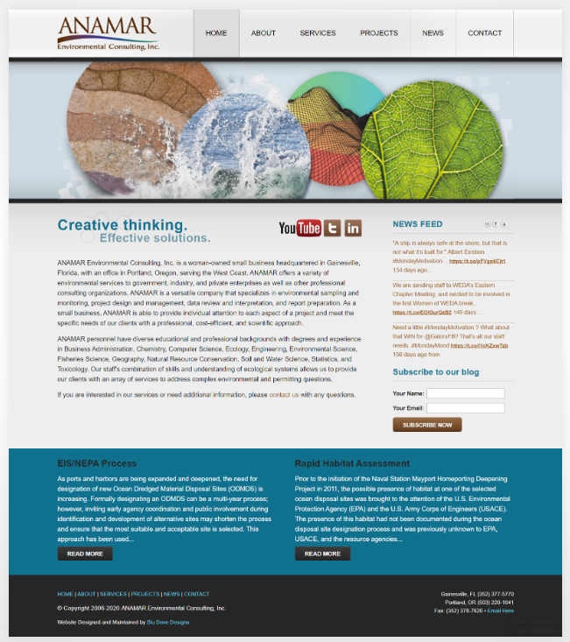

Miami Environmental

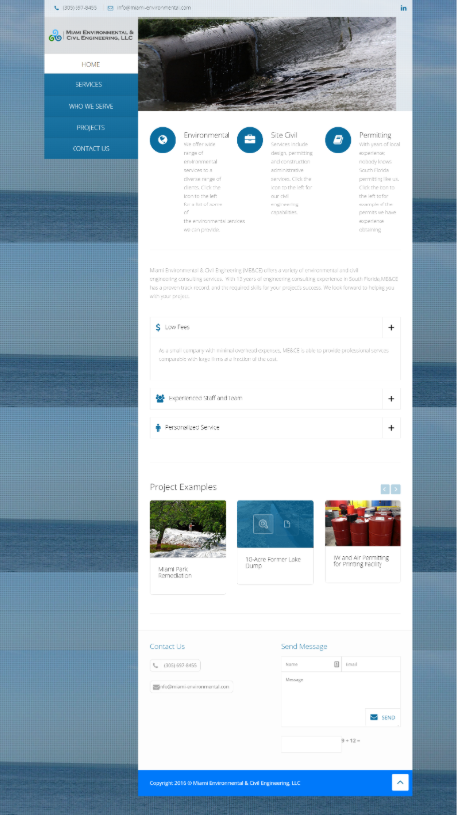

Air MD – Miami, FL

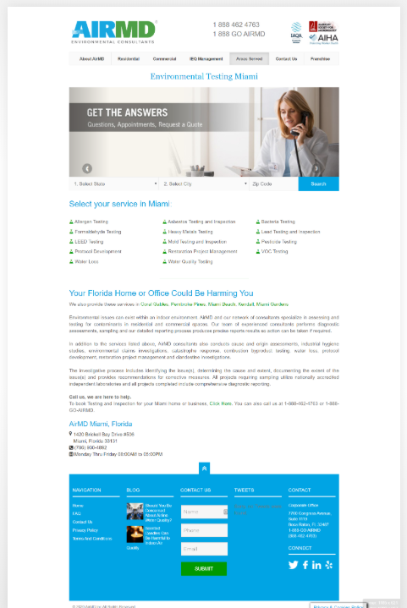

CM Environmental Services – Ocala, FL

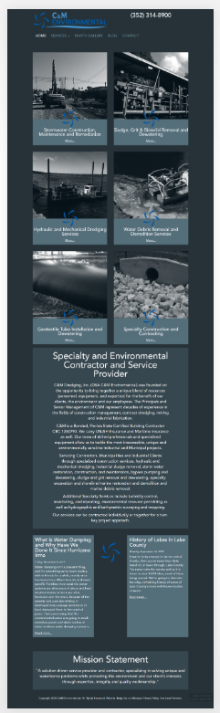

Generally speaking, excepting Air MD, these websites feel like lessons in what not to do, BUT it does show an apparent need for modernization of this sector’s web presence (which could be a future business opportunity), and they do have recurring elements (such as “Services”) that show what content is expected to be present by prospective website visitors.