**Step 1:**

In modern computers, the Memory Management Unit (MMU) does all of the management work for allowing programs to gain access to system memory. The MMU is a physical device usually located as a part of the computer’s CPU. While older operating systems would assign a memory address that corresponds with the physical memory address, modern computers now use virtual memory. Virtual memory assigns a virtual memory address to a program that requires memory, this address is then passed to the mapper which designates which physical address the application will gain access to based on availability. The virtual memory address does not always correspond with the physical address, so an application with a virtual address of “1” may be assigned memory address “5”. The MMU acts as the translator to allow the device to understand how to allocate resources by translating the virtual address into a physical memory location on the system’s RAM or disk.

**Step 2:**

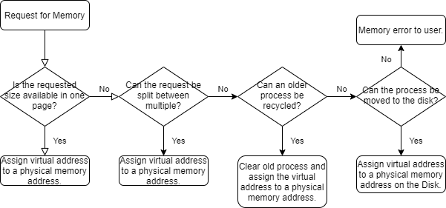

Modern computers handle memory faults with much more grace than older systems did. Before the implementation of virtual memory, any time a program would attempt to access a memory address that wasn’t available it could easily crash the system. If a memory address was out of range for the system (such as a 32-bit address on a system with less than 4GB of memory), the whole system would crash as well. Now with virtual memory, the system can handle situations where page faults occur. If a system comes across an issue where not enough memory is available (page fault), the system can either tell the process to wait for memory to clear up, clear up an older process, or move the process to the disk. This gives us multiple ways that a system will automatically deal with page faults without causing an error that would crash the system. The MMU also manages priority of process and ensures that the most active and most recent ones are given priority access to memory when needed, while older and less-frequently used processes are recycled to the disk to clear up space in the RAM.

**Step 3:**

The separation of mechanism and policy is a method of controlling how the management of resources is handled. This concept ensures that the methods of allocating resources and the polices that govern the priority and management are kept separate. The MMU, CPU, and RAM are the mechanism that execute the processing of data and memory allocation for processes in a computer system, but they are not what controls the allocation of the resources. The mapping software and operating system contain the guidelines for memory allocation and prioritization. This software will then send commands to the mechanism on how to implement the required command. This separation creates security and prevents errors from occurring due to conflicting commands that may come from the mechanisms.