Knudsen, Stephen, “Top Ten Contemporary Art Exhibits in 2013”, HUFFINGTON POST, 2 January 2014.

**Macintosh HD:private:var:folders:dr:y9n3qsg52ld76ddf8rg_738h0000gn:T:TemporaryItems:arts.gifTop Ten Contemporary Art Exhibits in 2013**

Posted: 01/02/2014 12:08 pm

Author: Stephen Knudsen

I can't think of a better way to open myself up to the slings and arrows of rebuke than making a top ten list like this. But someone did ask me to list the five best 2013 exhibits off the top of my head. I took them up on that and then added five more. If memorability is in fact, as Henry Geldzahler claimed, a good measure of aesthetic goodness, then perhaps this list is of some worth. So here goes...my top ten contemporary art exhibits in 2013. No ranking is intended in this list beyond just making the cut. My servitude to pop culture convention only goes so far.

**Benjamin Degen / Shadow Ripple Reflection**  
Susan Inglett Gallery  
Chealsea, NY  
24 Oct - 7 Dec, 2013

[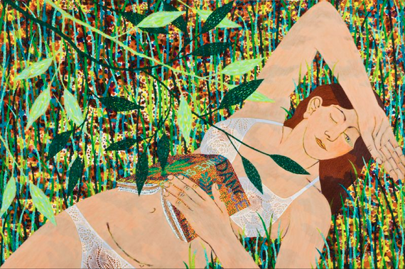](http://images.huffingtonpost.com/2013-12-31-ScreenShot20131230at9.57.33PM.png)  
Benjamin Degen, Dapple, 2013, Oil on linen over panel, 36 x 54 in.  
Courtesy: Susan Inglett Gallery, NYC.

With Shadow Ripple Reflection, an uplifting exhibition of eight new paintings, Benjamin Degen showed us that he is better than ever. These works skirt bravely close to cliché: sunshine, youthful figures lounging, reading, swimming, setting out and returning. But they take positive hold on the memory because they seem so unfamiliar in the fanatical and web-like detail in the non-flesh passages. In the most complex sections it is as if the pigment spun from spinnerets of a spider. The work may nod toward Matisse, Bonnard, Seurat, Renoir and Gauguin, but it is absolutely recognizable only as itself.

**Eija-Liisa Ahtila: Olentoja (Creatures)**

Davis Museum at Wellesley College,  
Wellesley, MA   
Sep 18 - Jan 5, 2014

***Nicolas Consuegra***  
Gallery Booth for La Central Gallery, Bogota, Columbia  
Miami Beach Art Basel, Miami, FL  
Dec 4-8, 2013

**Carnegie International Exhibition**  
Nicole Eisenman Survey in the Hall of Sculpture   
Carnegie Museum, Pittsburgh, PN  
Carnegie Museum October 5, 2013 - March 16 2014

***Laura McPhee: River of No Return***  
Kemper Contemporary Museum of Art,  
Kansas City, MO  
May 17-September 22, 2013

***Richard Serra: New Sculpture***  
Gagosian Gallery West 24th Street, NYC  
Through March 15, 2014  
Gagosian Gallery West 21st Street NYC  
Through February 8, 2014

***Li Songsong/We Have Betrayed the Revolution***

Pace, London  
Sept 19, 2013 - Nov 09, 2013

***James Turrell***  
Solomon R. Guggenheim Museum, NYC  
June 21-September 25, 2013

***Ai Weiwei: According to What?***

Pérez Art Museum Miami (PAMM)

Miami, FL  
Dec. 4, 2013 - March 16, 2014