Wolkoff, Julia, “Benjamin Degen,” Art in America, 30 October 2015.



Benjamin Degen

**at Susan Inglett,** **through Dec. 5**

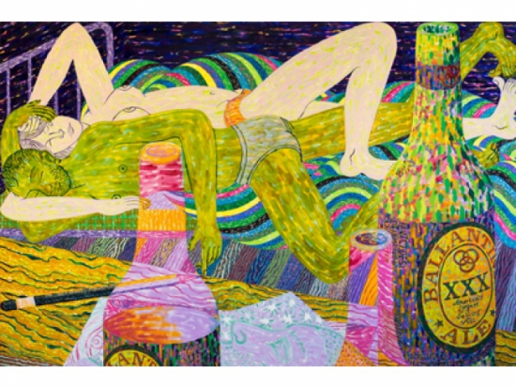522 West 24th Street

Recent paintings and works on paper by Benjamin Degen depict highly personal, domestic scenes. The artist, painted green and clad only in his underwear, appears intertwined with his semi-nude wife in bed in*Drawing, Drinking, Sleeping, Dreaming* (2015). The scale of the 6-by-9-foot painting further enhances the sense of exposed intimacy. Pointillist beer bottles in shades of purple, lurid greens and translucent pinks in the foreground add layers to an already visually complex scene. Colorful, rhythmic patterns on the wood grain of the floor and a striped blanket behind the bottles dreamily blend into one another while the couple lies blissfully undisturbed. Other works show ethnically ambiguous subjects dancing in a tangled mass and wearing Air Jordans and little else, among other activities. The paintings, sometimes too busy, are tempered by superb oil-stick-and-pastel still lifes. In this series, the quietude of elegant Chinese porcelains surrounded by flowers—like van Gogh's—are paradoxically rendered with frenetic brushwork, colors and patterns.

Pictured: Benjamin Degen: *Drawing, Drinking, Sleeping, Dreaming*, 2015, oil on linen over panel, 72 by 108 inches. Courtesy Susan Inglett, New York.