Steadman, Ryan, “12 Things to Do in New York’s Art World Before October 25,” The New York Observer, 22 October 2015.



**12 Things to Do in New York’s Art World Before October 25**

**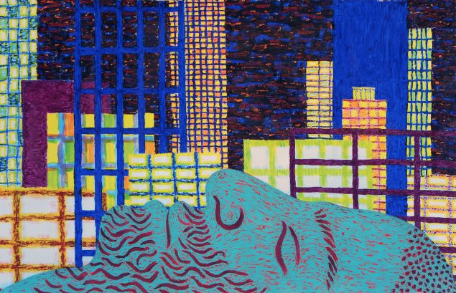**

**Rip Van, 2015. Oil stick and acrylic on paper by Ben Degen. (Photo: Courtesy of Susan Inglett)**

**Opening: Ben Degen at Susan Inglett Gallery**  
Brooklyn-based Cooper Union grad Ben Degen is a heck of a good painter. He turns images of the everyday (beer bottles, reclining bohemians, potted plants) into rhythmic, pulsating surfaces of harmonic color. No tricks here, like painting with a fire extinguisher or your “manhood,” just Degen’s patient exploration of the post-impressionist tenets that made van Gogh much more than just another Dutch nut job. Also, I suspect, that since Degen likes to paint beers, it means that there will be beers at his opening event. I am basing this conclusion on previous art-world experiments. You can set your watch to it.  
[Susan Inglett Gallery, 522 West 24th Street, New York, 6:00 – 8:00 p.m.](http://www.inglettgallery.com/" \t "_blank)