::::::Desktop:Screen shot 2016-03-26 at 10.17.21 AM.png

**By Carolina A. Miranda**

A trio of painters. Photography that records ruin in intelligent ways. And abstracted bits of landscape rendered as mosaic. Plus, the Underground Museum unveils a timely new exhibition. Here are four shows to see this week:

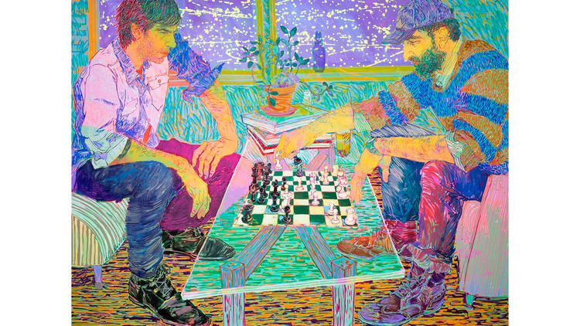

**[Hope Gangloff, Benjamin Degen and Yuri Masnyj at Richard Heller Gallery.](http://richardhellergallery.com/dynamic/exhibit.asp?ExhibitID=221" \t "_blank)**Heller’s gallery is featuring a series of solo exhibitions by a trio of New York-based painters. These include Gangloff’s moody portraits, Degen’s glitteringly surreal landscapes and the diagrammatic paintings by Masnyj, which function as strange inventories of objects and things. Opens Saturday at 5 p.m. and runs through April 30. Bergamot Station, 2525 Michigan Ave., Ste. B5, Santa Monica,*[richardhellergallery.com](http://richardhellergallery.com/info.htm" \t "_blank)*.