

THE INDEPENDENT VOICE OF CONTEMPORARY ART | MON **25** JUL

**Three Summer Shows in New York’s Chelsea You Shouldn’t Miss**

**There are many wonderful summer shows up right now in Chelsea, from group shows to solo exhibitions, sculpture to painting to mixed media; you certainly get a little taste of everything. While I enjoyed many exhibitions, there are three that left a strong impression on me: Annie Pearlman/Adrianne Rubenstein/Alyson Vega at White Columns, Skins: Body as Matter and Process at Garth Greenan Gallery and Intimisms at James Cohan Gallery.**

James Cohan Gallery

Intimisms

Intimisms, a large group show at James Cohan’s Chelsea space, is definitely worth the visit. A well-balanced mix of emerging and established artists, the show is based off the influence of the 20th century Intimists, like Vuillard and Bonnard. The intimists produced “intimate” portraits of friends and family in their moments of private solitude. Often set in vibrant backgrounds, these portraits allowed us to peek into the secretive lives of these artists’ loved ones. From Lucien Frued to Alice Neel to emerging artists such as Hope Gangloff and Benjamin Degen, the exhibition consists of different examples of these intimate moments. Open until 29 July, the vibrancy of color and exciting mix of artists makes it the perfect summer exhibition.

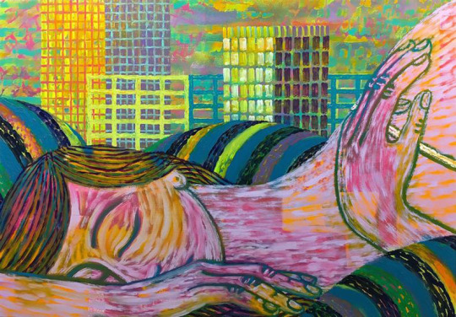

**Benjamin Degen, The City Rising, 2016, Oil paint and spray enamel on linen over panel, 42 x 60 inches, James Cohan Gallery, NYC.**

**Words: Gracie Brahimy © Artlyst 2016 Top Photo: Annie Pearlman**