### Macintosh HD:Users:susaninglett:Desktop:Screen shot 2016-07-08 at 10.38.02 AM.png

# What to See in New York Art Galleries This Week

JULY 7, 2016

‘Intimisms’

[*James Cohan Gallery*](http://www.jamescohan.com/) *533 West 26th Street, Chelsea  
Through July 29*

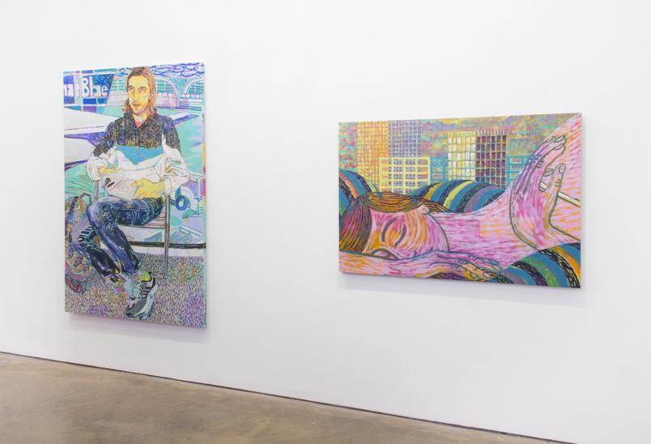

The title of “[Intimisms](http://www.jamescohan.com/exhibitions/2016-06-23_intimisms),” an excellent group show of figurative painting, pluralizes Intimism, the early modernist style best exemplified by the small, sometimes fraught domestic interiors of Édouard Vuillard and Pierre Bonnard. At a moment when so much art is for public consumption, the works here convey the intimacy of bodies, faces, emotions, touch and love.

Representing 26 artists from several generations, the show is organized by the gallery and the painter Aliza Nisenbaum. From the past, Jane Freilicher’s “Flowers in Armchair” (1956) and Fairfield Porter’s “The Bedroom” (1949) are exceptional. In an Alice Neel group portrait of the Fugs (1966), the band seems to be singing just for us. Henry Taylor’s forceful “Fawn Rogers” (2015) all but picks up Neel’s mantle.

Like Porter, numerous younger artists take us into the bedroom, often casting us as intruders, as in Benjamin Degen’s close up of a flushed woman sleeping. In rich colors and full forms that distantly evoke Léger, GaHee Park’s “Night Talk” features mysterious meldings of bodies, rooms, old-fashioned telephones and paintings within paintings. Ridley Howard portrays tender lovemaking in settings stripped of detail. Nicole Eisenman’s 1994 “Self-Portrait With Mr. Monopoly” conjures a moment of quiet existential terror, while Joan Brown’s “Twenty to Nine” (1972) depicts a woman who may be weeping sitting at a restaurant table with wine glasses for two. We see only the hands of two people building a fire in a new work by Giordanne Salley. Jordan Casteel zeros in on a woman resting her left hand on her knees; the title, “Mom Hand,” speaks volumes.

There is much to linger over, especially Anna Glantz’s portrait of a bare-chested, vulnerable young man. Sylvia Sleigh’s 1970 portrait — the same subject in a different mood — might have been painted yesterday.