Staff. “Life Lived in Bed-Stuy and Crown Heights Surveyed at BRIC Biennial, V.II,” *Brooklyn Reader*, 4 November 2016.



Life Lived in Bed-Stuy and Crown Heights Surveyed at BRIC Biennial, V.II

By [Brooklyn Reader](http://www.bkreader.com/author/brooklynreader)

The **BRIC Biennial: Volume II, Bed Stuy/Crown Heights Edition**is the largest and most ambitious exhibition organized by BRIC to date, highlighting the significance of Brooklyn as the place where New York artists create work and develop their careers.

This second edition of this initiative will be centered at BRIC House, beginning Friday, November 11, with portions of the show also on view at cultural institutions and art spaces in the neighborhoods, including [**Weeksville Heritage Center**](http://www.weeksvillesociety.org/), the main branch of the [Brooklyn Public Library](https://www.bklynlibrary.org/), and [FiveMyles](http://www.fivemyles.org/)Gallery.

The work of hundreds of artists based in Bedford-Stuyvesant and Crown Heights were reviewed, and 40 were selected for the exhibition.

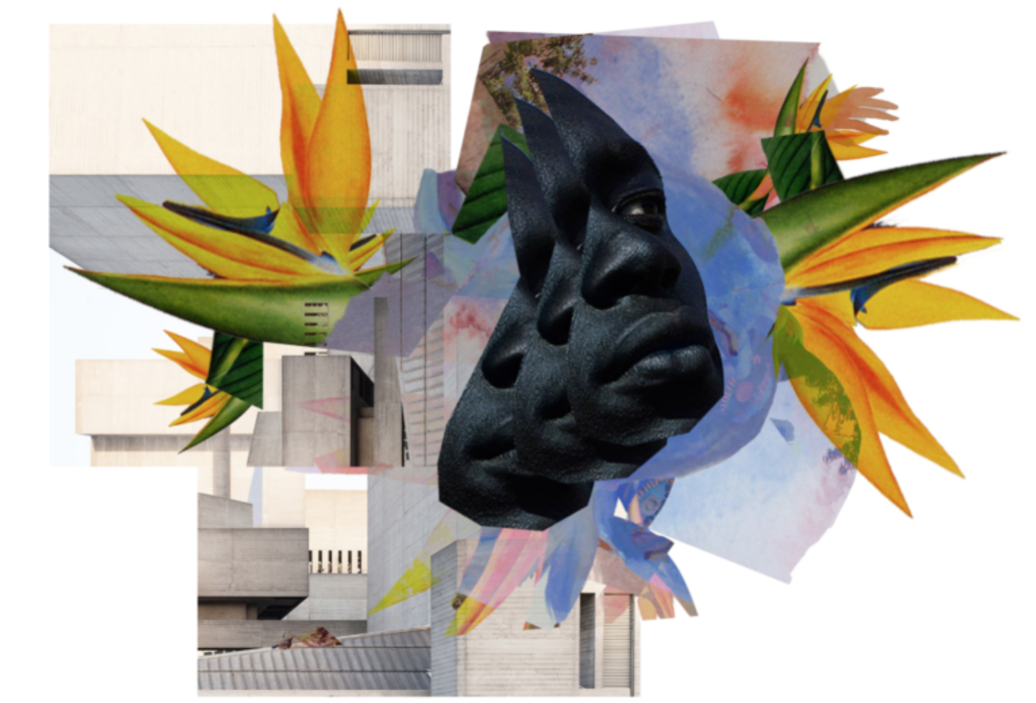This second edition will focus on the theme “**Affective Bodies**,” drawing from affect theory, which places emphasis on bodily experience rather than on learned knowledge. Artists exhibited at **Weeksville Heritage Center**will be grouped under the theme “**The Lived City**,” considering how people’s lives and experiences endow urban spaces with emotional resonance. The exhibition at the the main branch of the **Brooklyn Public Library**, “**Translations and Annotations**,” will include the work of five artists who use existing texts and documents as source material. By processes of alteration, annotation, translation, and reinterpretation, these artists endow these texts with new, emotional quality, relevant to their lives and to the time in which we live. (On view at BPL January 31, 2017.) And finally, **FiveMyles** will focus on presenting a series of performance artists.

EXHIBITION ARTISTS INCLUDE:

**BRIC House**: Lala Abaddon | Aisha Tandiwe Bell | Jen Bervin | The Black Lunch Table | Brooklyn Hi Art Machine | Brandon Coley Cox | Zachary Fabri | Rachel Frank | Aaron Gilbert | Asuka Goto | Phoebe Grip | Ilana Harris-Babou | Maria Hupfield | Sara Jimenez | Rachelle Mozman | Kambui Olujimi | Nkiruka J. Oparah | Rachel Ostrow | Macon Reed | sol’sax | Jakob Kudsk Steensen | William Villalongo

**Brooklyn Public Library:**Kumasi J. Barnett | Aaron G. Beebe | Asuka Goto | Hidemi Takagi | Chris Nosenzo

**FiveMyles:**Jonathan Allen | Keisha-Gaye Anderson | Anti/Matter Collective | Asylos Company | Bell and Clixby | Hot Hands | Andrea Haenggi | Maiko Kikuchi | Grey Mcmurray | Sari Nordman | Renegade Performance Group | Malik Nashad Sharpe

**Weeksville Heritage Center:**Chloe Bass | The Black Lunch Table | Adrian Coleman | Adama Delphine Fawundu | Russell Frederick | Duron Jackson | Olalekan Jeyifous | Mckendree Key | Baseera Khan | Stan Squirewell | sol’sax

TOURS of the exhibition for individuals and groups will be available on Wednesdays from 10:30am-12:30pm.