import sys, time
from socket import *

# Initialization Section
# Set host, port and timeout
host = '127.0.0.1'
port = 12000
timeout = 1 # in second
seq = 1
# create dgram udp socket
try:
s = socket(AF_INET, SOCK_DGRAM)
s.settimeout(1)
except socket.error:
print('Failed to create socket')
sys.exit()

# Ping for 10 times using a while loop
min_rtt = 1
max_rtt = 0
losses = 0
total_rtt = 0
while seq <= 10:
t = time.localtime()
message = f"Ping {seq} {time.asctime(t)}"
seq += 1

# Put the rest in a try/except block to handle any possible timeouts
try:
# YOU FILL IN: Set a variable for the time sent (hint: time.time() is nice)
start = time.time()
# YOU FILL IN:Send the UDP packet with the ping message
s.sendto(message.encode(), (host, port))

# YOU FILL IN: Receive the server response and address; user recvfrom(1024). Read the documentation!
# Pay attention to the format of the returned parameters.
data = s.recvfrom(1024)
reply = data[0]
addr = data[1]

# YOU FILL IN: Set a variable for the time received
finish = time.time()

# YOU FILL IN:Print the server response as an output as described earlier: PING FROM ADDRESS: MESSAGE
# Notice the message that is returned is a byte string, not a normal UTF-8 string
# To get a normal string use the mystring.decode() standard function
# Also, print only the IPv4 address. I'm not interested in the port number.
print(f"Reply from {addr[0]}: {reply.decode()}")
# YOU FILL IN: calculate and print the round trip time
rtt = finish-start
print(f"RTT: {rtt}")
if rtt < min_rtt:
min_rtt = rtt
if rtt > max_rtt:
max_rtt = rtt
total_rtt += rtt

except Exception as e:
losses += 1
# Server does not respond. Assume the packet is lost
# Assume the packet is lost
print ("Request timed out.")
continue

print(f'\n--- {addr[0]} ping statistics ---')
print(f'10 packets transmitted, {10-losses} received, {losses/10 * 100}% packet loss, time {total_rtt*1000:.0f}ms')
print(f'rtt min/avg/max = {min_rtt*1000:.3f}/{(total_rtt/(10-losses))*1000:.3f}/{max_rtt*1000:.3f} ms')

# Close the client socket
s.close()

Reply from 127.0.0.1: PING 1 TUE SEP 15 00:12:11 2020
RTT: 0.0005924701690673828
Request timed out.
Reply from 127.0.0.1: PING 3 TUE SEP 15 00:12:12 2020
RTT: 0.0010123252868652344
Reply from 127.0.0.1: PING 4 TUE SEP 15 00:12:12 2020
RTT: 0.0007503032684326172
Reply from 127.0.0.1: PING 5 TUE SEP 15 00:12:12 2020
RTT: 0.0011098384857177734
Reply from 127.0.0.1: PING 6 TUE SEP 15 00:12:12 2020
RTT: 0.0013206005096435547
Reply from 127.0.0.1: PING 7 TUE SEP 15 00:12:12 2020
RTT: 0.0005893707275390625
Reply from 127.0.0.1: PING 8 TUE SEP 15 00:12:12 2020
RTT: 0.0010259151458740234
Reply from 127.0.0.1: PING 9 TUE SEP 15 00:12:12 2020
RTT: 0.00023055076599121094
Reply from 127.0.0.1: PING 10 TUE SEP 15 00:12:12 2020
RTT: 0.00017762184143066406

--- 127.0.0.1 ping statistics ---
10 packets transmitted, 9 received, 10.0% packet loss, time 7ms
rtt min/avg/max = 0.178/0.757/1.321 ms

Reply from 129.82.44.96: PING 1 TUE SEP 15 00:15:14 2020
RTT: 0.00030112266540527344
Reply from 129.82.44.96: PING 2 TUE SEP 15 00:15:14 2020
RTT: 0.00022029876708984375
Request timed out.
Reply from 129.82.44.96: PING 4 TUE SEP 15 00:15:15 2020
RTT: 0.0003249645233154297
Reply from 129.82.44.96: PING 5 TUE SEP 15 00:15:15 2020
RTT: 0.00035762786865234375
Request timed out.
Reply from 129.82.44.96: PING 7 TUE SEP 15 00:15:16 2020
RTT: 0.0003590583801269531
Reply from 129.82.44.96: PING 8 TUE SEP 15 00:15:16 2020
RTT: 0.0003104209899902344
Request timed out.
Request timed out.

--- 129.82.44.96 ping statistics ---
10 packets transmitted, 6 received, 40.0% packet loss, time 2ms
rtt min/avg/max = 0.220/0.312/0.359 ms

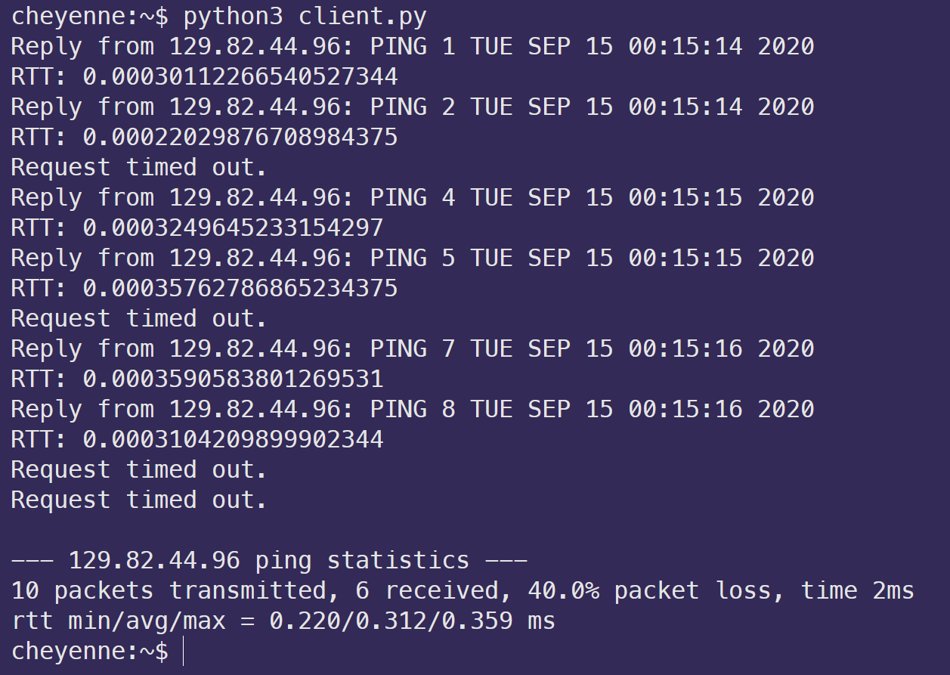
It took approximately twice as long for a packet to perform a round-trip on my local machine compared to the CS lab machines. This may be due to me running the experiment within the Windows Subsystem for Linux.

