Screenshots per announcement
Cs.colostate.edu
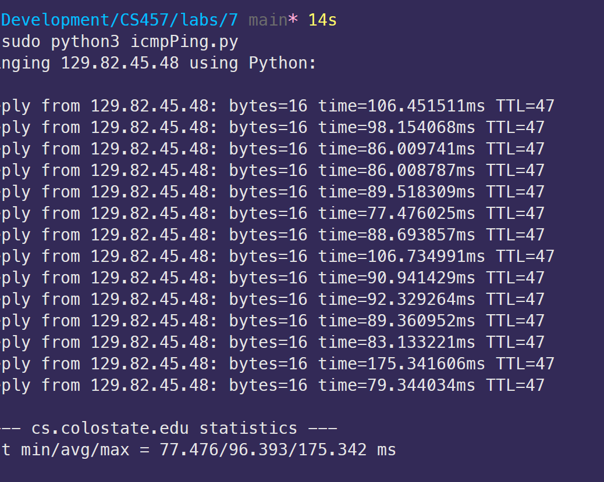
Google.com
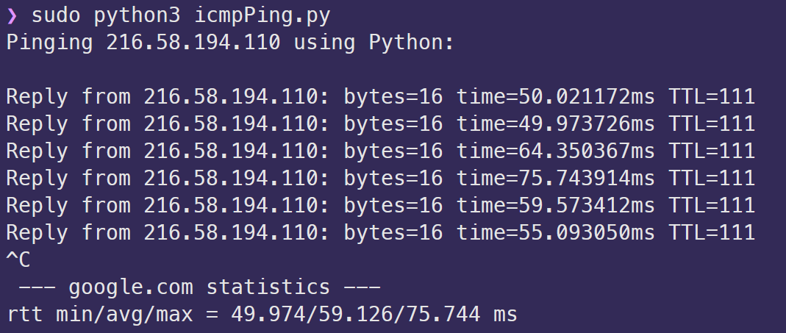
Screenshots per assignment
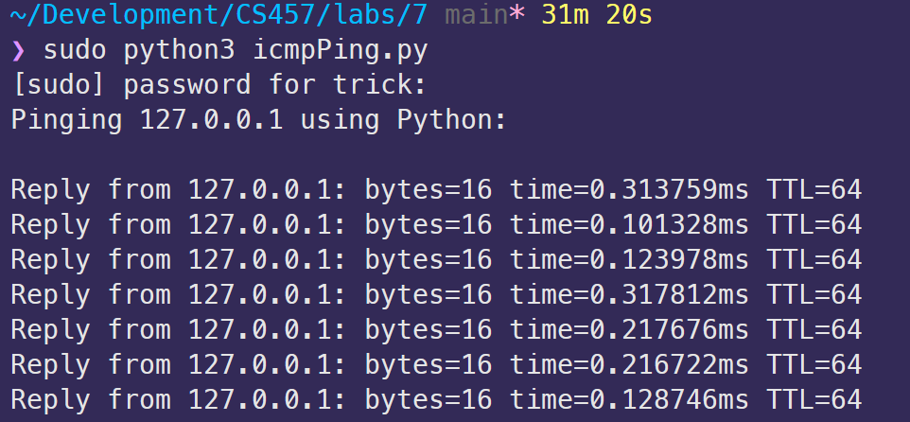
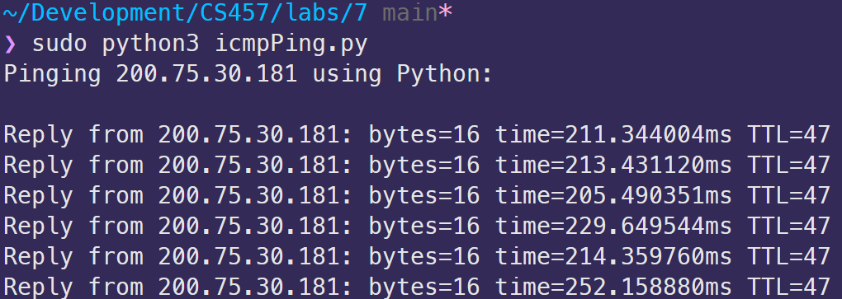
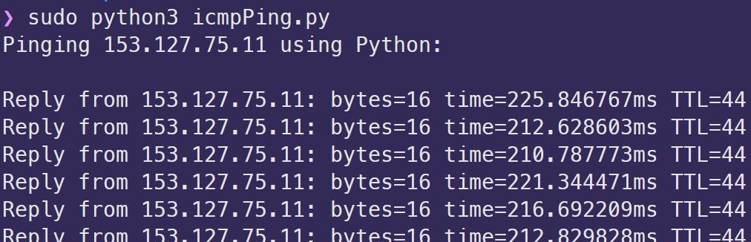
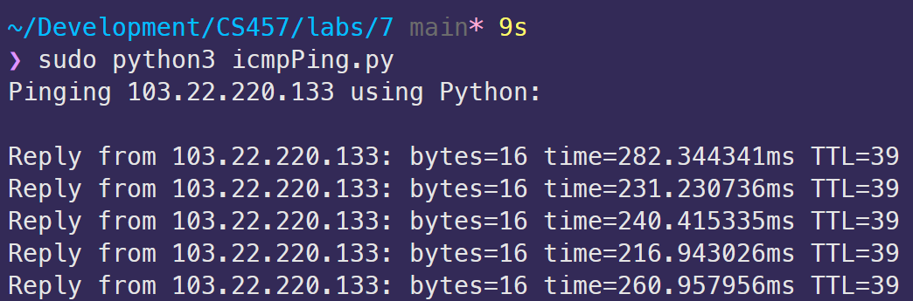
Approximately how much longer does it take to do a round-trip ping from/to a remote machine than from/to localhost? (Note, answers may vary if you are doing the experiment from your home or from the CS building itself and whether the destination is in North America or some other continent).

It takes approximately 210ms longer to do a round trip to a remote machine compared to localhost.

