Nall's Specialized Hauling
Driver Safety Manual
This manual is a company safety manual aligned with key FMCSA regulations. It is not officially approved or certified by FMCSA; FMCSA does not approve company safety manuals.
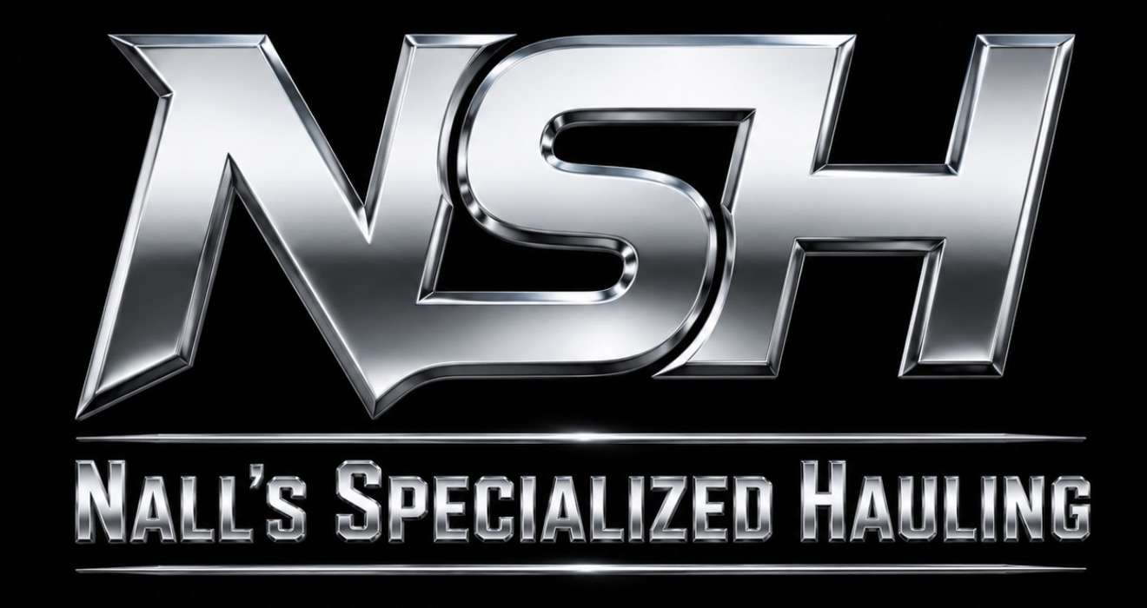

Safety Policy
Safety is the top priority. All drivers must comply with FMCSA regulations, company policies, and customer requirements.

Driver Qualifications
Maintain valid CDL, medical certificate, MVR standards, and required endorsements.

Hours of Service
Comply with HOS rules and use ELDs accurately. No falsification.

Vehicle Inspections
Complete pre-trip, en-route, post-trip inspections and DVIRs. Report defects immediately.

Drug & Alcohol
Follow FMCSA testing requirements. Zero tolerance for prohibited use.

Cargo Securement
Inspect and secure all loads before departure and during transport.

Speed & Distracted Driving
Obey speed limits, wear seat belts, and never use handheld mobile devices while driving.

Accident Reporting
Protect the scene, notify emergency services if needed, contact dispatch immediately, document with photos and witness information.

Disciplinary Policy
Violations may result in coaching, suspension, or termination depending on severity.

