Assessing Climate-driven Vegetation Change and Reliability of Historical Resurveys in E.C. Manning Provincial Park
Casey Lo
Biol 447 – Principles and Methodology in Biological Research Honours Thesis Introduction
Dr. Jeannette Whitton & Dr. Jeffrey Richards
The University of British Columbia
December 9, 2025

Anthropogenic climate change is rapidly altering the composition, structure, and functioning of ecosystems worldwide. As temperatures rise, plant species are expected to shift their distributions upslope to track suitable habitats, leading to changes in community composition and diversity. Historical vegetation resurveys provide a powerful approach for detecting these long-term changes, but their reliability may be limited by relocation error when non-permanent historical plot locations cannot be precisely re-established. In this study, my team and I resurveyed 52 historical vegetation plots spanning a 680-2130 m elevational gradient in E.C. Manning Provincial Park to quantify vegetation change over the past five decades and to test the influence of relocation error on resurvey studies. Using generalized linear mixed models, I found that species occurrence has changed over time and varies nonlinearly with elevation, with results indicating an average upslope range shift of 63.2 m, driven primarily by herbaceous species, while shrubs and trees showed comparatively limited responses. However, shrubs increased in overall occurrence, suggesting a potential increase in their prevalence within plant communities. To directly test the effects of relocation error, I compared paired resurveys conducted at original (2019), revisited (2025), and intentionally mislocated (2025 Error) plots. Species richness did not differ among treatments, whereas community composition differed between 2019 and both 2025 and mislocated plots, with no differences detected between 2025 and mislocated plots across both abundance-based and presence-absence analyses. These results indicate that while measurable vegetation change has occurred between 2019 and 2025, no difference between exactly relocated and mislocated plots suggest diversity metrics are robust to relocation error. Overall, results suggest that upslope range shifts are occurring in this study system, and estimates of these changes are robust to the level of relocation uncertainty tested here, supporting the use of historical resurveys as reliable tools for detecting and interpreting ecological responses to climate change in mountain systems.

Introduction
Anthropogenic climate change and intensifying human impacts on the environment are having unprecedented effects on the survival and health of species and ecosystems worldwide. Current climate projections suggest that due to these impacts, between one-sixth and one-third of species on Earth could face extinction within the next half century (Urban, 2024; Wiens & Zelinka, 2024), while growing empirical evidence has already documented species extinctions directly linked to climate change (Wiens, 2016). Beyond the threat of extinction, climate change is transforming ecosystems at an alarming rate, altering community composition, structure, and functioning globally (Parmesan, 2006). Among the systems most sensitive to climate change are mountainous regions, where the rate of temperature change is amplified due to higher altitudes (Pepin et al., 2015; Rangwala & Miller, 2012), causing shifts in seasonal weather patterns and reductions in snow cover at lower elevations (IPCC, 2019). These changes alter abiotic conditions and biotic interactions, forcing species to respond to rapidly changing environmental conditions. Some well-known responses include adaption, acclimatization to new climates, or the shifting of geographic ranges to track suitable habitats. However, the rate of current climate change likely exceeds the capacity for evolutionary adaptation in many species, particularly long-lived plants, making range shifts the most immediate response for persistence under warming conditions (Hoffmann & Sgrò, 2011; Jump & Peñuelas, 2005; Parmesan, 2006). Tracking these shifts therefore provides an essential understanding of the pace and direction of ecological responses to climate change, particularly for montane plant communities most at risk.
Vegetation Responses to Climate Change
Climate has been shown to be a primary driver of global vegetation patterns and distributions (Pearson & Dawson, 2003; Woodward & Williams, 1987). Because species can vary in their tolerance to temperature, precipitation, and other climate variables, climate change is altering the relative suitability of their current habitats. It is presumed that as temperatures are warming globally, the ideal temperature range of species shifts higher in elevation and polewards in latitude. For example, as lower-elevation environments warm, species adapted to those climatic conditions may shift their ranges upwards, while high-elevation species are forced to retreat upwards to increasingly smaller high elevation areas (Lenoir et al., 2008). This redistribution of species can impact both local abundance and diversity, while changing the overall composition of mountain vegetation.
One type of change in community composition is referred to as thermophilization, which occurs when communities become increasingly dominated by warm-adapted plant species at the expense of colder-adapted species. This shift in community composition is a signal that communities are rearranging themselves to track climatically suitable habitats which can create a cascade of consequences such as altered ecosystem processes, species interactions, and behaviours for the flora and fauna reliant on them. For these reasons, tracking thermophilization of communities has become increasingly important for measuring community responses to climate change, with several studies documenting its occurrence in mountain systems worldwide (Gottfried et al., 2012; Rumpf et al., 2018; Steinbauer et al., 2018).
Despite the well-documented evidence of directional species-specific and community responses to climate change, an alarming number of studies have reported a lack of any response to change, otherwise known as stasis (Lenoir et al., 2010; Pauli et al., 2012; Telwala et al., 2013). Stasis may be driven by microclimate buffering, biotic responses such as phenotypic plasticity, or dispersal limitations that prevent or delay a species ability to track suitable habitat. For instance, local microclimate buffering from dense tree canopies can create refuge and cooler conditions that dampen the effects of warming (De Frenne et al., 2013). Moreover, phenotypic plasticity, or the ability of a species to acclimatize to changing conditions, may buffer species’ immediate need to adapt to change (Jump & Peñuelas, 2005). While these conditions may negate a species’ need for an immediate response to climate change, their buffering capacity is finite. A lack of measurable response does not necessarily indicate immunity to climate change, but rather a delayed response that may become evident once those limits are exceeded (CITE). The case of dispersal limitations is particularly concerning for long-lived and slow-growing species such as trees or perennial plants who are limited by slow demography and the rate at which they are able to disperse and migrate with climate change (Zani et al., 2023). Upslope or poleward colonization and dispersal may also be limited by the inability of migrants to outcompete already-established species, despite these areas being more climatically suitable (Bjorkman et al., 2017). Regardless of the driving force behind stasis, the inability to respond to unsuitable conditions has future and immediately implied fitness consequences on plant survival and performance, emphasizing the importance of identifying where it is occurring.
Historical Vegetation Resurveys as Tools for Detecting Change
Given the diversity of potential responses to climate change, understanding how species and communities are responding regionally is essential from a conservation standpoint. However, because plants can grow slowly and detectable changes may take years, or even decades to occur, waiting for visible responses to assess climate impacts is neither efficient nor sufficient for informing conservation policies under the current rate of climate change. Consequently, data collected from historical vegetation surveys provide invaluable baselines for interpreting long-term ecological change. Often originally collected for the purpose of making maps or identifying areas for forestry, historical survey data of species presence and abundances at given locations can be repurposed to measure vegetation change that has occurred through time due to recent climate change. Vegetation resurveys, where researchers revisit sites originally surveyed years or decades earlier, provide robust evidence for ecological responses to climate change (Vellend et al., 2013). By resurveying historical plots, scientists can directly measure changes in community composition, diversity, and species geographic ranges through time, overcoming the temporal limitations of short-term studies, and allowing us to better predict future responses and impacts of climate change.
Several classic resurvey studies have demonstrated significant trends in upward shifts in species’ elevational ranges (Wilson et al., 2024), thermophilization of communities (Merle et al., 2020), and cases of stasis (Pauli et al., 2012) from regions worldwide. However, there are several caveats associated with resurvey studies such as plot relocation uncertainty, inconsistent sampling methods, surveyor bias from accuracy or effort, and temporal or environmental variability that may affect the ability to detect and interpret true change. These methodological limitations can introduce error or bias into estimates of ecological change, highlighting the need for careful data interpretation, standardized protocols, and multiple lines of evidence when attributing observed changes to climate.
Methodological Uncertainty: The Problem with Relocation Error
Aforementioned, a key limitation of vegetation resurvey studies is plot relocation error, which arises when present day researchers are unable to precisely re-establish the exact location of historical semi-permanent plots. Such discrepancies could be caused by a lack of precise historical coordinates or inaccurate GPS, as many historical surveys relied on descriptive field notes, hand-drawn maps, or compass bearings before handheld GPS units became commercially available in 1989 (Kapfer et al., 2016). Relocation error, thus, introduces the risk of pseudo-turnover, where apparent species gains or losses (i.e turnover) are artifacts of sampling error rather than true ecological change.
To date, only three studies have explicitly tested the robustness of resurveys to relocation error, and the results are mixed (Boch et al., 2019; Kopecký & Macek, 2015; Verheyen et al., 2018). Kopecký and Macek (2015) compared “exact” and “approximate” resurveys in temperate forests and found that diversity metrics, such as species richness, composition, and turnover were largely robust to relocation error, suggesting that moderate relocation error does not significantly bias long-term vegetation trend assessment. In contrast, Boch et al. (2019) demonstrated that while ecological indicators (measurable environmental conditions like soil moisture or light availability) are robust to GPS inaccuracy, species turnover increased significantly with relocation error, suggesting species compositional metrics are more sensitive to spatial uncertainty. Similarly, Verheyen et al. (2018) showed that turnover estimates in semi-permanent forest plots were inflated when compared to permanent plots, again suggesting the potential influence of pseudo-turnover in resurvey studies.
Despite its recognized importance, relocation error remains an underexplored aspect of resurvey methodology. Most studies assume that spatial uncertainty averages out across many plots or that its influence is minor compared to genuine ecological change. However, this assumption has rarely been tested empirically, particularly in mountainous regions. A more rigorous understanding of relocation error is critical to ensure that long-term resurvey datasets are interpreted with confidence.
Regional Context: Vegetation Change in E.C. Manning Provincial Park
E.C. Manning Provincial Park, located in the southern interior of British Columbia and between the coastal and coastal-interior transition zones, spans elevations from roughly 400 to 2,300 m. This large elevational gradient makes it an ideal system for examining elevational trends and vegetation responses to climate change. Over the last five decades alone, the mean annual temperature in Manning Park has risen by approximately 1.54 °C (ClimateNA, 2024), and warming had been most pronounced in the winter, leading to earlier snowmelt, longer growing seasons, and changing moisture regimes (British Columbia Ministry of Environment, 2016). Such changes are expected to alter the composition of mountain plant communities by favouring warm-adapted species and driving species’ ranges upslope.
Historical vegetation surveys conducted in Manning Park between 1976 and 2019 provide a rare multi-decade record of community composition in a mountainous protected area and provincial park. This legacy data forms a baseline for present-day resurveys to assess how vegetation has changed through time and across elevation gradients.
Study Overview and Hypotheses
In 2025, I resurveyed 52 historical vegetation plots in E.C. Manning Provincial Park to evaluate long-term vegetation change and test the effects of relocation uncertainty. To assess elevational change, I examined whether species occurrence across plots varied with elevation through time, allowing for the detection of shifts in species distributions along the elevational gradient. To assess relocation error, each 2019 plot was resampled twice, once at its original coordinates and once at a nearby, intentionally relocated site with similar slope, aspect, and community type. These 2019 sites were selected because their recent survey date and high GPS accuracy allowed for confident relocation, while also providing a short temporal window (six years) over which minimal ecological change is expected. This created a baseline against which relocation error could be evaluated. Specifically, differences between 2019 and mis-relocated 2025 plots were compared to differences between 2019 and accurately relocated 2025 plots. If these differences were not significantly greater, this would suggest that resurvey-based estimates of vegetation change are robust to the level of relocation uncertainty tested. This paired design replicates relocation uncertainty when the exact location of a historical semi-permanent site is unknown (i.e. a site from the 1970s surveyed prior to the creation of handheld GPS units), allowing me to test which diversity metrics are most robust to relocation error. By quantifying both ecological change and methodological bias, this study provides insight into long-term vegetation dynamics in Manning Park and offers methodological guidance for future resurvey projects. This research addresses the following questions:
- How have plant communities in E.C. Manning Provincial Park responded to climate change over the past five decades?
- How robust are estimates of vegetation change to relocation error?
I hypothesize that warming has driven upslope range shifts across the park’s elevational gradient as species redistribute to track suitable habitat. Furthermore, I expected that mis-relocated 2019 plots would show greater apparent species turnover compared to exactly relocated plots due to pseudo-turnover introduced by spatial misplacement. However, because this analysis was exploratory, no strong a priori hypotheses were made regarding the magnitude of this effect or the sensitivity of different diversity metrics to relocation error.
Methods
During the months of May to August 2025, my co-supervisor, Rachel Wilson, and I resurveyed 52 semi-permanent historical vegetation plots originally sampled in 1976, 1979, 1993, 2000, 2007, 2015, and 2019 across E.C. Manning Provincial Park (MAP FIGURE). Historical data were obtained from British Columbia’s Ministry of Forests Biogeoclimatic Ecosystem Classification (BEC) database. These data were collected under different projects and by different surveyors in each survey year, apart from 1976 and 1979, which were conducted by the same project group (SUP TABLE WITH PROJECTIDS AND N OF SURVEYS). Sites spanned an elevation range of 600m-2100m, making them an ideal study system for detecting elevational range shifts. Additionally, climate models estimated an increase of ~XX℃ in mean annual temperature and a XX change in precipitation since the earliest surveys in 1976 (ClimateNA, Wang et al. 2015).
Relocation Protocol
Historical plot centers were relocated using Global Positioning System (GPS) coordinates with a Garmin inReach 66i device. Latitude, longitude, and elevation for each site were obtained from the BEC database, along with descriptive site features recorded by the original surveyors such as percent slope, slope aspect, community composition, and site notes. Because latitude and longitude were provided for sites surveyed before 1989, when handheld GPS devices became commercially available, it is likely that earlier coordinates were translated from mapped locations and later entered into the database. For these reasons, plot locations prior to 1989 may have the lowest GPS coordinate accuracy across all sites surveyed in this study. Even for sites surveyed after this period, older GPS units tend to be less accurate, meaning coordinates from earlier survey years are generally less precise (CITE???). For example, reported coordinate accuracy in the BEC database improved from approximately 100 m in earlier surveys (~2000) to 7 m in more recent surveys (2019).
Given these limitations, plot centers were not relocated based on GPS coordinates alone. Upon arrival at the coordinates provided, we made informed plot relocation decisions based on all site descriptions provided by the original surveyors. Often, plot centers were shifted to better match site descriptions such as the percent slope, slope aspect, tree composition, and surveyor notes. We inferred that the site descriptions often allowed us to relocate plot centers with more accuracy than the coordinates alone, given it is known they can vary in accuracy. In a few instances, plots were relocated several hundred meters away from the coordinates provided based on exact relocation directions left by the original surveyors (see XX in the supplementary). To measure our own relocation confidence, we reported how confident we were that we accurately relocated sites based on how well our site matched the original location coordinates and site descriptions. Despite some relocation uncertainty, the majority of plots were confidently relocated and plot centers were on average ~19 metres away from exact original coordinates provided (see supplementary). However, as I only use older historical sites (pre-1989) for the component of the study assessing changes in species’ elevational distributions, and not plot-by-plot comparisons, relocation uncertainty in unlikely to impact my results (Kopecký and Macek 2015). I explicitly test the effects of relocation error in the second component of this thesis.
Field Surveying Methods
All surveying methods followed the protocol outlined in the BEC Field Survey Guide, which has remained unchanged between the 1991 and 2010 publications (CITE). To ensure the protocol was interpreted correctly, we interviewed Provincial BEC Ecologist, Heather Klassen, and confirmed our methods. Additionally, Courtney Collins, a former BEC surveyor, assisted with field surveys at several sites to verify that our techniques aligned with the BEC field protocol.
After establishing plot centers, 20.0 m × 20.0 m plots were set up along the slope aspect using a compass and an electronic sonar distance-measuring device (Sonin xxxx). From the plot center, we measured 10.0 m upslope and placed flags at 10.0 m intervals, creating four quadrats within each plot (Figure 2). Site features were recorded using an inclinometer and compass, and detailed site descriptions were documented, including location, community composition, plant condition, disturbances, and any relocation reasoning if plot centers were adjusted.
We began surveying by traversing the full plot and identifying all tree, shrub, and herb species present. Species were recorded using standardized Latin names and BEC species codes (four-letter genus and three-letter species abbreviations) to be directly comparable to the original survey data and consistent with provincial standards (British Columbia Ministry of Forests, 2025). Unknown species were photographed and given a temporary name until they could be identified later. To better estimate percent cover, we estimated cover for each species within each of the four quadrats and then averaged these values across the full plot. Within each quadrat, percent cover was recorded in 1% intervals for values greater than 1%, while cover between 0-1% was estimated with 0.1% precision.
Grasses, mosses, and lichens were not identified to the species level, and instead, their cover was recorded as functional groups (one for grasses and one for mosses and lichens). Analysis of functional groups was beyond the scope of this thesis and therefore not analyzed. Analysis of tree height data was also not included in analysis; however, tree cover was estimated by species within three height classes: A2 (>10 m), B1 (2–10 m), and B2 (<2 m). Tree heights were measured using a hypsometer (TruPulse 200X). Tree cover used in analysis was then derived by adding the cover for each species present across its height classes. Lastly, total tree canopy cover across all species was estimated within each quadrat and averaged to the plot level.
Field surveying methods for 2019 sites
Field surveying methods for 2019 sites followed the same protocol described above, with one modification to reduce sampling time. Percent cover was estimated in two of the four quadrats, selected diagonally across the full plot, rather than all four (Figure X). All species presences were still recorded by traversing the full plot; however, if a species was observed outside of the sampled quadrats, it was assigned a cover value of 0.1% in the field. Cover estimates from the two sampled quadrats were then averaged and extrapolated to represent the full plot. During analysis, any species with cover values less than 1% were adjusted to 1% to match the lowest cover class used in the 2019 surveys.
To assess relocation error, an additional “Error” plot was established at each of the sites originally surveyed in 2019 during the 2025 resurveys. Error plots were intentionally located away from the original plot center, while still matching the same general site conditions. At each site, we selected the furthest possible location from the estimated true plot center that maintained similar percent slope gradient, slope aspect, elevation, and overall community composition, based on the original site descriptions. This approach was used to simulate realistic relocation uncertainty, where a surveyor may misidentify the exact plot location while still matching key environmental and site features. Error plots were therefore designed to represent a worst-case, yet plausible, relocation scenario under typical field conditions.
Statistical analyses
All statistical analyses were conducted in R (version 4.5.3). Analyses were divided into two main components: (1) an analysis detecting changes in species presence across elevation and through time, and (2) an analysis evaluating the effects of relocation error on community composition and diversity metrics. To assess elevational change, I modelled species presence (binary; derived from observed cover >0) as a function of time and elevation using generalized linear mixed-effects models (GLMMs). Model selection was conducted using Akaike Information Criterion (AIC) to identify the best fitting and most parsimonious model structure. To evaluate relocation error, I compared the community composition among three treatments: 2019, 2025, and mis-relocated (“Error”) plots using both abundance-weighted (Bray-Curtis) and presence-absence (Jaccard) dissimilarities. Differences among treatments were assessed using permutational multivariate analysis of variance (PERMANOVA). In addition, species diversity (Shannon and Simpson indices) was compared among treatments using non-parametric tests.
Detecting upslope range shifts and model selection
To quantify changes in species’ distributions, I modelled species presence as a function of elevation and time. To ensure enough data was collected for each species and to reduce the influence of rare species and potential sampling error, analyses were restricted to the 30 most common species observed across historical and 2025 survey data. Species were only retained if they had a combined minimum of 20 occurrences across both survey periods and at least 7 occurrences in one of the two periods.
An initial modelling approach treated survey year as a continuous variable and included all available survey years (1976–2019) along with paired resurveys conducted in 2025 (results are reported in the supplementary). However, a significant correlation between survey year and elevation was detected (see Supplementary), indicating that sampling across years was not evenly distributed along the elevational gradient. Because of this correlation, it would have been impossible to parse apart the effect of sampling year and elevation from a change in species presence over elevation attributed to ecological change. Instead, for the final analysis, a subset of 34 of the total historical sites surveyed in 2000 and earlier were grouped together as “historical,” and compared to their paired resurveys in 2025 (“present”) to break the survey year and elevation correlation. This ensured that comparisons were made within the same sites across time.
Generalized linear mixed-effects models with a binomial distribution were used to model species presence using the glmer() function from the lme4 package in R. All candidate models included the main hypothesis of interest, testing whether the probability of species presence changed over time as a function of elevation through time, using a both a linear and quadratic term for elevation:
Present ~ Time * (Elevation² + Elevation)
A set of 26 candidate models were constructed to evaluate different random effects and covariate model structures (SUPPLEMENTARY). Random effects structures included species-specific responses to elevation, as well as intercept-only effects for grouping variables such as Plot Number (the unique plot identification ID), Project ID, and Site Surveyor. Latitude and longitude were also evaluated as fixed effects and all numerical variables (latitude, longitude, and elevation) were centered and scaled. Models were compared using Akaike Information Criterion (AIC), and models with a ΔAIC < 2 were considered to have equivalent support (Burnham & Anderson 2002). The final model was selected as the most parsimonious model among those with the lowest AIC. The selected model included species-specific random slopes for elevation, a random intercept for Plot Number, and latitude as a fixed effect:
Present ~ Time × (Elevation² + Elevation) + Latitude + ((Elevation² + Elevation) | Species) + (1 | Plot Number)
As sites in E.C. Manning Park were non-randomly distributed, Moran’s I test was conducted to assess potential spatial autocorrelation in model residuals and ensure that any observed patterns were not driven by underlying spatial clustering of sites. Additionally, two additional sensitivity analyses were performed on the final model by removing plots with low and medium relocation confidence to evaluate whether uncertainty in plot relocation influenced model outcomes.
Table X. Best fitting GLMM structure and fit of the categorical time model.
Response variable | Model type | Fixed effects | Random effects | Observations (n) | Species (n) | Plots (n) | AIC
Species presence | GLMM (binomial, logit) | Time × (Elevation + Elevation²) + Latitude | (Elevation + Elevation² | Species) + (1 | Plot) | 2040 | 30 | 34 | 2154.8

Lastly, functional group (whether species were an herb, a shrub, or a tree) was not included in the main model selection process, as it was not part of the primary hypothesis. However, as a post-hoc analysis, a three-way interaction between time, elevation, and functional group was added to the final model:
Present ~ Time × (Elevation² + Elevation) × Functional group + Latitude + ((Elevation² + Elevation) | Species) + (1 | Plot Number)
Because this addition did not change model fit (ΔAIC < 2), results were interpreted to assess whether different functional groups contributed differently to observed patterns.
Table X. Best fitting GLMM structure and fit of the categorical time model with a functional group interaction.
Response variable | Model type | Fixed effects | Random effects | Observations (n) | Species (n) | Plots (n) | AIC
Species presence | GLMM (binomial, logit) | Time × (Elevation + Elevation²) × Functional_group + Latitude | (Elevation + Elevation² | Species) + (1 | Plot) | Total: 2040  Herb: 748  Shrub: 884  Tree: 408 | 30 | 34 | 2156.2

Relocation Error Analyses
To assess the effect of relocation uncertainty on community-level inference, I compared vegetation composition among three treatments: the original 2019 plots, accurately relocated 2025 plots, and mis-relocated 2025 “Error” plots. Analyses were conducted using both abundance-weighted (Bray-Curtis) and presence-absence (Jaccard) dissimilarity metrics. Permutational multivariate analysis of variance (PERMANOVA) was used to test for differences in community composition among treatments, with site included as a stratification factor to account for the paired study design. Dissimilarity calculations and homogeneity of multivariate dispersion were assessed using the vegan package in R, with dispersion tested using the betadisper() function to ensure that significant results were not driven by differences in dispersion among groups. To further examine differences among treatments, pairwise PERMANOVA comparisons were conducted between all treatment combinations (2019 vs 2025, 2019 vs Error, and 2025 vs Error) using the pairwiseAdonis package. Within-site dissimilarities were calculated and compared using paired statistical tests.
Species diversity was compared among treatments using Shannon and Simpson diversity indices. The Shannon index incorporates both species richness and evenness, giving more weight to rare species, whereas the Simpson index emphasizes the dominance of common species within a community. Comparing these indices will allow me to identify if relocation error is more sensitive or robust to the influence of rare species. Diversity was calculated at the plot level and averaged within sites. Differences among treatments were assessed using Friedman tests, with site treated as a blocking factor to account for the paired study design, followed by post-hoc pairwise comparisons.
Results
Changes in species occurrence across elevation
In agreement with the hypothesis of upslope range shifts, species across E.C. Manning Provincial Park exhibited a significant upslope shift in their elevational distributions between historical and present surveys (Figure X). This was supported by the model with a significant interaction between time and elevation (β = 0.352, p = 0.016; Table X), indicating that species occurrence increased in elevation over time. On average, species experienced an upslope range shift of 63.2 m, calculated by the difference in the peak probability of occurrence between historical surveys and 2025 surveys (Figure X). However, there was no significant interaction between time and quadratic elevation, indicating that the shape of species’ elevational distributions remained consistent through time (β = −1.239, p < 0.001; Table X). Furthermore, across species, the probability of occurrence increased significantly through time (β = 0.530, p = 0.000891; Table X).
Without an interaction of time, species occurrence across sites tends to be strongly shaped by elevation and latitude. The significant quadratic effect of elevation on species presence indicates that species exhibit a unimodal (hump-shaped) distribution across the elevation gradient (β = −1.239, p < 0.001; Table X). In contrast, the linear effect of elevation was not significant, suggesting no consistent directional increase or decrease in occurrence across the elevational gradient sampled (β = −0.267, p = 0.432; Table X). Lastly, latitude had a significant positive effect on occurrence, suggesting that species presence also varied systematically with latitude (β = 0.740, p < 0.001; Table X).
Model diagnostics indicated that assumptions were met as there was no evidence of overdispersion (dispersion ratio = 1.021, p = 0.60) and residual diagnostics showed no deviation from uniformity or excess outliers (Supplementary). Tests for spatial autocorrelation were not significant (Moran’s I = −0.086, p = 0.80), indicating that residuals were spatially independent and that spatial structure was adequately accounted for in the model.
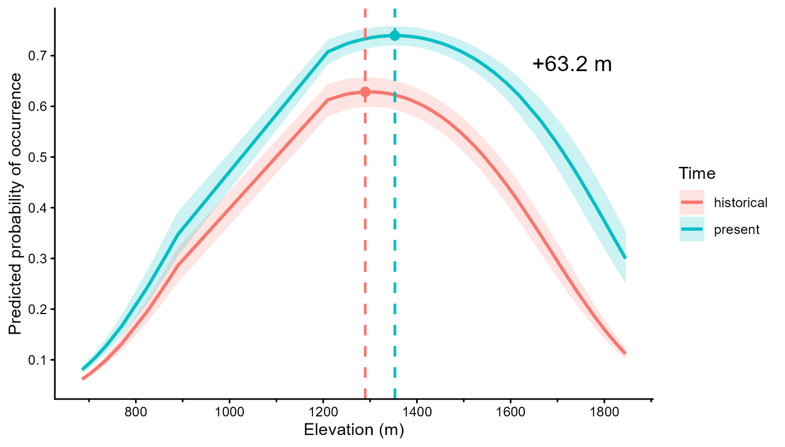
Figure X. Predicted probability of species occurrence across the elevational gradient from the categorical generalized linear mixed model, generated using ggpredict. Curves show predictions at the historical time point (1976-2000, red) and the present time point (2025, blue). The shaded areas represent the 95% confidence intervals. Points and dashed lines indicate the elevation of the peak predicted probability of occurrence for each time point (+63.2 m).

Table X. Fixed effects from the GLMM for the best categorical time model. BEC data from 1976-2000 have been binned together as “historical” data and compared to their paired 2025 resurveys.
Predictor | Estimate | Std. Error | z value | p-value
Intercept | 0.512 | 0.266 | 1.926 | 0.0541 .
Time (present vs past) | 0.530 | 0.160 | 3.323 | 0.000891 ***
Elevation | -0.267 | 0.340 | -0.786 | 0.432
Elevation² | -1.239 | 0.198 | -6.244 | <0.001 ***
Latitude | 0.740 | 0.190 | 3.897 | <0.001 ***
Time × Elevation | 0.352 | 0.147 | 2.400 | 0.016 *
Time × Elevation² | 0.122 | 0.139 | 0.881 | 0.378

Functional group differences in elevational change
In the model including the functional group interaction, patterns of change through time varied among functional groups with herb species showing the strongest evidence of upslope range shifts (Figure X). Herb species exhibited a significant relationship between occurrence and elevation through time (β = 0.807, p = 0.0019; Table X), with an estimated increase of 139.6 m between historical and present surveys (Figure X). In contrast, there was no significant change in the elevational distribution of shrubs (β = 0.091, p = 0.673; Table X) or trees (β = 0.050, p = 0.880; Table X), showing much smaller estimated upslope changes of 14.8 m and 36.3 m, respectively (Table X; Figure X).
While shrubs did not exhibit significant range shifts, the overall probability of occurrence increased significantly through time (β = 0.674, p = 0.0056; Table X), while increases for herbs were marginal (β = 0.463, p = 0.069; Table X) and not significant for trees (β = 0.267, p = 0.474; Table X).
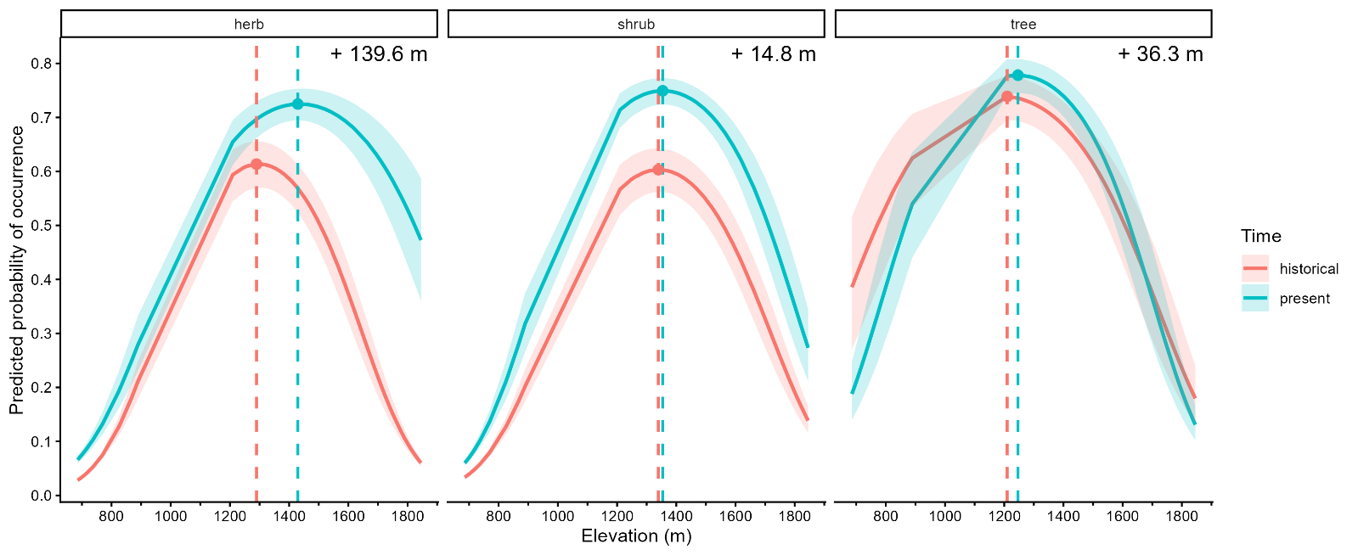
Figure X. Predicted probability of species occurrence across the elevational gradient from the categorical generalized linear mixed model separated by functional group, generated using ggpredict. Curves show predictions at the historical time point (1976-2000, red) and the present time point (2025, blue). The shaded areas represent 95% confidence intervals. Points and dashed lines indicate the elevation of maximum predicted occurrence for each time point.

Table X. Fixed effects from a binomial GLMM testing changes in species occurrence across time (historical vs. present), elevation (linear and quadratic), and functional group for the full model. Coefficients are on the logit scale and relative to herb species and the historical time period.
Predictor | Estimate | Std. Error | z value | p-value
Intercept | 0.445 | 0.382 | 1.164 | 0.244
Time (present vs historical) | 0.463 | 0.255 | 1.817 | 0.069 .
Elevation | -0.333 | 0.530 | -0.628 | 0.530
Elevation² | -1.530 | 0.298 | -5.135 | <0.001 ***
Shrub (vs herb) | -0.026 | 0.471 | -0.055 | 0.956
Tree (vs herb) | 0.465 | 0.596 | 0.781 | 0.435
Latitude | 0.767 | 0.195 | 3.940 | <0.001 ***
Time × Elevation | 0.805 | 0.259 | 3.104 | 0.0019 **
Time × Elevation² | 0.611 | 0.240 | 2.545 | 0.0109 *
Time × Shrub | 0.211 | 0.351 | 0.600 | 0.549
Time × Tree | -0.196 | 0.452 | -0.434 | 0.664
Elevation × Shrub | 0.345 | 0.678 | 0.509 | 0.611
Elevation² × Shrub | 0.270 | 0.357 | 0.755 | 0.450
Elevation × Tree | -0.339 | 0.841 | -0.404 | 0.686
Elevation² × Tree | 0.679 | 0.440 | 1.542 | 0.123
Time × Elevation × Shrub | -0.715 | 0.332 | -2.155 | 0.031 *
Time × Elevation² × Shrub | -0.581 | 0.317 | -1.833 | 0.067 .
Time × Elevation × Tree | -0.754 | 0.416 | -1.812 | 0.070 .
Time × Elevation² × Tree | -1.005 | 0.392 | -2.562 | 0.010 *

Table X. Pairwise contrasts of elevational trends between time periods (historical and present) within each functional group using emtrends().
Functional group | Contrast | Estimate | Std. Error | p-value
Herb | Historical - Present | -0.807 | 0.260 | 0.0019
Shrub | Historical -Present | -0.091 | 0.215 | 0.673
Tree | Historical -Present | -0.050 | 0.329 | 0.880

Table X. Pairwise contrasts of trends in probability of occurrence between time periods (historical and present) within each functional group using emmeans().
Functional group | Contrast | Estimate | Std. Error | p-value
Herb | Historical - Present | -0.463 | 0.255 | 0.069
Shrub | Historical -Present | -0.674 | 0.243 | 0.0056
Tree | Historical -Present | -0.267 | 0.374 | 0.474

Effects of relocation error on community composition metrics
Community composition differed significantly among treatments (2019, 2025, and Error plots) in the overall PERMANOVA for both the abundance-weighted Bray-Curtis dissimilarity and the presence-absence based Jaccard dissimilarity. Although these effects were statistically significant, the proportion of variance explained by treatment was low for both metrics. Under Bray-Curtis dissimilarity, treatment explained 4.1% of the variation in community composition (F = 0.511, R² = 0.0408, p = 0.0004; Table X), whereas Jaccard dissimilarity explained 4.3% of the variation (F = 0.535, R² = 0.0427, p = 0.0005; Table X).
Pairwise PERMANOVA comparisons showed that community dissimilarity was driven by differences between 2019 plots and both 2025 and Error plots, while 2025 and Error plots did not differ from one another. Under Bray-Curtis dissimilarity, community composition differed between 2019 and 2025 plots (F = 0.574, R² = 0.0346, p = 0.0039) and between 2019 and mislocated plots (F = 0.760, R² = 0.0453, p = 0.0039), whereas no difference was detected between 2025 and Error plots (F = 0.195, R² = 0.0121, p = 0.7305; Table X). The same pattern was observed using Jaccard dissimilarity. Community composition differed between 2019 and 2025 plots (F = 0.653, R² = 0.0392, p = 0.0078) and between 2019 and Error plots (F = 0.790, R² = 0.0470, p = 0.0039), while 2025 and Error plots did not differ (F = 0.142, R² = 0.0088, p = 0.8398; Table X).
Visualizations of these dissimilarities across both metrics, using NMDS, show that within sites, 2025 plots were typically displaced from their corresponding 2019 plots. Error plots showed similar magnitudes and directions of displacement from 2019 plots as the 2025 resurveys, and in many cases were positioned close to the 2025 plots in ordination space (Figures X and X). Across both ordinations, 2025 and Error plots tended to shift away from 2019 plots toward the center of the ordination space.
Table X. Results of permutational multivariate analyses of variance (PERMANOVA) testing for differences in plant community composition among treatments using both Bray-Curtis dissimilarity and Jaccard dissimilarity. Analyses were stratified by site to account for the paired sampling design.
Dissimilarity | Source | Df | R² | F | p-value
Bray-Curtis | Treatment | 2 | 0.040 | 0.500 | 0.0007 **
 | Residual | 24 | 0.960 | — | —
Jaccard | Treatment | 2 | 0.041 | 0.513 | 0.0007 **
 | Residual | 24 | 0.959 | — | —

Table X. Pairwise PERMANOVA comparisons of community composition among treatments using both Bray–Curtis and Jaccard dissimilarities.
Dissimilarity | Comparison | R² | F | p-value
Bray–Curtis | 2019 vs 2025 | 0.034 | 0.557 | 0.0039 **
 | 2019 vs Error | 0.044 | 0.745 | 0.0078 **
 | 2025 vs Error | 0.012 | 0.195 | 0.7305
Jaccard | 2019 vs 2025 | 0.037 | 0.616 | 0.0078 **
 | 2019 vs Error | 0.045 | 0.760 | 0.0039 **
 | 2025 vs Error | 0.009 | 0.142 | 0.8398

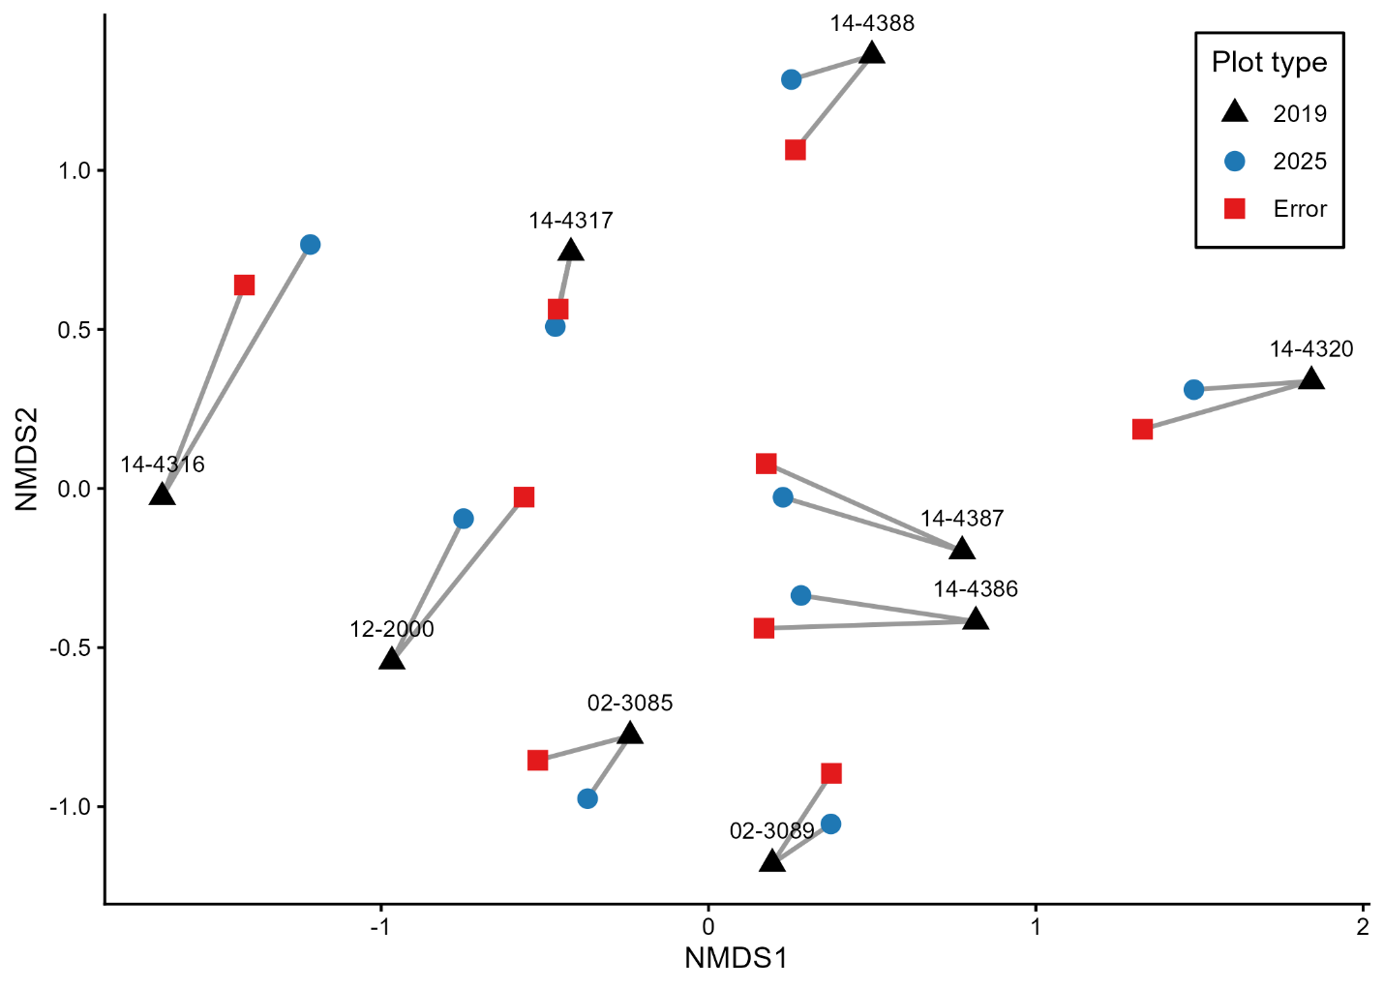

Figure X. Non-metric multidimensional scaling (NMDS) ordination of plots based on Bray-Curtis dissimilarity. Points represent plots, colours and shapes indicate treatment, and grey lines connect plots from the same site. Stress = 0.117.
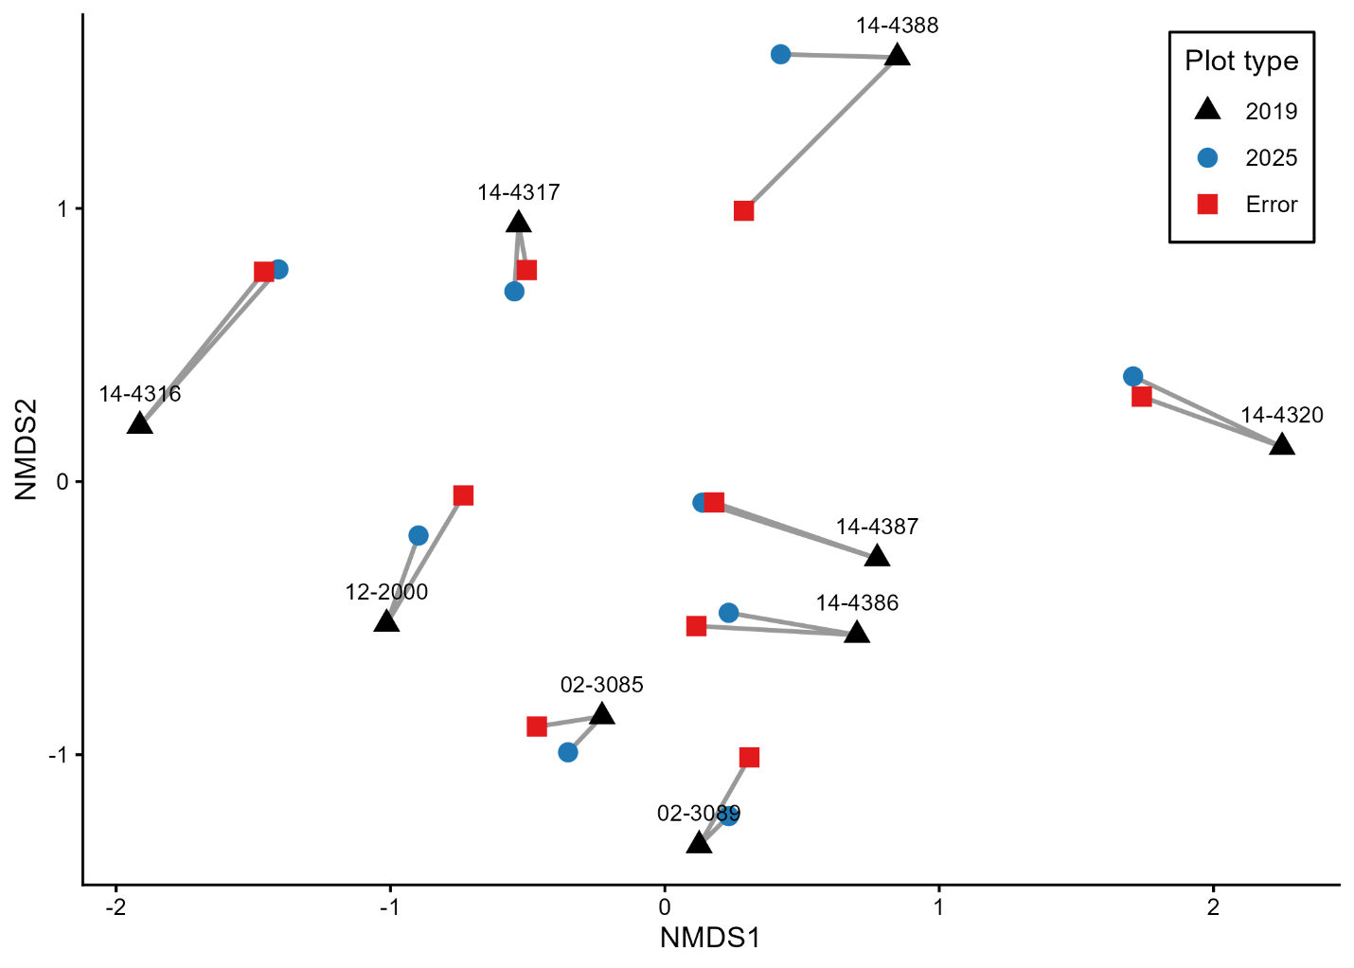

Figure X. NMDS ordination of plots based on Jaccard dissimilarity. Points represent plots, colours and shapes indicate treatment, and grey lines connect plots from the same site. Stress = 0.090.

Effects of relocation error on species richness indices
In contrast to patterns in community composition, species richness did not differ among treatments (Table X). Pairwise comparisons showed no differences between any treatment combinations (2019 vs 2025: p = 0.3738; 2019 vs Error: p = 0.2349; 2025 vs Error: p = 0.6725). Similarly, diversity indices did not vary among treatments. Shannon diversity showed no effect of treatment (Friedman test: χ² = 0.667, p = 0.7165), and Simpson diversity was also not affected (χ² = 2.667, p = 0.2636; Table X).

Table X. Differences in species richness, Shannon’s diversity, and Simpson’s diversity among treatments (2019, 2025, and Error plots).
Metric | Comparison / Test | Statistic | p-value
Species richness | 2019 vs 2025 | V = 14.5 | 0.3738
 | 2019 vs Error | V = 12 | 0.2349
 | 2025 vs Error | V = 14.5 | 0.6725
Shannon diversity | Friedman test (3 treatments) | χ² = 0.667 | 0.7165
Simpson diversity | Friedman test (3 treatments) | χ² = 2.667 | 0.2636

Discussion Outline
1. Overview: Two key findings
- This study provides evidence for both (1) climate-driven vegetation change and (2) robustness of resurvey methods to relocation error.
- Detectable community change occurred even over a short six-year window, while relocation error did not inflate estimates of that change.
  - What else could be driving this?? Is this relocation error???
- Together, these results suggest that early signals of vegetation change are emerging in this system and can be reliably detected using resurvey approaches.
Part I: Ecological responses to climate change
2. Evidence for upslope range shifts, driven by herbs
- Restate main result: significant upslope shift (~63 m overall), with herbs showing the strongest shift (~140 m).
- Interpret:
  - Herbs likely responding more rapidly due to shorter generation times and faster turnover.
  - Consistent with expectations that non-woody species track climate more quickly than woody species.
- Emphasize that shrubs and trees showed limited elevational shifts, uneven response across functional groups.
3. Evidence for shrub increases and potential shrubification
- Key result: shrubs increased significantly in overall occurrence, despite no upslope shift.
- Interpret this as:
  - Early-stage shrubification signal (increase in shrub abundance without clear range shift yet).
- Link to broader literature:
  - Shrubification is commonly observed in warming systems, especially where growing seasons lengthen.
- Your system:
  - Shrubs may be expanding within existing elevational ranges, not yet shifting upslope.
- Important nuance:
  - This differs from herbs, which are shifting distributions rather than simply increasing.
4. Visual evidence from NMDS species overlays
The ordinations help reinforce this interpretation:
- Across both Bray–Curtis and Jaccard ordinations:
  - 2025 and Error plots shift away from 2019 plots in similar directions.
  - Species overlays suggest clustering shifts that include more shrub-associated species in the direction of change.
- Interpretation:
  - Communities may be reorganizing toward greater shrub representation, even if richness remains unchanged.
- Important caveat:
  - This is qualitative/visual evidence, but it aligns with the statistical increase in shrub occurrence.
5. Explaining mixed responses: change + stasis
- Your system shows:
  - Clear change (herbs shifting upslope, shrubs increasing)
  - Simultaneous stasis (trees not shifting)
- Mechanisms:
  - Dispersal limitation (trees)
  - Longevity and slow turnover (woody species)
  - Microclimate buffering (forest canopy)
- Interpretation:
  - These results support the idea that climate responses are lagged and taxon-specific, not uniform.
6. Why composition changed but richness did not
- Key finding: no change in richness, Shannon, or Simpson diversity.
- Interpretation:
  - Species replacement rather than gain/loss
  - Early-stage community reorganization
- Implication:
  - Climate change effects may first appear as compositional turnover, not biodiversity loss.
Part II: Reliability of resurvey methods
7. Relocation error does not bias estimates of change
- Key result:
  - 2025 ≈ Error plots
  - Both differ from 2019
- Interpretation:
  - Differences are not driven by relocation error
  - Indicates robustness of both Bray–Curtis and Jaccard metrics
- Contribution:
  - Direct experimental evidence addressing a major limitation in resurvey studies
8. Unexpected result: detectable change over a short time window
- Prediction:
  - Expected minimal change between 2019 and 2025
- Result:
  - Significant compositional differences detected within ~6 years
- Interpretation:
  - Vegetation may be responding more rapidly than expected
  - OR system experienced a disturbance pulse
9. Potential role of the 2020 heat dome
- Introduce as a plausible driver:
  - Extreme climatic event in British Columbia (2020 heat dome)
- Possible effects:
  - Acute mortality or stress in sensitive species
  - Rapid shifts in competitive dynamics
  - Favoring drought-tolerant or shrub species
- Link to your results:
  - Could explain:
    - Rapid compositional change
    - Increase in shrubs
- Important framing:
  - This is speculative but biologically plausible
  - Suggests that extreme events, not just gradual warming, may drive rapid community change
10. Implications for interpreting resurvey studies
- findings challenge two assumptions:
  - That short-term resurveys cannot detect meaningful change
  - That relocation error strongly biases results
- Instead:
  - Real ecological signals can emerge over short timeframes
  - These signals can be reliably detected despite spatial uncertainty
Synthesis
11. Integrating both storylines
- Vegetation change is occurring:
  - Upslope shifts (herbs)
  - Increasing shrub dominance
  - Community reorganization without richness change
- At the same time:
  - These changes are not artifacts of relocation error
- Interpretation:
  - Your study provides both ecological insight and methodological validation

12. Broader implications
- Mountain ecosystems may already be undergoing subtle but meaningful restructuring
- Shrubification may be an early signal of longer-term vegetation change
- Historical resurveys remain a powerful and reliable tool for detecting these dynamics
- Extreme climate events may accelerate vegetation responses beyond gradual trends

