Comparing average species richness per plot of each project ID for BEC surveys and 2025 surveys
Using a Mann Whitney U-Test to compare the mean species richness/ project in BEC vs. 2025 data:
- WITH grass, mosses and lichens in the BEC data:
ProjectID | mean_richness_2025 | mean_richness_BEC | sd_richness_2025 | sd_richness_BEC | n_plots_2025 | n_plots_BEC
Alpine2007_BEC | 23 | 25.14286 | 3.265986 | 6.890297 | 7 | 7
BC Parks Manning TEM | 25 | 28.6 | 7.644897 | 6.86699 | 10 | 10
BEC-Vancouver | 37.11111 | 42.77778 | 6.411795 | 5.739725 | 9 | 9
NCBG_ESSFplots | 26.33333 | 14.44444 | 8.087754 | 5.101582 | 18 | 18
RCOBEC15 | 28 | 24 | NA | NA | 1 | 1
Skagit Rhodo. Comm. | 24.28571 | 33.71429 | 2.811541 | 6.264032 | 7 | 7

ProjectID | statistic | p.value | method | alternative
Alpine2007_BEC | 19.5 | 0.56 | Wilcoxon rank sum test with continuity correction | two.sided
BC Parks Manning TEM | 32 | 0.184 | Wilcoxon rank sum test with continuity correction | two.sided
BEC-Vancouver | 22.5 | 0.12 | Wilcoxon rank sum test with continuity correction | two.sided
NCBG_ESSFplots | 289.5 | <0.001 | Wilcoxon rank sum test with continuity correction | two.sided
RCOBEC15 | 1 | 1 | Wilcoxon rank sum exact test | two.sided
Skagit Rhodo. Comm. | 6 | 0.021 | Wilcoxon rank sum test with continuity correction | two.sided

Key results:
- Statistically different:
- NCBG_ESSFplots (p < 0.001)
- Skagit Rhodo. Comm. (p = 0.021)
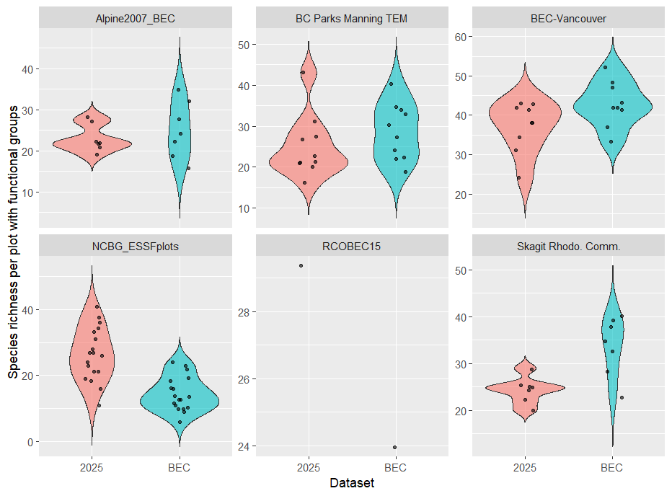

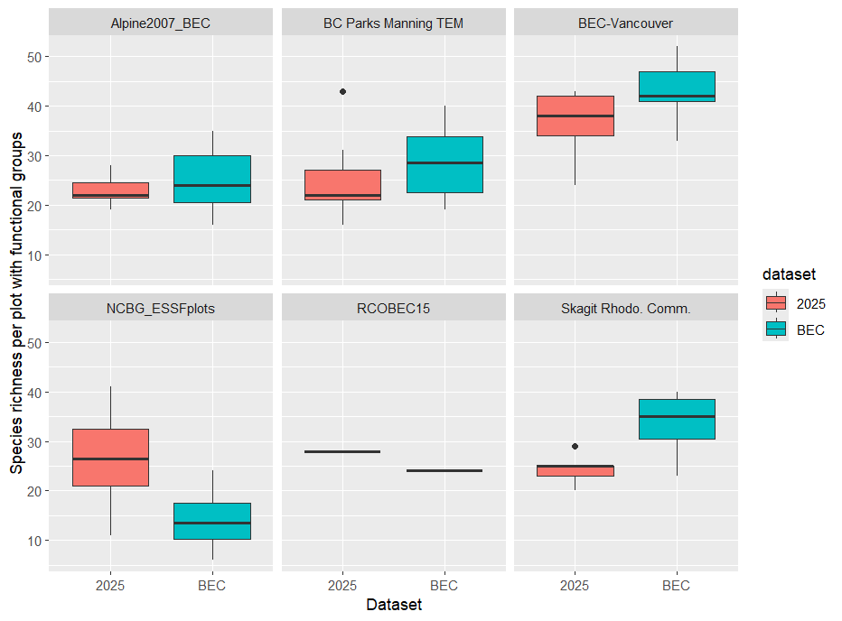

- WITHOUT grass, mosses and lichens in the BEC data:
ProjectID | mean_richness_2025 | mean_richness_BEC | sd_richness_2025 | sd_richness_BEC | n_plots_2025 | n_plots_BEC
Alpine2007_BEC | 23 | 18.28571 | 3.265986 | 3.9036 | 7 | 7
BC Parks Manning TEM | 25 | 23.1 | 7.644897 | 5.665686 | 10 | 10
BEC-Vancouver | 37.11111 | 32.55556 | 6.411795 | 4.824705 | 9 | 9
NCBG_ESSFplots | 26.33333 | 14.16667 | 8.087754 | 4.865847 | 18 | 18
RCOBEC15 | 28 | 20 | NA | NA | 1 | 1
Skagit Rhodo. Comm. | 24.28571 | 24 | 2.811541 | 4.795832 | 7 | 7

ProjectID | statistic | p.value | method | alternative
Alpine2007_BEC | 40.5 | 0.045 | Wilcoxon rank sum test with continuity correction | two.sided
BC Parks Manning TEM | 58.5 | 0.544 | Wilcoxon rank sum test with continuity correction | two.sided
BEC-Vancouver | 60.5 | 0.084 | Wilcoxon rank sum test with continuity correction | two.sided
NCBG_ESSFplots | 292 | <0.001 | Wilcoxon rank sum test with continuity correction | two.sided
RCOBEC15 | 1 | 1 | Wilcoxon rank sum exact test | two.sided
Skagit Rhodo. Comm. | 24.5 | 1 | Wilcoxon rank sum test with continuity correction | two.sided

Key results:
- Statistically different:
- NCBG_ESSFplots (p < 0.001)
- Alpine2007_BEC (p = 0.045)
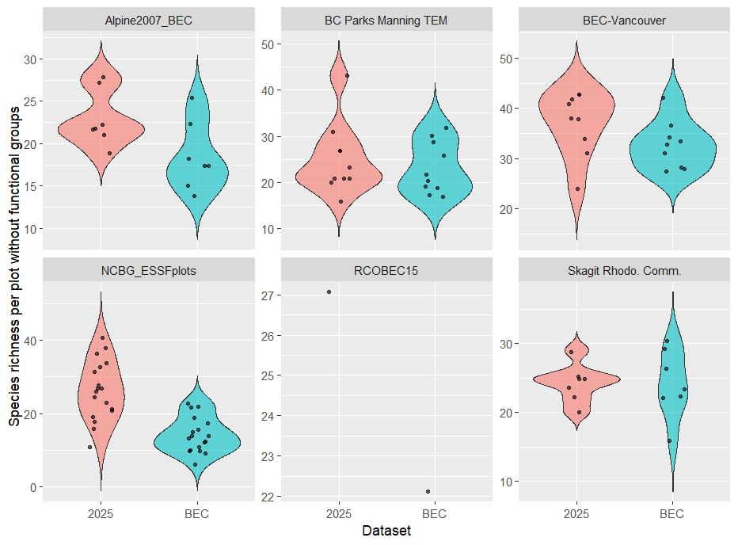

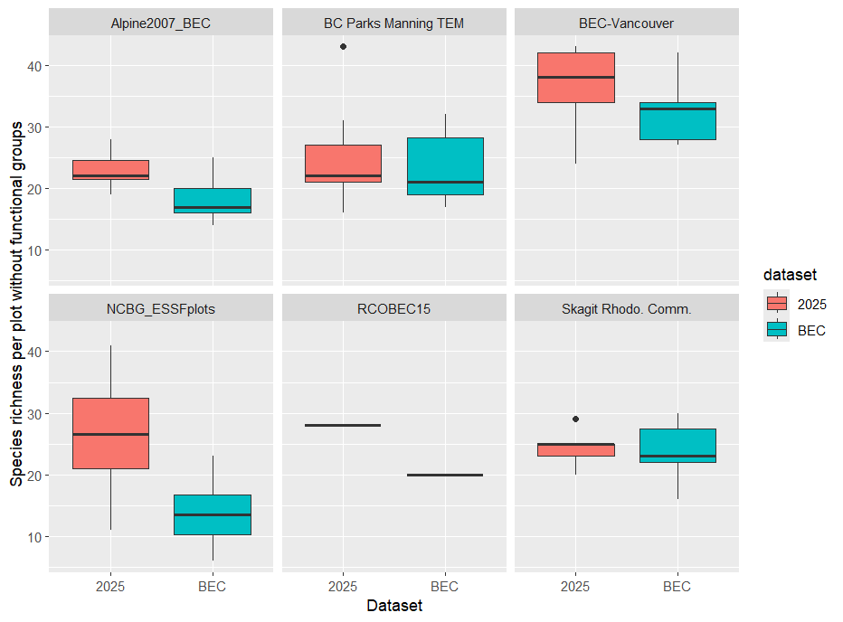
Testing Different Models

Simple Model: Time x Elevation interaction
mod1_full <- glmer(
present ~ Time_sc * poly(Elevation_sc, 2, raw = TRUE) + (1 | Species),
data = model_data,
family = binomial,
control = glmerControl(optimizer = "bobyqa")
)
Anova Table of Interaction vs. No Interaction
Data: model_data
Models:
mod1_reduced: present ~ Time_sc + poly(Elevation_sc, 2, raw = TRUE) + (1 | Species)
mod1_full: present ~ Time_sc * poly(Elevation_sc, 2, raw = TRUE) + (1 | Species)
 | npar | AIC | BIC | logLik | -2*log(L) | Chisq | Df | Pr(>Chisq)
mod1_reduced | 5 | 3202.7 | 3232.3 | -1596.3 | 3192.7
mod1_full | 7 | 3199.4 | 3240.9 | -1592.7 | 3185.4 | 7.2482 | 2 | 0.02667

Result statement: A generalized linear mixed model revealed a significant interaction between time since initial survey and elevation (χ² = 7.25, df = 2, p = 0.027), indicating that the relationship between elevation and species occurrence has changed over time.

Model 2: Adding (Elevation_sc | Species)
mod2_full <- glmer(
present ~ Time_sc * poly(Elevation_sc, 2, raw = TRUE)
+ (Elevation_sc | Species), # Do species differ in how much they shift
data = model_data,
family = binomial,
control = glmerControl(optimizer = "bobyqa"))
Data: model_data
Models:
mod2_reduced: present ~ Time_sc + poly(Elevation_sc, 2, raw = TRUE) + (Elevation_sc | Species)
mod2_full: present ~ Time_sc * poly(Elevation_sc, 2, raw = TRUE) + (Elevation_sc | Species)
 | npar | AIC | BIC | logLik | -2*log(L) | Chisq | Df | Pr(>Chisq)
mod2_reduced | 7 | 2666.8 | 2708.2 | -1326.4 | 2652.8
mod2_full | 9 | 2662.6 | 2716.0 | -1322.3 | 2644.6 | 8.1767 | 2 | 0.01677

Result statement: Allowing species-specific elevational responses improved model fit, and a significant interaction between time and elevation remained (χ² = 8.18, df = 2, p = 0.017), indicating that species’ elevational distributions have shifted over time.

Model 3: Adding (1 | PlotNumber)
mod3_full <- glmer(
present ~ Time_sc * poly(Elevation_sc, 2, raw = TRUE)
+ (Elevation_sc | Species) # Do species differ in how much they shift
+ (1 | PlotNumber),
data = model_data,
family = binomial,
control = glmerControl(optimizer = "bobyqa"))
Data: model_data
Models:
mod3_reduced: present ~ Time_sc + poly(Elevation_sc, 2, raw = TRUE) + (Elevation_sc | Species) + (1 | PlotNumber)
mod3_full: present ~ Time_sc * poly(Elevation_sc, 2, raw = TRUE) + (Elevation_sc | Species) + (1 | PlotNumber)
 | npar | AIC | BIC | logLik | -2*log(L) | Chisq | Df | Pr(>Chisq)
mod2_reduced | 8 | 2612.3 | 2659.7 | -1298.1 | 2596.3
mod2_full | 10 | 2608.2 | 2667.4 | -1294.1 | 2588.2 | 8.1122 | 2 | 0.01732

Results statement: A generalized linear mixed-effects model including species-specific elevational responses and plot-level random effects revealed a significant interaction between time and elevation (χ² = 8.11, df = 2, p = 0.017), indicating that species’ elevational distributions have shifted over time.

Model 4: Adding (poly(Elevation_sc,2) | Species)

mod4_full <- glmer(
present ~ Time_sc * poly(Elevation_sc, 2, raw = TRUE)
+ (Elevation_sc | Species) # Do species differ in how much they shift
+ (1 | PlotNumber)
+ (poly(Elevation_sc,2) | Species),
data = model_data,
family = binomial,
control = glmerControl(optimizer = "bobyqa"))

DID NOT CONVERGE.

Results Statement: We attempted a more complex random-effects structure allowing species-specific curvature / shifts, but the model was not identifiable and failed to converge; we therefore retained the most complex converged model supported by the data.

Model 5: Adding (poly(Elevation_sc,2) | Species) instead of (Elevation_sc | Species)
mod5_full <- glmer(
present ~ Time_sc * poly(Elevation_sc, 2, raw = TRUE)
#+ (Elevation_sc | Species) # Taking out simpler elevation term
+ (1 | PlotNumber)
+ (poly(Elevation_sc,2, raw = TRUE) | Species),
data = model_data,
family = binomial,
control = glmerControl(optimizer = "bobyqa"))

Data: model_data
Models:
mod5_reduced: present ~ Time_sc + poly(Elevation_sc, 2, raw = TRUE) + (1 | PlotNumber) + (poly(Elevation_sc, 2, raw = TRUE) | Species)
mod5_full: present ~ Time_sc * poly(Elevation_sc, 2, raw = TRUE) + (1 | PlotNumber) + (poly(Elevation_sc, 2, raw = TRUE) | Species)
 | npar | AIC | BIC | logLik | -2*log(L) | Chisq | Df | Pr(>Chisq)
mod2_reduced | 11 | 2581.8 | 2647.0 | -1279.9 | 2559.8
mod2_full | 13 | 2577.3 | 2654.4 | -1275.7 | 2551.3 | 8.4924 | 2 | 0.01432

Model 6: Adding (Elevation_sc:Time_sc | Species)
mod6_full <- glmer(
present ~ Time_sc * poly(Elevation_sc, 2, raw = TRUE)
+ (1 | PlotNumber)
+ (poly(Elevation_sc,2, raw = TRUE) | Species)
+ (Elevation_sc:Time_sc | Species),
data = model_data,
family = binomial,
control = glmerControl(optimizer = "bobyqa"))

Warning message:
In checkConv(attr(opt, "derivs"), opt$par, ctrl = control$checkConv, :
Model is nearly unidentifiable: large eigenvalue ratio
- Rescale variables?

Results Statement: We initially explored a maximal mixed-effects model allowing species-specific variation in both elevational niche shape and temporal shift rates. This model failed to converge reliably and showed evidence of non-identifiability, indicating overparameterization. Therefore, we proceeded with a reduced random-effects structure supported by the data.
Comparing models 1-5:

Model | Random Effects | Biological Question | AIC (Reduced) | AIC (Full) | ΔAIC (Full-Reduced) | Convergence | Interpretation
Model 1 | (1 | Species) | Do species shift on average over time? | 3202.674 | 3199.426 | -3.248 | Yes | Weak-moderate evidence of global shift
Model 2 | (Elevation | Species) | Do species differ in elevation response and shift? | 2666.786 | 2662.61 | -4.176 | Yes | Stronger support for shift with species heterogeneity
Model 3 | (Elevation | Species) + (1 | Plot) | Do shifts persist after accounting for plot effects? | 2612.268 | 2608.156 | -4.112 | Yes | Shift remains after controlling for site variation
Model 4 | (Elevation | Species) + (poly(Elevation²) | Species) + (1 | Plot) | Do species differ in niche shape and shift rate? | N/A | N/A | N/A | No | Model overparameterized; not identifiable
Model 5 | (poly(Elevation²) | Species) + (1 | Plot) | Do species differ in niche shape and show global shifts? | 2581.827 | 2577.334 | -4.493 | Yes | Best-supported model; final model??

Model | Fixed Effect | Random Effects | AIC (Full)
mod8.4 | present ~ Time * poly(Elevation_sc, 2, raw = TRUE) + Lat_sc | (poly(Elevation_sc,2) | Species) + (1 | PlotNumber) | 2154.832
mod8 | present ~ Time * poly(Elevation_sc, 2, raw = TRUE) + Lat_sc + Lon_sc | (poly(Elevation_sc,2) | Species) + (1 | PlotNumber) | 2155.63
mod8.1 | present ~ Time * poly(Elevation_sc, 2, raw = TRUE) + Lat_sc + Lon_sc | (poly(Elevation_sc,2) | Species) + (1 | ProjectID) + (1|PlotNumber) | 2157.095
mod5.1 | present ~ Time * poly(Elevation_sc, 2, raw = TRUE) | (poly(Elevation_sc,2) | Species) + (1 | PlotNumber) + (1 | ProjectID) | 2166.161
mod6 | present ~ Time * poly(Elevation_sc, 2, raw = TRUE) | (poly(Elevation_sc,2) | Species) + (1 | SiteSurveyor) + (1 | PlotNumber) | 2166.161
mod5 | present ~ Time * poly(Elevation_sc, 2, raw = TRUE) | (poly(Elevation_sc,2) | Species) + (1 | PlotNumber) | 2168.062
mod8.5 | present ~ Time * poly(Elevation_sc, 2, raw = TRUE) + Lon_sc | (poly(Elevation_sc,2) | Species) + (1 | PlotNumber) | 2168.49
mod9.4 | present ~ Time * poly(Elevation_sc, 2, raw = TRUE) + Lat_sc | (Elevation_sc| Species) + (1 | PlotNumber) | 2173.573
mod9 | present ~ Time * poly(Elevation_sc, 2, raw = TRUE) + Lat_sc + Lon_sc | (Elevation_sc| Species) + (1 | PlotNumber) | 2174.273
mod9.1 | present ~ Time * poly(Elevation_sc, 2, raw = TRUE) + Lat_sc + Lon_sc | (Elevation_sc| Species) + (1 | ProjectID) + (1|PlotNumber) | 2175.732
mod3.1 | present ~ Time * poly(Elevation_sc, 2, raw = TRUE) | (Elevation_sc | Species) + (1 | PlotNumber) + (1 | ProjectID) | 2184.266
mod7 | present ~ Time * poly(Elevation_sc, 2, raw = TRUE) | (Elevation_sc) | Species) + (1 | SiteSurveyor) + (1 | PlotNumber) | 2184.266
mod3 | present ~ Time * poly(Elevation_sc, 2, raw = TRUE) | (Elevation_sc | Species) + (1 | PlotNumber) | 2185.114
mod9.5 | present ~ Time * poly(Elevation_sc, 2, raw = TRUE) + Lon_sc | (Elevation_sc| Species) + (1 | PlotNumber) | 2185.305
mod8.2 | present ~ Time * poly(Elevation_sc, 2, raw = TRUE) + Lat_sc + Lon_sc | (poly(Elevation_sc,2) | Species) + (1 | ProjectID) | 2187.066
mod8.3 | present ~ Time * poly(Elevation_sc, 2, raw = TRUE) + Lat_sc + Lon_sc | poly(Elevation_sc,2) | Species) | 2189.657
mod9.2 | present ~ Time * poly(Elevation_sc, 2, raw = TRUE) + Lat_sc + Lon_sc | (Elevation_sc| Species) + (1 | ProjectID) | 2202.855
mod9.3 | present ~ Time * poly(Elevation_sc, 2, raw = TRUE) + Lat_sc + Lon_sc | (Elevation_sc| Species) | 2206.325
mod5.2 | present ~ Time * poly(Elevation_sc, 2, raw = TRUE) | (poly(Elevation_sc,2) | Species) + (1 | ProjectID) | 2226.694
mod6.1 | present ~ Time * poly(Elevation_sc, 2, raw = TRUE) | (poly(Elevation_sc,2) | Species) + (1 | SiteSurveyor) | 2226.694
mod4 | present ~ Time * poly(Elevation_sc, 2, raw = TRUE) | (poly(Elevation_sc,2) | Species) | 2231.260
mod3.2 | present ~ Time * poly(Elevation_sc, 2, raw = TRUE) | (Elevation_sc | Species) + (1 | ProjectID) | 2239.805
mod7.1 | present ~ Time * poly(Elevation_sc, 2, raw = TRUE) | (Elevation_sc) | Species) + (1 | SiteSurveyor) | 2239.805
mod2 | present ~ Time * poly(Elevation_sc, 2, raw = TRUE) | (Elevation_sc | Species) | 2243.889
mod1 | present ~ Time * poly(Elevation_sc, 2, raw = TRUE) | (1 | Species) | 2554.472

