User’s Manual

**Introduction**

The server (acadweb1) enables us to view a webpage linked to a given database. Follow along to understand how to access the site, view information stored in the database from the site, alter information stored in the database from the site, and more. All of the demonstrations can be completed for any of the other categories(Sales Representative, Customer, Order, Part, and Order Line), but because the functionality is the same with different data, this manual will guide you through the features of the website using the “Customers” page as an example.

**Start Up**

1. Select a compatible web browser (recommended: Google Chrome)

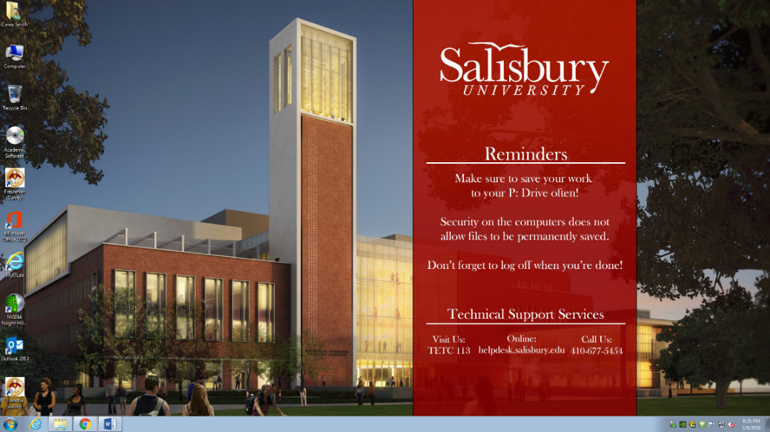

1. In the web browser, go to the homepage: **acadweb1.salisbury.edu/~CS4447/p1**

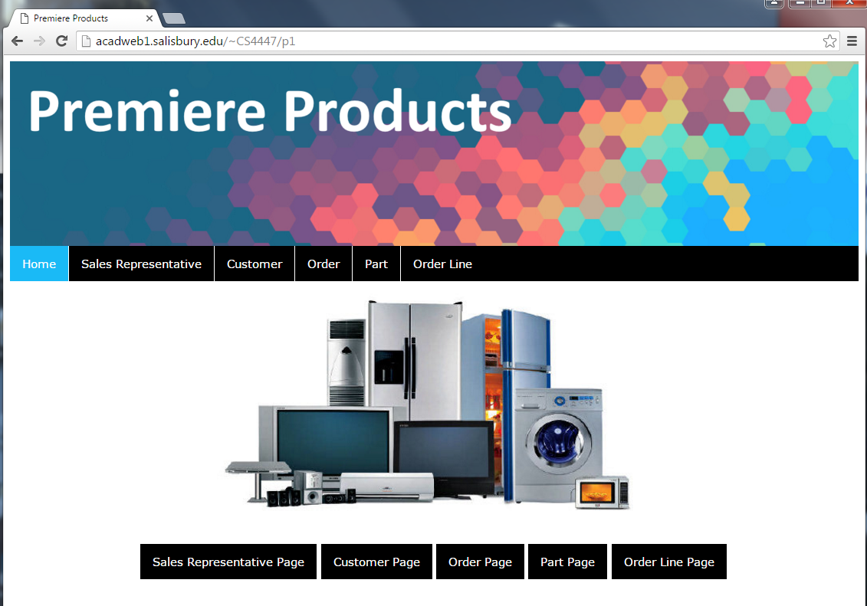

**About The Home Page**

The homepage enables users to navigate to the desired page in multiple locations. The black bar along the top includes shortcut links to the pages as well as the square buttons beneath the picture. The arrows allude to the selections that you can click on to advance to another page.



**About The Selected Pages**

Once you have made your selection and navigated away from the homepage, users can begin to access data according to the category they selected from the homepage. The black tool bar at the top of every page enables easy shortcuts back to the starting page in the case a user changes their mind or just doesn’t need to be on the page they navigated to. Beneath the picture on each page, there are navigations to begin to access data from the categories. In this case, we are viewing the Customer Page and can select to view data based on customer files. Select one of the 5 black buttons at the bottom of the page to proceed.

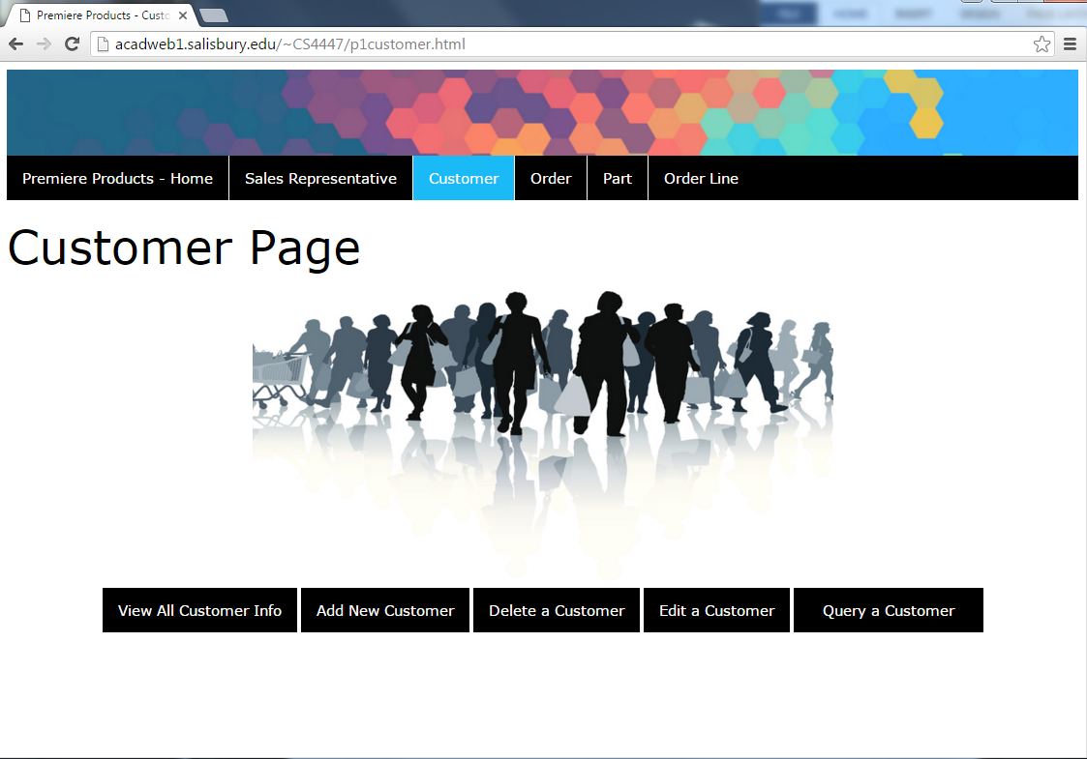

Navigation bar for easy browsing

Start looking at data by clicking one!

**View All Information**

1. Select the “View All [Customer] Info” button.



CLICK!

1. All data from the table is then provide to in an easy-to-read table. There is a button to return to the previous page at the bottom, or you could always use the navigation bar at the top.

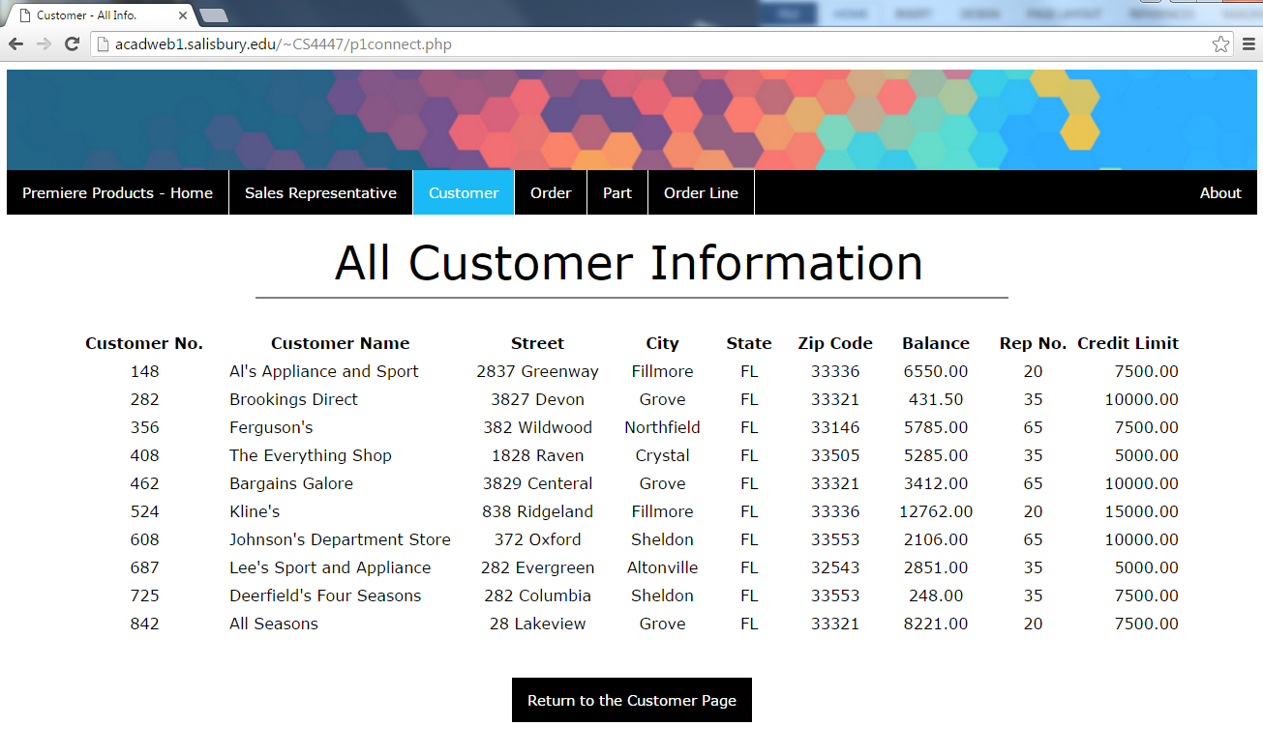

Link to previous page

Table with data

Enter your criteria   
in these boxes!

**Adding Records**

1. From the “Customer Page”, select the “Add New Customer” button.

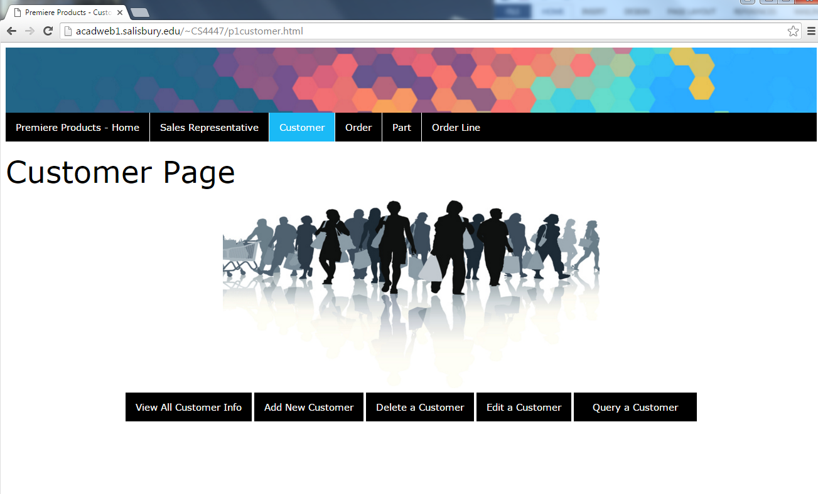

CLICK!

1. The Add New Customer page allows you to add a customer to the database. You must fill in the allotted criteria and press submit. Once you submit the page, you will be redirected to a page that shows all the updated customer information. There is a clear entries button so if you find you want to restart what you had begun typing in the text entry boxes, click clear entries and it will all erase. Navigation buttons remain at the top and bottom of the page.

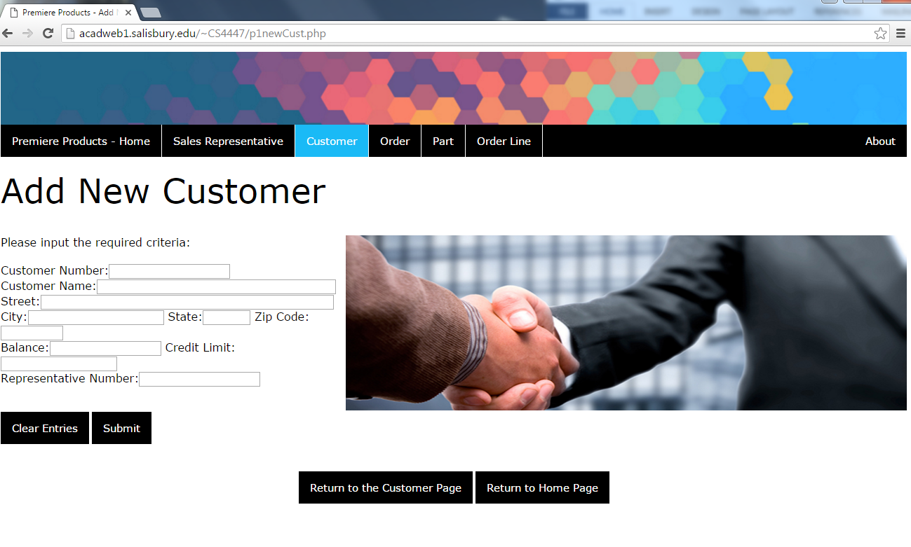

Continued navigation

Fill in and submit

1. Here is an example of the page that follows pressing submit. 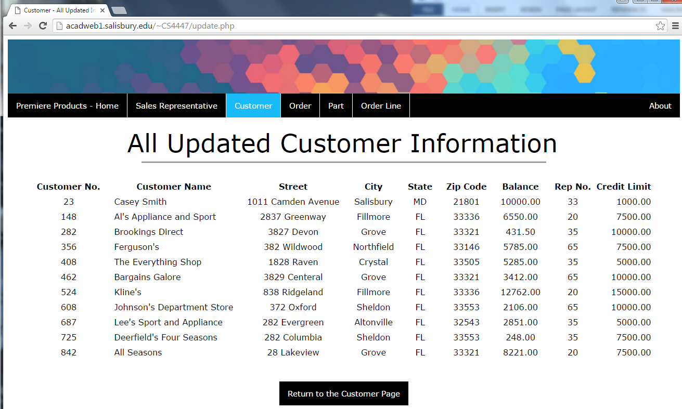

New to the info!

**Deleting Records**

1. From the “Customer Page”, select the “Delete a Customer” button.



CLICK!

1. The Delete a Customer page allows you to delete a customer from the database. You must fill in the allotted criteria and press submit. Once you submit the page, you will be redirected to a page that informs you the customer was removed. There is a clear entries button so if you find you want to restart what you had begun typing in the text entry box, click clear entries and it will all erase. Navigation buttons remain at the top and bottom of the page.

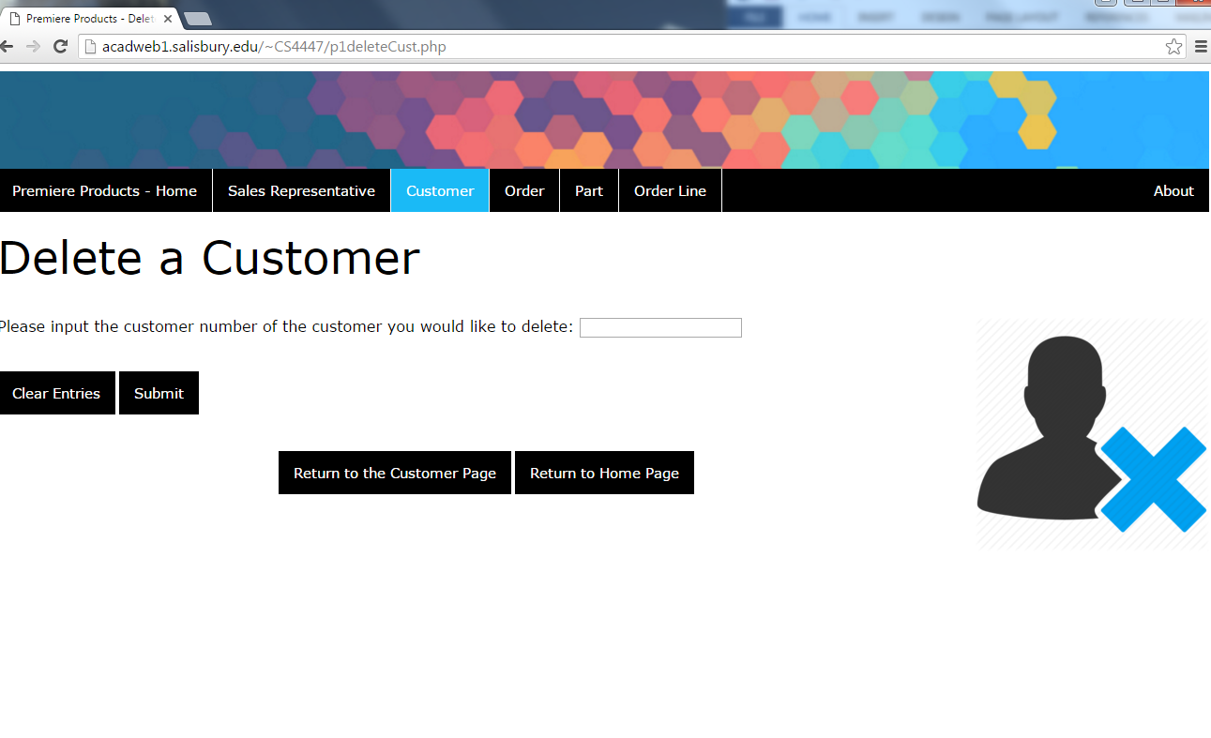

1. This is the page that follows submitting the change. Click the bottom button to return to the customer page.

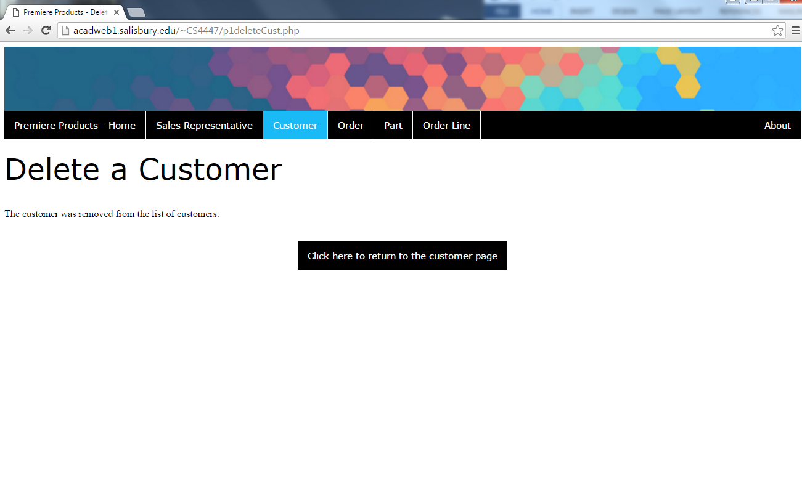

1. From the customer page, you can click the “View All Customer Info” button to see the customer you wanted to remove is no longer there.

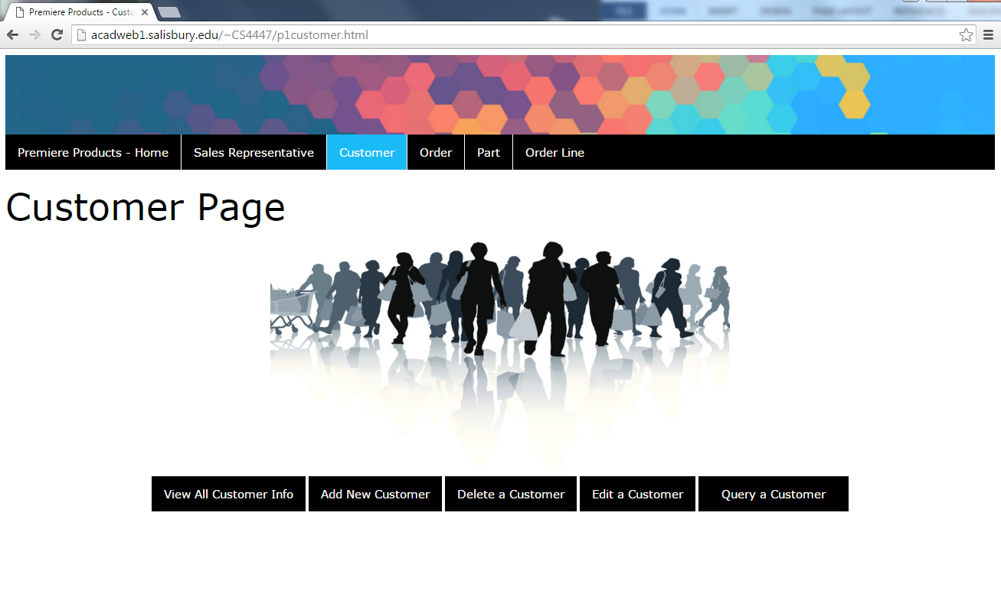

CLICK!

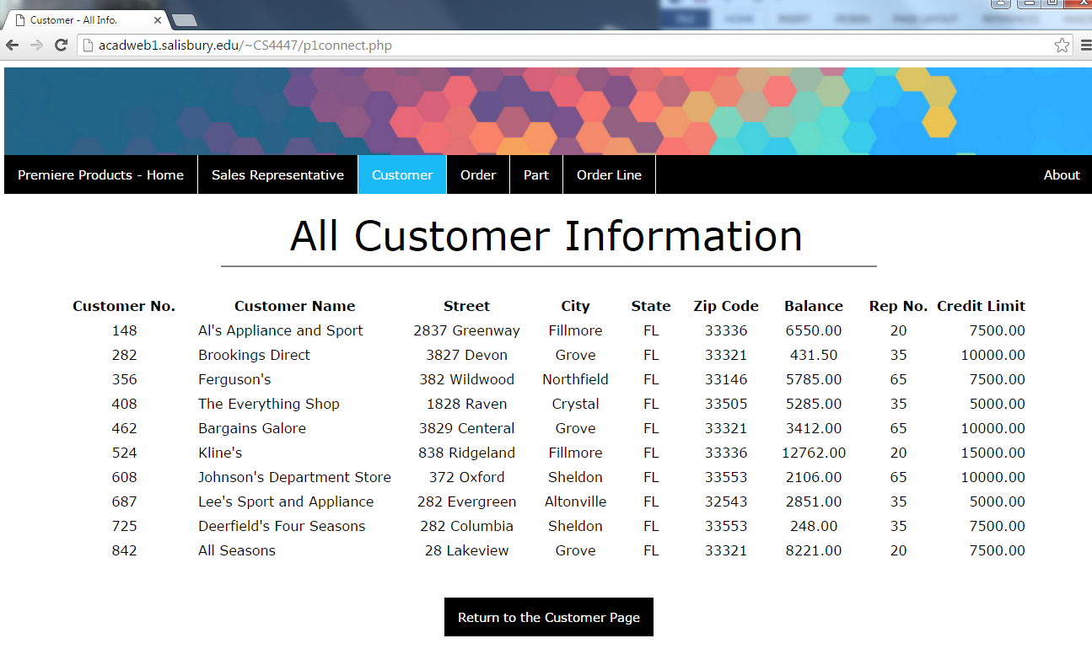

**Editing Records**

**Error Messages**