Improving Success for Struggling Algebra Learners with Online CAI

Isaac Berniker, Math Teacher, Oakland Unified School District, Oakland, Calif.
Anthony Barcellos, Math Professor, American River College, Sacramento, Calif.
Robert Bekes, Math Professor, Santa Clara University, Santa Clara, Calif.

5/7/2010

Abstract
Middle school and high school students who do not successfully progress through Pre-Algebra, Algebra, and Geometry with their peers are likely to become constrained or delayed in college and career choices. Students entering college may not be ready for the math courses offered, or may get bogged down in non-credit developmental math courses. In recent years a variety of online computer aided instruction (CAI) products have been introduced to help these students who are falling behind in mathematics. We review some criteria for evaluating these products, identify a number of the offerings, and describe one specific program in detail. We focus on applications that integrate assessments with immediate, targeted remediation so that students advance at their own pace. CAI applications are not suggested as a replacement for pedagogically sound classroom teaching utilizing discussion, connections, inquiry, projects, open-ended questions, and collaboration, but we discuss their usefulness for reviewing, practicing, and mastering skills; developing problem-solving ability; and visualizing mathematical concepts.

Introduction
Students can fall behind in math for many reasons (Barcellos). As instructors, we recognize the challenge in teaching groups of students with varying learning modalities, varying motivation levels, varying aptitude, and varying areas of math weakness. Providing math intervention for struggling students within a regular classroom may at best address only a small percentage of the students at any given time.

In most education institutions, students who lag sufficiently behind their peers are afforded extra time for remediation or are removed from the main course flow. Extra-time accommodation may permit lagging students to remain in their classes, but create additional time management complications for their teachers, while students who are removed from their classes necessitate the creation of alternative venues requiring separate staffing and space. Since the latter alternative has a significant negative budgetary impact, the former alternative is more readily implemented.

While it is widely accepted that one-to-one instruction is the optimal approach to math remediation, the costs are usually prohibitive. CAI may provide an economical alternative to increasing teaching staff and tutorial staff, enhancing the ability of existing teachers and tutors to provide individualized instruction to groups of struggling students.

The 2008 National Math Panel report stated: “Research has demonstrated that tutorials (i.e., CAI programs, often combined with drill and practice) that are well designed and implemented can have a positive impact on mathematics performance, particularly at the middle and high school levels.”

We discuss the use of modern online CAI products, examine their methodologies, and suggest criteria for their evaluation. We describe in greater detail the online CAI program titled Catchup Math, with which we are the most familiar.

Categories of Online Math Learning Offerings
Integrated math learning technology offerings may be grouped into three categories:

- Assessment-only: Products in this area (e.g., ACCUPLACER, COMPASS, and STAR Math) are not the subject of this article, but are mentioned because they can be used for segmenting students for course placement or targeted teacher or tutor instruction.

- Curricular: These offerings (e.g., Carnegie Learning, ALEKS) were designed for complete curriculum coverage. Curricular products may have, or may soon have versions of their programs that are intended for intervention and remediation.

- Supplementary: These offerings have been designed for students in need of intervention, or for temporary purposes such as reviewing prerequisites at the beginning of a new course, reviewing material as it applies to current topics in a science or math course, or for preparing for high-stakes tests. Such products include Apangea Learning, AutoSkill, Catchup Math, and Study Island.

There are myriad other online or computer-based math offerings in areas outside the scope of this article, including homework-help, live online tutoring, simulations, games, and drill and practice.

Principal Characteristics
When considering a service to use, there are several characteristics to be considered. We divide these into two groups, the first pertaining to implementation and the second to the content and methodology of the service itself.

Implementation:

- What are the installation and maintenance issues involved in getting the service to work on a campus network?
- How is student progress/achievement reported to the teacher or administrator? Summary and detailed reporting may vary in thoroughness and convenience, and may or may not communicate well with any school or district reporting interfaces.
- How easy is the service to use, both for students and for teachers?
- How much does the program cost? Costs are generally charged on a per-student per year basis paid and by the school. Such costs can vary by a factor of 10 or more. A related consideration is whether the service is available for parent purchase.

Content and Methodology:

- What are the lowest and highest levels of math that are covered?
- What age group is targeted? (Note that this is separate from the subject level; younger students may be engaged by different web appearance, vocabulary, and activities than older students, even if they are studying the same level.)
- In what languages is the service offered?
- With which sets of standards (district, state, and/or national) is the program correlated, and how clear is the correlation?
- Is there an option for live online tutoring?
- What methods of presentation of lessons and tutorials are offered (e.g., written material, audio and/or video, conceptual activities, interactive tutorials)?
- How are students assessed, and how does the service prescribe material for review?
- How does the service motivate students to learn? Services may offer credits towards tangible rewards for effort or progress, and/or may provide rewards in the form of games or congratulatory encouragement.
- The systems must judge which areas (lessons) are best sequenced for the student by some algorithm. Each product makes efficacy tradeoffs (rigor vs. practicality) in methodology of assessment and presentation of material.
- To what degree can the service be locally reference-checked for reliability and effectiveness?

A Discussion of Catchup Math
Catchup Math (catchupmath.com) provides an exemplar with which we can compare and contrast other online instructional offerings. Catchup Math is an entirely online (web-delivered) intervention providing supplemental, differentiated instruction and practice in the skills of Algebra and Geometry and their prerequisites. In Catchup Math, students are assigned (either by a teacher or by a self-guided placement test) into one of several subject proficiency programs (Pre-Algebra, Algebra 1, Geometry, or Algebra 2). Students take short (10-question) quizzes (fig-1) after which a sequence of ‘ready-to-learn’ lesson topics are prescribed based on incorrect quiz answers. For each lesson prescribed, students can choose among written lessons in English or Spanish (fig-2), video tutorials (fig-3), and concept-activities (fig-4). Furthermore, students can choose among an array of games and skill-builders to practice foundational skills such as order of operations and adding fractions. To advance to the next prescribed lesson, students are required to try practice problems on their own, after which they view a self-paced, interactive hint-step explanation for how to solve the problem (fig-5). Students may enter their own solutions to the practice problems using their mouse and keyboard on an online whiteboard for later review or grading by instructors, if desired (fig-6). Students advance through the material, retaking modified quizzes until they pass a section and then move forward in the material as quickly as they are able.

Instructors use an online administrative page for tracking student effort and progress. A specific group or class may be viewed in summary and sorted based on subject, quiz scores, or most recent login. Graphical assessment summaries show the general progress of students through assigned programs, and also show which lessons are most often prescribed, so that students may be pulled out based on common needs and given additional targeted teaching or tutoring. For each student, a detailed history assesses individual effort and progress. For each quiz, the standards covered by the quiz are listed along with those prescribed to the student based on incorrect answers. A printable ‘report card’ presents a summary of effort and progress. The report card could be used to gauge student readiness for a new course or as a component of credit recovery. Note that by reviewing the student whiteboard solutions the teacher can ascertain whether the student performed the work on his or her own.

Catchup Math is intended either for summary course review or as a supplementary companion to ongoing courses; chapter-specific programs are included that correlate to typical textbook chapter topics. Also, teachers may create a custom selection of the lessons for individuals or groups of students. Students may be enrolled by the teacher individually or by class. Teachers may assign a specific program to students, or Catchup Math will automatically place them in the lowest level course where they need review, and then advance them at the student’s pace to the desired level. Finally, Catchup Math has graduation exam preparation programs.

Catchup Math is a fully online offering with no installation or maintenance required for operation on campus networks. While the lowest program offer is Pre-Algebra, foundational skills review covers material down to third grade level. No material above Algebra 2 (Intermediate Algebra) is covered. Students may switch between English and Spanish for the lessons and activities as they wish.

Usage Examples
The following suggests some ways for using online math CAI products:
Middle School: For students who are required to take Algebra in the 8th grade but are not ready for it, they might use the CAI in summer school (or in place of summer school) and/or in extra computer lab sessions each week during the school year. Additionally, all students can be invited to utilize the CAI voluntarily to practice their math skills.

High School: Students who have failed Algebra 1 might be assigned to a remedial class instead of, or in addition to, a mainstream class. The remedial class could consist of a lecture or discussion for half the period, and then the students could work independently in the computer lab for the other half. All students could be assigned to use the CAI at school or for homework in preparation for a state graduation exam.

College: The CAI could be made available to all students in the Learning Center. Students wishing to enroll in a developmental math course (or Precalculus) could be required to use the CAI to demonstrate readiness for the course or prepare for placement tests. The CAI could also be assigned on a lesson-topic basis for students to review and practice for homework.

Summary
Online Math CAI products can be a significant component of a school or college review and remediation program. While not interchangeable with classroom learning, they may be a cost-effective supplement for addressing the nation’s critical need to improve student math comprehension and math scores. The best use of these programs is in a setting where a math instructor is available to provide supervision and timely student assistance.

Bibliography

Barcellos, A. (2005), Mathematical misconceptions of college-age algebra students,
Unpublished dissertation, University of California, Davis,
http://www.box.net/shared/rbusphj07l

U.S. Department of Education (2008), Foundations for Success: The Final Report of the National Mathematics Advisory Panel, Washington, DC,
http://www2.ed.gov/about/bdscomm/list/mathpanel/report/final-report.pdf

Figures

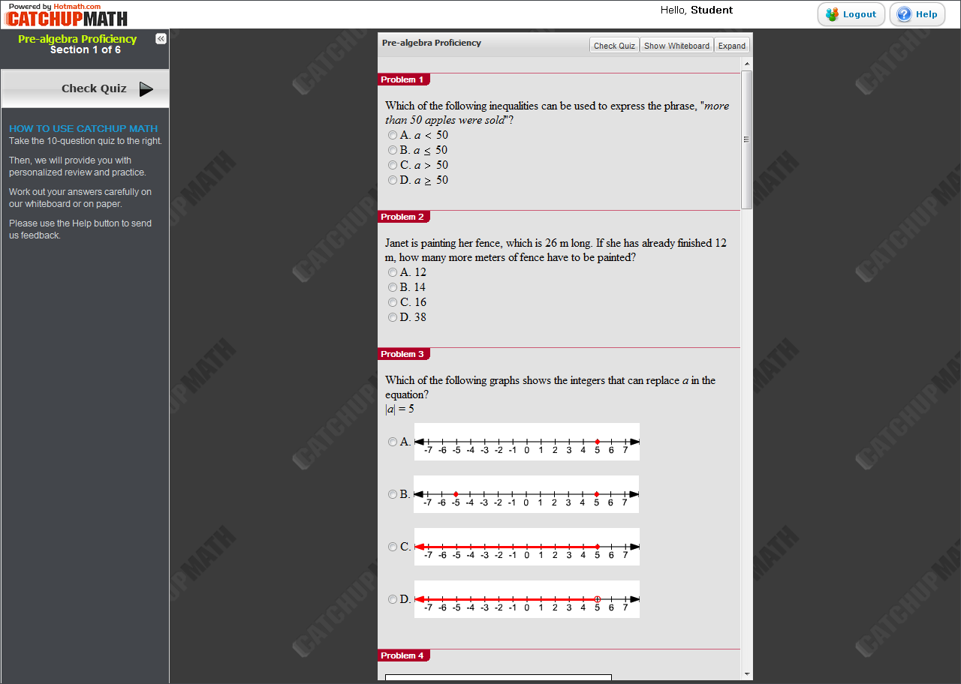

Figure 1: Quiz

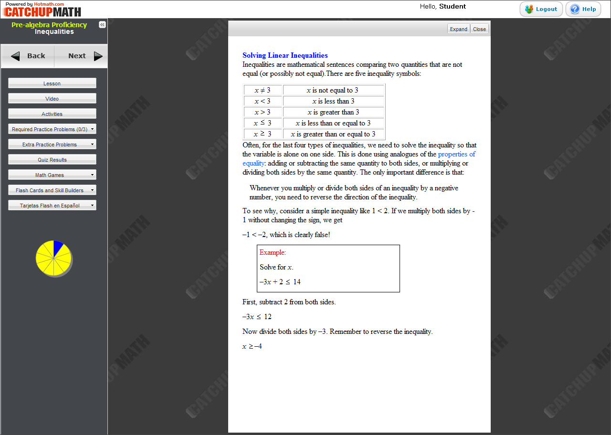

Figure 2: Written Lesson

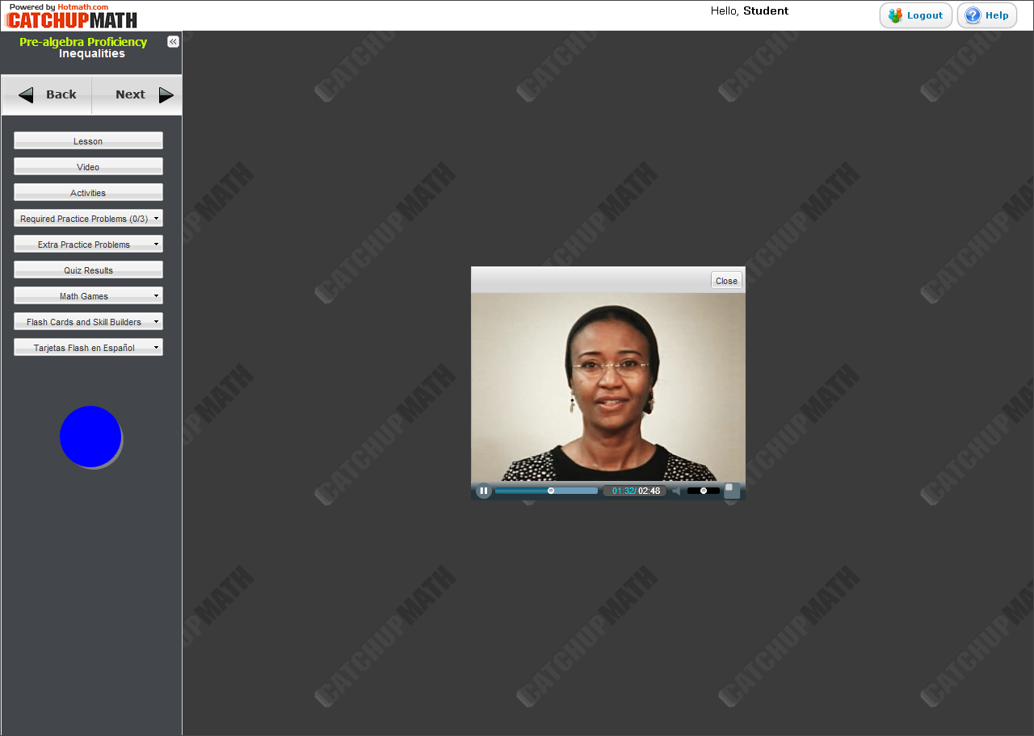

Figure 3: Video

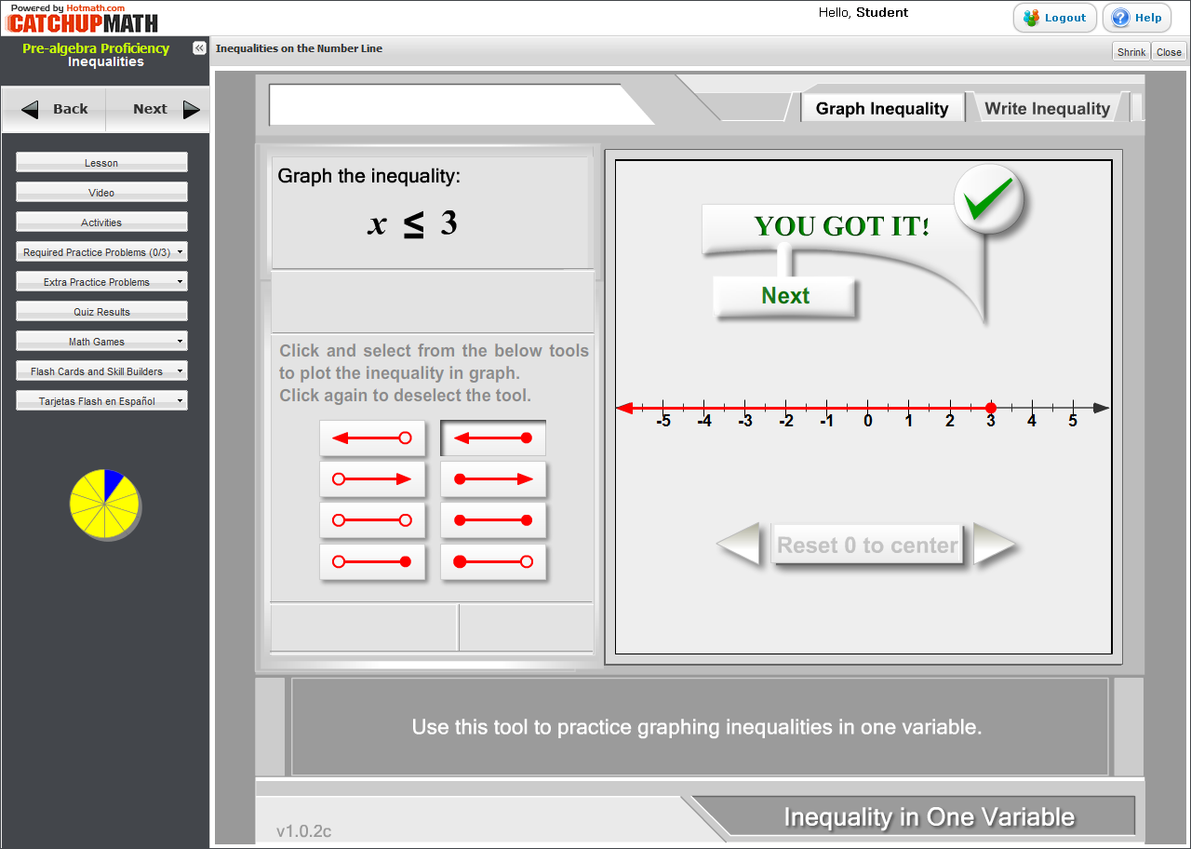

Figure 4: Activity

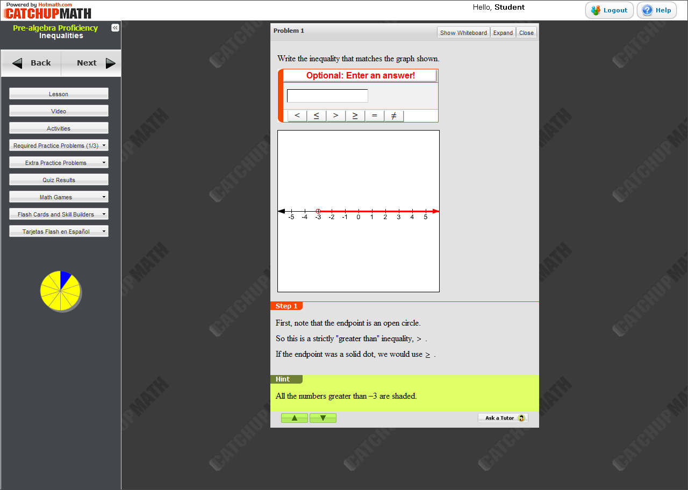

Figure 5: Guides Solution

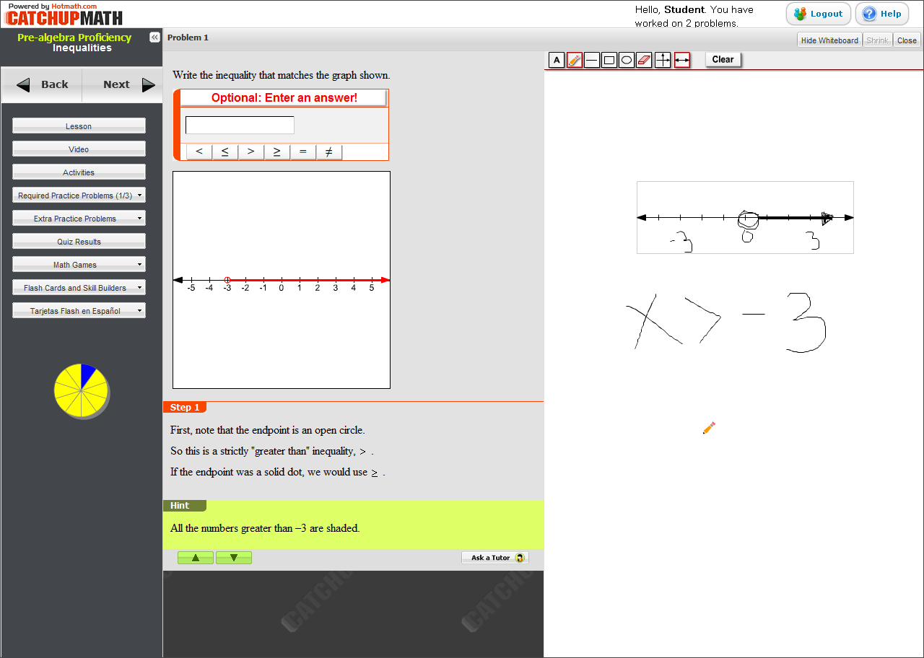

Figure 6: Whiteboard

