NT Assignment Repetition
A Day in the Life: Brief Repetition of Network Technologies

Task 1: Start Linux Environment with Kathara
The connectivity between the network nodes work great together, except for the mobile. The mobile doesn’t have an ipaddress and therefor is unable to be pinged or ping other nodes.

Task 2: DHCP Protocol
In order to configure the DHCP server to distribute to all possible addresses, we changed the netmask, added a dns and default router. The new config file of router1 looks as the following now;

dhcpd.conf
#
# Sample configuration file for ISC dhcpd
#
# option definitions common to all supported networks...
option domain-name "example.org";
option domain-name-servers ns1.example.org, ns2.example.org;

default-lease-time 600;
max-lease-time 7200;

# The ddns-updates-style parameter controls whether or not the server will
# attempt to do a DNS update when a lease is confirmed. We default to the
# behavior of the version 2 packages ('none', since DHCP v2 didn't
# have support for DDNS.)
ddns-update-style none;

# If this DHCP server is the official DHCP server for the local
# network, the authoritative directive should be uncommented.
authoritative;

# This is a very basic subnet declaration.

#subnet 10.254.239.0 netmask 255.255.255.224 {
# range 10.254.239.10 10.254.239.20;
# option routers rtr-239-0-1.example.org, rtr-239-0-2.example.org;
#}

subnet 68.80.1.0 netmask 255.255.255.0 {
range 68.80.1.11 68.80.1.100;
option domain-name-servers 68.80.0.1;
option routers 68.80.1.254;
}
After configuring the DHCP server, restarting the network and running dhclient eth0 on the mobile, the mobile got an IP-address assigned and was able to be and get pinged. See Figure 1 : Assigned IP-Address Mobile.

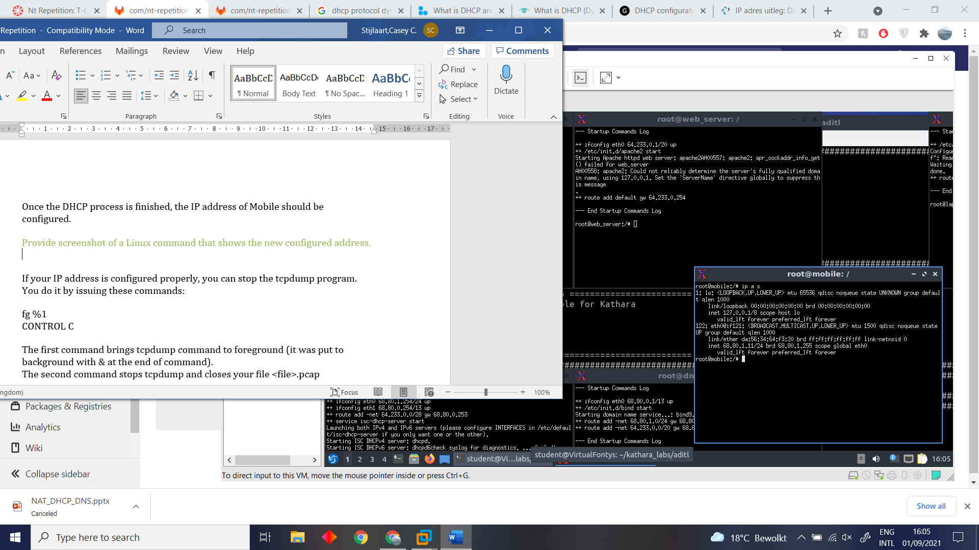
Figure 1 : Assigned IP-Address Mobile.
With the help of Wireshark we are capable of having a clear overview of the received and send packages on the network. A screenshot is provided to give an overview of the four DHCP packets, which have been received/sent. See Figure 2 : Wireshark DHCP DORA packets.

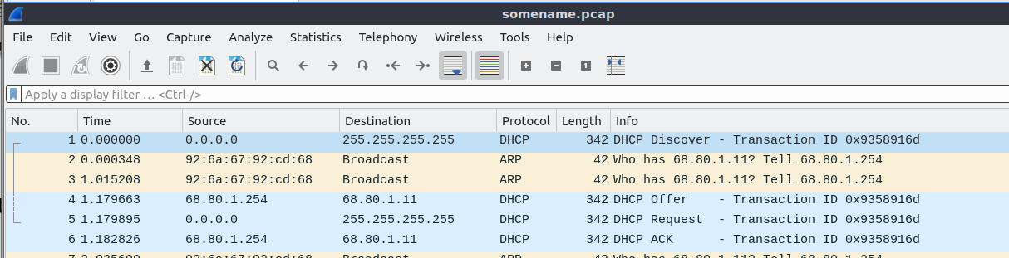
Figure 2 : Wireshark DHCP DORA packets.

There are four DHCP DORA packets exchanged since each packet containts it’s own information. The Discovery, Offer, Request and Acknowledge package. The Discovery packet is send when the client want’s to retrieve a configuration from the DHCP server. Every DHCP server that receives the broadcast then replies with a Offer. The client then takes the IP on the destion field from the package but also send to the server that they’ll take the offer using the Request packet. The server then acknowledges this using the ACK packet.

With the help of Wireshark we are capable of reading the offered IP addresses, which have been offered in the Offer packet. The IP address we found is 68.80.1.11. See Figure 3 : Wireshark offered IP in Offer packet.

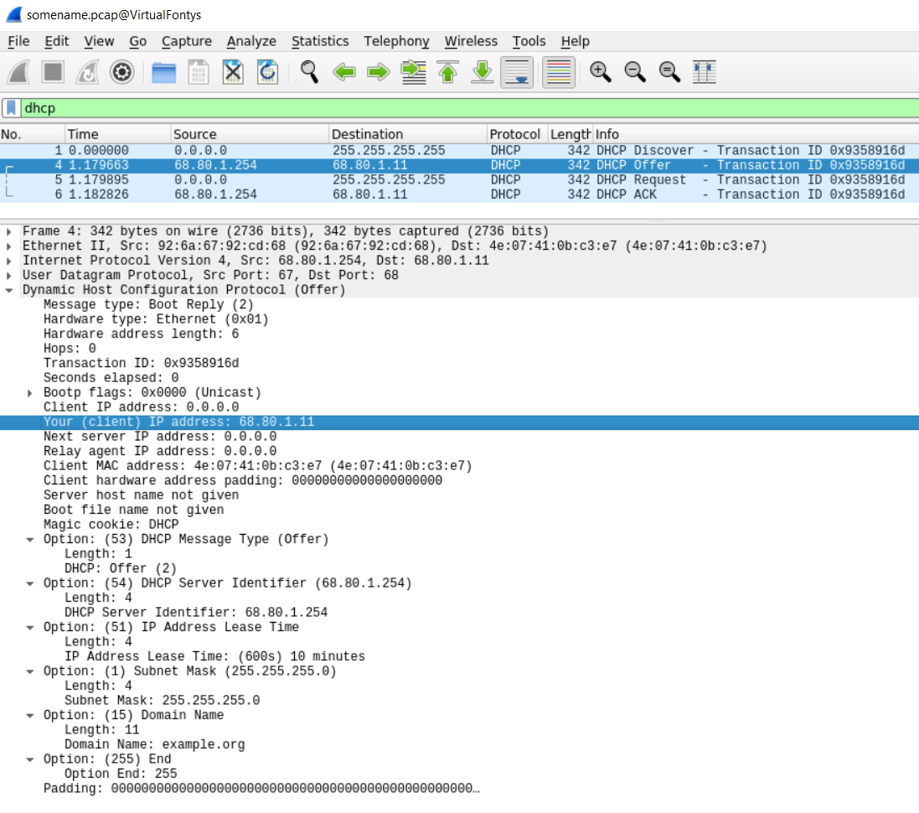
Figure 3 : Wireshark offered IP in Offer packet.

Task 3: DNS
Part 1:
Study the DNS protocol from the provided material and/or Internet. You are going to do a simple configuration of the DNS server (DnsServer node). When you look at the subdirectories of the DNSServer node in the lab, you’ll find an example configuration for a domain mygoogle.com. Make up your own domain name and configure it in exact the same way as mygoogle.com. Find out some name for your host (it will map to the IP address of the WebServer) and add an A record for it. Just look at the way mygoogle.com and host1.mygoogle.com is configured and create your configuration in an analogue way.

With the help of a pre-configured DNS-server, we configured another DNS-server. To be more specific, we did the following to configure the DNS-server;

In named.conf on the dns_server we added a extra zone (top level domain). We also told it where to find the specific information about the subdomains the ip lookup tables. In the BIND configuration file (db.website.com) we configured on what name server this configuration should be published and we then configured the ip table to describe what name should be mapped to what IP. To check if the DNS-server configuration was succesful, we pinged the server from the laptop. See Figure 4 : PING to the configured DNS-server.

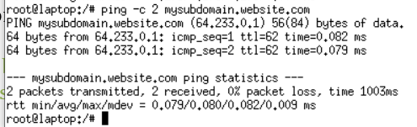
Figure 4 : PING to the configured DNS-server.
The configured DNS-server is authoritive because it has all the information it needs to resolve the name already and does not need another DNS server to cache the result from.

Part 2:
With the help of the Linux dig command we found out what the IP address of the website www.fontys.nl is. See Figure 5 : Website IP with dig-command.

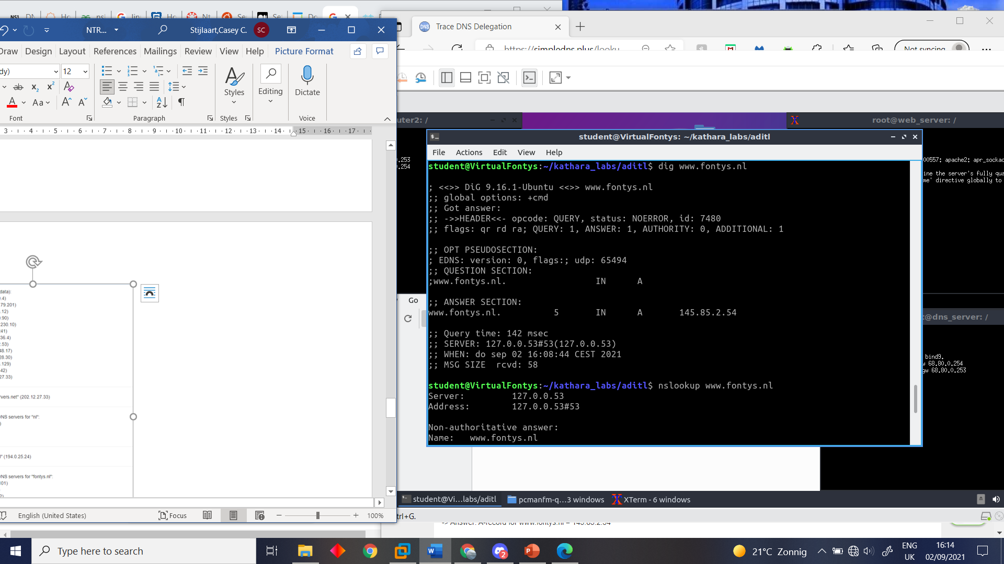
The dig command describes what information the DNS send back including the flags, error codes, etc. It then also shows the actual anser for the DNS resolve and some statistics about when and how long the request took.

The exact IP address that was found with the help of the dig command is 145.85.2.54 for the website www.fontys.nl.
Figure 5 : Website IP with dig-command.
Lastly, with the help of http://simpledns.com/lookup-dg page we came to the conclusion which root server is used for the website, which is m.root-servers.net" (202.12.27.33). See Figure 5 : Website IP with dig-command.

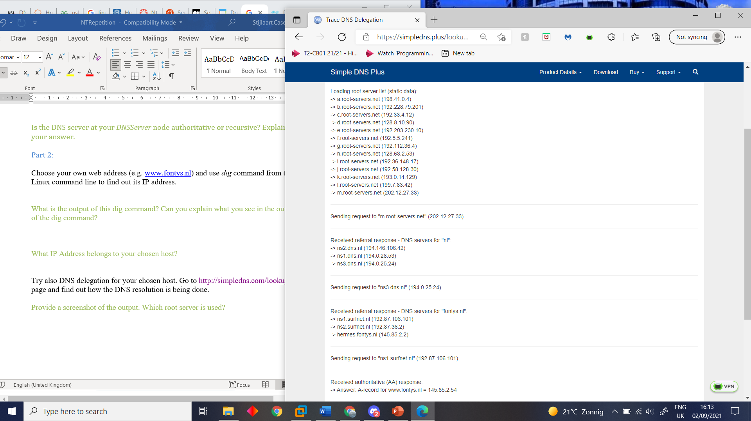
Figure 6 : DNS resolution www.fontys.nl.

