Stijlaart,Casey C.
466488
Fontys University of Applied Science
27-09-2021
LAB3 Interrupts
Embedded Systems 3

Abstract
Interrupts, regarding to programming, allows the programmer to efficiently make use of multi-process multitasking. An interrupt prompts the operating system to stop working on the main function, and work on another function instead. Therefor this document is to cover the understanding of interrupts and the approach on how to set them up and use them.

Table of Contents
1. Introduction 2
2. Research 3
2.1. Hardware 3
2.2. Algorithm 3
2.3. Debouncing buttons 3
2.4. MCP internal 3
2.5. Reading time 3
3. Design 4
3.1. General flow chart 4
3.2. General state diagram 4
3.3. Button flow chart 5
3.4. Button state diagram 5
4. Proof of concept 6
5. Reflection 7
6. References 8

Table of figures
Figure 1 : Flowchart general program. 4
Figure 2 : State diagram general program. 4
Figure 3 : Flowchart buttons. 5
Figure 4 : State diagram buttons. 5

1. Introduction
Using delays in your program can cause many problem regarding to making your program run smoothly. Delay causes unnecessary hold ups while executing. To solve this, interrupts can be used. Interrupts allows the main program to continuously run without constantly being held up due to a delay. An interrupt allows the programmer to smoothly switch to another part in the software, which briefly needs attention. The interrupt is very short and fast, therefor it does not unnecessary hold up the main program.
Throughout this report there will be discussed how I tackled using interrupts regarding to the assignment. The assignment itself is to create a program that turns on a LED when a button is pressed shortly and turned of when it has been pressed long, the same rules apply for the other LED and button. For the exact requirements of the assignment see Lab 3 Interrupts (Andova, 2021).

2. Research

2.1. Hardware
The hardware that is chosen for this program is the Nucleo F303RE. The Nucleo has two LED’s, two resistors and two buttons wired up with the help of a breadboard.

2.2. Algorithm
The algorithm for the program is based on its input it receives from the button interrupt. Based on the received input it will take action. First of all, when no button interrupt appears, there doesn’t happen anything. When a button interrupt does appear, it will follow the following steps; first it will check if it is the first or the second interrupt, when it is the first interrupt, the timer will start. When it is the second interrupt, the timer will stop. Regarding to the what the first and second interrupt is, see 2.4. MCP internal. Based on the start and stop time of the timer, there will be calculated how much time has passed. Lastly based on this, the LED will turn on/off or the will be ignored, since it was noise within the button.

2.3. Debouncing buttons
Debouncing a button is used to filter out any unwanted actions to appear when there is any noise in the button. Regarding to filtering out the noise, there are multiple ways to do so. For example there could be made use of a delay. This solution can cause unnecessary delay’s within reading buttons and even missing a interrupt since the program is on a hold. There for I’ve made the decision to not use a delay for a debounce, but ignore the first 20 milliseconds when a there is an interrupt. This reason here for is that the noise in a button usually does not last longer than 20 milliseconds. If any noise does appear withing this period of time, we can ignore it since it’s not an actual button press.

2.4. MCP internal
The MCP regarding to the button has be set up with the help of the interrupt registers. This is due to the fact that the button is the reason for the main program to be interrupted. Therefor multiple registers need to be set, two of them are the rising and falling edge. In this scenario there is made use of the both of them. The reason for settling on this decision, is since the duration of the button press can be easily be timed. The timer will start when the first interrupt happens, and will stop once the second interrupt has appeared. In 2.5. Reading time there will be a more detailed look in how the reading the time will happen.

2.5. Reading time
As mentioned in 1. Introduction there needs to be measured how long the button is pressed and based on this the LED will turn on or off accordingly. I decided on making use of HAL_GetTick() function. The reason for settling on this option, is since it will not cause any unsuspected problem with the program. The HAL function a HAL library function, and is based on the system timer. The HAL_GetTick() return the current passed time in Millis.

3. Design

3.1. General flow chart
The flow chart for the overall program can be seen as an easy diagram since the main will keep looping until an interrupt appears. When the button appears there will be checked which button has caused the interrupt and the following actions based on how long the button press was. See Figure 1 : Flowchart general program.
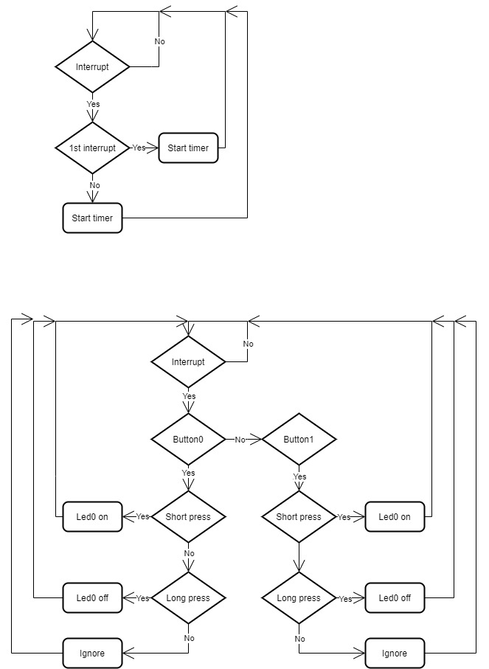
Figure 1 : Flowchart general program.

3.2. General state diagram
The state diagram for the general program can be seen as a simple diagram, since the main program will continuously loop until it gets interrupted. The main program can be interrupted by two buttons, button0 and button1. When the interrupt is enabled, the interrupt will decide on the state of the LED based on the how long the button is pressed. See Figure 2 : State diagram general program.
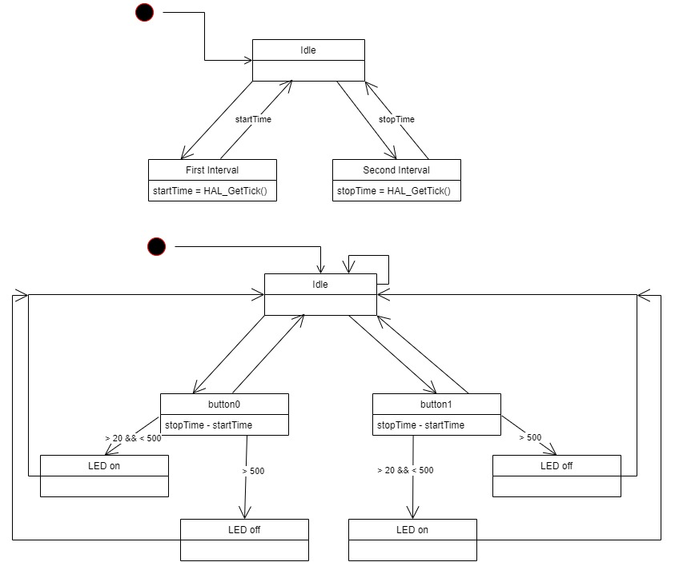
Figure 2 : State diagram general program.

3.3. Button flow chart
Both of the buttons work in the exact same way and there for the flowchart can be applied to the both of them. Regarding to the actual flowchart, it can be simplified based on if an interrupt appears. When an interrupt appears it will be checked if it was the first time, rising edge the interrupt appeared or the second time, falling edge. Afterwards it will forward the retrieved information and return this to the main program. See Figure 3 : Flowchart buttons.

Figure 3 : Flowchart buttons.

3.4. Button state diagram
Regarding to the state diagram of the buttons, they both have the same state diagram since they work in the same way, except for the used variable names. In the state diagram there can be seen that the interrupt will starts the timer and what it returns to the program. See Figure 4 : State diagram buttons.

Figure 4 : State diagram buttons.

4. Proof of concept

5. Reflection
Throughout this assignment I’ve learned multiple things. This is mainly due to the fact I ran into multiple different problems. For example, I did not properly draw out my flow chart prior. Therefor ended up running into problem since I did not have enough knowledge on how I wanted to achieve the preferred end result.
Secondly I learned how to properly use interrupts and they work in practise. For example due to putting it in to practise, I learned the clear difference between only enabling a falling edge or rising edge and enabling the both of them. When brain storming about how I wanted to approach the assignment, I wasn’t completely sure on what kind of edge I wanted to implement and decided to find the difference in how they work in practise. Due to trying this out, I got an better understanding of how to use them and when to use them.
Thirdly, learned how powerful interrupts can be. When reflecting back on how a simple program with turning a LED on/off based on the duration of a button press, I would notice that sometimes it wouldn’t recognize a button press due to the delay in it’s function or another process being executed.
Lastly I learned that I should always make the video earlier on. For some reason the LED’s aren’t working anymore. With the help of debugger I checked if it was still reading the interrupts and that was going well, but the LED’s would not turn on anymore. Due to the lack of time, since I ran into this problem when I wanted to film at before handing it in, I don’t have any video attached and I hope to be able to show you in person.

6. References
Andova, S. (2021). Lab 3 interrupts. From Git: https://git.fhict.nl/technology/t-sem3-cb/-/blob/master/es/Interrupts/Lab_03_Interrupts.pdf
Brown, G. (2016, June 5). Discovering the STM32 Microcontroller. From legacy.cs.indiana.edu: https://legacy.cs.indiana.edu/~geobrown/book.pdf
st. (2017, January). DM00043574 ReferenceManual STM32F303RE. From Git: https://git.fhict.nl/technology/t-sem3-cb/-/raw/master/es/Intro_STM32_mictrocontroller/DM00043574-ReferenceManual_STM32F303RE.pdf
STM32F439xx HAL User Manual. (n.d.). From disca.upv.es: https://www.disca.upv.es/aperles/arm_cortex_m3/llibre/st/STM32F439xx_User_Manual/group__hal__exported__functions__group2.html#gaa8361d44d76b7f6256834f828165837a

Manual Control Panel

