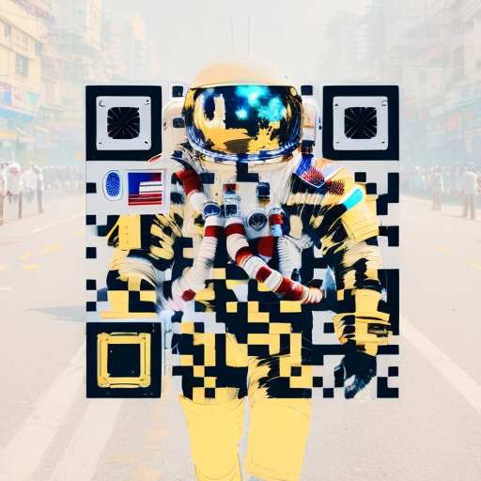

**https://github.com/caseytechschool-cts/AI-TimbarraTeacherPD**