# 1、官网类

1）

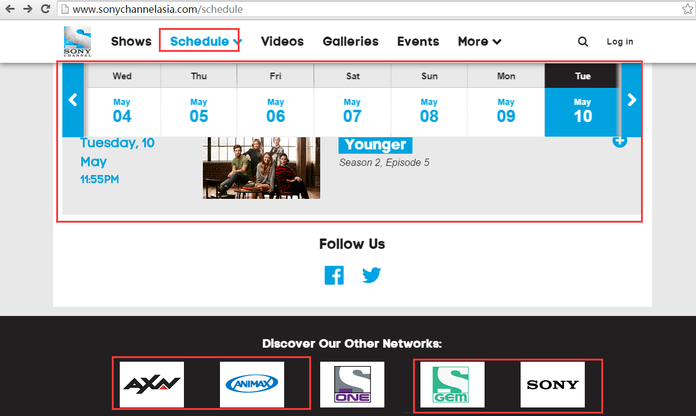

需爬取预告的频道如表所列：

|  |  |  |
| --- | --- | --- |
| Animax East Asia | Chinese | <http://www.animax-asia.com/schedule（英文）> |
| Animax India | Japanese | <http://www.animax-asia.com/schedule/india> |
| Animax Taiwan | Chinese | <http://www.animax-taiwan.com/schedule（英文）> |
| AXN East Asia | English | <http://www.axn-asia.com/schedule> |
| AXN India | English | http://www.axn-india.com/schedule |
| AXN Philippines | English | http://www.axn-asia.com/schedule/ph |
| AXN Taiwan | Chinese | http://www.axn-taiwan.com/schedule |
| Gem TV Asia | Chinese | <http://www.gemtvasia-th.com/schedule> |
| Sony Channel Asia HD | English | http://www.sonychannelasia.com/schedule |
| Sony Channel Philippines | English | http://www.sonychannelasia.com/schedule/ph |

2）

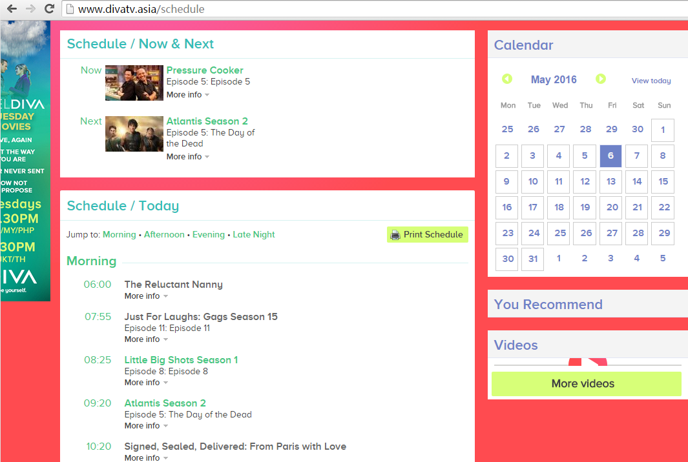

|  |  |  |
| --- | --- | --- |
| Diva 2 | English | <http://www.divatv.asia/schedule英文> |
| Diva Asia | English | <http://www.divatv.asia/schedule英文> |

3）

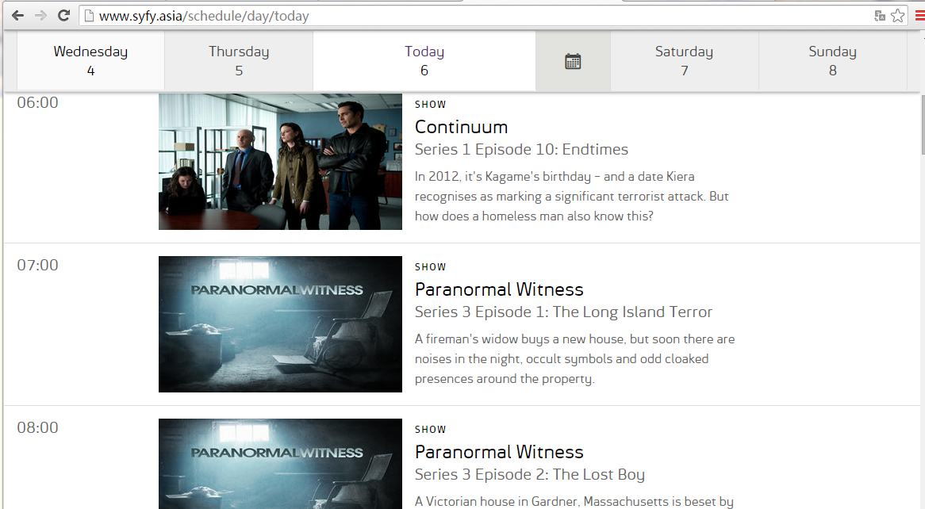

|  |  |  |  |  |  |  |  |  |
| --- | --- | --- | --- | --- | --- | --- | --- | --- |
| |  |  |  | | --- | --- | --- | | Syfy Asia | English | <http://www.syfy.asia/schedule/day/today> | | Universal Channel Asia | English | <http://www.universalchannel.asia/schedule/day/today> | |  |  |

# 2、电视猫网站

|  |  |
| --- | --- |
| BBC Earth Asia | <http://www.tvmao.com/program/BBC-BBC-KNOWLEDGE-ASIA-w5.html> |
| BBC Entertainment Asia | <http://www.tvmao.com/program/BBC-BBC-ENTERTAINMENT-ASIA-w5.html> |
| BBC Lifestyle Asia | <http://www.tvmao.com/program/BBC-BBC-LIFESTYLE-ASIA-w5.html> |
| CBeebies Asia | <http://www.tvmao.com/program/BBC-BBC-CBEEBIES-ASIA-w5.html> |
| Boomerang Australia | http://www.tvmao.com/program/CARTON-BOOMERANG-w5.html |
| Cartoon Network Philippines | http://www.tvmao.com/program/CARTON-CARTOON-HK-w5.html |
| Cartoon Network South East Asia | http://www.tvmao.com/program/CARTON-CARTOON-SG-w5.html |
| Cartoon Network Taiwan | http://www.tvmao.com/program/CARTON-CARTOON-TW-w4.html |
| CNN International Asia Pacific | http://www.tvmao.com/program/CNN |
| Disney Channel Asia | http://www.tvmao.com/program/DISNEY-DISNEY-SG-w5.html |
| Disney Channel Hong Kong | http://www.tvmao.com/program/DISNEY-DISNEY-HK-w6.html |
| Disney Channel Taiwan | http://www.tvmao.com/program/DISNEY-DISNEY-TW-w5.html |
| Disney Junior Asia | http://www.tvmao.com/program/DISNEY-DISNEY-JUNIOR-SG-w5.html |
| Disney Junior Taiwan | http://www.tvmao.com/program/DISNEY-DISNEY-JUNIOR-TW-w5.html |
| Disney XD Asia | http://www.tvmao.com/program/DISNEY-DISNEY-XD-SG-w5.html |
| Toonami | http://www.tvmao.com/program/NOWTV/TOONAMI |

# 3、汇总 30个频道，5个无找到预告网站

|  |  |  |  |  |
| --- | --- | --- | --- | --- |
| Animax East Asia | TV8020 | Chinese | Live Channel | <http://www.animax-asia.com/schedule> |
| Animax India | TV8015 | Japanese | Live Channel | <http://www.animax-asia.com/schedule/india> |
| Animax Taiwan | TV8018 | Chinese | Live Channel | <http://www.animax-taiwan.com/schedule> |
| AXN East Asia | TV8013 | English | Live Channel | <http://www.axn-asia.com/schedule> |
| AXN India | TV8014 | English | Live Channel | http://www.axn-india.com/schedule |
| AXN Philippines | TV8017 | English | Live Channel | http://www.axn-asia.com/schedule/ph |
| AXN Taiwan | TV8016 | Chinese | Live Channel | http://www.axn-taiwan.com/schedule |
| BBC Earth Asia | TV8023 | English | Live Channel | <http://www.tvmao.com/program/BBC-BBC-KNOWLEDGE-ASIA-w5.html> |
| BBC Entertainment Asia | TV8025 | English | Live Channel | <http://www.tvmao.com/program/BBC-BBC-ENTERTAINMENT-ASIA-w5.html> |
| BBC Lifestyle Asia | TV8026 | English | Live Channel | <http://www.tvmao.com/program/BBC-BBC-LIFESTYLE-ASIA-w5.html> |
| Boomerang Australia | TV8035 | English | Live Channel | http://www.tvmao.com/program/CARTON-BOOMERANG-w5.html |
| Cartoon Network Australia | TV8033 | English | Live Channel |  |
| Cartoon Network Philippines | TV8030 | English | Live Channel | http://www.tvmao.com/program/CARTON-CARTOON-HK-w5.html |
| Cartoon Network South East Asia | TV8028 | English | Live Channel | http://www.tvmao.com/program/CARTON-CARTOON-SG-w5.html |
| Cartoon Network Taiwan | TV8029 | Chinese | Live Channel | http://www.tvmao.com/program/CARTON-CARTOON-TW-w4.html |
| CBeebies Asia | TV8024 | English | Live Channel | <http://www.tvmao.com/program/BBC-BBC-CBEEBIES-ASIA-w5.html> |
| CNN International Asia Pacific | TV8027 | English | Live Channel | http://www.tvmao.com/program/CNN |
| Disney Channel Asia | TV8012 | English | Live Channel | http://www.tvmao.com/program/DISNEY-DISNEY-SG-w5.html |
| Disney Channel Hong Kong | TV8011 | Chinese | Live Channel | http://www.tvmao.com/program/DISNEY-DISNEY-HK-w6.html |
| Disney Channel Taiwan | TV8007 | English | Live Channel | http://www.tvmao.com/program/DISNEY-DISNEY-TW-w5.html |
| Disney Junior Asia | TV8010 | English | Live Channel | http://www.tvmao.com/program/DISNEY-DISNEY-JUNIOR-SG-w5.html |
| Disney Junior Taiwan | TV8009 | Chinese | Live Channel | http://www.tvmao.com/program/DISNEY-DISNEY-JUNIOR-TW-w5.html |
| Disney XD Asia | TV8008 | English | Live Channel | http://www.tvmao.com/program/DISNEY-DISNEY-XD-SG-w5.html |
| Diva 2 | TV8002 | English | Live Channel | <http://www.divatv.asia/schedule> |
| Diva Asia | TV8004 | English | Live Channel | <http://www.divatv.asia/schedule> |
| E! Asia & Pacific | TV8006 | English | Live Channel |  |
| E! PHILIPPINES | TV8005 | English | Live Channel |  |
| Gem TV Asia | TV8021 | Chinese | Live Channel | <http://www.gemtvasia-th.com/schedule> |
| Sony Channel Asia HD | TV8022 | English | Live Channel | http://www.sonychannelasia.com/schedule |
| Sony Channel Philippines | TV8019 | English | Live Channel | http://www.sonychannelasia.com/schedule/ph |
| Syfy Asia | TV8001 | English | Live Channel | <http://www.syfy.asia/schedule/day/today> |
| TCM Asia | TV8031 | English | Live Channel |  |
| TCM Australia | TV8034 | English | Live Channel |  |
| Toonami | TV8032 | English | Live Channel | http://www.tvmao.com/program/NOWTV/TOONAMI |
| Universal Channel Asia | TV8003 | English | Live Channel | <http://www.universalchannel.asia/schedule/day/today> |