游戏日志Web API

数据部

|  |  |
| --- | --- |
| *版本:* | *1.0* |
| *日期:* | 2013.10.16 |
| *状态:* | ***编写中*** */ 已提交 / 已发布* |
| *作者:*  *审核：* | *安洋* |

|  |  |  |  |
| --- | --- | --- | --- |
| **修改日期** | **版本号** | **修改内容** | **作者** |
|  |  |  |  |
|  |  |  |  |

**Web Api接口使用说明：**

**测试环境URL：**

公司内网：http://188.188.1.141:8099/api/GameLog?code=123456

公司外网：http://218.241.144.114:42085/api/GameLog?code=123456

**线上正式环境URL（请勿测试使用）：**

http://115.182.49.81:8099/api/GameLog?code=NWFTcDVwV3c1NldlNW8ydTVMcVM2WU9vNVlxbw

**请求类型：**

HTTP POST

**传参说明：**

1、GameId：游戏id，数据部统一分配，请与数据部联系

2、LogName：日志名称

3、Logs：游戏日志，Json数据格式

**例子：**

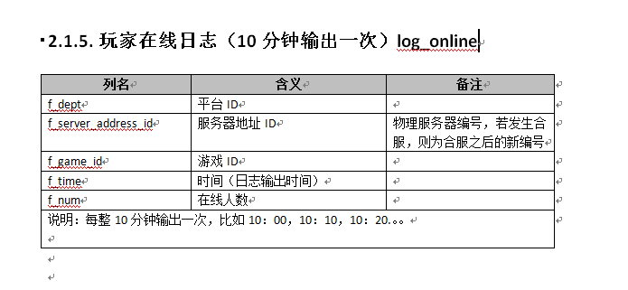

Uri：http://188.188.1.141:8099/api/GameLog?code=123456

Http Method：Post

Request Body:

gameid=123&logname=log_online&logs={"f_dept":"1","f_server_address_id":"1","f_game_id":"3","f_time":"2013-10-16 10:00:00","f_num":"999"}

**JAVA版本demo**：

|  |
| --- |
| package demo;  import java.io.IOException;  import java.io.OutputStreamWriter; import java.net.HttpURLConnection; import java.net.URL; /** * 发送http请求的工具类 * @author 尹纪元 * 2013-11-5 */ public class RequestHttp {      private URL url;      private String method;      public RequestHttp(String urlpath,String method) throws IOException{           url=new URL(urlpath);           this.method=method;      }            /**      * 向服务器发送post请求      * @param paramliststr  参数列表的字符串      * @return 返回http状态吗      * @throws IOException      */      public int request(String paramliststr) throws IOException{           HttpURLConnection httpconnect;httpconnect=(HttpURLConnection)url.openConnection();           httpconnect.setRequestMethod(method);           httpconnect.setDoOutput(true);           httpconnect.setDoInput(true);           httpconnect.setUseCaches(false);           httpconnect.setRequestProperty("Content-Type", "application/x-www-form-urlencoded");           OutputStreamWriter osw=new OutputStreamWriter(httpconnect.getOutputStream());           osw.write(paramliststr);           osw.flush();           osw.close();           return httpconnect.getResponseCode();      }       public URL getUrl() {           return url;      }       public void setUrl(URL url) {           this.url = url;      } } |

|  |
| --- |
| package demo;  import java.io.IOException;  public class RequestDemo {       /**      * @param args      */      public static void main(String[] args) {           try {                /***                * 对象参数                * 1地址                * 2方法类型                */                RequestHttp rh=new RequestHttp("http://188.188.1.141:8099/api/GameLog","POST");                rh.request("请求内容，即参数");           } catch (IOException e) {                // TODO Auto-generated catch block                e.printStackTrace();           }       }  } |