Instructions for Video-conference System

Two steps to be taken before you organize meetings among more than 2 people and share video, audio files.

Step 1 Log into the system with a valid APP account and open a cyber meeting room.

Step 2 Send the web-link to all the participants of the meeting or conference venues. And attend the meeting via web-browser or APP.

Step one

Log into the system with a valid APP account and open a cyber meeting room

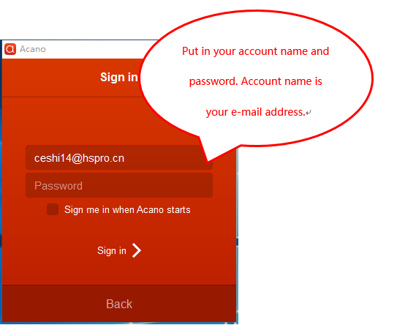

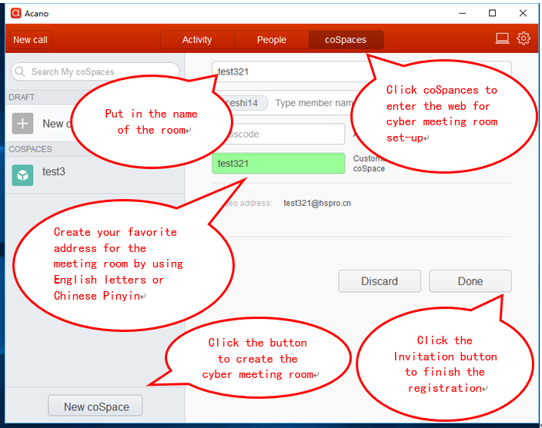

Step 2

Send the web-link to all the participants of the meeting or conference venues. And attend the meeting via web-browser or APP.

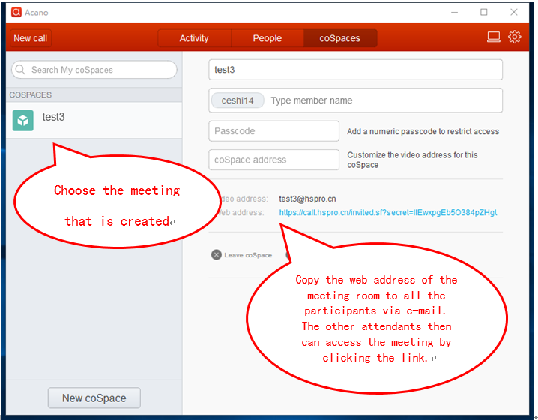

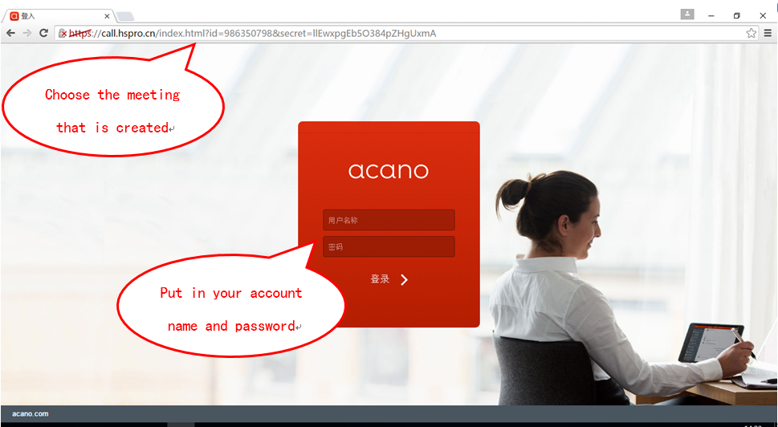

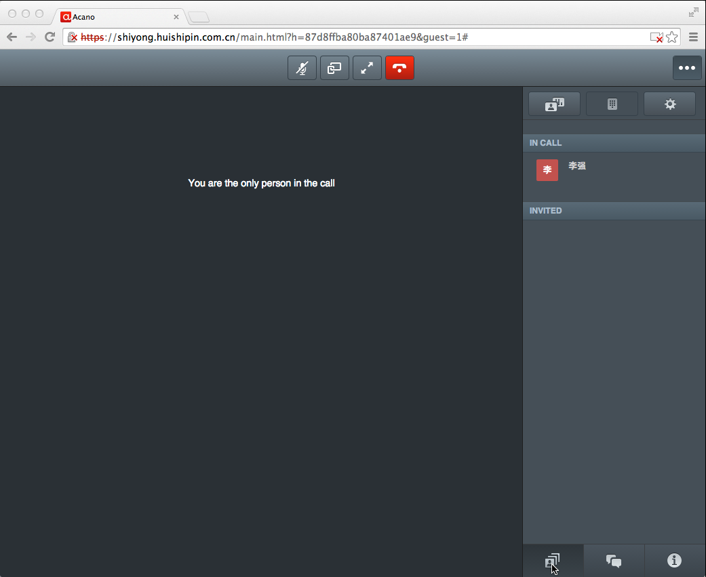

Please contact the staff of local GTEC stations or customer managers for the APP account information.