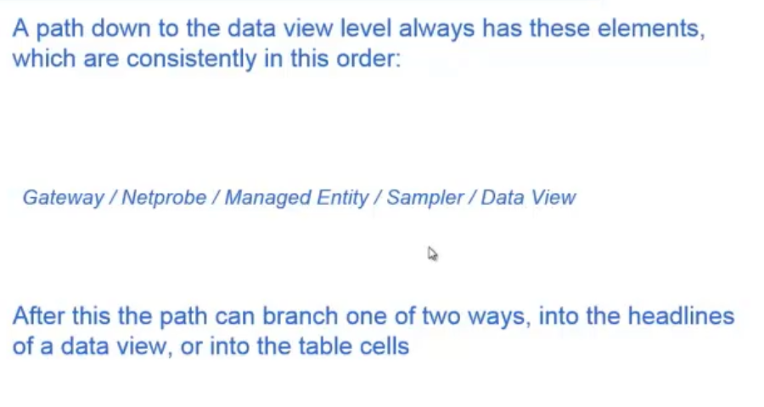

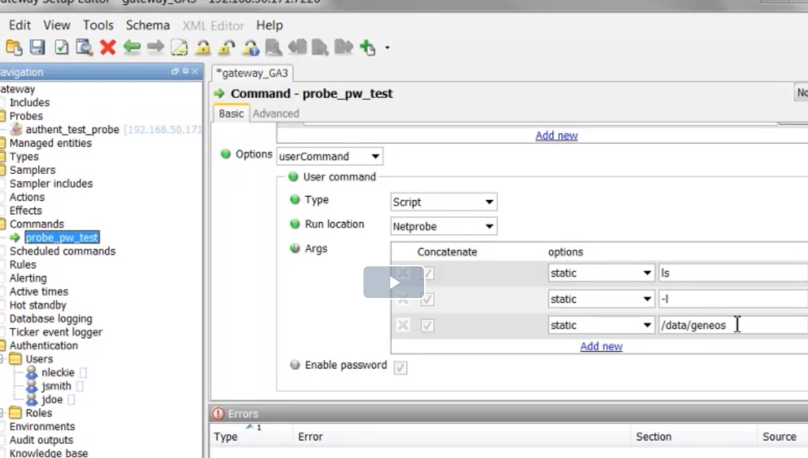

FKM – File keywork monitoring

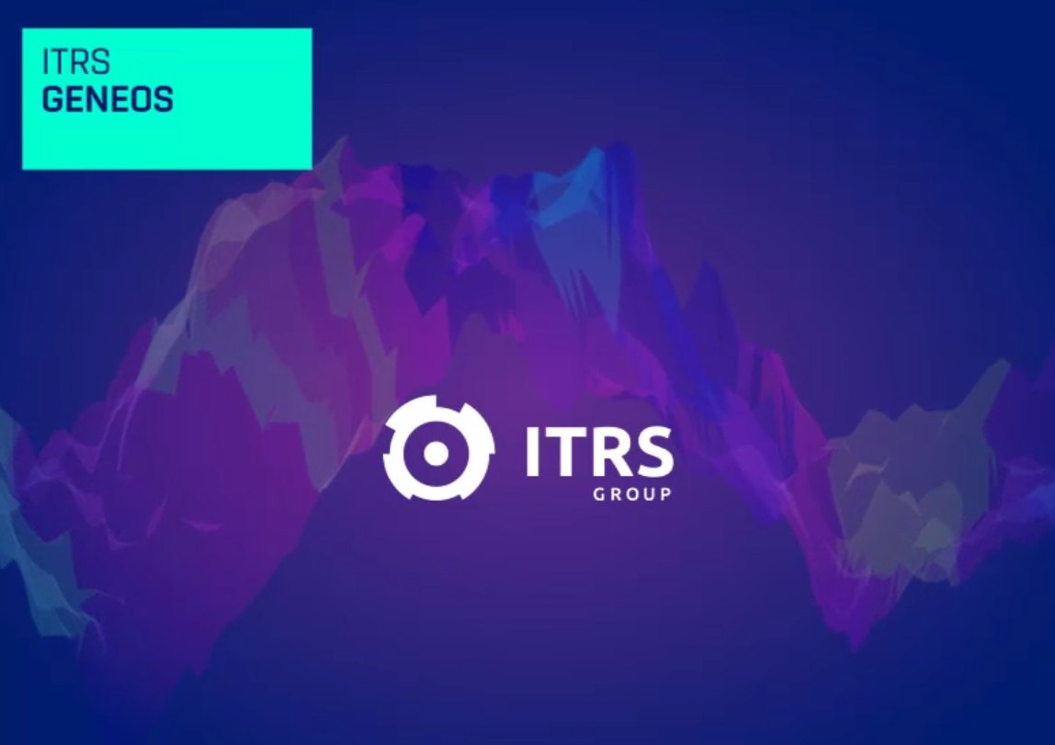

Whats is ITRS Geneos?

International Transaction Reporting System  
Real-time monitoring for all your environments in one platform

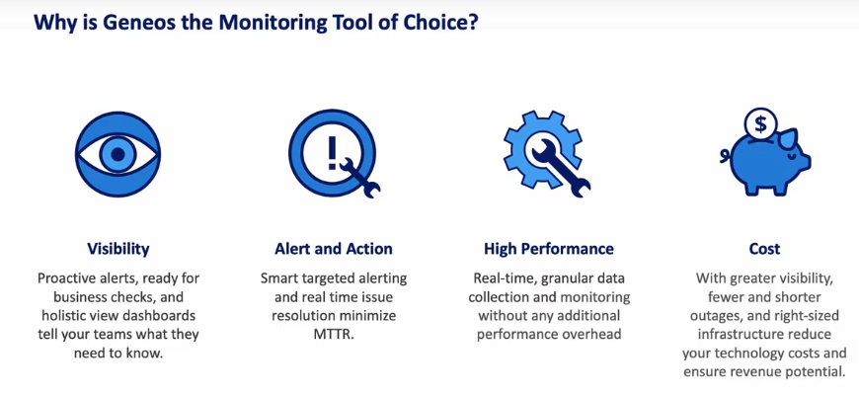

Overview:

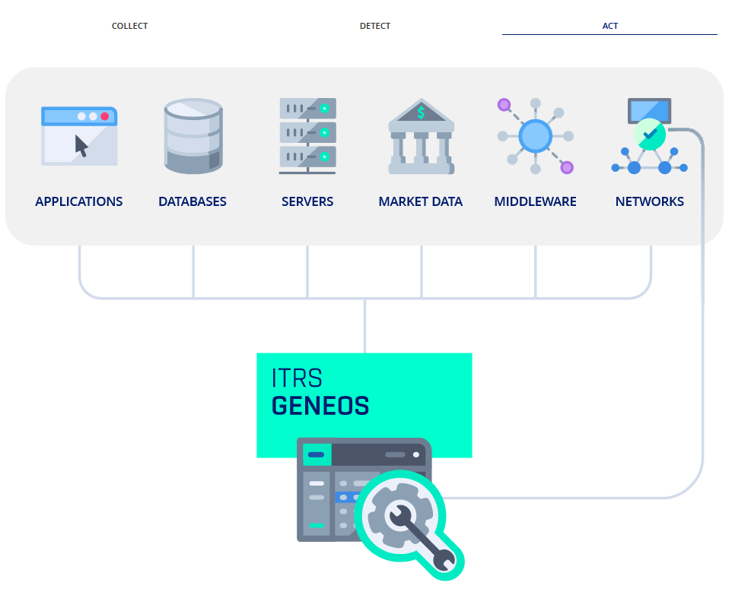

HOW

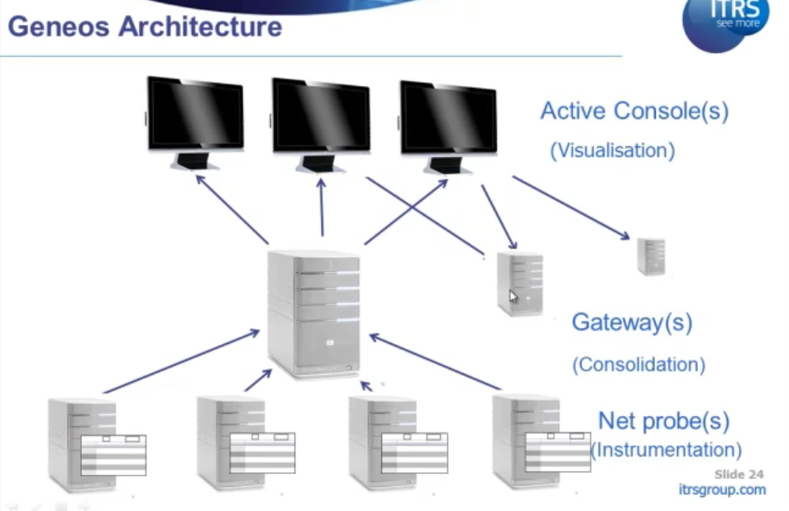

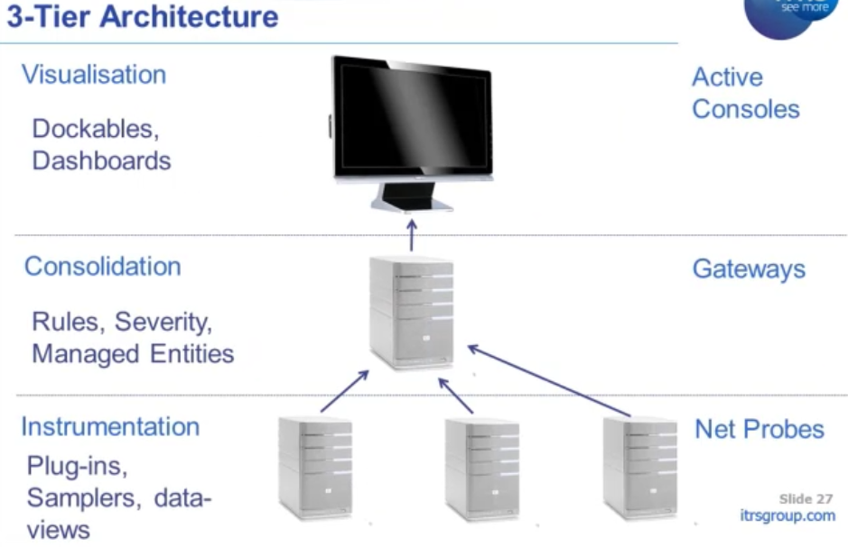

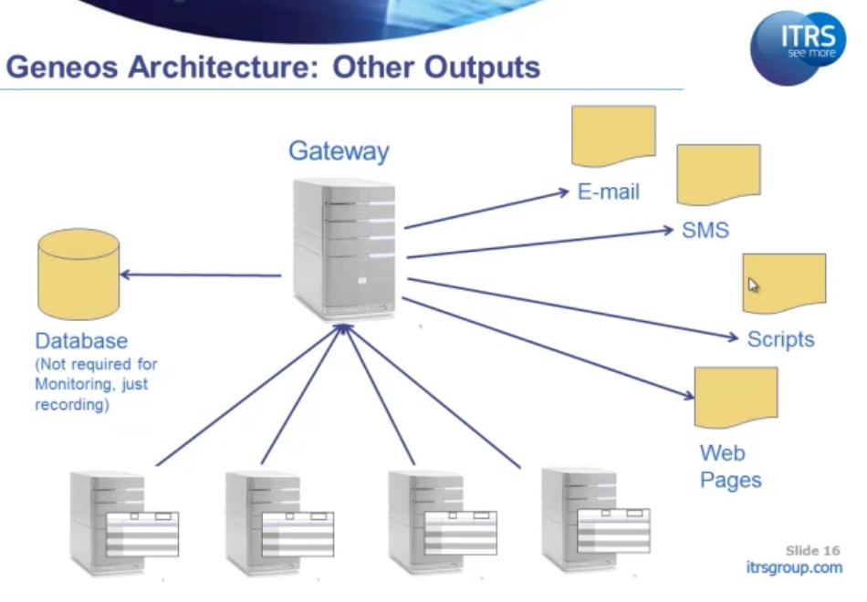

No configuration in netprobe but all in Gateways are configured by XML file

GENEOS

GENEOS UI

State view (logical view)

Physical view

Gateway Configuration Editor

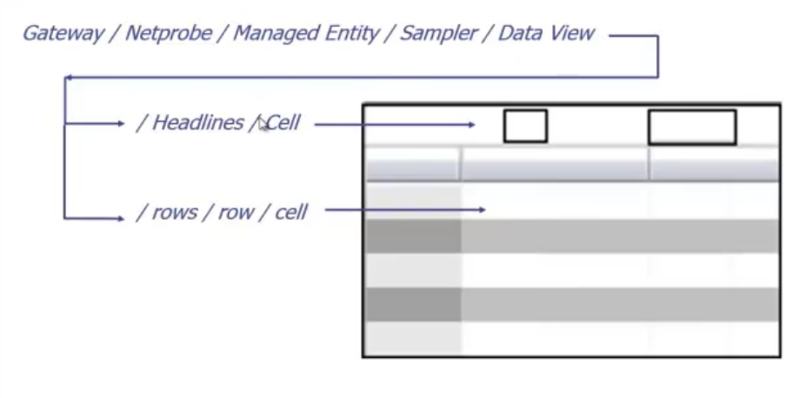

Displaying anything in Geneos UI

1. NetProbe
2. Managed Entity
3. Sampler