LAB REPORT Observing Linux Behavior
CSCI411 Lab

Submission Requirements

Submit to Blackboard
- This report
- Source file built in Part B

Introduction
The Linux kernel is a collection of data structure instances (kernel variables) and functions. The collective kernel variables define the kernel’s perspective of the state of the entire computer system. Each externally invoked function – a system call or an IRQ (interrupt request) – provides a prescribed service and causes the system state to be changed by having the kernel code changed its kernel variables. If you could inspect the kernel variables, then you could infer the state of the entire computer system.
This report demonstrates your knowledge of the observations obtained about kernel and its status.

Lab Environment
Describe the /proc directory
This directory holds details about a Linux system, including:its kernel, its processes, and its configuration parameters.

Describe/explain why the /proc directory is often referred to as a virtual file system. You will have to define what a virtual file system is, too.
A virtual file system is an abstract layer on top of a file system.

The /proc directory is quickly accessed with other file systems though it does not exist on its own.

Interactive Observation Questions
Answer the following questions about the Linux machine that you used to do these exercises. Include the program/command or other method you used to obtain the information. For each, give a brief explanation the information provided.
- What is the system hostname?
The hostname is a label that is assigned to a device connected to a computer network and that is used to identify the device in various forms of electronic communication.

My system’s hostname is thur114-06

  - What commands did you use to get this information?
Cat /proc/sys/kernel/hostname

  - What system files contain the information?
/sys/kernel/hostname

  - Give a brief explanation of the information provided.
The information provided is simply the name this Linux computer uses to network with other computers and systems.

- What version of the Linux kernel is being used
Linux version 4.15.0-43-generic (buildd@lgw01-amd64-001) (gcc version 7.3.0 (Ubuntu 7.3.0-16ubuntu3)) #46-Ubuntu SMP Thu Dec 6 14:45:28 UTC 2018

  - What commands did you use to get this information?
Cat /proc/version

  - What system files contain the information?
/sys/kernel/uname

- How many processors are on this system?
4 double threaded cores

  - What commands did you use to get this information?
Cat /proc/cpuinfo

  - What system files contain the information?
/cpuinfo

- For each processor: list the CPU Vendor, model number and model name.
Vendor ID: GenuineIntel
Model Number: 60
Model Name: Intel(R) Core(TM) i7-4790S CPU @ 3.20GHz

  - What commands did you use to get this information?
Cat /proc/cpuinfo

- How much memory is on the machine? How much if currently free?
MemTotal: 16323440 kB
MemFree: 269480 kB

  - What commands did you use to get this information?
Cat /proc/meminfo

  - What system files contain the information?
/meminfo

- How long in seconds has the system been up (since last boot)?
1,436,653.15 seconds

  - What commands did you use to get this information?
Cat /proc/uptime

  - What system files contain the information?
/uptime

  - Provide a screen shot of your output
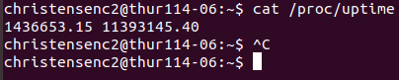

- How much of that time was spent idle, in seconds?
11,393,145.40 seconds

  - What commands did you use to get this information?
Cat /proc/uptime

- For each processor, how much of the total CPU time has been spent executing in user mode? System mode? Idle?
cpu0 user: 47,380 + 371 = 47,751 system: 9,565 idle: 143,678,433
cpu1 user: 40,035 + 349 = 40,384 system: 8,520 idle: 143,688,459
cpu2 user: 52,770 + 718 = 52,948 system: 7,836 idle: 143,678,322
cpu3 user: 33,999 + 422 = 34,421 system: 7,036 idle: 143,692,351
cpu4 user: 36,481 + 298 = 36,779 system: 6,247 idle: 143,692,412
cpu5 user: 47,495 + 286 = 47,781 system: 6,240 idle: 143,678,476
cpu6 user: 9,348,286 + 3,045 = 9,351,331 system: 196,757 idle: 133,855,827
cpu7 user: 29,658 + 1,911 = 31,569 system: 7,070 idle: 143,611,273

  - What commands did you use to get this information?
cat /proc/stat

  - Provide a screen shot of your output
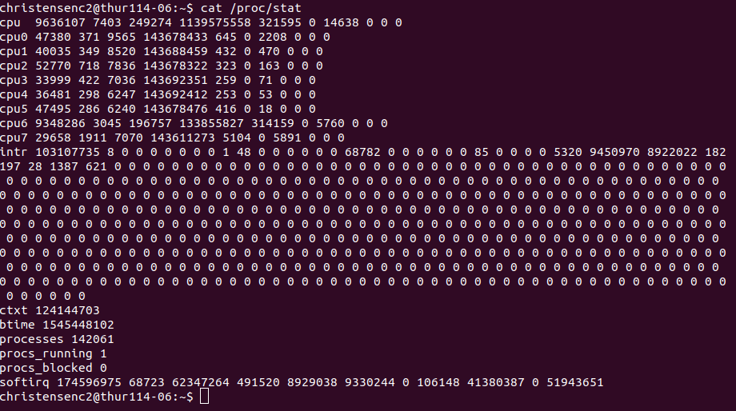
  - Give a brief explanation of what is provided in this file and how the data is interpreted to discover the answer
The info in this file gives the time signatures for the many CPUs that the computer has. It also gives info about interupts, context switches, system boot time, processes created, processes running and processes blocked.

- How many context switches has the kernel performed across all CPUs?
124,144,703 switches

  - What commands did you use to get this information?
cat /proc/stat

  - Provide a screen shot of your output
- How many context switches has your bash process performed?
1,364 voluntary context switches
0 non-voluntary context switches

  - What commands did you use to get this information?
Ps got me the <pid>

cat /proc/11967/status

  - Provide a screen shot
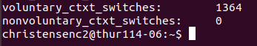
  - Give a brief explanation of the information provided.
The info in this file is a ton of kernel data accessible to other programs in a format that is easier to parse.

- How many processes have been created since the system was booted?
142,875 processes

  - What commands did you use to get this information?
Cat /proc/stat

  - What system files contain the information?
/stat

- Find the number of disk read requests made on the system for one disk block device
7 0 loop0 415856 0 833786 26156 0 0 0 0 0 716 23928
7 1 loop1 191370 0 384790 9076 0 0 0 0 0 576 7664
7 2 loop2 2 0 10 0 0 0 0 0 0 0 0
8 0 sda 7835148 8658 502782418 1760604 881075 1418124 419888392 2506564 0 1703932 4266652
8 1 sda1 7835097 8658 502779258 1760588 875268 1418124 419888392 2498864 0 1697392 4258908

  - What commands did you use to get this information?
cat /proc/diskstats

  - What system files contain the information?
/diskstats

  - Provide a screen shot
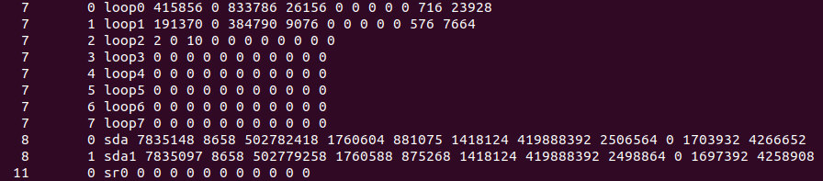

Part B
Provide screen shot or cut and paste
Attach your source file separately

Cut and Paste:
/*Cashton Christensen
* 1/7/2019
* Lab 01
* You are asked to write a C++ program to read and report some of the data you explored.
*/
#include <iostream>
#include <fstream>
int main()
{
//Open the file for CPU hostname
std::ifstream thisProcFile;
std::cout << "\n1) CPU hostname:\n";
thisProcFile.open ("/proc/sys/kernel/hostname", std::ios::in);
// Read the file. Note this file only has the host name in it
std::string line;
getline(thisProcFile, line);
std::cout << line << std::endl << std::endl;
thisProcFile.close();

//Open the file for the number of processing units on the machine
std::cout << "2) Number of Processing Units:\n";
system("grep -c ^processor /proc/cpuinfo");
std::cout << std::endl;

//Open the file for the CPU Vendor and Model for each processor
std::cout << "3) CPU Vendor and Model for each processor:\n";
system("awk '/model name/ {print}' /proc/cpuinfo");
std::cout << std::endl;

//Open the file for the Kernel version
std::cout << "4) The Version of Linux:\n";
thisProcFile.open ("/proc/version", std::ios::in);
getline(thisProcFile, line);
std::cout << line << std::endl << std::endl;
thisProcFile.close();

//Open the file for the amount of time since the system was last booted. How long in hh/mm/ss has it been since the system was last booted?
std::cout << "5) The amount of time since the system was last booted in seconds:\n";
thisProcFile.open ("/proc/uptime", std::ios::in);
getline(thisProcFile, line);
std::cout << line << std::endl << std::endl;
thisProcFile.close();

std::cout << " The amount of time since the system was last booted in hh/mm/ss:\n";
system("awk '{print int($1/3600)\":\"int(($1%3600)/60)\":\"int($1%60)}' /proc/uptime");
std::cout << std::endl;

//Open the file for the amount of memory configured into this computer and the memory currently available
std::cout << "6) The amount of memory configured into this computer and the memory currently available:\n";
thisProcFile.open ("/proc/meminfo", std::ios::in);
getline(thisProcFile, line);
std::cout << line << std::endl;
getline(thisProcFile, line);
std::cout << line << std::endl;
getline(thisProcFile, line);
std::cout << line << std::endl << std:: endl;
thisProcFile.close();
}

