RealTimeController(DS3231)

20131109
This use i2c_rd and i2c_wr.

Reference;
DS3231_0.2.f

Connection
RTC DS3231 Propeller
scl ---- P28
sda ---- P29
32kHz ---- n LED p --- 220ohm -- 3.3V
INT/SQW ---- n LED p --- 220ohm – 3.3V

Modified DS1337_1.3.f. because DS3231's register structure is almost same as DS1337.
But A1M1/A1M3/A2M3?A2M4-bit is 1 on DS3231 at power-on.
So, these bit is set at 1 when executing 'set_current'.

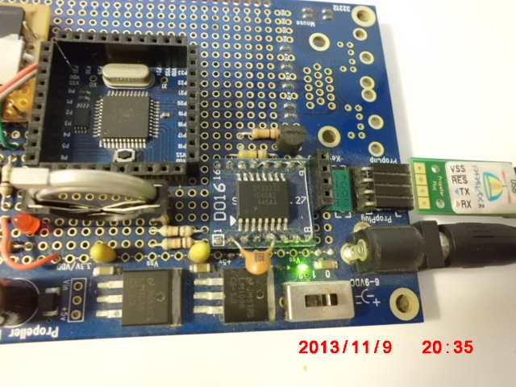

Display register value (After power on)
Prop0 Cog6 ok
disp_reg
Address(hex) value(hex)
00 00
01 01
02 00
03 01
04 01
05 01
06 00
07 80
08 02
09 A3
0A 1A
0B 30
0C 88
0D 82
0E 1C
0F 88
10 00
11 12
12 00

--- Because of A1M1/A1M3/A2M3/A2M4=1, alarm1/alarm2 is strange
Prop0 Cog6 ok
all

CurrentTime
Year: 2000
Date: JAN 1 MON
Time: 00:01:05

Alarm1 setting
Date: 20
Time: A3:02:80

Alarm2 setting
Time: 88:30

Prop0 Cog6 ok
---- Set current-tome 2013 11/8 Friday 08:08:00
Prop0 Cog6 ok
2013 11 8 5 8 8 set_current

CurrentTime
Year: 2013
Date: NOV 8 FRI
Time: 08:08:00

Prop0 Cog6 ok
all

CurrentTime
Year: 2013
Date: NOV 8 FRI
Time: 08:08:04

Alarm1 setting
Date: 20
Time: 23:02:00

Alarm2 setting
Date: 2
Time: 08:30

Prop0 Cog6 ok
Prop0 Cog6 ok
chk_INT
Alarm1 Flag:0
Alarm2 Flag:0

Set alarm1 at Date8 08:14:00
Prop0 Cog6 ok
8 8 14 set_alm1

Alarm1 setting
Date: 8
Time: 08:14:00

Alarm1 Interupt:Enabled
Alarm2 Interupt:Disabled
Prop0 Cog6 ok

--- At 8:14 Alarm1 Flag is 1, and INT/SQW-pin goes to low
Prop0 Cog6 ok
chk_INT
Alarm1 Flag:1
Alarm2 Flag:0

Prop0 Cog6 ok

--- Cleared alarm1 Flag, INT/SQW-pin goes to high
Prop0 Cog6 ok
alarm1 clr_INT
Alarm1 Flag:0
Alarm2 Flag:0

Prop0 Cog6 ok

Opeartion about alarm1/alarm2 is almost same as DS1337.

--- Enabled 32.768kHz pulse from 32kHz-pin(1-pin)
Prop0 Cog6 ok
1 32kHz_out
Prop0 Cog6 ok
1 32kHz_out
32.768kHz already is enabled.
Prop0 Cog6 ok

--- Disabled 32.768kHz pulse from 32kHz-pin(1-pin )
0 32kHz_out
Prop0 Cog6 ok
0 32kHz_out
32.768kHz already is disabled.
Prop0 Cog6 ok

Display temperature value
Prop0 Cog6 ok
disp_Temp
30 .0degree
29 .5degree
29 .5degree
29 .5degree
29 .5degree
29 .5degree
29 .5degree
29 .5degree
29 .75degree <--- Touch by finger on chip
29 .75degree
29 .75degree
29 .75degree
29 .75degree
30 .0degree
30 .0degree
30 .0degree
30 .0degree
30 .0degree
30 .0degree
30 .0degree
30 .0degree
30 .25degree
30 .25degree
30 .25degree
30 .25degree
30 .25degree

Prop0 Cog6 ok
These value is a littel high.
Chip might be close 5V-regurater.

Checking osc status
If no operate, message print and start
osc_state
Oscillator operate
Prop0 Cog6 ok

When INTCN-bit is 1, INT/SQW-pin goes to low at maching current-time and alarm1/alarm2 . (Default)
Frequency by setting RS1/RS2 always out from INT/SQW-pin when this bit is 0.

Prop0 Cog6 ok
0 set_INT

